Week commencing 06/07/2020

Hey Everyone!

We hope you all staying healthy and happy and managing to still have some fun at home.

In maths this week you will continue with algebra. This week we are looking at formulae and forming equations.

For reading, you will have sections of mock SATs papers, along with some questions that focus on 3 mark answers.

Don’t forget, if you need us we are still here for you – just email the Year 6 email address and we will respond as soon as we can!

Have a great week – you are all doing a super job! Keep it up!

Wednesday 8th July 2020

Spellings

Use the words below in a sentence

Challenge: can you use all of the words in just one sentence?
Or can you use all of the words in a cohesive paragraph, about just one topic?

1. existence
2. explanation
3. familiar
4. foreign
5. forty

Reading

Length after length

This is an extract from a novel about a teenage girl called Jess.
The story begins when Jess is at her local swimming pool.

Half-past nine in the morning and the pool was crowded already. That was
the down-side to summer holidays, especially hot ones like this, but she knew
she shouldn’t grumble: she’d been here since six thirty, together with the usual
hard-core of serious swimmers, and she’d managed a leisurely four miles
without interruption.

But she did grumble; the mere sight of all these people flopping in like
lemmings made her want to shout with frustration. She wasn’t ready to stop
yet, not by a long way. She had energy left and she wanted to use it.

She stuck to her lane, doggedly ploughing length after length, trying to ignore
the splash of other swimmers. Sometimes she’d found that if she just forced
herself to keep swimming up and down her lane without stopping or swerving,
the other users of the pool seemed by some collective telepathy to accept the
space as hers, and leave it to her. But that wouldn’t work today: they seemed
to be jumping in by the score. Another quarter of an hour and it would be
unbearable.

She locked into her stroke and drove herself on, her breath beating its
practised rhythm in time with the strokes, as even as the chime of a clock. In
for a gulp of oxygen, her mouth twisted upwards to snap its life from the air,
then face down again and the long exhalation to a slow, steady count, bubbles
teasing her lips like tiny fish.

She loved this rhythm; she needed it. It kept her thoughts on track when
they started to wander. Sometimes, when things were going well and she
was feeling secure in herself and had something pleasant to think about, she
was happy to let them wander; but if she was tiring or feeling vulnerable or
worrying, she focused on that rhythm and it settled her, sometimes even when
she wasn’t swimming.

But she was always swimming. She needed to swim. To be deprived of
swimming would be like a perverse kind of drowning. She loved the sensation
of power and speed, the feeling of glistening in a bed of foam, even the strange
isolation of mind in this watery cocoon. Distance swimming was as much
about will as about technique; and she knew she was strong in both. All she
needed now, to set that will alight, was a big swimming challenge; something
to test herself against. Something she could one day be proud of.

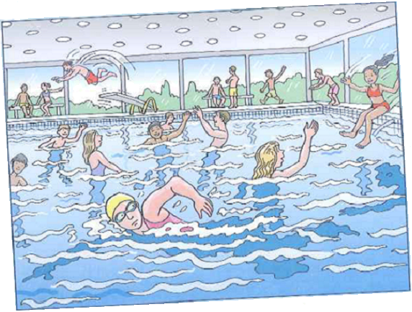

1. Look at the paragraph beginning: She stuck to her lane...

Find and copy two words that suggest everyone understood that the space belonged to Jess.

______________________________________________________________

1 mark

2. To be deprived of swimming would be like a perverse kind of drowning.

What does this show about Jess’ feelings towards swimming?

______________________________________________________________

______________________________________________________________

1 mark

3. Describe the character of Jess based on what you have read.

Explain your answer, using evidence from the whole text.

______________________________________________________________

______________________________________________________________

______________________________________________________________

______________________________________________________________

______________________________________________________________

______________________________________________________________

______________________________________________________________

3 marks

1. Award 1 mark for:

• collective telepathy

1 mark

2. Award 1 mark for answers that recognise that Jess needs to swim / cannot survive without it, eg:

• she loves it so much that she would rather die than go without swimming

• this shows that Jess loves swimming and she is saying she couldn’t live without it

• she needed it

• she couldn’t do without it.

1 mark

3.
Acceptable point | Likely evidence / quotation linked to text
1. hard-working / motivated / dedicated | there at 6.30 / stays a long time / swims a long way
2. persistent / determined / stubborn | locked into her stroke / doggedly ploughing / forced herself to keep swimming
3. impatient of others / selfish / frustrated / irritable | says it is becoming unbearable / tries to ignore them / grumbles / made her want to shout with frustration / calls them lemmings / says they are ‘flopping’
4. passionate | needed to swim
5. likes / needs a challenge / optimistic about success | big swimming challenge / something to test herself against
6. insecure | vulnerable / worrying
7. confident / optimistic. | loves the isolation of long distance swimming / knows she is strong in will and technique.

Award 3 marks for reference to at least three of the acceptable points, with evidence from the text for each, eg:

• she is dedicated, ‘she stuck to her lane’ shows she will carry on and on. She is quite irritable, ‘the mere sight of the lemmings flopping made her want to shout’ shows she is also a passionate person as ‘she needed swimming’, her love for swimming was immense. [B1+ evidence, B2 + evidence, B4 + evidence]

Award 2 marks for reference to two of the acceptable points, with evidence from the text for both, eg:

• she feels really annoyed and frustrated at the other swimmers because she complains ‘that they flop in like lemmings’. Jess is very determined and she hopes that one day, she’d enter a competition and do something she’d be proud of [B3 + evidence, B2 + evidence]

• I think she is determined – ‘drove herself’. I think she’s ambitious – ‘something she could one day be proud of’. [B2 + evidence, B4 + evidence]

Award 1 mark for reference to one of the acceptable points with evidence from the text, or two or more acceptable points without evidence from the text eg:

• she is determined as it says that ‘she drove herself on’ [B2 + evidence]

• I think she might be a bit short tempered because when people get in her way she gets quite annoyed. I think she might be quite determined because she wants to swim longer and she won’t give up. [B3 + B2]

Accept the same evidence for more than one acceptable point, if appropriate.

Up to 3 marks

Wednesday Maths
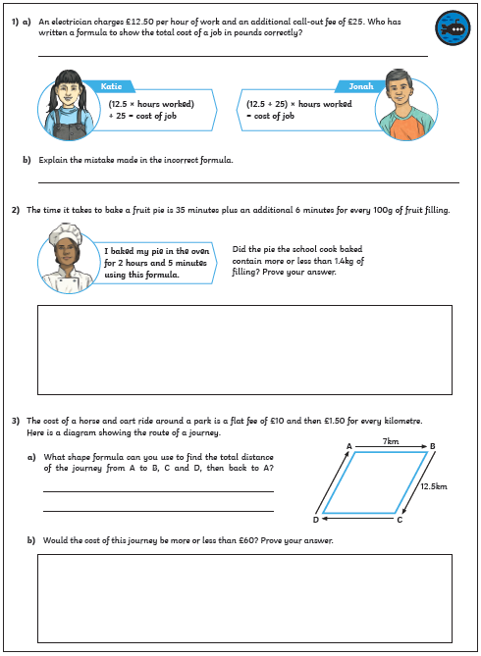
Maths Answers

