Ebony Regular

Week commencing 1/06/2020

Hey Everyone!

We hope you all had a good half term break and are staying healthy and happy.

In maths this week you will be using fractions to find the whole. For example: Find 2/5 of 25.

In order to calculate this, you must first divide the whole by the denominator, then multiply the quotient – the answer – by the numerator. This is your answer.

25 ÷ 5 = 5

5 x 2 = 10

2/5 of 25 is 10.

For reading, you will have sections of mock SATs papers, along with some questions that focus on 3 mark answers.

Don’t forget, if you need us we are still here for you – just email the Year 6 email address and we will respond as soon as we can!

Have a great week – you are all doing a super job!

Wednesday 3rd June 2020

Spellings

Use the words below in a sentence

*Challenge: can you use all of the words in just one sentence?*

*Or can you use all of the words in a cohesive paragraph, about just one topic?*

existence

explanation

familiar

foreign

forty

Reading

*People travel great distances to watch whales in their natural environment. Lucy Carter is one of them. She went whale watching off the coast of Canada in 1999, and her first trip made a deep impression on her.*

**

*Editor*

ON THE WHALE TRAIL



I wasn’t really sure what to expect. We had to put on waterproof suits before the boat left the dock – I felt rather like an intrepid explorer journeying into unfamiliar territory. Even the boat trip out to where the whales were last spotted was memorable – I can remember being dazzled by the sunlight on the water’s surface.

As we approached the area where the group of whales had last been sighted, the captain slowed the boat down and we looked right across the surface of the Pacific hoping to catch a glimpse of one of the creatures.

At first we seemed to be the only living things around apart from a few gulls screeching above us. Then suddenly, without a sound, something cut through the still surface of the water a short distance away. It travelled a few metres and then, silently, disappeared. I didn’t speak – just craned my neck and scanned the ocean for another sighting.

There was nothing to see for a few minutes, I even began to wonder if I had imagined it. Then, with no warning, the boat was rocked as 30 tonnes of grey whale launched itself out of the water and flew through the air. I was speechless – it was so much more spectacular than I had expected – bigger, louder, closer. I hadn’t really had time to take in what we’d just seen when several whales appeared simultaneously, two leaping clean out of the water, others just breaking the surface. I was drenched by the spray as they crashed back into the depths of the ocean.

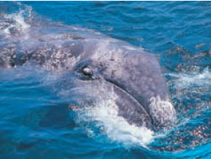

We watched them for an hour. I felt like an intruder in what was so clearly the whales’ territory – perhaps because they seemed so unaware of our presence. Even when the ocean was still and the captain assured us they had moved further out to sea, I was reluctant to return to the shore, hoping for one last chance to see these truly amazing creatures.

But as we approached land, I was increasingly glad that we hadn’t shared all their secrets. It was satisfying to know that some parts of the whales’ life below the ocean waves remained truly their own, untouched by human curiosity.

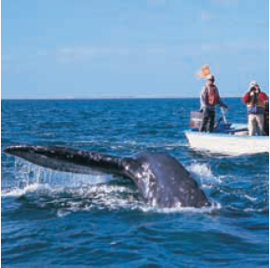

1.      What did Lucy have to do before the boat left the dock?

         Circle the correct option.



1 mark

2.      Lucy’s account of whale watching is made up of five main events.

         Number each stage of the trip to show the order in which they happen.

         The first one has been done for you.

|  |  |
| --- | --- |
| goes back to the dock |  |
| sees one whale swimming |  |
| sets off on the journey |  |
| sees several whales leaping |  |
| prepares for the journey |  |

2 marks

3.      In the first paragraph, Lucy feels as if she is going somewhere completely new.

**Find** and **copy** a word or phrase which tells you this.

___________________________________

1 mark

4.      The author describes the whale and makes the event seem dramatic.

         Explain how each of these phrases helps to make the description effective.

(a)     *There was nothing to see for a few minutes*

______________________________________________________________

______________________________________________________________

1 mark

(b)     *I was speechless*

______________________________________________________________

______________________________________________________________

1 mark

5.      *launched* and *crashed*

Explain the impression these words give you of the whale's movements.

___________________________________________________________________

___________________________________________________________________

___________________________________________________________________

___________________________________________________________________

___________________________________________________________________

___________________________________________________________________

2 marks

6.      Towards the end of the trip, Lucy admits that she has a mixture of feelings about her experience.

         Explain her different feelings.

___________________________________________________________________

___________________________________________________________________

___________________________________________________________________

___________________________________________________________________

___________________________________________________________________

___________________________________________________________________

___________________________________________________________________

3 marks





PE

Look at the yoga poses below. Choose one from each row to try. How long can you hold the pose for? Yoga poses have interesting names like: downward dog, child’s pose and sun salutation. What would you name the poses you chose?

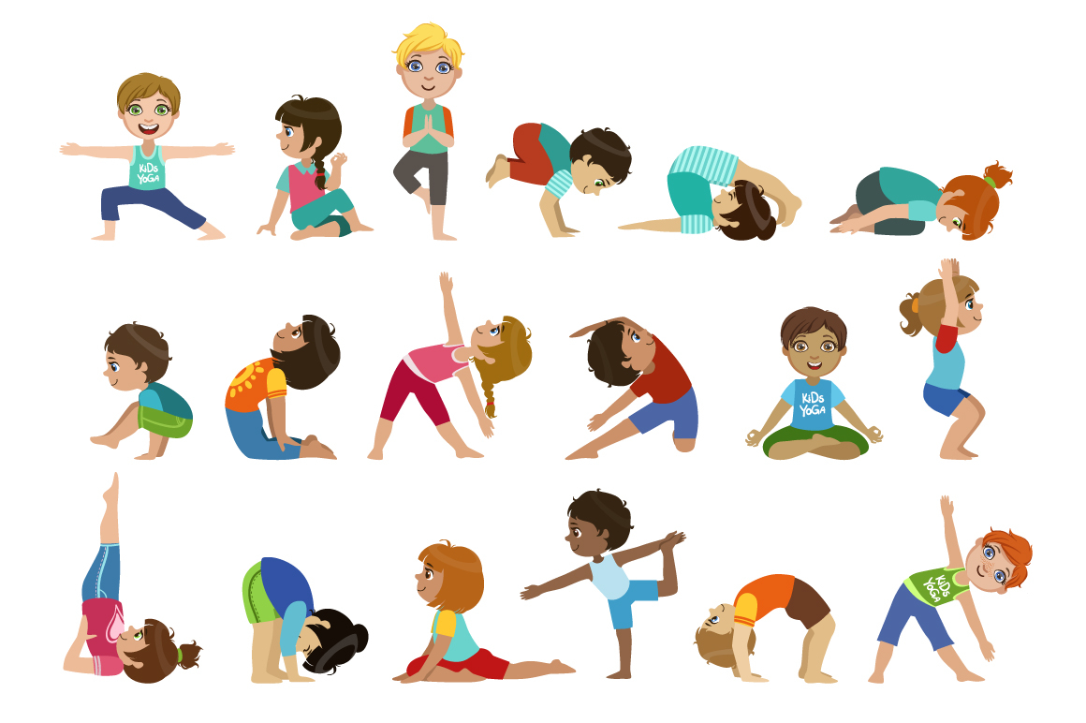

Make sure you are warmed up before you attempt a yoga pose. Breathe in slowly through your nose and out through your mouth as you hold the pose. Stop holding the pose if it hurts you. If you are balancing on one leg, stand near something or someone you can hold on to if you get wobbly.

Mark schemes- Whale Trail

1

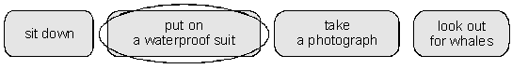

**1 mark**

2        Award **1 mark** for two or three stages correctly numbered.

          Award **2 marks** for all four stages correctly numbered.

|  |  |
| --- | --- |
| goes back to the dock |  |
| sees one whale swimming |  |
| sets off on the journey |  |
| sees several whales leaping |  |
| prepares for the journey |  |

**up to 2 marks**

3        Award **1 mark** for any of the following:

*•        I wasn’t really sure what to expect;*

*•        (intrepid) explorer;*

*•        (journeying into) unfamiliar territory.*

**Also accept** responses expressed in the third person, eg:

*•        she didn’t know what to expect.*

**1 mark**

4        (a)     *There was nothing to see for a few minutes*

          Award **1 mark** for references to building suspense or expectation, eg:

*•        it makes you tense and expectant;*

*•        it’s a type of cliff hanger;*

*•        it makes you want to carry on reading to find out what happens;*

*•        it makes you feel it may not have been worth the trip and there might be nothing to see, but you know there will be.*

(b)     *I was speechless*

Award **1 mark** for responses which describe the effect of the author’s choice of language on the reader, eg:

*•        it shows you how amazing the experience must have been;*

*•        it makes you think that it’s beyond description;*

*•        it makes you feel that you want to go there yourself and see exactly why;*

*•        the description shows you how shocked she was.*

**Do not accept** explanations of the phrase, eg:

*•        she was struck dumb with admiration.*

**up to 2 marks**

5        Award **1 mark** for general answers which refer only to the movement and / or bulk / size of the whale, eg:

*•        it’s big and moves fast;*

*•        it swims up fast from the bottom of the sea, leaps into the air and then flips.*

Award **2 marks** for more developed answers which explain the link between launched / crashed and suddenness / bulk / power, eg:

*•        it looked like a rocket taking off;*

*•        because the whale made an explosion when it hit the water;*

*•        because whales put all of their force into jumping out of the water.*

Also award **2 marks** for answers which refer to effect / authorial intent / aptness of word choice in evoking the whales’ size or movement, eg:

*•        these words make the whales sound big and strong;*

*•        it makes it seem very dramatic and loud and ‘crashed’ is an onomatopoeic word;*

*•        to tell the reader that the whale was heavy and its movements were violent;*

*•        it makes you imagine that the whale was getting ready to show off and to jump as high as it could.*

**Do not accept** very general answers, eg:

*•        it makes it seem exciting / interesting / dramatic;*

*•        they are powerful verbs (not specific to this text);*

          or answers which simply provide synonyms without explaining the vocabulary choice.

**up to 2 marks**

6        Award marks based on the identification and explanation of Lucy’s feelings:

pleased at having seen whales / impressed by the whales;

reluctant to return to shore / hoping for another sight of the whales;

glad that the whales still had some secrets;

concerned, as though she had intruded.

          Award **1 mark** for responses which explain one of Lucy’s feelings, eg:

*•        Lucy felt that she was an intruder in the whales’ territory because the whales were so unaware of her presence;*

*•        Lucy was feeling amazed she had seen the whales and was so glad she’d seen them;*

*•        she felt very glad that they hadn’t shared all their secrets.*

Also, award **1 mark** for answers which either simply identify more than one feeling or quote two or more appropriate sections of the text but without interpretation, eg:

*•        she feels like an intruder, glad and satisfied;*

*•        she felt like an intruder and she was reluctant to return to shore;*

*•        I was increasingly glad we hadn’t shared all their secrets, I felt like an intruder.*

Award **2 marks** for responses which explain at least two of Lucy’s feelings, eg:

*•        Lucy’s feelings were glad and satisfied because she had seen a whale and because the whales still have a place of their own;*

*•        she felt like she was an intruder in the whales’ territory. When they approached land she was increasingly glad that she didn’t share all the whales’ secrets.*

Award **3 marks** for developed answers which explain at least two of Lucy’s feelings and identify some ambivalence, eg:

*•        first she felt guilty for disturbing the whales and bursting into their living area without being asked. Later when returning she felt they were so amazing, she did not want to go, but afterwards she felt sorry for the whales and was glad to know that we have not found out all their secrets so they have freedom;*

*•        Lucy felt like a stranger on the whales’ property, but was still anxious to see them. As she approached land she was pleased that she didn’t know all the whales’ secrets;*

*•        she felt like an intruder as it was the whales’ ‘territory’; also glad that they hadn’t shared all their secrets. She was relieved that life below the ocean wave remained their own but she was still glad she had seen them.*

**up to 3 marks**

