Week commencing 22/06/2020

Hey Everyone!

We hope you all had a good half term break and are staying healthy and happy.

In maths this week you will be practising forming expressions in algebra.

For reading, you will have sections of mock SATs papers, along with some questions that focus on 3 mark answers.

Your topic work is in a separate pack this week for you to work through at your own pace.

Don’t forget, if you need us we are still here for you – just email the Year 6 email address and we will respond as soon as we can!

Have a great week – you are all doing a super job! Keep it up!

Wednesday 24th June 2020

Spellings

Use the words below in a sentence

Challenge: can you use all of the words in just one sentence?
Or can you use all of the words in a cohesive paragraph, about just one topic?

1. competition
2. conscience
3. conscious
4. controversy
5. convenience

Reading

A Life Underwater

David Doubilet is a well known underwater photographer, who has had his work published in many books and magazines. He was born in New York and started taking photos underwater at a very young age.

I grew up in New York City, a very strange place to go diving. When I was ten, my uncle took me to the premiere of the movie The Silent World. Produced by Jacques Cousteau, the famous underwater photographer, the film was shot in the Red Sea and the Indian Ocean. I was absolutely mesmerised. Sometimes it happens to you. You see something - a moment, a part of life - that changes the course of your life. I was very lucky because it happened when I was only ten.

After the film, knees trembling, I went up to Jacques Cousteau, who stood straight, tall and aloof, talking to people in the theatre. I sneaked between a forest of legs, looked up at him, pulled his jacket and said: "Oh, Captain Cousteau, I want to swim underwater and take pictures. I want to be an underwater photographer." He looked down and said: "Why not?"

My family spent summers at our house on the New Jersey shore. The sea there is dark and murky and changes all the time. Rough or calm, it is always green. That's where I began diving. I had a simple yellow face mask and green flippers from a company called Frankie the Frog Man. The flippers looked like lily pads. My snorkel was made of hard rubber that hurt my mouth, but I could put my head under and breathe when I swam. I learned to be a good free diver and how to spear fish, too, because that's what you did underwater in those days.

At 12, I learned to scuba dive using a double air tank that was heavier than I was. I became a certified diver at 13. There was a group called the New York Skin Diving Academy. I had to study the physics of diving. In 1956 the sport was barely 12 years old, so I was a young pioneer.

I liked to be underwater for one simple reason: I could escape the rest of the world. I could escape school or parents or lunch if I didn’t like it. I was constantly being sought for something I was either late for, or forgot to do, or did not want to do in the first place. Being at the bottom of the pool was like being at the bottom of the ocean – no one could reach me.

My parents never really encouraged me, but they never discouraged me either. Everyone in my family did different things. My father, a doctor, liked to fish; my mother played golf; one sister skied; my other sister ice-skated. Everything I did, I did on my own, and everything was possible. I learned early on that if you want to do something, you go and do it.

There were few books about underwater photography back then. I didn’t know as much as the authors of those books, but I wasn’t far behind. Using a rubber bag, I adapted my first camera, a Kodak Brownie Hawkeye, for underwater pictures. The first results were absolutely terrible, but I wasn’t discouraged. I was taking pictures of everything: fish, mussels and clams, and people peering down from the surface of a swimming pool. I was shooting bubbles. At 14, I won my first photography contest. At 15, my picture of a diver pulling up an anchor sold to a South American magazine. My school did not offer photography courses like many schools do today. But even if you’re a student, you can’t say, “I want to make student pictures.” You must say, “I want to make real pictures that will tell a story and please me.”

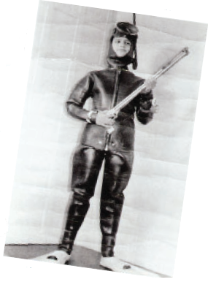

Photography depends on light. How does the light look in the morning? What kind of shadow does a glass of juice cast? Einstein called photographers “light monkeys,” because they are fooling with, playing with, and constantly moving the light. A photographer must be as aware of light as a perfume-maker is of smells.
Photography comes from the heart. Strangely enough, it’s not something you do, but something you use to explore your interests and to translate them into images.  David Doubilet | 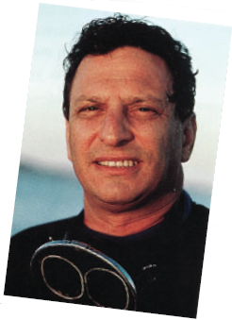

Mark Scheme

1. I grew up in New York City, a very strange place to go diving.

What does the writer, David Doubilet, mean by this?

Tick one.
New York City was a difficult place to grow up.
People in New York didn’t approve of strangers diving there.
It was unusual for people to go diving in New York City.
There was nowhere to practise diving in New York City.

1 mark

2. Look at the paragraph beginning: After the film...

When Jacques Cousteau replied Why not? to David’s remark about wanting to be an underwater photographer, he was

Tick one.
making a joke.
offering encouragement.
expecting David to answer.
trying to make David angry.

1 mark

3. Look at the paragraph beginning: I grew up in New York City...

Find and copy a word that shows David Doubilet’s interest was captured by the film he saw.

______________________________________________________________

1 mark

4. How can you tell that David Doubilet admires Jacques Cousteau?

Explain fully referring to the text in your answer.

______________________________________________________________

______________________________________________________________

______________________________________________________________

______________________________________________________________

______________________________________________________________

______________________________________________________________

______________________________________________________________

______________________________________________________________

3 marks

5. Look at the paragraph beginning My family spent…

From the description of his equipment, how do we know that he was a child when he first learned to dive?

______________________________________________________________

______________________________________________________________

______________________________________________________________

1 mark

6. In 1956 the sport was barely 12 years old, so I was a young pioneer.

What does the word pioneer mean in this sentence?

______________________________________________________________

______________________________________________________________

______________________________________________________________

1 mark

7. David Doubilet enjoyed being underwater because he could get away from people or things he had to do.

Find and copy a sentence that shows this.

______________________________________________________________

______________________________________________________________

1 mark

8. How did David Doubilet change his camera so that he could use it for underwater photography?

______________________________________________________________

______________________________________________________________

1 mark

9. A photographer must be as aware of light as a perfume-maker is of smells.

What does David Doubilet mean by this?

______________________________________________________________

______________________________________________________________

______________________________________________________________

______________________________________________________________

______________________________________________________________

2 marks

10. Complete the table to show whether you think David Doubilet would agree or disagree with each statement.

Statement | Agree or disagree
To learn to dive you need the best equipment available.
Photographers are light monkeys.
Meeting Jacques Cousteau changed the course of my life.
It is really important that your parents support your interests.

2 marks

11. Draw lines to match the event in David Doubilet’s life to the age he was when it happened. One has been done for you.

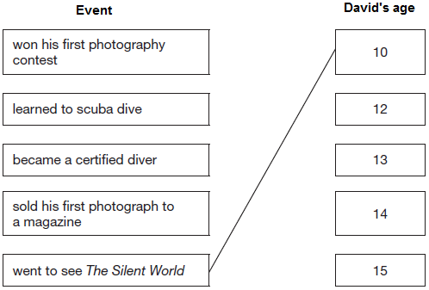

1 mark

12. I learned early on that if you want to do something, you go and do it.

What does this statement by David Doubilet tell us about his character?

______________________________________________________________

______________________________________________________________

______________________________________________________________

1 mark

1. Award 1 mark for correct box ticked.
New York City was a difficult
place to grow up.
People in New York didn’t
approve of strangers diving there.
It was unusual for people to go
diving in New York City.
There was nowhere to practise
diving in New York City.

1 mark

2. Award 1 mark for correct box ticked.

making a joke.

offering encouragement.

expecting David to answer.

trying to make David angry.

1 mark

3. Award 1 mark for:

♦ (I was absolutely) mesmerised.

1 mark

4. Award 3 marks for 3 acceptable points or 2 points with one developed.
Award 2 marks for 2 acceptable points or 1 developed point.
Award 1 mark for 1 acceptable point.

Acceptable points:

♦ He enjoyed Jacques Cousteau’s film (The silent world) / he was mesmerised

♦ The film changed the course of his life

♦ His knees are trembling when he approached him (which shows he’s nervous about meeting his hero)

♦ The way he addresses Jacques Cousteau Oh Captain Cousteau (suggests he is in awe of him / very respectful)

♦ He tells Jacques Cousteau that he wants to do what he does (I want to swim underwater and take pictures).

Also accept:

♦ He followed in his footsteps by becoming an underwater photographer.

up to 3 marks

5. Award 1 mark for one of the following:

♦ His equipment is for children / sounds childish

♦ His equipment is very basic / simple

• Adults wouldn’t wear something made by Frankie the Frogman

• His flippers looked like lily pads

• He only has a simple yellow face mask and green flippers

Do not accept:

♦ Because he was 12 when he learned to dive

♦ the air tank was heavier than he was.

1 mark

6. Award 1 mark for recognising that diving was a new sport, eg:

♦ He was one of the early people in the field of diving

♦ Diving was a very new sport and he was young too.

♦ it means he was one of the first people to do it.

Do not accept:

• He was first to go diving

• It means he was a young explorer

• He was first.

1 mark

7. Award 1 mark for one of the following sentences.

♦ I could escape the rest of the world

♦ I could escape school or parents or lunch if I didn’t like it

♦ Being at the bottom of the pool was like being at the bottom of the ocean – no one could reach me.

1 mark

8. Award 1 mark for:

♦ He used a rubber / waterproof bag.

Do not accept:

♦ He put the camera in a bag.

1 mark

9. Award 2 marks for responses which make the comparison between photography and making perfume explicit, focussing on the importance of the light and smells respectively, eg:

• I think he was explaining how perfume-makers are good because they know their smells, so to be a good photographer you have to understand the effects and the importance of light

Award 1 mark for a response that refers to either the photographer or the perfume maker, eg:

• It is important for a photographer to understand light and how it can affect the photograph

• He used a simile to show that photography is harder than it looks - it is not just taking a picture.

Do not accept:

• Light and smell are important ingredients

2 marks

10. Award 2 marks for all correct, 1 mark for at least three correct.

Statement | Agree or disagree
To learn to dive you need the best equipment available. | Disagree
Photographers are light monkeys. | Agree
Meeting Jacques Cousteau changed the course of my life. | Agree
It is really important that your parents support your interests. | Disagree

up to 2 marks

11. Award 1 mark for all events correctly matched.

Event David’s age

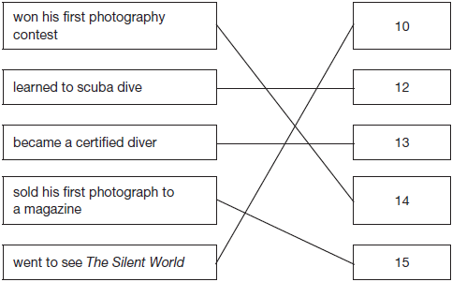

1 mark

12. Award 1 mark for responses which describe his independence and determination, eg:

• He is very driven

• He is someone who doesn't let anything or anyone stop him doing what he wants to do.

Do not accept a paraphrase: It means he just gets on and does things.

1 mark

Maths

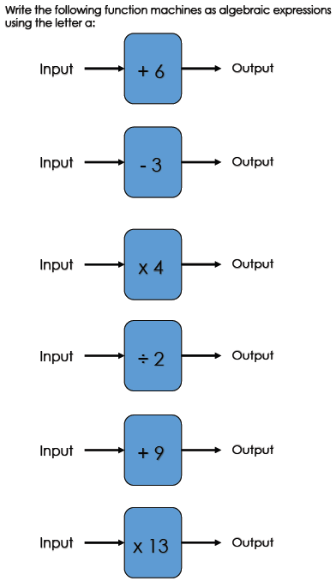
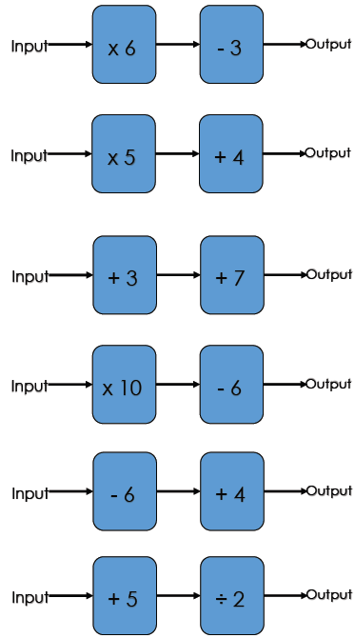

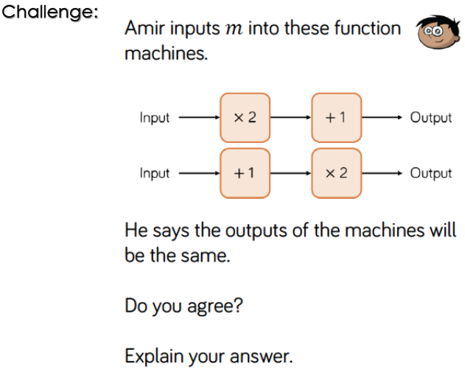

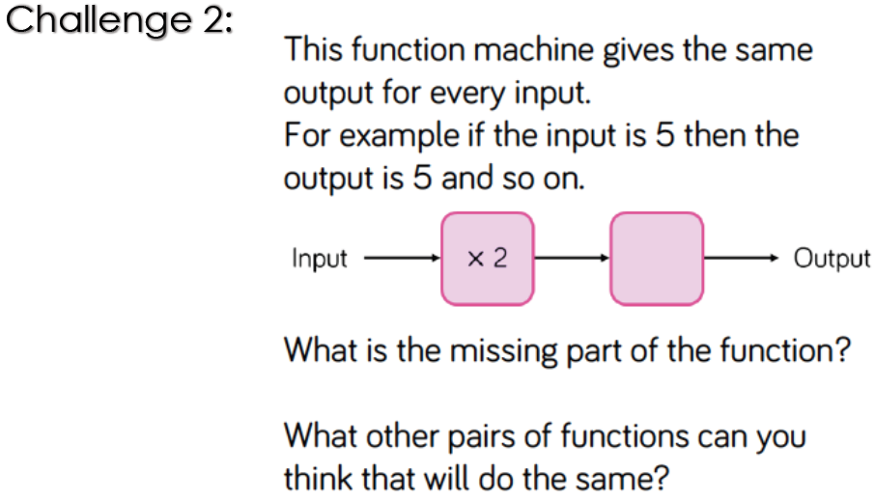
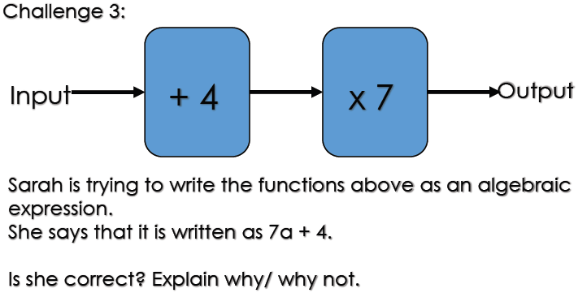

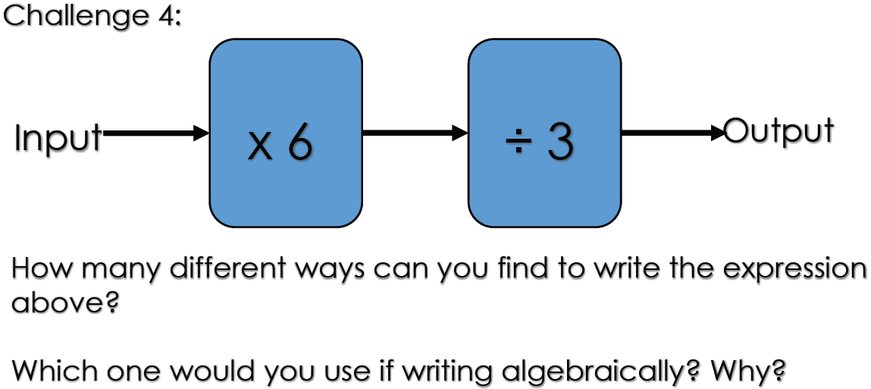

Maths answers

Challenge 1
Not the same output. 2m + 1 is not the same as m+1 x 2 [It would be 2m +2]

Challenge 2
Missing part of the function would be ÷2. Other functions that would work include x3 and ÷3, x4 and ÷4 etc.

Challenge 3
It is 7(a + 4) which equals 7a + 28. The order of the functions matters.

Challenge 4
(a x 6) ÷ 3
6a ÷ 3
2a

