Week commencing 29/06/2020

Hey Everyone!

We hope you all staying healthy and happy and managing to still have some fun at home.

In maths this week you will carry on with algebra

For reading, you will have sections of mock SATs papers, along with some questions that focus on 3 mark answers.

Don’t forget, if you need us we are still here for you – just email the Year 6 email address and we will respond as soon as we can!

Have a great week – you are all doing a super job! Keep it up!

Wednesday 1st July 2020

Spellings

Use the words below in a sentence

Challenge: can you use all of the words in just one sentence?
Or can you use all of the words in a cohesive paragraph, about just one topic?

- determined
- develop
- dictionary
- embarrass
- environment

Reading

The Humble Potato

Where it all began  Potatoes were first grown for food in South America thousands of years ago. People found a way to preserve them by leaving them out at night in the cold and then warming them in the sun the following day. During the day, the potatoes were crushed by stamping on them. After doing this for five days, ‘chuno’ (a potato pulp) was made which could be stored and kept for up to ten years in case crops failed. | 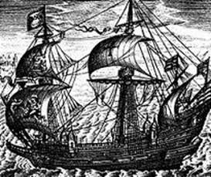
In 1532 Spanish traders, who had been searching for gold, brought potatoes back from South America and used them on board ships as food. It was not long before farmers in Spain began to grow what they called ‘patatas’ and the potato spread across the rest of Europe. They were regarded with suspicion, however, and many people thought they weren’t suitable for humans to eat, partly because of their odd shape. In some places, they were grown just as food for animals.

How the potato arrived in Britain

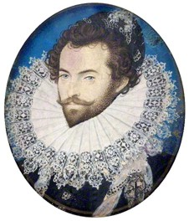  Sir Walter Raleigh | There are different opinions about how the potato came to Britain in the late 1500s.  One view is that Spanish fishermen ate potatoes on their fishing trips to the North Sea. On their way home, they would land in Ireland to put salt on the cod they had caught to stop it rotting. It is believed that the sailors gave some of their potatoes to the farmers who grew them in the rich Irish soil.  Another view is that Sir Walter Raleigh, an explorer who went to the Americas many times, brought potatoes back to his Irish farm and planted them there.
It is said that he gave a potato plant to Queen Elizabeth I as a gift, and to celebrate, a royal feast was held to eat the potatoes. Legend has it that the cooks threw away the potatoes and instead served up the boiled stems and leaves (which are poisonous). This made everyone very ill and potatoes were then banned from the royal menu.

Potatoes today – good to eat and good to grow!

Potatoes are very popular today and, despite what some people think, they are also good for you. A baked potato contains a surprisingly large amount of vitamin C – and more fibre than two slices of wholemeal bread. Potatoes also provide carbohydrates and other important nutrients like vitamin B6. They are low in fat too, provided you don’t fry them or add lots of butter! | 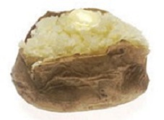
Potatoes are easy to grow. This makes them a perfect crop for farmers in the developing world, who can grow a nutritious food in poor soil. There are plenty of different varieties to choose from and they usually produce a good harvest.

Grow Your Own Potatoes Project

In 2005 the Grow Your Own Potatoes Project was started. It was one of the first projects to encourage primary schools to grow their own food. Since then it has become the largest of its kind, with almost 1 million children taking part by 2010.  In 2011 the winning school had a child on frost watch at the end of every school day and if there was a chance of frost at night they brought their pots of potatoes indoors. No wonder they were winners! | 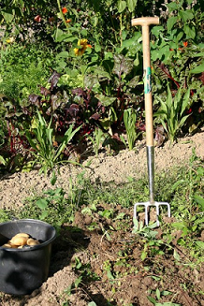

Potato facts
British people are the third largest consumers of potatoes in Europe.
The potato was the first vegetable to be grown in space.
Potatoes can be converted into fuel for cars.
One of the largest potatoes ever grown weighed in at 3.2 kilograms – the weight of a small dog!

Questions

1. Where were potato plants first grown for food?

______________________________________________________________

1 mark

2. How long could the chuno pulp be stored for?

_______________________________

1 mark

3. Which of these were the Spanish traders looking for?

Tick one.
potatoes
food
gold
farms

1 mark

4. Look at the section headed: Where it all began.

Find and copy one phrase which shows that some people in Europe were unsure about eating potatoes.

______________________________________________________________

______________________________________________________________

1 mark

5. Look at the section headed: How the potato arrived in Britain.

What did Spanish fishermen use to preserve fish?

Tick one.
milk
soil
salt
water

1 mark

6. Look at the section headed: How the potato arrived in Britain.

Find and copy a group of words that suggests that people are not sure how the potato first came to Britain.

______________________________________________________________

1 mark

7. Look at the section headed: How the potato arrived in Britain.

Identify one piece of information which shows that potatoes were an exciting discovery.

______________________________________________________________

______________________________________________________________

1 mark

8. Legend has it that the cooks threw away the potatoes…

Draw a line to show the phrase that is closest in meaning to Legend has it.

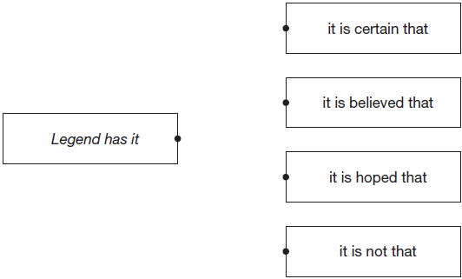

1 mark

9. Look at page 2.

Explain why the potato crop is important to people today, all over the world.

Give two reasons.

1. ____________________________________________________________

______________________________________________________________

2. ____________________________________________________________

______________________________________________________________

2 marks

10. No wonder they were winners!

Why is the writer not surprised that they were the winning school?

Give two reasons.

1. ____________________________________________________________

2. ____________________________________________________________

2 marks

Mark Scheme

1 Award 1 mark for:

• South America.

Do not accept America

1 mark

2 Award 1 mark for:

• (up to) ten years.

1 mark

3 Award 1 mark if the correct answer is ticked.
potatoes
food
gold | 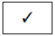
farms

1 mark

4 Award 1 mark for any one of the following quotations:

1. (they were) regarded with suspicion

2. (many people thought they) weren’t suitable (for humans to eat)

3. (partly because of their) odd shape

4. (they were grown) just as food for animals.

1 mark

5 Award 1 mark if the correct answer is ticked.

milk
soil
salt
water

1 mark

6 Award 1 mark for any one of the following acceptable quotations:

1. (There are) different opinions (about how the potato came to Britain)

2. (It is) believed (that the sailors gave some of their potatoes to the farmers)

3. One view (is that Spanish fishermen ate potatoes)

4. Another view (is that Sir Walter Raleigh)

5. It is said (that he gave a potato plant to Queen Elizabeth).

Do not accept: Legend has it (that the cooks threw away the potatoes).

Do not accept responses which quote a complete sentence from the text.

1 mark

7 Award 1 mark for answers that refer to one of the following:

1. they were suitable for royalty

• Sir Walter Raleigh gave Queen Elizabeth I a potato plant as a present

• they were fit for a queen to eat

2. they were given as a gift

• they gave them as presents

3. a feast was held (to celebrate them)

• they had a feast to eat the potatoes.

Also award 1 mark for answers that refer to the fact that potatoes came to Britain from the Americas, which was unusual / a long way to bring them at the time, eg:

• Sir Walter Raleigh, an explorer, went to America to get potatoes and no one usually got food from that far away

• he brought them back from America which was a long way away.

1 mark

8 Award 1 mark for a correctly drawn line.

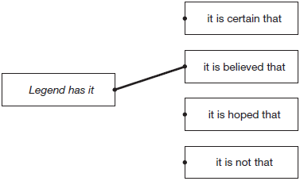

1 mark

9 Award 1 mark for each acceptable point up to a maximum of 2 marks.

Acceptable points:

1. easy to grow / grow in poor soil

• because potatoes are easy to grow

2. perfect for (farmers in) the developing world

• people in poor countries can grow a good supply of food

3. potatoes are good for you / details of nutritional qualities

• because potatoes are good to eat, very healthy and full of vitamins

• it’s important because it gives us healthy food, full of vitamin C and fibre and carbohydrates and vitamin B6 – and they’re low in fat so they won’t make you fat

4. they yield a good harvest

• they produce a good harvest

5. can be converted into fuel for cars

• and they can also be used to make fuel for cars when petrol is running out.

Up to 2 marks

10 Award 1 mark for each acceptable point up to a maximum of 2 marks.

Acceptable points:

1. having a child on frost watch (every day)

• because they made it a duty for one of the school children to be on frost watch

• because they had set up a frost watch

2. bringing the potatoes indoors if it was frosty

• they brought the potatoes inside to avoid the frost

3. the effort involved / commitment of the school / pupils

• it took a lot of effort to bring them in

• they chose to be on duty every night

• they would have had to work really hard to do all those things

• so lots of children had to be involved in the frost watch.

Also accept for 1 mark responses which quote the whole sentence, eg:

• In 2011 the winning school had a child on frost watch at the end of every school day, and if there was a chance of frost at night, they brought their pots of potatoes indoors.

Up to 2 marks

Wednesday Maths

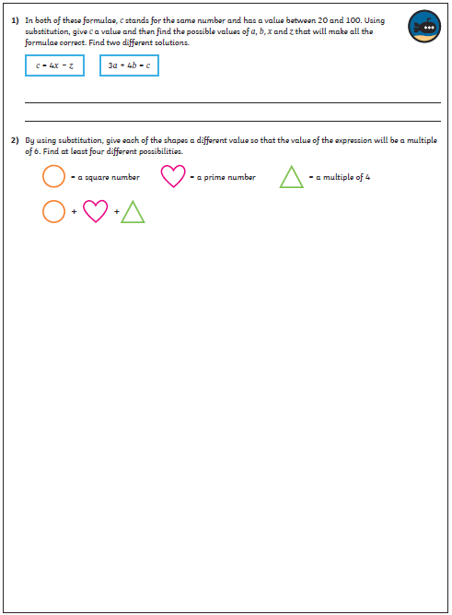
Maths Answers

