Week commencing 15/06/2020

Hey Everyone!

We hope you all had a good half term break and are staying healthy and happy.

In Maths this week you will continue working on algebra.

For reading, you will have sections of mock SATs papers, along with some questions that focus on 3 mark answers.

There is also some PSHE and PE for you to do this week.

Don’t forget, if you need us we are still here for you – just email the Year 6 email address and we will respond as soon as we can!

Have a great week – you are all doing a super job!

Wednesday 17th June 2020

Spellings

Use the words below in a sentence

Challenge: can you use all of the words in just one sentence?
Or can you use all of the words in a cohesive paragraph, about just one topic?

- available
- average
- awkward
- bargain
- bruise

Reading

The Lost Queen

Maria and Oliver are attending a party in the garden of a house that used to belong to Maria's family. They sneak away to explore the grounds.

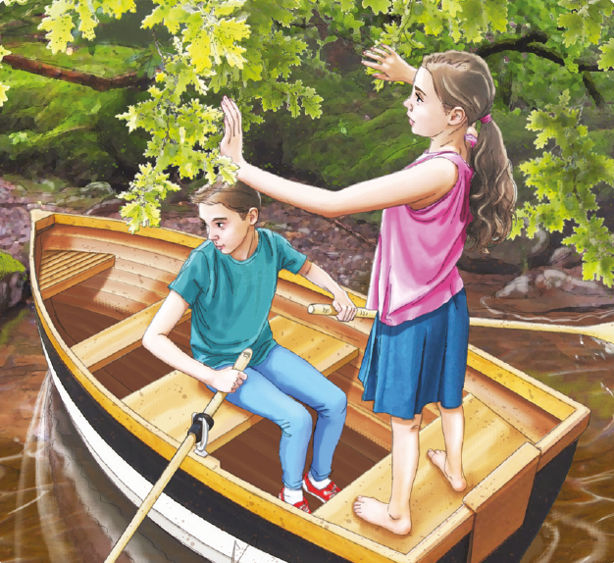

Maria and Oliver were quite a distance from the party when they found the little rowing boat in the grassy shallows of a small lake beyond the garden.

Glancing nervously behind her, Maria suggested that they row out to the island in the middle of the lake. Oliver looked at her questioningly. Maria explained that there was a secret monument on the island to one of her ancestors. This was a woman who had married a prince at the time when there was a struggle for the throne. The struggle had been between two rival families – one had a lion as its symbol, the winner had a bear.

“Come on,” Maria said impatiently.

Oliver rowed while Maria stood barefoot in the boat, staring straight ahead. The oars made a click-clack sound in the hush and haze of the summer afternoon. Ripples of water fanned out behind them as they crossed the glassy surface of the lake.

The tiny island, thick with creeping vines and roots, looked as if it floated. At its centre, an ancient oak tree towered over it. The tree's branches were like bent fingers, twisting and stretching outwards, until the tips of its leaves touched the still water. Oliver carefully steered the boat through a narrow opening in the branches. Then they stepped out of the boat, and into a murky green space under an umbrella of leaves. The air was cool and damp.

Maria led Oliver across the tangled ground to the hidden monument. It was a column of marble, weathered and mossy with age. A delicate crown sat at the top, and an inscription was carved into a flat slab at the base. Oliver used his thumbnail to scrape out the letters that were cut into it.

It was a name.

Maria's family name.

“You could have been a queen?” said Oliver, whispering.

Maria laughed gently in the gloom.

“We were the family of the lion,” she said.

Oliver could still hear the shouts and laughter of the party, up on the sunny lawn near the big house. But now the noise seemed to be getting further and further away.

1. Look at the paragraph beginning: Glancing nervously...

Find and copy one word meaning relatives from long ago.

____________________________________

1 mark

2. The struggle had been between two rival families...

Which word most closely matches the meaning of the word rival?

Tick one.
equal
neighbouring
important
competing

1 mark

3. Look at page 2.

How can you tell that Maria was very keen to get to the island?

______________________________________________________________

______________________________________________________________

1 mark

4. Look at the paragraph beginning: Oliver rowed...

Find and copy one word that suggests that the summer afternoon was quiet.

____________________________________

1 mark

5. ...they crossed the glassy surface of the lake.

Give two impressions this gives you of the water.

1. ____________________________________________________________

2. ____________________________________________________________

2 marks

6. Look at the paragraph beginning: The tiny island... to the paragraph ending: ...were cut into it.

What impressions of the island do you get from these two paragraphs?

Give two.

1. ____________________________________________________________

2. ____________________________________________________________

2 marks

7. Write down three things that you are told about the oak tree on the island.

1. ____________________________________________________________

2. ____________________________________________________________

3. ____________________________________________________________

3 marks

8. Which of these drawings best represents the monument?

Tick one.

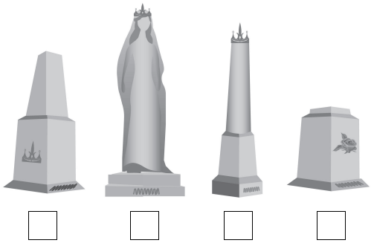

1 mark

9. Look at the paragraph beginning: Maria led Oliver...

(a) Why did Oliver find it difficult to read the inscription on the monument?

_________________________________________________________

1 mark

(b) What did he have to do in order to read the inscription?

_________________________________________________________

1 mark

10. What was revealed at the end of the story?

Tick one.
Oliver was keeping a secret.
The monument was damaged.
The two families were still enemies.
Maria's family did not win the throne.

1 mark

11. Using information from the text, tick one box in each row to show whether each statement is true or false.

 | True | False
Two families fought for the throne.
Maria’s family symbol was the lion.
The monument was for a prince.
It was hot on the island.

1 mark

1. Content domain: 2a – give / explain the meaning of words in context

Award 1 mark for:

• ancestors.

1 mark

2. Content domain: 2a – give / explain the meaning of words in context

Award 1 mark for:

equal
neighbouring
important
competing

1 mark

3. Content domain: 2d – make inferences from the text / explain and justify inferences with evidence from the text

Award 1 mark for answers referring to any of the following:

1. recognition that Maria speaks or behaves impatiently, e.g.

• "Come on," Maria said

• she was being impatient.

2. recognition that she is rushing Oliver, e.g.

• she was telling him to hurry up.

Also accept reference to Maria giving an order.

1 mark

4. Content domain: 2a – give / explain the meaning of words in context

Award 1 mark for:

• hush.

1 mark

5. Content domain: 2g – identify / explain how meaning is enhanced through choice of words and phrases

Award 1 mark for reference to any of the following, up to a maximum of 2 marks:

1. reflective / shiny / mirror-like, e.g.

• the water reflects the light

• shining under the sun.

2. clear / transparent, e.g.

• you could see through the water.

3. still / calm / undisturbed

4. flat / smooth.

Up to 2 marks

6. Content domain: 2d – make inferences from the text / explain and justify inferences with evidence from the text

Award 1 mark for reference to any of the following, up to a maximum of 2 marks:

1. uninhabited / abandoned

2. holds secrets

3. overgrown

4. dark / shady / gloomy

5. small

6. mysterious / creepy / unsettling

7. quiet / peaceful

8. important / a special place

9. old.

Do not accept haunted / dangerous.

Do not accept reference to what is on the island, e.g. it contains an oak tree / vines / roots / leaves / a monument.

Do not accept quotations alone.

Up to 2 marks

7. Content domain: 2b – retrieve and record information / identify key details from fiction and non-fiction

Award 1 mark for reference to any of the following (whether given as acceptable point or quotation), up to a maximum of 3 marks:

1. it is in the middle

2. it is very old

3. it is big / tall / dominates

4. its branches are twisted / bent

5. its branches stretch over the island / out to the water

6. the branches are close together.

Accept quotations that meet an acceptable point. Longer quotations that cover more than one acceptable point should be awarded 1 mark.

Do not accept reference to roots / vines.

Up to 3 marks

8. Content domain: 2b – retrieve and record information / identify key details from fiction and non-fiction

Award 1 mark for:

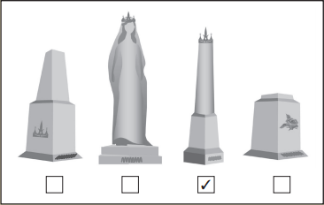

1 mark

9. (a) Content domain: 2d – make inferences from the text / explain and justify inferences with evidence from the text

Award 1 mark for reference to any of the following:

1. it is mossy / dirty

2. it is covered

3. it is weathered.

Do not accept reference to it being old.

1 mark

(b) Content domain: 2b – retrieve and record information / identify key details from fiction and non-fiction

Award 1 mark for references to scraping out the letters / the moss, e.g.

• he scrapes out the stuff in the letters

• uses his thumbnail to scratch the letters out.

1 mark

10. Content domain: 2b – retrieve and record information / identify key details from fiction and non-fiction

Award 1 mark for:

Oliver was keeping a secret.
The monument was damaged.
The two families were still enemies.
Maria’s family did not win the throne.

1 mark

11. Content domain: 2b – retrieve and record information / identify key details from fiction and non-fiction

Award 1 mark for all four correct:

 | True | False
Two families fought for the throne. | ✔
Maria’s family symbol was the lion. | ✔
The monument was for a prince. |  | ✔
It was hot on the island. |  | ✔

1 mark

Wednesday - Maths

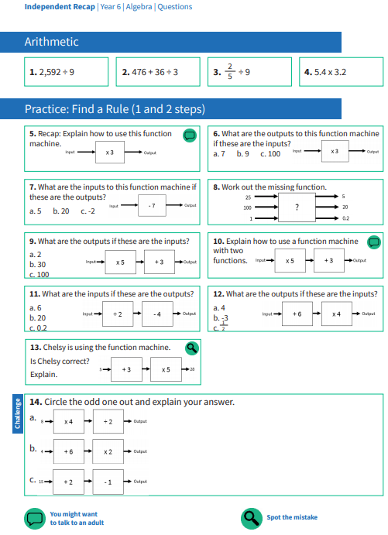

Use this page to record your working out and your answers

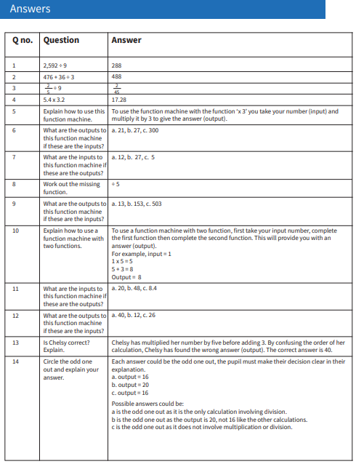

Wednesday - PSHE

