Week commencing 13/07/2020

Hi Everyone!

It’s the last week of Year 6 and this is your last learning pack of the year!

For Reading, you will have sections of mock SATs papers, along with some questions that focus on 3 mark answers.

In Maths this week you will continue with algebra. There is an end of topic assessment for you to complete on Friday.

There is also some Science and PSHE for you to complete in your topic pack

If you need us, we are still here. You can email the Year 6 email address and we will respond as soon as we can. Over the summer, your families can still contact the school office if you need anything, but unfortunately they won’t be able to print any more learning packs for you.

Have a great last week – you have all done a super job!
Have a lovely summer and good luck in Year 7 – you will all be fantastic!

Miss Dibble

Wednesday 15th July 2020

Spellings

Use the words below in a sentence

Challenge: can you use all of the words in just one sentence?
Or can you use all of the words in a cohesive paragraph, about just one topic?

1. identity
2. immediate,
3. immediately
4. individual
5. interfere

Reading

The Story of King Midas

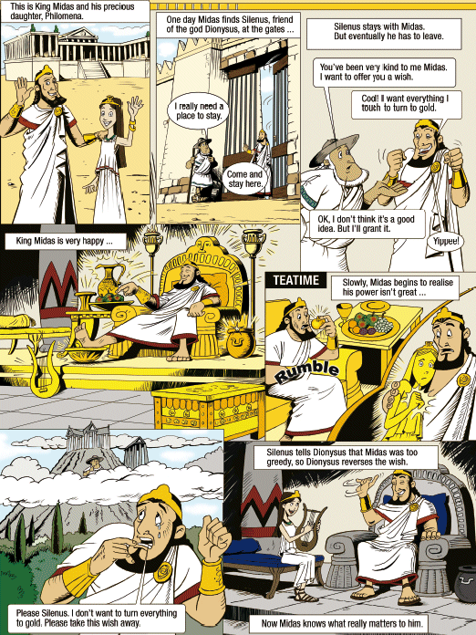

1. How does Silenus warn Midas about his wish?

______________________________________________________________

______________________________________________________________

1 mark

2. ...King Midas and his precious daughter Philomena.

What is the meaning of the word precious in this sentence?

______________________________________________________________

1 mark

3. Find and copy what Midas says when his wish is granted.

______________________________________________________________

1 mark

4. Look at the picture below.
Write down what Midas might be thinking at this point in the story.

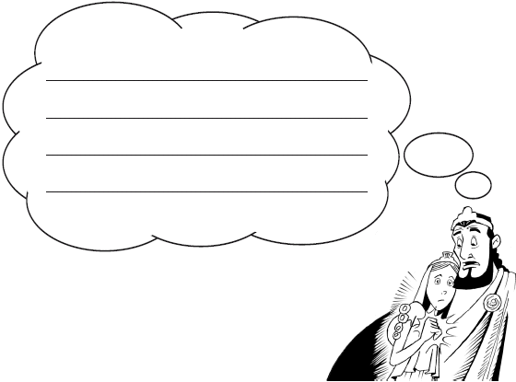

2 marks

1. Award 1 mark for answers which refer to Silenus telling Midas that he thought the wish was a bad idea, eg:

• by telling him it’s not a good idea.

Also award 1 mark for direct quotation:

▪ (OK,) I don’t think it’s a good idea. (But I’ll grant it.) 1 mark

2. Award 1 mark for references to rare / valuable, e.g.

• invaluable

• fine

1 mark

3. Award 1 mark for:

▪ Yippee!

Do not accept responses drawn from the story, eg:

• It works, it works! 1 mark

4. Award 2 marks for answers which recognise that Midas is regretful and refer to the role of his daughter or his greed in his realisation of the implications of his wish, eg:

• ooops! I really am stupid! Why did I wish for such a greedy thing

• what have I done? I am so greedy

• I wish I didn’t get an awful wish like this. I want my daughter back now!

• oh no I turned my daughter into gold

• I can’t hug my daughter anymore because she will turn to gold. I wish I didn’t say this wish

• oh no! How can this have happened. I have to find Silenus and change this back.

Award 1 mark for undeveloped answers which recognise that Midas has realised the implications of his wish or that he is becoming concerned, eg:

• oh no!

• I was wrong

• what is going to happen now?

• what have I done?

• I don’t want this wish and I am such a fool

• he might be thinking he’s greedy and he loves his precious daughter.

Also award 1 mark for direct quotation:

▪ Slowly, Midas begins to realise his power isn’t great...

Accept responses expressed in the 3rd person. up to 2 marks
Wednesday Maths
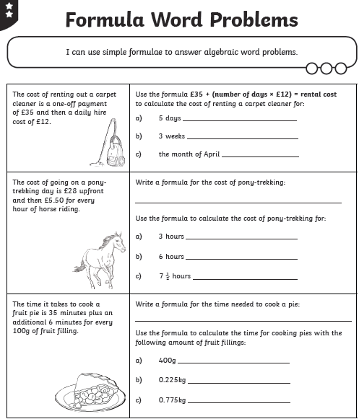
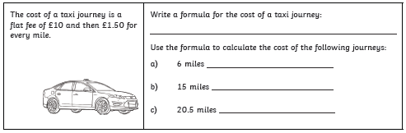
Maths Answers

