Week commencing 08/06/2020

Hey Everyone!

We hope you all had a good half term break and are staying healthy and happy.

In maths this week you will begin to look at algebra.

For reading, you will have sections of mock SATs papers, along with some questions that focus on 3 mark answers.

Don’t forget, if you need us we are still here for you – just email the Year 6 email address and we will respond as soon as we can!

Have a great week – you are all doing a super job!

Wednesday 10th June 2020

Spellings

Use the words below in a sentence

Challenge: can you use all of the words in just one sentence?
Or can you use all of the words in a cohesive paragraph, about just one topic?

- accommodate
- accompany
- according
- achieve
- aggressive

Reading

This is an introduction to Stephen Halliday's book The Great Stink of London. During Victorian times, there were serious problems with water supply and sanitation in London. Crisis point was reached in the summer of 1858.

The Great Stink of London

In the mid-19th century, Britain was gripped by the fear of cholera, a highly infectious and deadly disease. When cholera struck Hamburg in Germany, the British government grew alarmed that this latest outbreak might spread to Britain. They decided to create a special committee to deal with the expected epidemic.

However, the epidemic never happened because of the work of one man: Sir Joseph Bazalgette.
At that time, London’s sewage flowed straight into the River Thames. From here it leaked into adjacent springs, wells and other sources of drinking water. This was the root cause of cholera, a waterborne disease. Contemporary accounts describe London being crowded with men, women and children struggling to survive in terrible conditions. In 1849, one journalist reported that the air had 'the smell of a graveyard, and a feeling of nausea comes over anyone unaccustomed to it.' About the Thames, he wrote, 'heavy bubbles now and then rise up in the water, which is covered with a scum like an encrusted cobweb. In it float large masses of noxious, tangled weed and against the posts of the bridges are swollen carcasses of dead animals.'

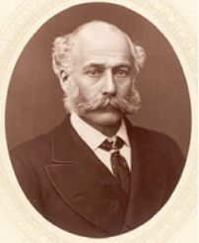

In the summer of 1858, the stench from the Thames was so bad that Members of Parliament fled from the rooms overlooking the river. The Prime Minister, Benjamin Disraeli, rushed from the debating chamber, handkerchief to nose. The press called the crisis The Great Stink. Disraeli introduced to Parliament a Bill that gave Bazalgette the authority to construct the sewers which he had designed; it was rushed through within sixteen days and Bazalgette began work immediately.

By 1874 Bazalgette had completed his ingenious scheme. He designed a grand system of drains and sewers to carry foul water to new pumping stations and holding tanks, and new embankments to make the river cleaner. In all, he built 1,182 miles of sewers, four pumping stations and two major water treatment works which are still operating to this day.
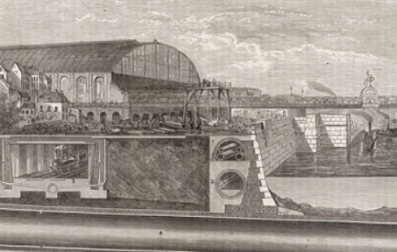

Bazalgette did much else besides. He designed and created many famous London streets and several magnificent bridges across the River Thames, including Tower Bridge, a present day London landmark. In fact, Bazalgette created more of London than anyone else before or since. But his greatest claim to fame is the system of sewers, which banished cholera forever and which still serve the capital city to this day.

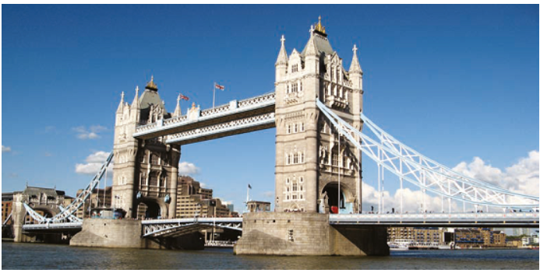

1 Award 1 mark for two correct answers, 1 for paragraph 1 (In the mid-19th century) and 1 for paragraph 4 (In the summer); award 0 marks for one or no correct answers:

paragraph 1 (In the mid-19th century):

♦ (Britain was) gripped by the fear (of cholera a highly infectious and deadly disease).

♦ (The British government) grew alarmed (that this latest outbreak might spread to Britain).

♦ (They decided to create a) special committee (to deal with the expected epidemic).

paragraph 4 (In the summer):

♦ (The press called the) crisis (the Great Stink)

♦ (Disraeli) introduced to Parliament a Bill

♦ a bill that gave Bazalgette the authority to construct the sewers (which he had designed)

♦ (it was) rushed through (within sixteen days)

♦ (Bazalgette) began work immediately

Also accept a combination of bullets 5 and 6 or of bullets 7 and 8

1 mark

2. Award 1 mark for:

• modern.

1 mark

3. Award 1 mark for an explanation that recognises what the writer's choice of language tells us, linked to one of the following ideas:

♦ Answers which recognise that the river was extremely dirty / unpleasant.

• It tells us very effectively that the river was disgusting.

♦ Answers which recognise that it is dangerous.

• It's like a trap.

• It's harmful.

Comments must be rooted in the text.

Also accept answers that focus on how dirty it is by using an intensifier, eg really.

Do not accept answers that identify dirty without an intensifier.

1 mark

4. Award 2 marks for two correctly ticked boxes.

Award 1 mark for one correctly ticked box.

Award 0 marks for answers where more than two boxes are ticked.

"It was essential we started straight away. We had to work quickly, there was no time to lose."
"I was really just responsible for the construction work. I was given a brilliant design to follow."
"Our London sewerage system was built to last."
"Everything I have built is hidden beneath the streets."

up to 2 marks

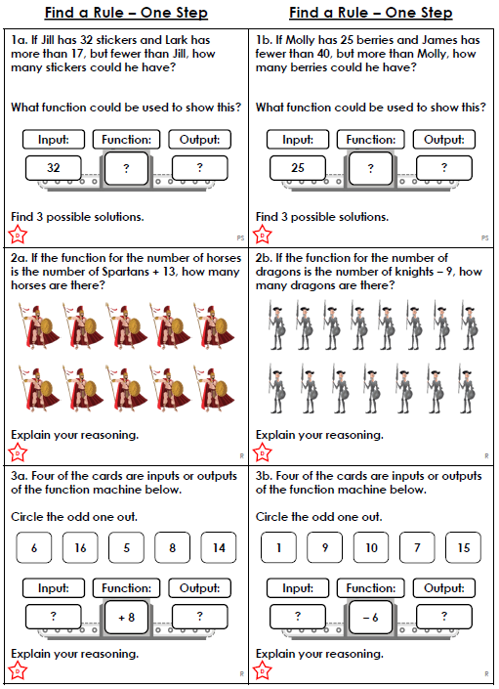

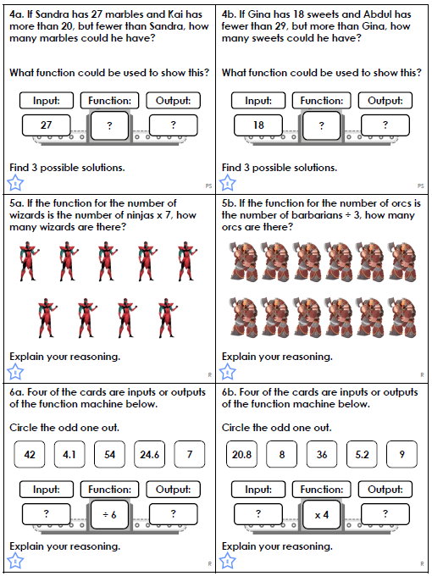

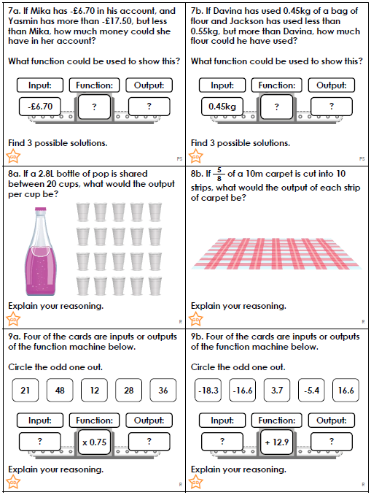

Maths Answers
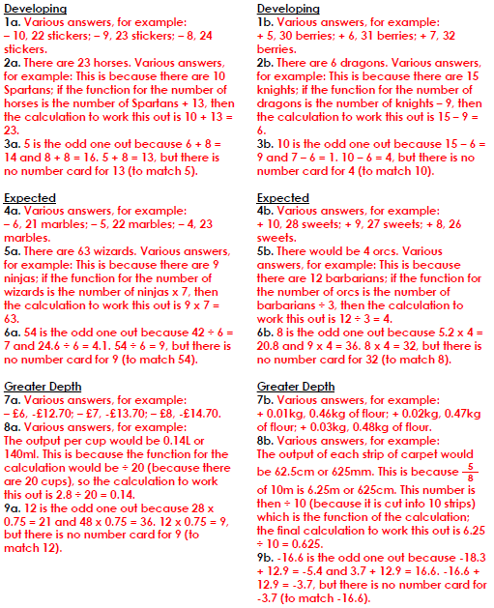

PE -Wednesday

