**This week’s homework – Week beginning 22.6.20**

We have broken down your homework into

topics: check in, phonics/handwriting, maths. We recommend that you do these topics in this order as they mirror your school day.

You still need to practice the days of the week and writing your name in your best handwriting.

Try your best to get through all of this work, but don’t worry if it’s too difficult. If you find the work easy, or want more to do, why not try completing the work for 6SD/6PN? We are so proud of you for adapting to your new school day - you are doing a great job!



**Contents page**

Monday page 2

Tuesday page 9

Wednesday page 17

Thursday page 25

Friday page 32

**Monday 22nd June 2020**

**Check in:**

How are you feeling today? Are worried, concerned or anxious about anything? Talk to someone at home about your feelings, or email me and I’ll email you back! Draw a picture below to show how you are feeling.

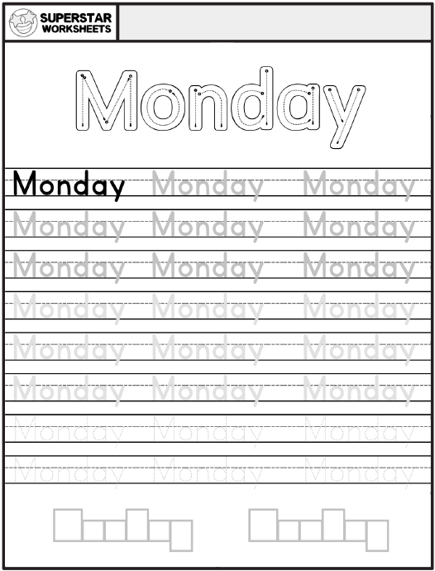

**Write your name in Monday’s box on page 38.**

**Phonics/Handwriting**

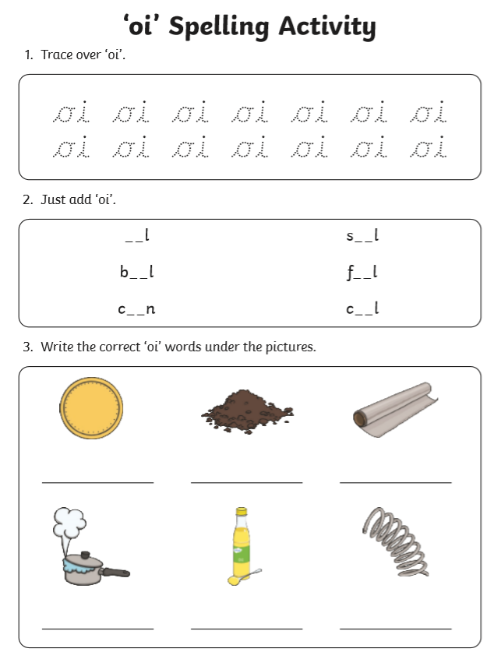**Challenge: Can you write a sentence featuring each word?**

**Maths:**

**Go to the webpage to help you learn about arrays and how they can help you multiply.**

[**https://www.bbc.co.uk/bitesize/topics/zqbg87h/articles/z3tvcj6**](https://www.bbc.co.uk/bitesize/topics/zqbg87h/articles/z3tvcj6)

**Now try to complete the questions below.**

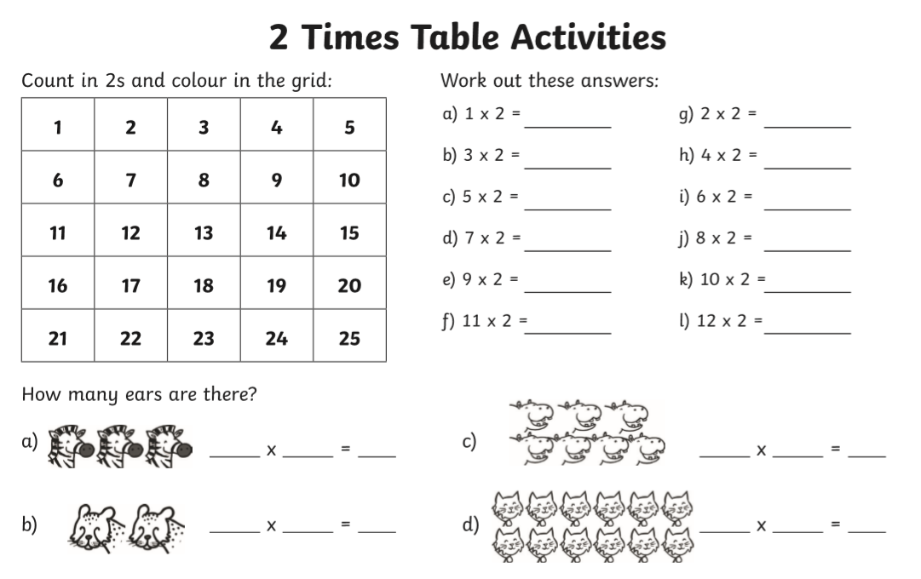

**Geography:**

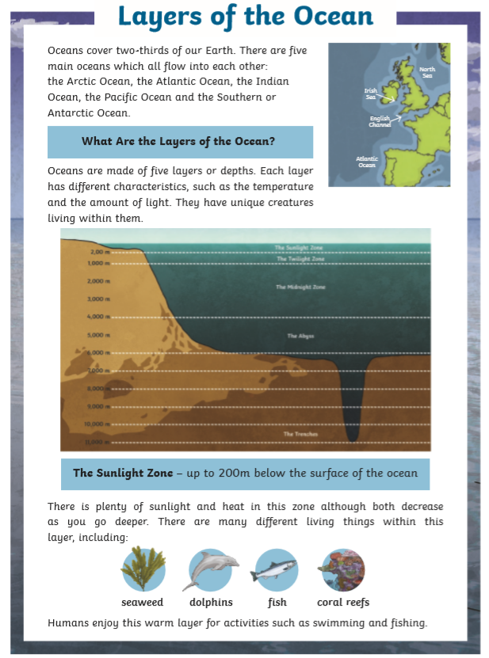

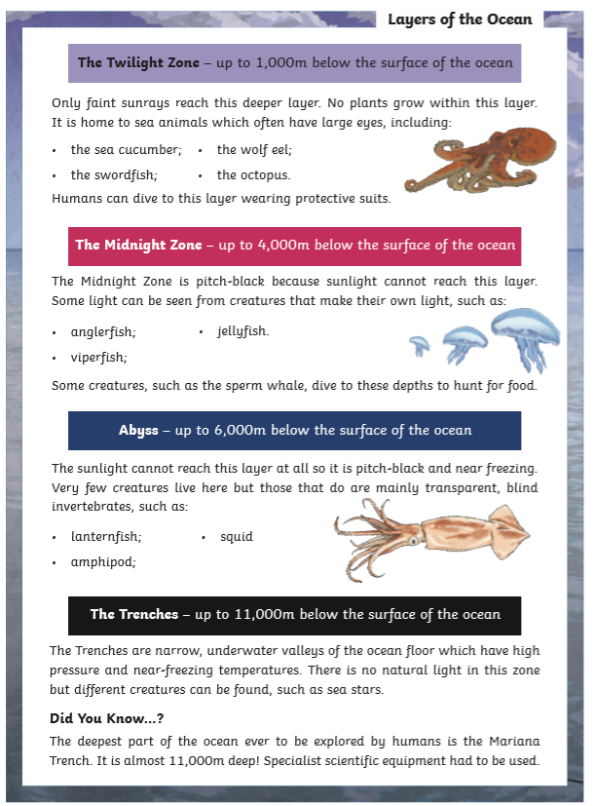

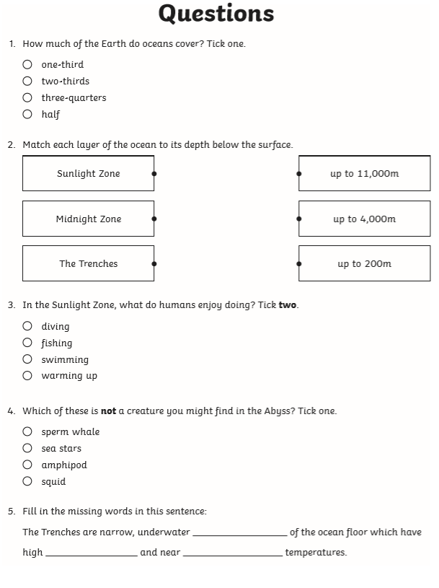

**Well done! You have completed today’s homework!**

**Tuesday 23rd June 2020**

**Check in:**

How are you feeling today? Are worried, concerned or anxious about anything? Talk to someone at home about your feelings, or email me and I’ll email you back! Draw a picture below to show how you are feeling.

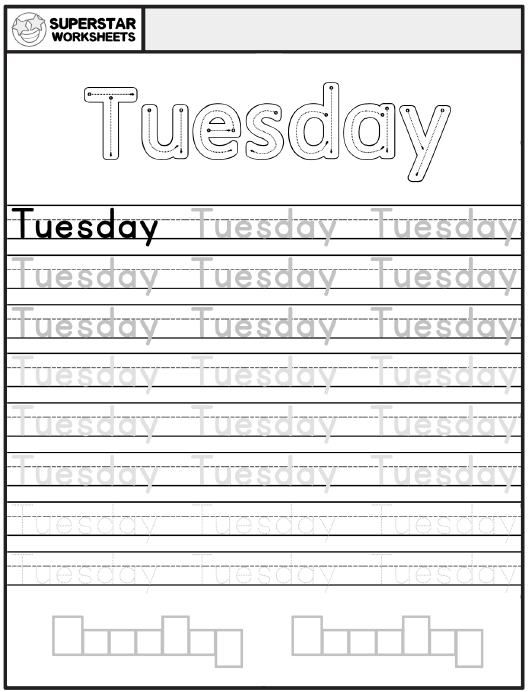

**Write your name in Tuesday’s box on page 38.**

**Phonics/Handwriting:**

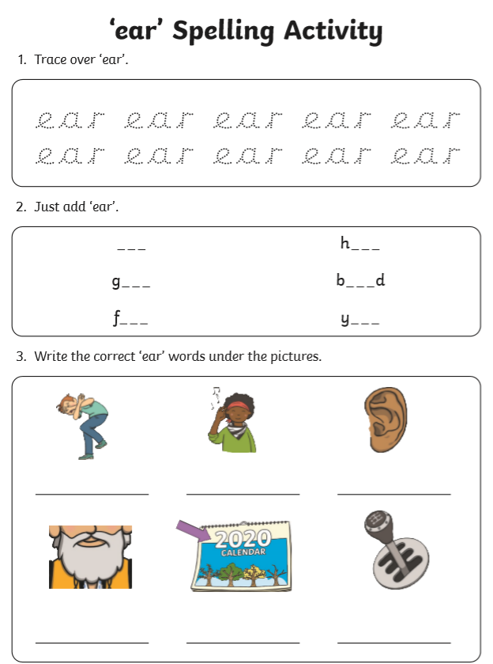**Challenge: Can you write a sentence featuring each word?**

**Maths:**

**Go to the webpage to help you learn about arrays and how they can help you multiply.**

[**https://www.bbc.co.uk/bitesize/topics/zqbg87h/articles/z3tvcj6**](https://www.bbc.co.uk/bitesize/topics/zqbg87h/articles/z3tvcj6)

**Now try to complete the questions below.**

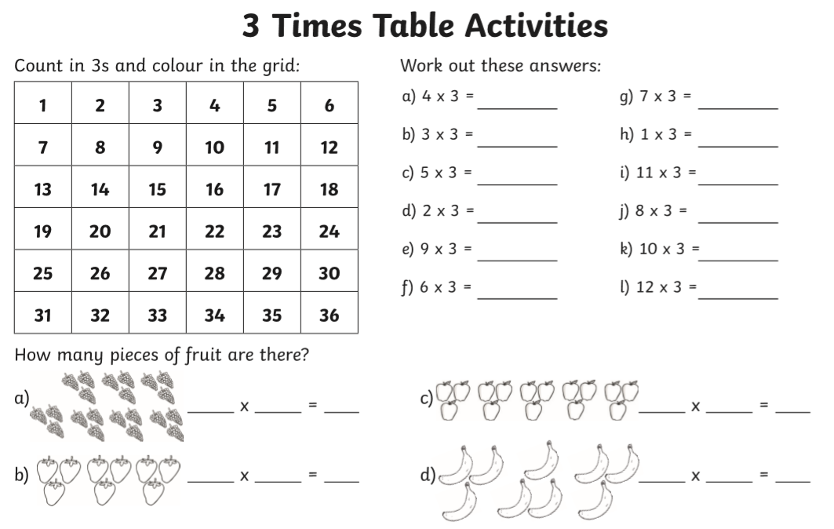

**Geography:**

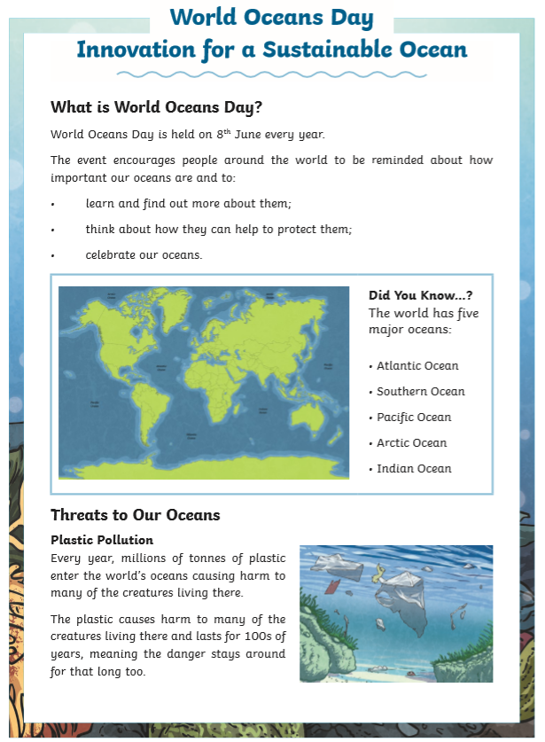

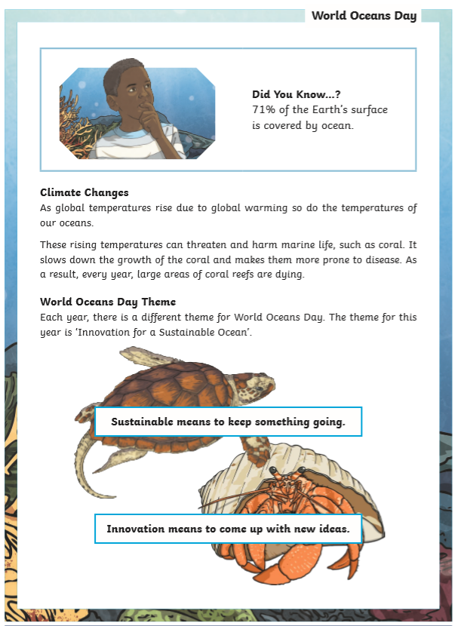

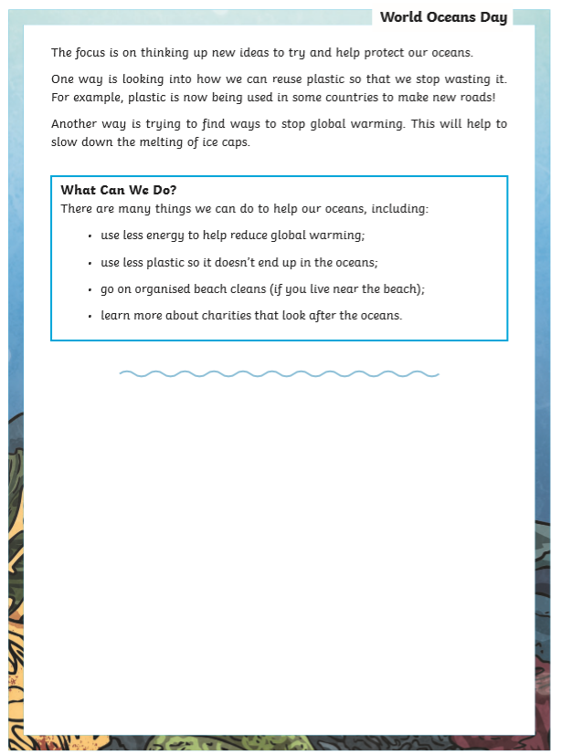

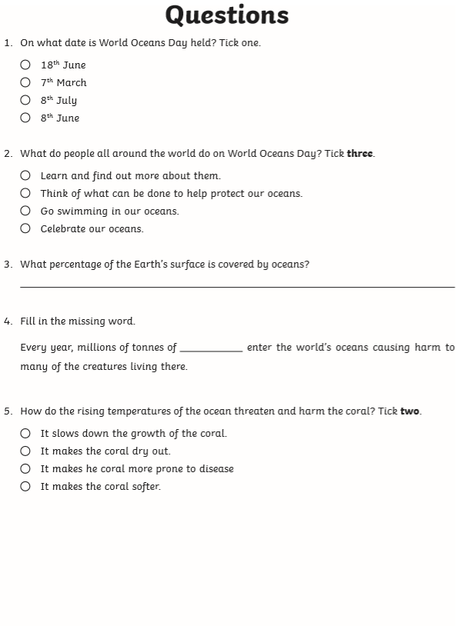

**Well done! You have completed today’s homework!**

**Wednesday 24th June 2020**

**Check in:**

How are you feeling today? Are worried, concerned or anxious about anything? Talk to someone at home about your feelings, or email me and I’ll email you back! Draw a picture below to show how you are feeling.

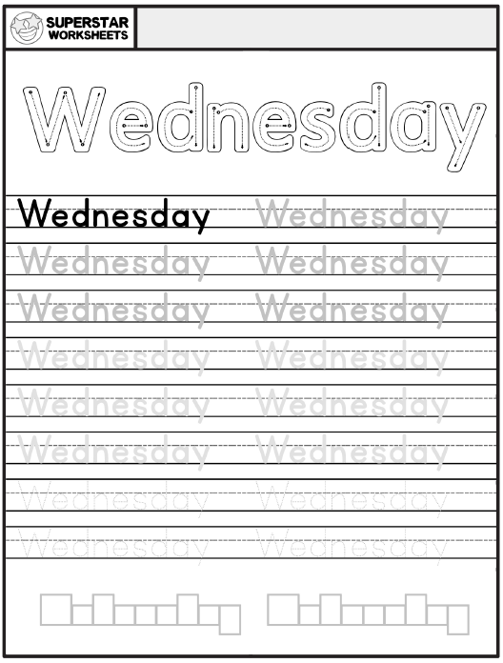

**Write your name in Wednesday’s box on page 38.**

**Phonics/Handwriting:**

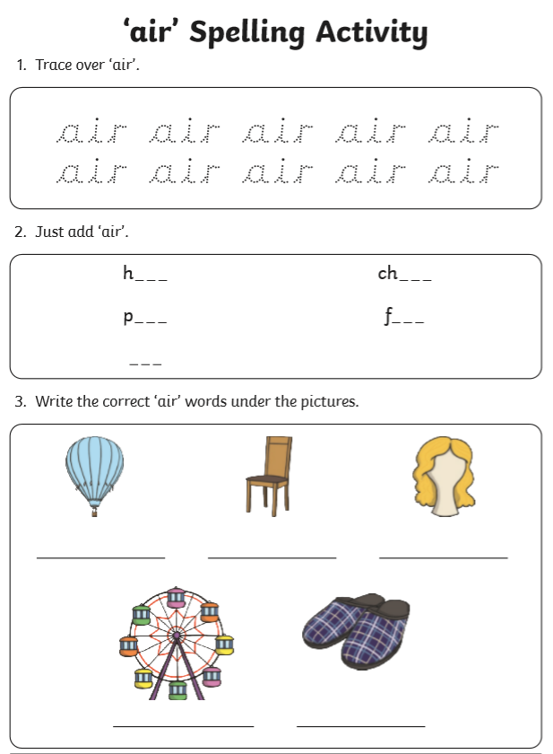**Challenge: Can you write a sentence featuring each word?**

**Maths:**

**Go to the webpage to help you learn about arrays and how they can help you multiply.**

[**https://www.bbc.co.uk/bitesize/topics/zqbg87h/articles/z3tvcj6**](https://www.bbc.co.uk/bitesize/topics/zqbg87h/articles/z3tvcj6)

**Now try to complete the questions below.**

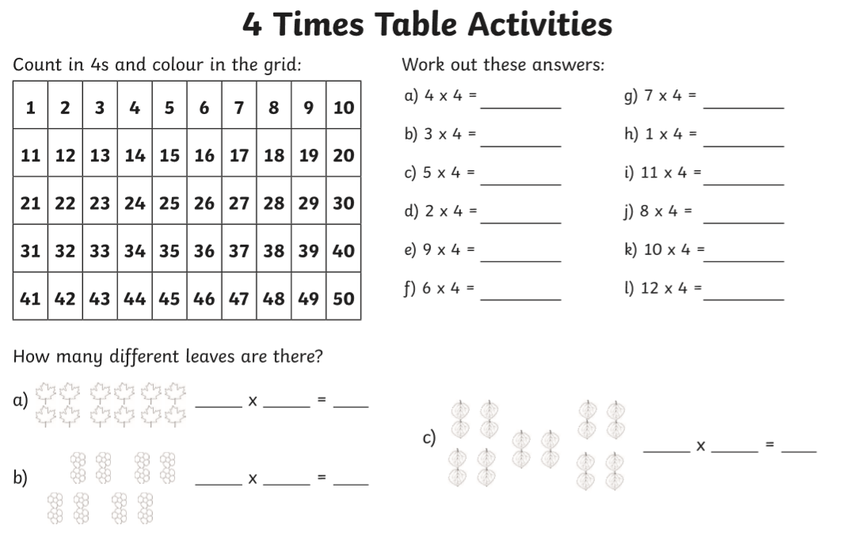

**Geography:**

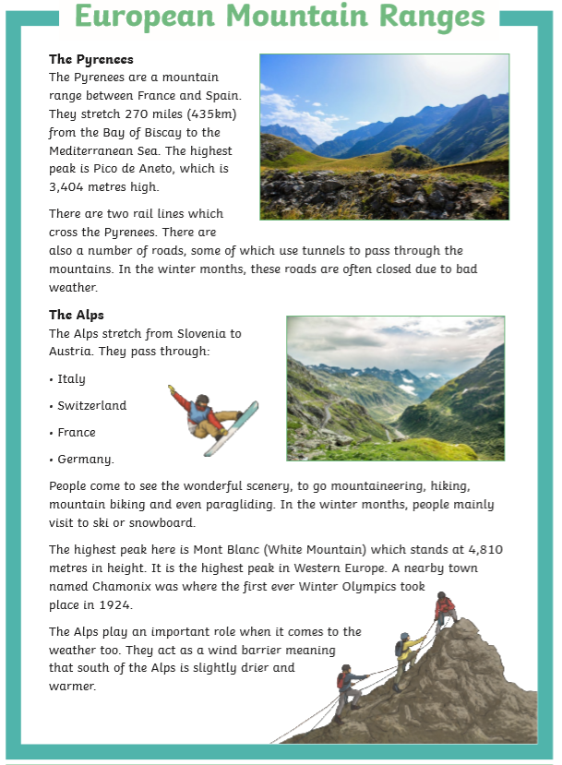

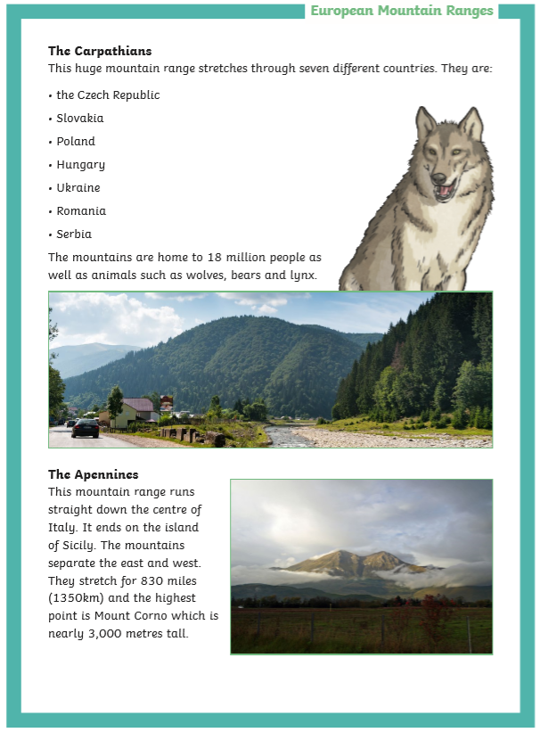

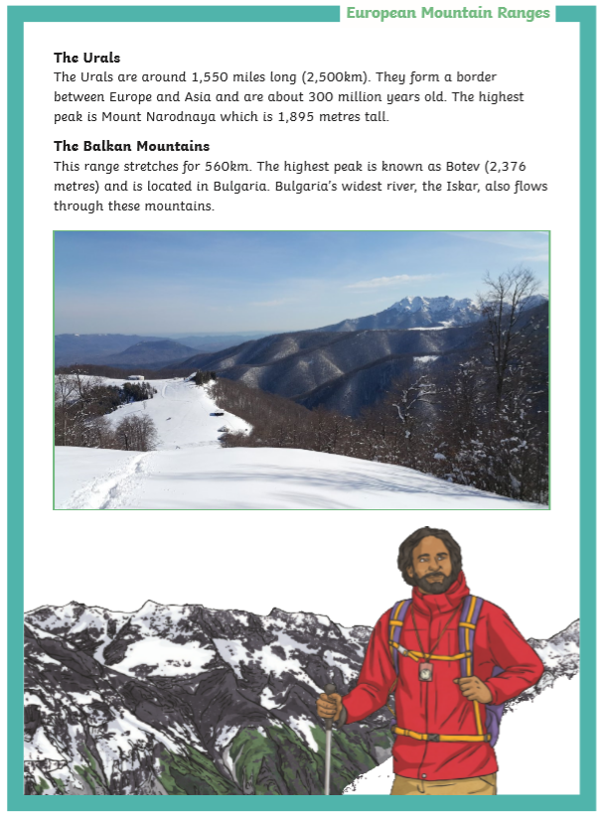

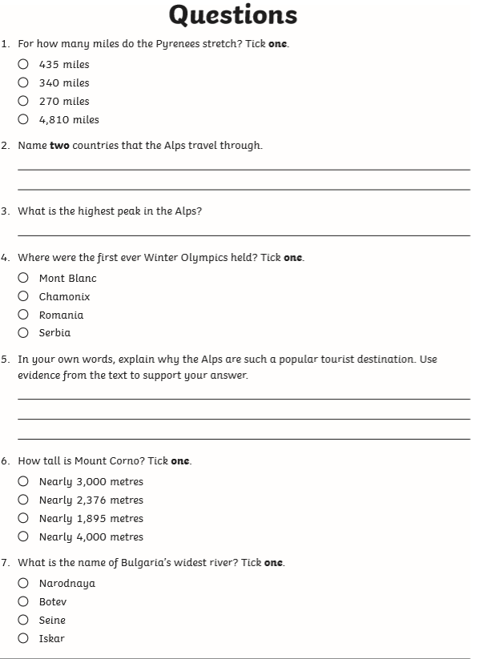

**Well done! You have completed today’s homework**

**Thursday 25th June 2020**

**Check in:**

How are you feeling today? Are worried, concerned or anxious about

anything? Talk to someone at home about your feelings, or email me and I’ll email you back! Draw a picture below to show how you are feeling.

**Write your name in Thursday’s box on page 38.**

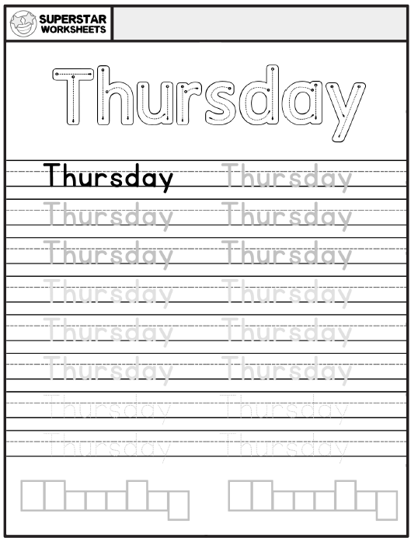

**Phonics/Handwriting:**

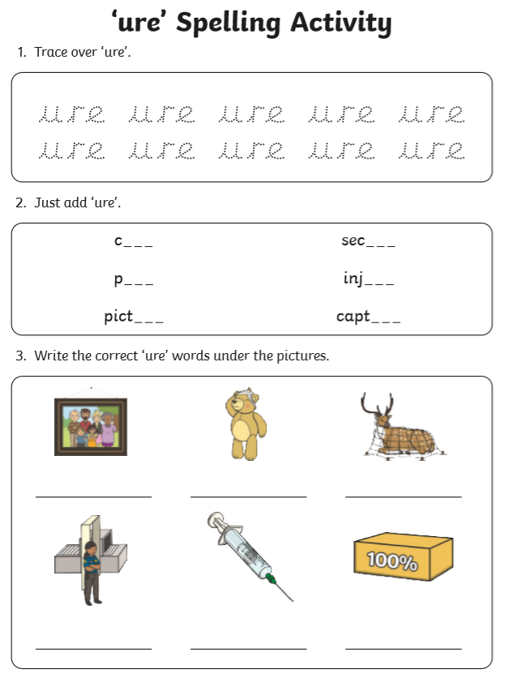**Challenge: Can you write a sentence featuring each word?**

**Maths:**

**Go to the webpage to help you learn about arrays and how they can help you multiply.**

[**https://www.bbc.co.uk/bitesize/topics/zqbg87h/articles/z3tvcj6**](https://www.bbc.co.uk/bitesize/topics/zqbg87h/articles/z3tvcj6)

**Now try to complete the questions below.**

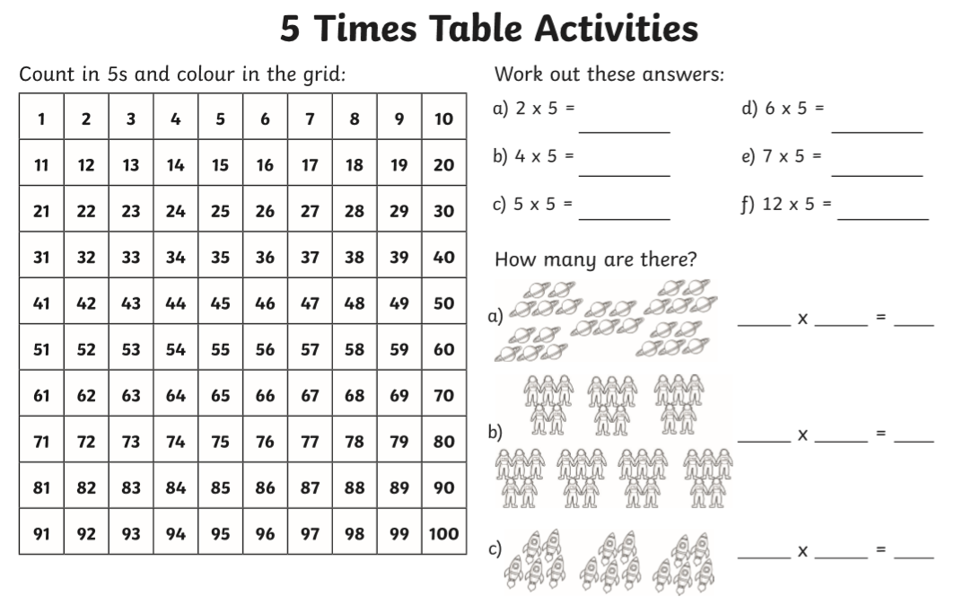

**Geography:**

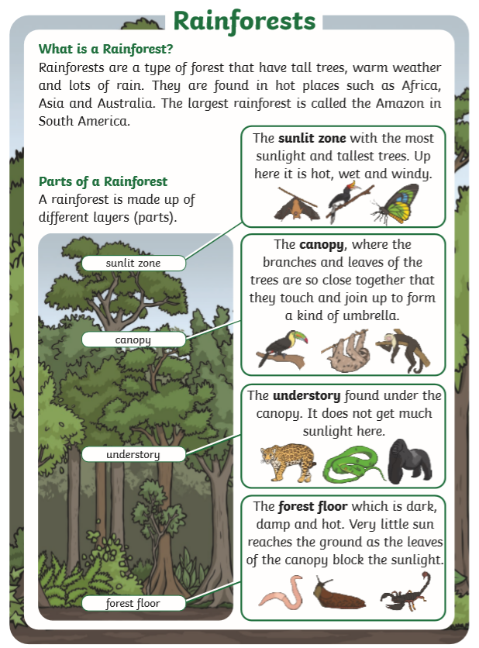

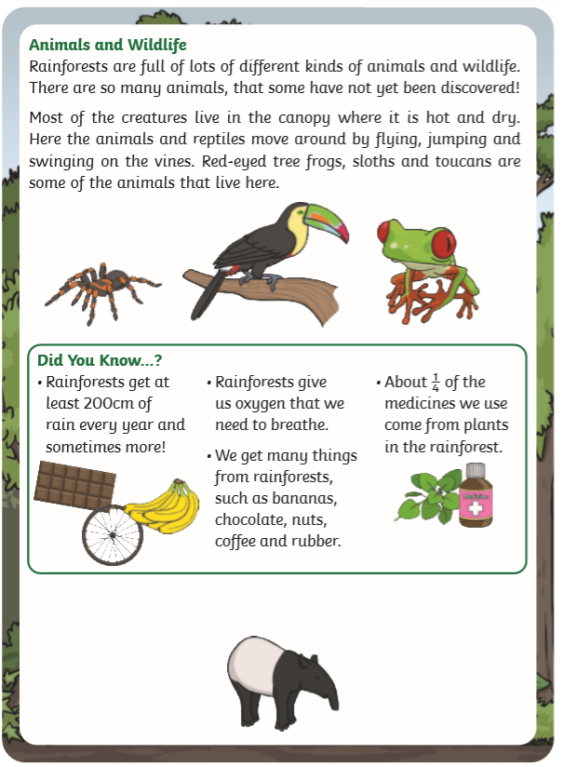

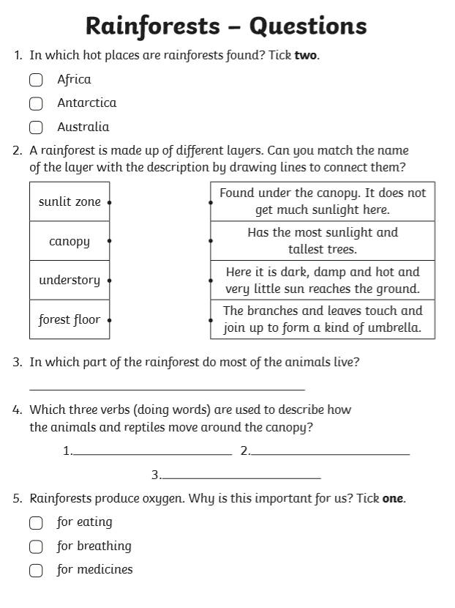

**Well done! You have completed today’s homework!**

**Friday 26th June 2020**

**Check in:**

How are you feeling today? Are worried, concerned or anxious about

anything? Talk to someone at home about your feelings, or email me and I’ll email you back! Draw a picture below to show how you are feeling.

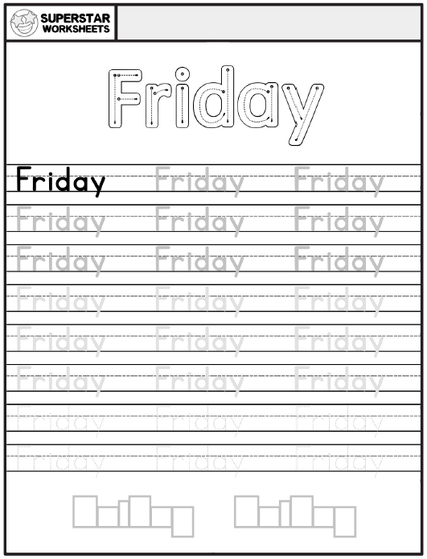

**Write your name in Friday’s box on page 38.**

**Phonics/Handwriting:**

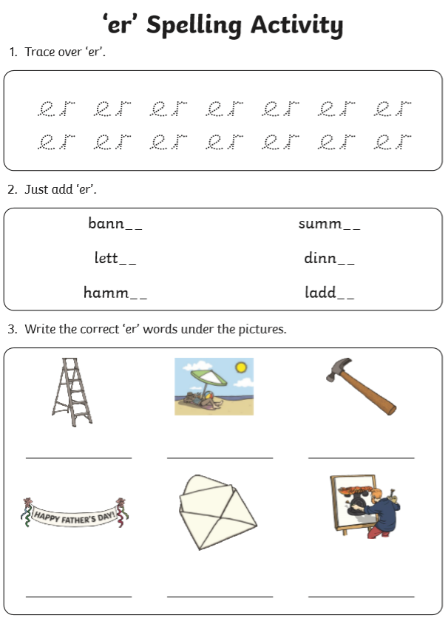**Challenge: Can you write a sentence featuring each word?**

**Maths:**

**Go to the webpage to help you learn about arrays and how they can help you multiply.**

[**https://www.bbc.co.uk/bitesize/topics/zqbg87h/articles/z3tvcj6**](https://www.bbc.co.uk/bitesize/topics/zqbg87h/articles/z3tvcj6)

**Now try to complete the questions below.**

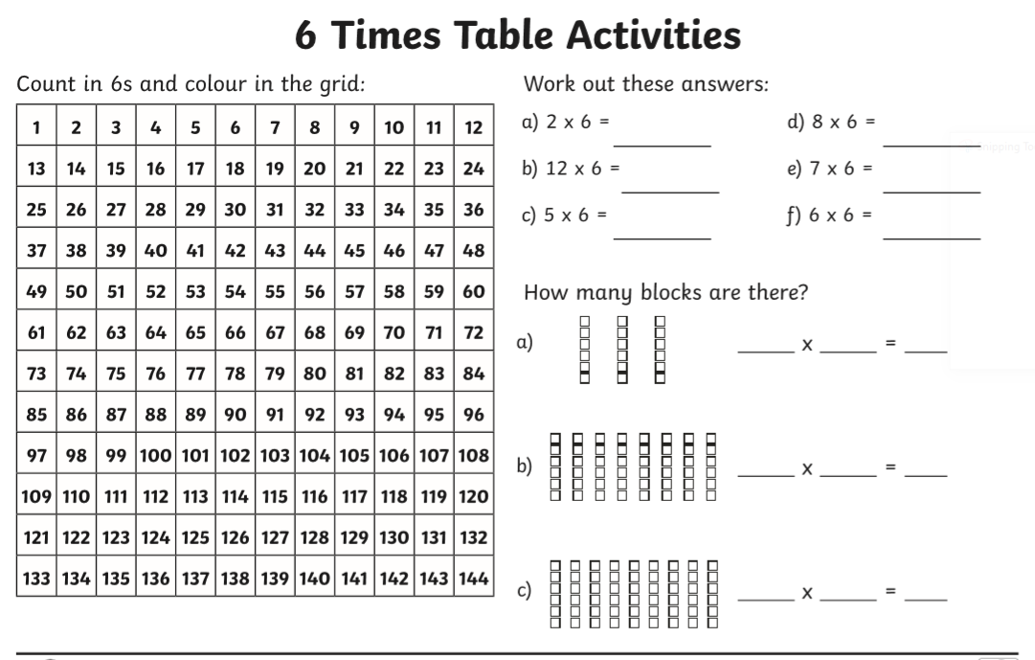

**.**

**Geography:**

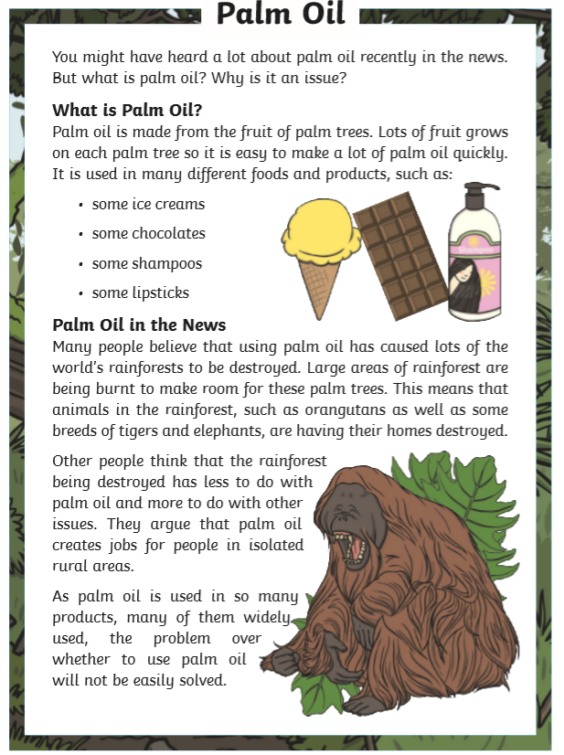

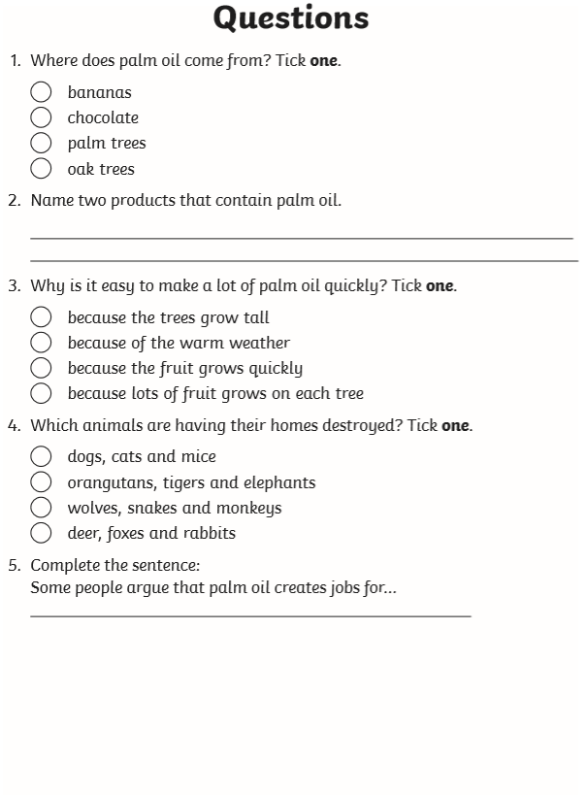

**Well done! You have completed today’s homework!**

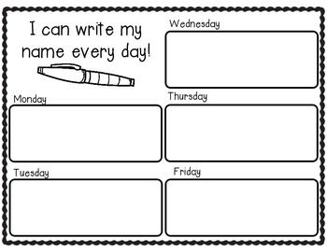

**Parents, if you need extra work for your child please email** [**year6.year6@hovingham.org**](mailto:year6.year6@hovingham.org) **and ask for more green group resources. I will get back to you as soon as I can.**

**In the meantime, you may also want to have a look at the pack for 6PN and 6SD on the Year 6 website.**

**On there, you will also find resources related to transition to high school as well as links to online education websites.**