Week commencing 8/06/2020

Hey Everyone!

We hope you all had a good half term break and are staying healthy and happy.

In maths this week you will begin to look at algebra.

For reading, you will have sections of mock SATs papers, along with some questions that focus on 3 mark answers.

Don’t forget, if you need us we are still here for you – just email the Year 6 email address and we will respond as soon as we can!

Have a great week – you are all doing a super job!

Tuesday 9th June 2020

Spellings

Correct the spellings of the words below

- acomadote
- accmpny
- accodng
- achve
- aggresiv
- amatur
- ancent
- aparent
- apprcite
- atacthed

Reading

The Giant Panda Bear

Panda bears are very popular animals, partly because of their unusual appearance and partly because there is something mysterious and fascinating about them. However, their numbers are falling. It is thought that only around 1600 giant pandas still survive in the wild.

Appearance

Giant pandas have the same type of body shape as other bears. They have thick black and white fur, which some scientists think may be to disguise them in the snowy and rocky surroundings where they live. An adult can grow up to 1.5 metres and weigh up to 150 kilograms. They might look cute but they have razor-like claws. They also have powerful jaws for crushing and grinding bamboo!

Habitat

Giant pandas in the wild live on mountainous slopes in western China. Their habitat is densely populated with fir trees and bamboo. It is the forests in these mountains that attract the panda as bamboo is their favourite food.

Diet

In the wild, their main diet is bamboo. To survive, they need to eat for most of the day. In fact, they eat 15 to 30 kilograms of food every day and spend 10 to 16 hours feeding. In zoos, they have a specially prepared diet of bamboo, eggs, fish and honey.

Cubs

Newborn cubs weigh around 150 grams (about the weight of an apple) and are all white at birth. The black spots develop after about a month. They begin eating bamboo at six months and weigh 31 to 36 kilograms at the end of the first year. Cubs stay with their mother for two to three years, reach maturity at five to seven years and live in the wild for about 25 years.

Other interesting facts

• Giant panda bears have to eat every day which means, unlike other bears, they cannot hibernate in the winter.

• Giant pandas’ bodies are able to digest meat but they rarely eat it.

• Until recently, scientists thought that pandas spent most of their lives alone, but new studies show that small groups of pandas can share a large territory.

Why are people concerned about the giant panda?

Many people fear that giant pandas will become extinct as only a few are born in the wild each year and they do not always survive. Bamboo supplies are diminishing in panda habitats, cutting off a vital food supply. In addition, poaching and humans moving into the pandas’ territory have also reduced their numbers.

There are very few pandas in zoos, although this is changing. Where there are pandas in captivity, important programmes are in place to try to increase their numbers and find out more about these puzzling creatures.

How can people help?

There are projects where people are invited to ‘adopt a panda’. The money goes towards researching, protecting and monitoring them. It also goes towards supporting them in the wild.

What about the future?
In two of China’s main research centres, 19 cubs have been born. There are now over 300 pandas in captivity and the next challenge is to return them to the wild. The Chinese government has created 50 panda reserves to continue the work.
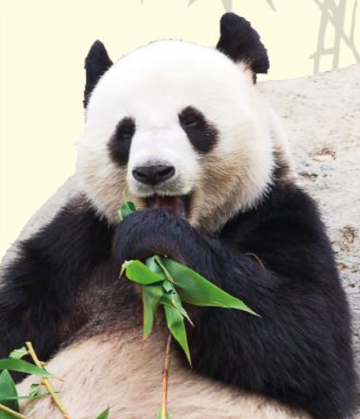

Did you know?

In China, the panda is a symbol of peace.

The Chinese word for panda is ‘Xiongmao’ (giant cat bear) because a panda’s eyes are shaped like a cat’s. Over the centuries, pandas have also been called ‘spotted bear’ and ‘black and white bear’.

1. According to the text, approximately how many giant pandas currently live in the wild?

____________________________________

1 mark

2. According to some scientists, how does giant pandas’ fur help them to survive in the wild?

______________________________________________________________

1 mark

3. Look at page 1.

Pandas can grow up to 1.5 metres and weigh up to 150 kilograms.

What else in the text tells us that giant pandas could be dangerous animals?

______________________________________________________________

1 mark

4. Look at page 1.

According to the text, what do pandas spend the majority of their time doing?

______________________________________________________________

1 mark

5. Number these facts about the life of the giant panda cub from 1-5 in the order in which they happen.

The first one has been done for you.

A cub eats bamboo for the first time.
A cub leaves its mother.
A cub develops black spots.
A cub weighs 31 to 36 kilograms.
A cub weighs about the same as an apple.

1 mark

6. Look at page 1.

According to the text, give one way that giant pandas are…

(a) similar to other bears.

_________________________________________________________

1 mark

(b) different from other bears.

_________________________________________________________

1 mark

7. Look at the section headed: Other interesting facts.

Complete the sentence below.

Recent studies show that…

Tick one.
giant pandas always spend most of their lives alone.
most giant pandas live in captivity.
giant pandas only live in the wild in China.
some giant pandas live in the same area.

1 mark

8. Look at the section headed: Why are people concerned about the giant panda?

Find and copy one word which shows that there are lots of things we do not yet know about giant pandas.

____________________________________

1 mark

9. … cutting off a vital food supply.

What does the word vital mean in this sentence?

Tick one.
essential
available
useful
healthy

1 mark

10. According to the text, why are giant pandas under threat of extinction?

Give two reasons.

1. ____________________________________________________________

2. ____________________________________________________________

2 marks

11. According to the text, how are people trying to help giant pandas survive?

______________________________________________________________

1 mark

12. Look at the section headed: What about the future?

Find and copy one word that shows that helping the giant panda is not easy.

____________________________________

1 mark

13. Look at page 2.

What is one name that pandas have been called in the past because of their fur?

______________________________________________________________

1 mark

14. Which statement is the best summary for the whole of page 2?

Tick one.
How the giant panda first got its name.
How charities raise money for giant pandas.
How people are working to save giant pandas.
How giant pandas’ territory is changing.

1 mark

15. Using information from the text, tick one box in each row to show whether each statement is a fact or an opinion.

 | Fact | Opinion
Giant pandas are fascinating animals.
Giant pandas’ main food in the wild is bamboo.
Giant panda cubs weigh about 150g when born.

1 mark

1. Content domain: 2b − retrieve and record information / identify key details from fiction and non-fiction

Award 1 mark for:

• (around) 1600.

1 mark

2. Content domain: 2b − retrieve and record information / identify key details from fiction and non-fiction

Award 1 mark for reference to disguise / camouflage, e.g.

• to hide them in snow and rocks

• to help them blend into the snowy mountains.

Do not accept answers relating to fur which do not recognise how it helps disguise or camouflage the panda, e.g.

• it keeps them warm.

1 mark

3. Content domain: 2d − make inferences from the text / explain and justify inferences with evidence from the text

Award 1 mark for reference to either of the following:

1. their razor-like claws, e.g.

• their claws are sharp

2. their powerful jaws, e.g.

• they have strong jaws for crushing things.

Do not accept answers which refer simply to claws and jaws without some indication of threat, e.g.

• it tells us about their claws and jaws.

Do not accept answers which swap the qualities of the claws and jaws, e.g.

• they have powerful claws

• razor-like jaws.

1 mark

4. Content domain: 2b − retrieve and record information / identify key details from fiction and non-fiction

Award 1 mark for reference to eating / feeding, e.g.

• most of the day they eat bamboo

• they mostly just feed

• they need to eat all day.

Do not accept answers which refer to another activity in addition to eating / feeding, e.g.

• eating bamboo and sleeping.

1 mark

5. Content domain: 2b − retrieve and record information / identify key details from fiction and non-fiction

Award 1 mark for the correct sequence:

A cub eats bamboo for the first time.
A cub leaves its mother.
A cub develops black spots.
A cub weighs 31 to 36 kilograms.
A cub weighs about the same as an apple.

1 mark

6. (a) Content domain: 2h − make comparisons within the text

Award 1 mark for reference to them having the same body shape as other bears, e.g.

• pandas have the same type of body

• they are shaped as bears are.

Do not accept answers drawing on general knowledge of other bears which is not given as a direct comparison in the text, e.g.

• they are both furry

• they like honey.

1 mark

(b) Content domain: 2h − make comparisons within the text

Award 1 mark for reference to any of the following:

1. giant pandas can’t / don’t hibernate, e.g.

• panda bears aren’t able to hibernate when it’s cold.

2. giant pandas needing to eat every day.

Also accept answers which refer to their unusual appearance, e.g.

• they have thick black and white fur.

Do not accept answers drawing on general knowledge of other bears which is not given as a direct comparison in the text, e.g.

• they live on mountain slopes in China but bears live in wild forests

• they don’t eat meat that often.

1 mark

7. Content domain: 2b − retrieve and record information / identify key details from fiction and non-fiction

Award 1 mark for:

giant pandas always spend most of their lives alone.
most giant pandas live in captivity.
giant pandas only live in the wild in China.
some giant pandas live in the same area.

1 mark

8. Content domain: 2a − give / explain the meaning of words in context

Award 1 mark for:

• puzzling.

1 mark

9. Content domain: 2a − give / explain the meaning of words in context

Award 1 mark for:

essential
available
useful
healthy

1 mark

10. Content domain: 2b − retrieve and record information / identify key details from fiction and non-fiction

Award 1 mark for reference to any of the following, up to a maximum of 2 marks:

1. very few being born each year, e.g.

• very few giant pandas are born

• only a few are born in the wild.

2. not all the baby giant pandas born in the wild surviving, e.g.

• pandas often die young

• some baby pandas don’t survive.

3. giant pandas’ food supplies diminishing or being cut off, e.g.

• bamboo is harder to find

• not enough food.

4. humans moving into giant pandas’ territory / destruction of the pandas’ habitat, e.g.

• people come into their space

• their habitat is being destroyed.

5. humans killing / hunting giant pandas, e.g.

• humans are killing them

• poaching.

6. there being very few giant pandas in captivity, e.g.

• there are very few giant pandas in zoos to keep up the number.

7. there being only around 1600 pandas in the wild, e.g.

• it is thought that only around 1600 giant pandas still survive in the wild

• because there were only 1600 left in the wild.

Do not accept answers that rephrase or define extinction without specifying why pandas are under threat, e.g.

• because their numbers are going down and there will not be any left

• there is not a large number of them.

Up to 2 marks

11. Content domain: 2b − retrieve and record information / identify key details from fiction and non-fiction.

Award 1 mark for reference to any of the following:

1. joining the ‘adopt a panda’ project, e.g.

• there are projects where people are invited to adopt them

• by adopting them.

2. the creation of panda reserves, e.g.

• panda reserves have been built to help the pandas

• by creating 50 panda reserves

3. breeding programmes, e.g.

• in zoos people are trying to raise how many pandas there are

• they are trying to make giant pandas breed.

4. people donating money towards supporting them in the wild / researching / protecting / monitoring, e.g.

• lots of people are giving money to help protect giant pandas

• putting money in to give to researching.

Do not accept reference to people trying to return them to the wild.

1 mark

12. Content domain: 2a − give / explain the meaning of words in context

Award 1 mark for:

• challenge.

1 mark

13. Content domain: 2b − retrieve and record information / identify key details from fiction and non-fiction

Award 1 mark for either of the following:

1. spotted bear

2. black and white bear.

1 mark

14. Content domain: 2c − summarise main ideas from more than one paragraph

Award 1 mark for:

How the giant panda first got its name.
How charities raise money for giant pandas.
How people are working to save giant pandas.
How giant pandas’ territory is changing.

1 mark

15. Content domain: 2d − make inferences from the text / explain and justify inferences with evidence from the text

Award 1 mark for all three correct:

 | Fact | Opinion
Giant pandas are fascinating animals. |  | ✔
Giant pandas’ main food in the wild is bamboo. | ✔
Giant panda cubs weigh about 150g when born. | ✔

1 mark

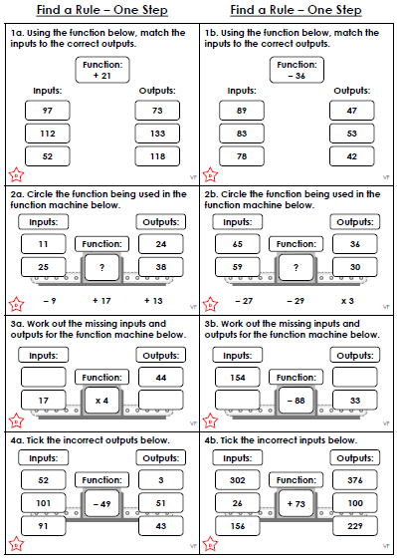

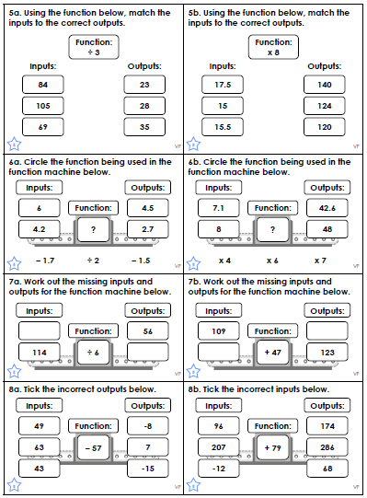
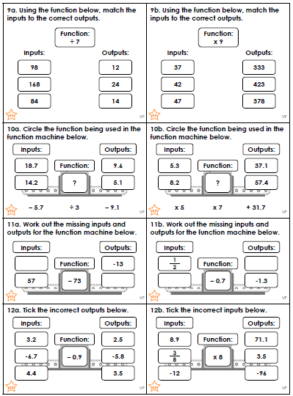
Maths Answers

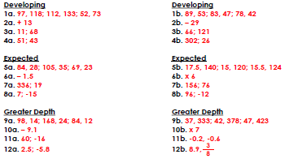

PE - Tuesday

