Week commencing 06/07/2020

Hey Everyone!

We hope you all staying healthy and happy and managing to still have some fun at home.

In maths this week you will continue with algebra. This week we are looking at formulae and forming equations.

For reading, you will have sections of mock SATs papers, along with some questions that focus on 3 mark answers.

Don’t forget, if you need us we are still here for you – just email the Year 6 email address and we will respond as soon as we can!

Have a great week – you are all doing a super job! Keep it up!

Tuesday 7th July 2020

Spellings

Correct the spellings of the words below

1. egistene
2. explnatin
3. femliar
4. forign
5. forte
6. freqntly
7. govrment
8. garnte
9. haras
10. hendrace

Reading
Guide Dogs
What guide dogs do
Guide dogs help people who are blind or visually impaired move around safely, and often transform their lives. They are usually allowed anywhere that the public can go, even where other dogs aren’t allowed. In order to help their owner, guide dogs must know how to:
• keep a steady pace
• stop at all kerbs
• recognise and avoid obstacles
• stop at the bottom and top of stairs
• lie quietly when their owner is sitting down
• help their owner to board public transport
• obey spoken commands
• ignore distractions such as other animals and people.

Guide dogs and their owners

Guide dogs must also know not to obey any command that would put their owner in danger. This is called selective disobedience and is perhaps the most amazing thing about guide dogs: they know when to obey their owner and when they should disobey to keep their owner safe.

Selective disobedience is extremely important at road crossings, where the owner and dog must work very closely together to cross safely. When they reach the kerb, the dog stops and signals to the owner that they have reached a crossing. Dogs cannot recognise the colour of traffic lights, so the owner must decide when it is safe to cross the road. The owner listens to the flow of traffic to judge when the light has changed and then gives the command ‘forward’. If there is no danger, the dog crosses the road. If there are cars coming, the dog waits until they pass and then crosses.

The guide dog doesn’t know where they are going, so it must follow the owner’s instructions. The owner can’t see obstacles so the guide dog must help the owner to avoid them. The owner is like the navigator on an aircraft who must know how to get from one place to another, and the dog is the pilot who gets them there safely.

How guide dogs are trained  Not all dogs are suited to the life of a guide dog. Puppies born to be guide dogs have to be intelligent and good-natured; it is important that they aren’t nervous of crowds or frightened by sudden noises.  When it is eight weeks old, the puppy sets out on its journey to become a life-changing guide dog. It goes to live with a volunteer ‘puppy-walker’, who teaches the pup to follow simple commands and to walk on a lead. The puppy-walker also takes it to busy town centres and on different kinds of public transport. The puppy is introduced to the sights, sounds and smells of a world in which it will play such an important part.  When the puppy is about a year old, it returns to the guide dog centre for the next part of its training. It can be hard for puppy-walkers to say goodbye to a puppy, but they have the satisfaction of knowing they have helped to raise a dog who will one day be someone’s eyes.  Work and play  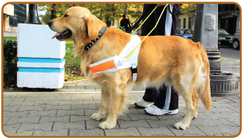  Guide dogs work hard and there is no room for fun during the working day. If you see a guide dog, you should leave it alone so that it can concentrate on helping its owner.  At the end of the day, however, a guide dog will play just like an ordinary pet.  “Before I got my guide dog, Benji, I spent most of my time at home. Now I’m out and about almost every day. He has given me confidence: now I can catch a bus into town, meet my friends and go shopping. I can go anywhere I want, without thinking twice.”  Guide dog owner Lucy, talking about her guide dog. | Did you know?  • The first guide dogs in  the UK were trained in  1931 by Rosamund Bond  and Muriel Crooke.  • There are now 4,500  guide dog owners in this  country.  • The working life of a  guide dog is 6 – 7 years.  • The lifetime cost of a  guide dog is £50,000.
Play your part!
If you sponsor a gorgeous
little guide dog puppy, you
play an important part in its
amazing journey. It costs
from only £1.00 a week
and you get regular
‘pupdates’ with photos
as it grows up and news
of all its adventures!
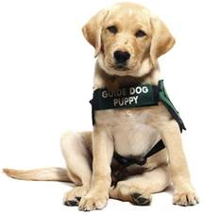

1. Look at the section headed: What guide dogs do.

Find and copy the word or group of words that show how much
difference a guide dog can make to someone.

______________________________________________________________

1 mark

2. According to the text, which of the following do guide dogs have to learn to do?

Tick two.
obey a whistle
stop at all kerbs
obey spoken commands
recognise the colour green
walk very slowly

1 mark

3. Look at the section headed: Guide dogs and their owners.

Why does the text use italics to draw attention to the word disobey?

Tick one.
because it’s a word that people don’t know
to show that dogs should do as they are told
it’s the opposite of what you would expect
because it’s explained in a glossary

1 mark

4. Look at the section headed: Guide dogs and their owners.

Why is it important that guide dogs demonstrate selective disobedience?

______________________________________________________________

______________________________________________________________

1 mark

5. The owner is like the navigator on an aircraft who must know how to get from one place to another, and the dog is the pilot who gets them there safely.

What does this comparison tell you about the relationship between the owner and the guide dog?

Tick one.
The dog decides where the owner wants to go.
The dog relies on the owner to avoid the obstacles.
The owner and the dog work together as a team.
The owner keeps the dog safe on the journey.

1 mark

6. Look at the paragraph beginning: When it is eight weeks old…

Find and copy one word that suggests that training a guide dog is a long process.

___________________________________

1 mark

7. What do puppy-walkers train the guide dogs to do?

Give two examples.

1. ____________________________________________________________

2. ____________________________________________________________

1 mark

8. Look at the section headed: How guide dogs are trained.

Find and copy two groups of words that suggest guide dogs do a very special job.

1. ____________________________________________________________

______________________________________________________________

2. ____________________________________________________________

______________________________________________________________

2 marks

9. Puppy-walkers have mixed feelings when they give the puppy back for the next stage of its training.

Explain why.

______________________________________________________________

______________________________________________________________

______________________________________________________________

2 marks

10. Look at the section headed: Work and play.

How are guide dogs like normal dogs?

______________________________________________________________

______________________________________________________________

1 mark

11. Having a guide dog made Lucy feel more:

Tick one.
curious.
thoughtful.
independent.
careful.

1 mark

12. Look at the section headed: Play your part!

This section ...

Tick one.
informs you about how to get ‘pupdates’.
persuades you to sponsor a guide dog.
explains how the money will be spent.
describes the pups’ adventures.

1 mark

13. Draw lines to match the age of a guide dog to what it does at that age.

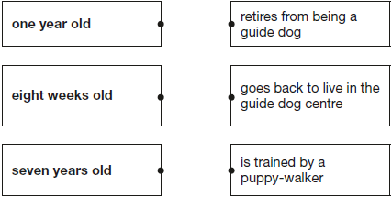

1 mark

14. Tick to show which statements about guide dogs are true and which are false.

Statement | True | False
Guide dogs need to be very focused and have excellent concentration skills.
Guide dogs must listen to the flow
of traffic.
Guide dogs are encouraged to have fun during the working day.
The first guide dogs in the UK were
trained in 1931.
Puppy-walkers get to keep their puppies.

2 marks

15. Draw lines to match each section to its main purpose.

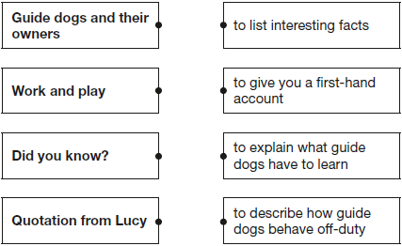

1 mark

Tuesday Maths
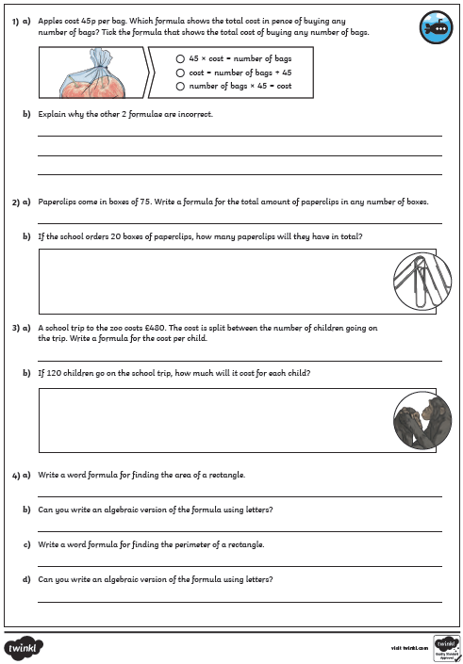
Maths Answers

