Ebony Regular

Week commencing 1/06/2020

Hey Everyone!

We hope you all had a good half term break and are staying healthy and happy.

In maths this week you will be using fractions to find the whole. For example: Find 2/5 of 25.

In order to calculate this, you must first divide the whole by the denominator, then multiply the quotient – the answer – by the numerator. This is your answer.

25 ÷ 5 = 5

5 x 2 = 10

2/5 of 25 is 10.

For reading, you will have sections of mock SATs papers, along with some questions that focus on 3 mark answers.

Don’t forget, if you need us we are still here for you – just email the Year 6 email address and we will respond as soon as we can!

Have a great week – you are all doing a super job!

Tuesday 2nd June 2020

Spellings

Correct the spellings of the words below

existense

explaination

familliar

foreign

fourty

frequently

goverment

gaurantee

harrass

hindrence

Reading

**The Spider Web**

Not all spiders spin webs, but they can all make silk.  
Spiders spin their silk through organs called spinnerets.  
The silk starts as a sticky liquid which hardens to form a  
very light but very strong thread. If you make a steel  
thread as fine as a thread of a spider silk, the silk  
would be just as strong as the steel. Each kind of  
web-building spider builds its own kind of web.  
The moment a spider hatches from its egg, it  
knows how to spin a certain pattern by instinct.

**How a spider spins a web**

It takes a spider about an hour to spin an orb web.  
The fine silk thread looks delicate but it can  
hold 1,000 times the spider’s own weight!

After finishing its web, the spider usually waits out of sight  
with one leg on a ‘signal thread’. When an insect lands in the web,  
the thread shakes. Instantly the spider pounces.  
Parts of the orb are made of a special sticky silk, so insects   
can’t escape before the spider arrives.

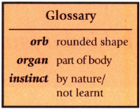

|  |  |
| --- | --- |
|  |  |
| Firstly, the spider spins a thread between two supports – helped, perhaps, by a breeze that carries the thread. Then it spins another and dangles down from it. | Secondly, it drops a new thread to make a Y-shape, and spins more threads from the centre to the edge. |
|  |  |
| Then, the spider spins round and round in a spiral, working slowly out from the middle. | Finally, it spirals back into the centre. The web is then ready for the spider to catch its prey. |

1.      Choose the correct option to complete each sentence below.

(a)     On pages 1 and 2 you can find out how a garden spider spins a web. It takes the spider about



to spin a web.

1 mark

(b)     Spiders know how to spin their webs and catch flies

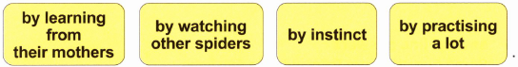

1 mark

(c)     When it has finished its web, the spider



1 mark

(d)     Once an insect is caught, it cannot get away because



1 mark

2.      The information tells us how a spider spins a web.

Below is a summary of the four stages.

Number each stage (1-4) to show the correct order.

|  |  |
| --- | --- |
| spins third thread downwards. |  |
| returns spinning from outside to middle |  |
| spins thread to join two supports |  |
| spins from inside to edge |  |
|  |  |

1 mark

3.      Write down **two** things from the text which show that spiders’ silk is very strong.

**1.** _________________________________________________________________

___________________________________________________________________

**2.** _________________________________________________________________

___________________________________________________________________

2 marks

4.      *...helped, perhaps, by a* ***breeze*** *that carries the thread.* (page 2)

Give the meaning of the word *breeze* in this sentence.

___________________________________________________________________

1 mark

5.      These questions are about the way in which the information is presented.

(a)     ***The Spider Web***

Why have these words been made to stand out?

______________________________________________________________

______________________________________________________________

1 mark

(b)     ***How a spider spins a web***

Why are these words smaller, but still in **bold** print?

______________________________________________________________

______________________________________________________________

1 mark

(c)     (i)      What is a glossary?

_________________________________________________________

_________________________________________________________

1 mark

(ii)      Why are some words in the glossary printed in italics, ***like this****?*

_________________________________________________________

_________________________________________________________

1 mark



PE:

Play this fitness board game- you can play it alone or with someone in your household. If you don’t have a dice, you can type ‘roll dice’ into google, or get someone else in your house to call out random numbers between 1-6.

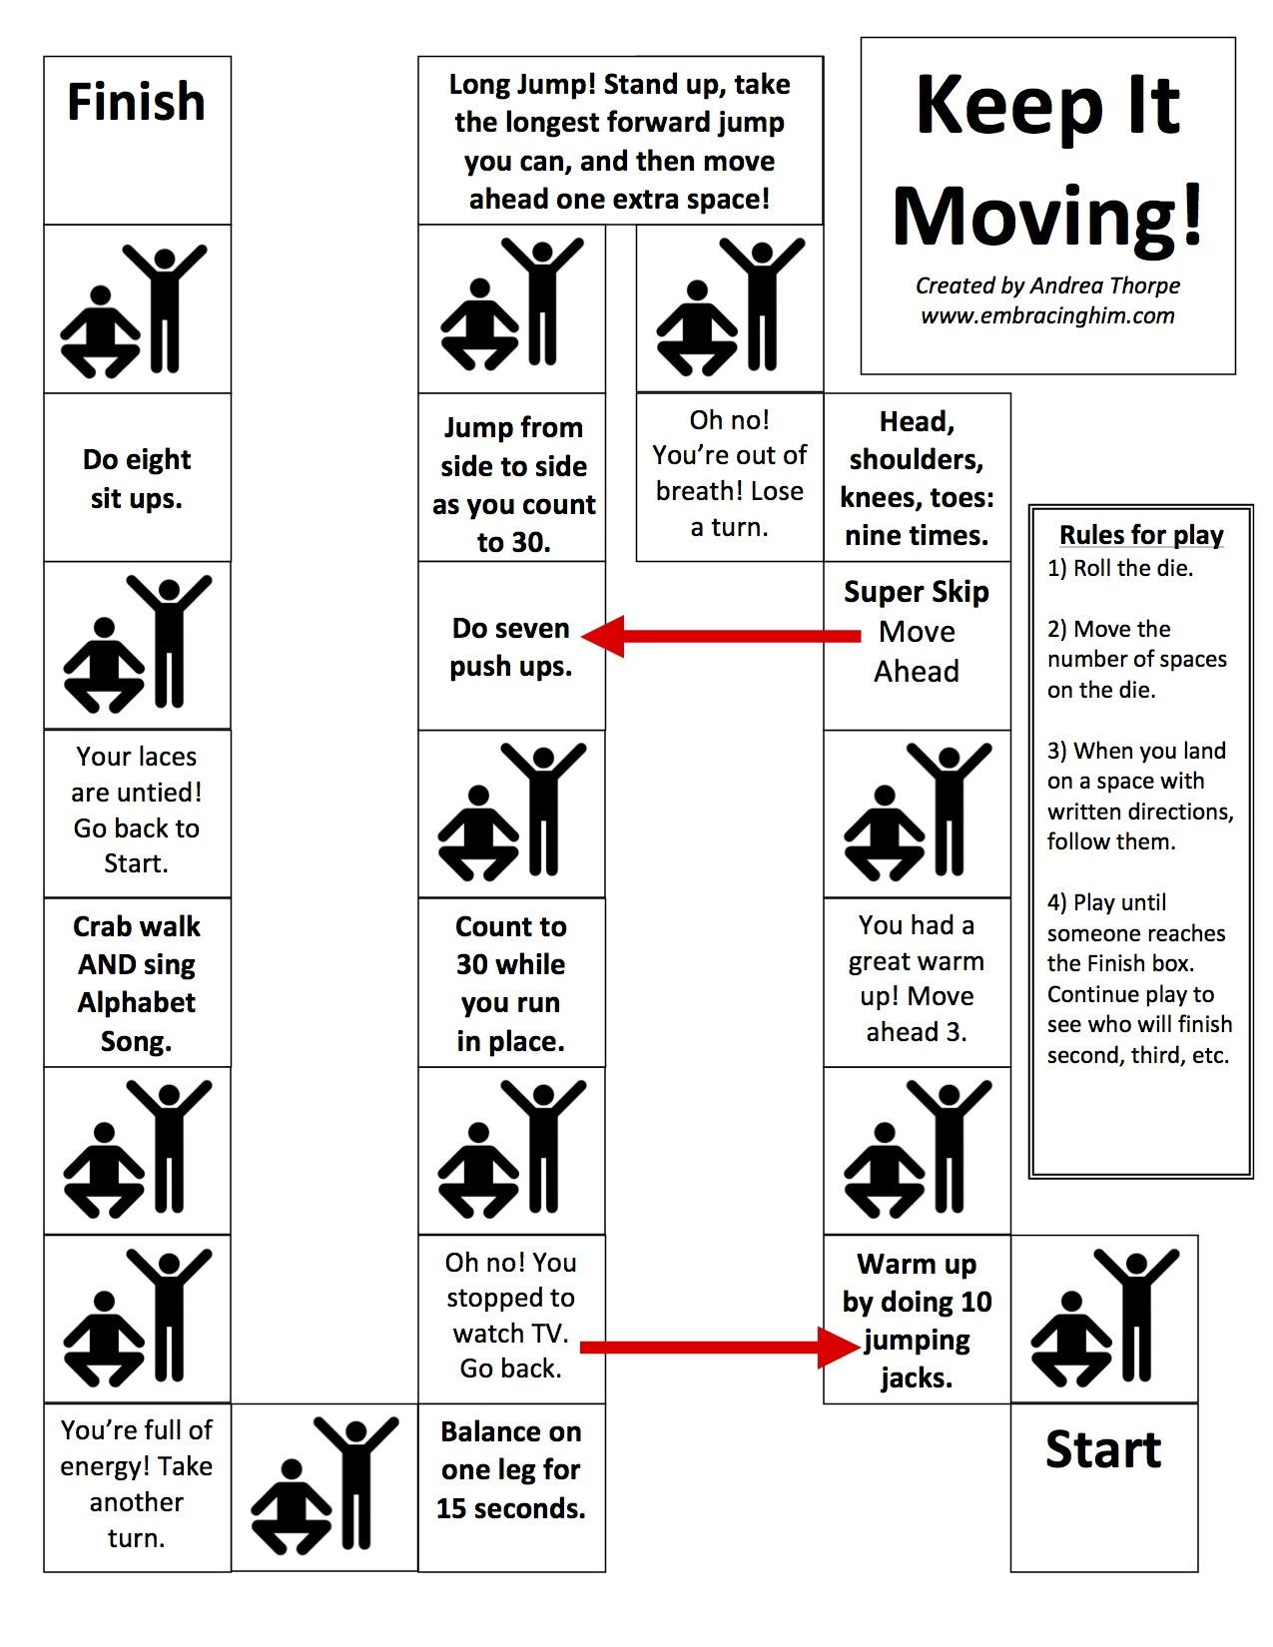

Mark schemes- **Spider Wed**

1.      Award **1 mark** for each correct choice.

(a)



(b)

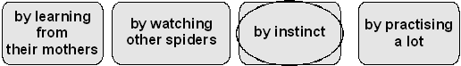

(c)

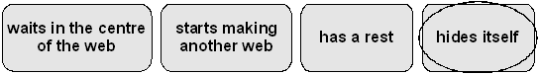

(d)

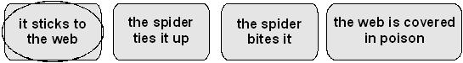

**up to 4 marks**

2.      Award **1 mark** for all stages correctly numbered.

|  |  |
| --- | --- |
| spins third thread downwards. |  |
| returns spinning from outside to middle |  |
| spins thread to join two supports |  |
| spins from inside to edge |  |

**1 mark**

3.      Award **1 mark each** for answers along the following lines up to a maximum of **2**:

*•        can hold 1000 times the spider’s own weight (Accept 10,000 or 100);*

*•        as strong as steel thread.*

**Do not accept:**

*•        the insects cannot escape from the web;*

*•        the liquid silk hardens;*

*•        a light but strong thread (given).*

**up to 2 marks**

4.      **Award 1 mark** for answers that refer to (a light)wind.

**1 mark**

5.      (a)     Award **1 mark** for appropriate explanations about the prominence of these words, eg:

*•        it is the main heading / title of the whole page / it is the title;*

*•        tells you what the whole page is about;*

*•        so your eye is drawn to it first of all.*

**Do not accept:**

*•        so you can see it / to catch your eye (implicit in question);*

*•        it’s important;*

*•        it’s the title of the paragraph;*

*•        it is the main information.*

(b)     Award **1 mark** for explanations that refer to subheadings or their features, eg:

*•        it is a subheading / side-heading;*

*•        tells you what one section is about;*

*•        they are not as important as the main heading;*

*•        because it’s still about webs but it’s a different part.*

(c)     (i)      Award **1 mark** for definitions such as:

*•        it tells you what words mean;*

*•        it’s like a little dictionary;*

*•        a key to the meaning of words.*

**Do not accept:**

*•        a key.*

(ii)     Award **1 mark** for explanations about the effect of typographical variation, eg:

*•        so you can tell the word from its meaning;*

*•        to distinguish the words from the explanations;*

*•        because that is the word they are telling you about / that is being explained;*

*•        because they are words taken from the text.*

**Do not accept:**

*•        they are the difficult / hard words.*

**up to 4 marks**

