Week commencing 22/06/2020

Hey Everyone!

We hope you all had a good half term break and are staying healthy and happy.

In maths this week you will be practising forming expressions in algebra.

For reading, you will have sections of mock SATs papers, along with some questions that focus on 3 mark answers.

Your topic work is in a separate pack this week for you to work through at your own pace.

Don’t forget, if you need us we are still here for you – just email the Year 6 email address and we will respond as soon as we can!

Have a great week – you are all doing a super job! Keep it up!

Tuesday 23rd June 2020

Spellings

Correct the spellings of the words below

1. compition
2. coscience
3. conscus
4. controvrse
5. convenince
6. corespnd
7. criticse
8. curosity
9. definate
10. dsperite

Reading

Inventions

Think about your home and all the things inside it. Everything was invented by someone. Many things were invented to speed up housework, some were made for our enjoyment and others help us communicate. A few make homes safer, while others make your house cleaner.

The Telephone
In 1849, Italian engineer Antonio Meucci made the first telephone. He came across the idea by accident when he was trying to find a cure for headaches. Meucci believed that headaches could be cured by electricity. During his experiments he found that when the electricity was turned on sound travelled down the wires he was using. Meucci discovered that a pair of small cones joined together by wires made a basic telephone.  Soon after, a very similar invention was produced by a man called Alexander Graham Bell. Sadly, Meucci was unable to prove that his telephone was the first and he failed to make any money for all his hard work. | 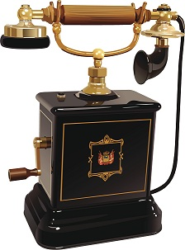

The Vacuum Cleaner
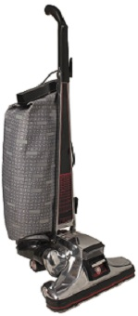 | At the beginning of the 20th century cleaning a carpet meant lifting it from the floor, carrying it outside and beating it until all the dust fell out. It was hard, dirty work. Surely there was an easier, cleaner way of cleaning?  Hubert Booth, a British engineer, went to watch an inventor demonstrating a cleaning machine that blew dust from the seats of railway carriages. It certainly worked! The jet of air blew dust from the cushions – into the faces of everyone watching!  Booth thought that it would be even more useful if the machine sucked the dirt up, rather than just blowing it to another place. So he put a handkerchief on a chair cushion. Pressing his mouth against it, he took a deep breath and breathed in a lungful of dust. Once he had stopped coughing he turned the handkerchief over. On the back was a dark ring of dirt where his mouth had been. Using this idea, Booth bought an electric motor and pump and in 1901 built the world’s first vacuum cleaner.

The Toaster  Charles Strite was so fed up with burnt toast that he invented a pop-up toaster in 1919. This meant you didn’t have to stand around waiting for the bread to toast – you just put it in the toaster and it would pop up when it was ready. | 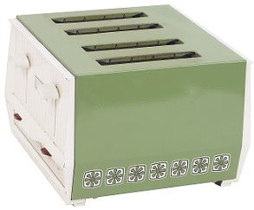

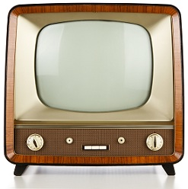 | The Television  Although the invention of the television was the result of work by many people, Scottish inventor John Logie Baird is thought to be the first person to have produced an image on television.  In 1925, he created a camera which was made up of a jumble of lenses, spinning cardboard discs and electric motors. He pointed it at the head of a dummy called ‘Stooky Bill’. Amazingly, it worked. An image of the dummy appeared on the little screen.

The Microwave
During the Second World War in the 1940s, Percy Spencer, an American, was working on the radar – a machine used to detect enemy aeroplanes. One day, while he was working on this machine, he noticed that a bar of chocolate in his pocket had melted. He immediately realised that the microwaves from the radar machine had heated it.  Spencer sent his assistant to buy some dry corn, and put this right in front of the machine. Switching on the power turned it instantly into popcorn. | 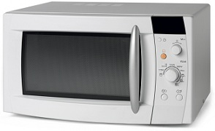

Next, Spencer put an egg in front of the machine, flipped the switch and waited. It trembled. It fizzed. Finally it exploded, sending shell and yolk everywhere, including in the face of his assistant!

Spencer designed his invention so that it was like a mini-oven. The first microwave cost the same as an expensive car!

In the future

Now that the internet is being used more, people are inventing ‘smart’ machines so that owners can control them by phone. Imagine being able to put some washing on by sending a message to your washing machine. One washing machine, which was made recently, can even call out the engineer when it breaks down!

1. Where could all these inventions be used?

______________________________________________________________

1 mark

2. Look at the section about the telephone.

What was Meucci trying to do when he had the idea for the telephone?

Tick one.
cure headaches
invent a cleaning machine
send sound down a wire
make money

1 mark

3. Look at the section about the vacuum cleaner.

Cleaning carpets the old way was hard, dirty work.

What made it hard work?

______________________________________________________________

______________________________________________________________

1 mark

4. The vacuum cleaner was based on another machine.

What made the vacuum cleaner different to the machine that it was based on?

______________________________________________________________

______________________________________________________________

1 mark

5. Look at the section about the toaster.

What problems did the pop-up toaster solve?

Write two things.

1. ____________________________________________________________

2. ____________________________________________________________

2 marks

6. Look at the paragraph beginning: Next Spencer put an egg...

How does the writer make this paragraph exciting?

Give two ways.

1. ____________________________________________________________

2. ____________________________________________________________

2 marks

7. According to the text, how might our machines be controlled in the future?

______________________________________________________________

______________________________________________________________

1 mark

8. In what order do the inventions appear in the text?

Tick one.
order of importance
no particular order
alphabetical order
chronological order

1 mark

9. Who invented what?

Fill in the missing information.

Invention | Inventor
vacuum cleaner
 | Charles Strite
 | John Logie Baird
microwave

2 marks

10. Which two of the inventions were invented by accident?

1. ____________________________________________________________

2. ____________________________________________________________

2 marks

11. Where would you expect to find this text about inventions?

Tick one.
in a diary
in a story book
in a non-fiction book
in an atlas

1 mark

Mark Scheme

1. Award 1 mark for reference to the home / in the house.

Also accept references to specific rooms in the house, eg:

• in the kitchen.

1 mark

2. Award 1 mark for the correct box ticked.

cure headaches

invent a cleaning machine

send sound down a wire

make money

1 mark

3. Award 1 mark for references to either of the following:

♦ lifting / carrying / removing (the carpets), eg:

• because you had to carry it outside

• because the carpet might have been heavy.

♦ beating (the carpets), eg:

• they had to bang it

• they had to beat it until all the dust came out.

1 mark

4. Award 1 mark for reference to the machine sucking the dust up rather than just blowing it away.

1 mark

5. Award 1 mark for each of the following, up to a maximum of 2 marks:

♦ A references to burning toast, eg:

• you will not have burned toast

♦ references to waiting, eg

• you did not have to stand around.

Do not accept it would pop up when it was ready.

up to 2 marks

6. Award 1 mark for any of the following, up to a maximum of 2 marks:

♦ use of short sentences build tension / suggest something is about to happen

♦ use of specific words to create excitement, eg: (It) trembled / (It) fizzed / (Finally it) exploded

♦ use of the exclamation mark

up to 2 marks

7. Award 1 mark for reference to use of a phone / internet / message

1 mark

8. Award 1 mark for correct box ticked.

order of importance

no particular order

alphabetical order

chronological order

1 mark

9. Award 2 marks for all four correct.
Award 1 mark for two or three correct.

Invention | Inventor
vacuum cleaner | Hubert and / or Booth
toaster | Charles Strite
television / TV | John Logie Baird
microwave | Percy and / or Spencer

up to 2 marks

10. Award 1 mark for each of the following, up to a maximum of 2 marks:

♦ (tele)phone

♦ microwave.

up to 2 marks

11. Award 1 mark for the correct box ticked.

in a diary

in a story book

in a non-fiction book

in an atlas

1 mark

Maths

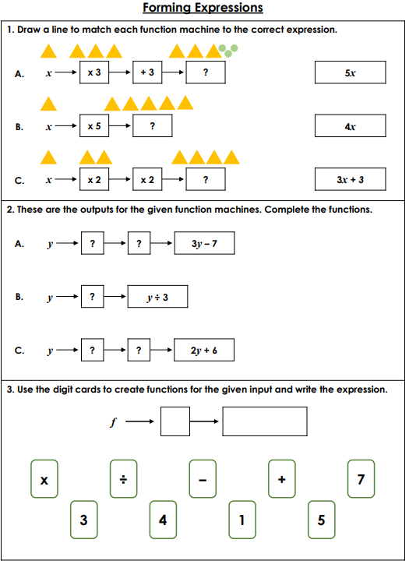
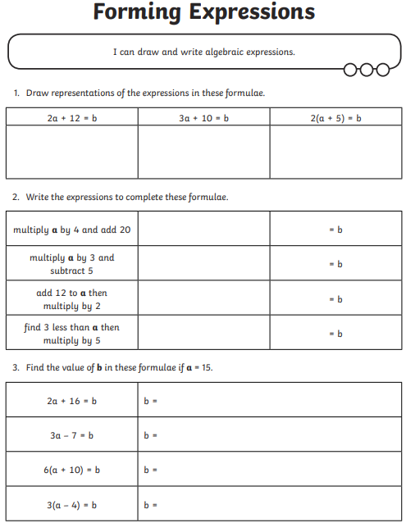

Maths answers
