Ebony Regular

Week commencing 18/05/2020

Hey Everyone!

We hope you all had a good week and are staying healthy and happy.

In maths you will be continuing dividing fractions by fractions and then moving onto dividing fractions by integers – or whole numbers. When dividing fractions by integers there are two key rules: Firstly, convert the integer to a fraction. Then secondly, keep your first fraction, change the division to a multiplication and flip the second fraction.

For example: 4/5 ÷ 2 becomes 4/5 ÷ 2/1, then 4/5 x 1/2.

For reading, you will have sections of mock SATs papers, along with some questions that focus on 3 mark answers.

Tuesday 19th May 2020

Spellings

Correct the spellings of the words below

Identitty

Immediataly

Individuel

Interfer

Interupt

Langage

Leisere

Lightnning

Marvelous

Mischevious

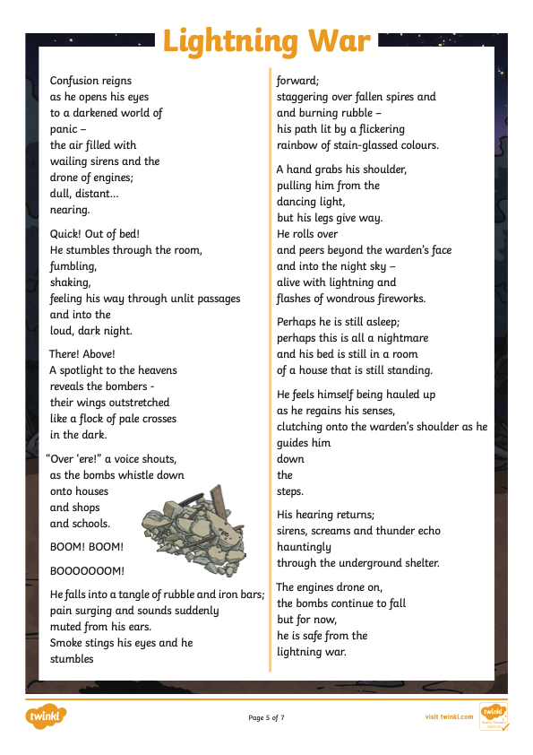Reading









PSHE: Managing my mental health

Something that a lot of young people struggle with is friendships and bullying. For some students, this can cause stress and mental health problems. 22% of ten year olds reported that they had been bullied in the past year.

There are lots of different ways someone could be bullied. Think of examples for each heading:

Physical:

Emotional:

Virtual/Online:

There is more awareness about bullying in schools nowadays, and more help available for young people online. For example, childline run a 24/7 online counselling service on their website. However, some argue that technology has allowed bullying to continue all day and night, whereas some years ago this might not have been the case.

Do you think that technology has had a positive or negative impact when it comes to bullying? Explain your opinion in full sentences.







