Week commencing 15/06/2020

Hey Everyone!

We hope you all had a good half term break and are staying healthy and happy.

In Maths this week you will continue working on algebra.

For reading, you will have sections of mock SATs papers, along with some questions that focus on 3 mark answers.

There is also some PSHE and PE for you to do this week.

Don’t forget, if you need us we are still here for you – just email the Year 6 email address and we will respond as soon as we can!

Have a great week – you are all doing a super job!

Tuesday 16th June 2020

Spellings

Correct the spellings of the words below

1. avalble
2. avrage
3. awkwad
4. bargin
5. bruice
6. categry
7. cemetry
8. commite
9. communcate
10. comunite

Reading
Michael is a young fisherman. He often takes out his boat, the ‘Louisa May’, for a day of fishing.

An Encounter at Sea

It was hot. Really hot. There wasn’t the slightest breeze to cool the skin or make even a baby-finger crease on the surface of the sea. The Louisa May floated like a toy sitting on a glass table.

For the first time in over a week, Michael hadn’t seen a dolphin all day. He was two miles offshore now, motoring along his daily survey course. The Louisa May pulled the reflection of the sky and the island into pleats behind her, and the putt-putt of her engine was lost in the big, quiet stillness of the afternoon.

Michael shut off the outboard motor and stopped. He leaned over the side to scoop up a bucket of seawater to cool himself, and looked down. Long fingers of sunlight slanted into the clear water, shifting slightly in arcs of radiating lines, and were swallowed up at last into the perfect blueness of the depths.

He poured the water over himself, savouring the delicious coolness.

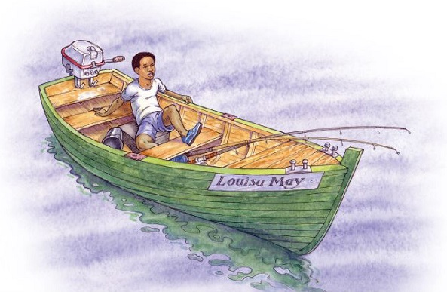

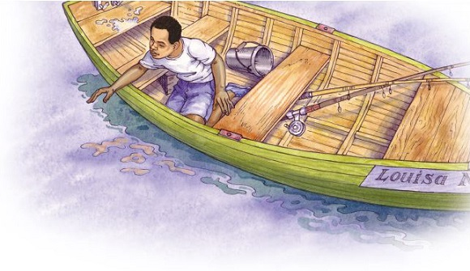

Pppfffffwwwwraa! The sound came from close behind him, and made him spin round so fast he lost his balance and fell into the bottom of the boat.

Pppfffff – shorter and louder, even closer.

Michael picked himself up and looked over the side.

A black shape, much, much bigger than the biggest dolphin, showed about five metres from the boat. It was like a polished rock. On its rounded side was a slit like a flattened S, bigger than a man’s two clenched fists, with a raised lip around it. As Michael watched, astonished, not understanding what he was seeing, the lips pinched together, the hole closed, and the black shape sank rapidly beneath the sluicing water.

A whale! Its dark head and blowhole! That’s what he had seen.

Pppfffffwwwwraa!

Now it had surfaced on the other side of the boat. This second surfacing was hardly less shocking than the first, although Michael just managed to stay on his feet and cross the boat this time.

Carefully, Michael leaned over to look: on one side of the boat lay the whale’s tapering tail; on the other side, the head with its scarred lines lay like a piece of huge, dark wreckage. This close, Michael could see that big sections of skin had peeled off in straight lines, giving the whale’s head a patchwork look in greys and blacks. Closest of all to the boat, only just submerged, was the whale’s eye. Michael looked right into it, and the whale looked back. It was so very, very close. He leaned out further and further, stretching his hand slowly towards it. The whale didn’t draw away.

He reached down, until his fingertips touched the crease of skin that gave the whale a kind of eyebrow. It was cool and smooth, like a carved stone covered in a finely stretched coat of rubber.

And as his fingertips touched the whale, he looked into its eye. It was impossible to say what colour it was: dark but with rays of brightness. It was like a window into a whole galaxy, with stars and planets, comets and supernovae moving inside.

Effortlessly, as if movement and thought were the same thing, the whale submerged out of reach of Michael’s hand. There was a last shushing sigh as the flipper caressed the boat one more time, and then they were separate again.

The setting sun made a path over the sea, bathing Michael in golden light. He felt as if he were lit up inside too. He had touched a whale and looked into its eye! Like a sleeper waking from a dream, he looked around, dazed.

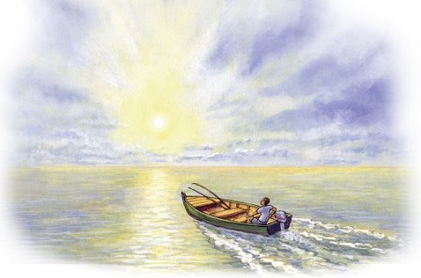

1. ...like a toy sitting on a glass table.

What does this description suggest about the boat?

______________________________________________________________

1 mark

2. Look at page 1.

What was unusual for Michael about this day?

______________________________________________________________

______________________________________________________________

1 mark

3. ...the ‘putt-putt’ of her engine was lost in the big, quiet stillness of the afternoon.

Choose the best words to match the description above. Circle both of your choices.

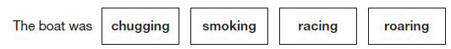

1 mark

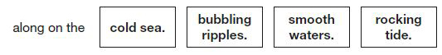

1 mark

4. Look at page 1.

Find and copy two different words that show Michael enjoyed the feeling of the cool water.

1. ____________________________________

2. ____________________________________

1 mark

5. Look at page 2.

How is the whale made to seem mysterious?

Explain two ways, giving evidence from the text to support your answer.

______________________________________________________________

______________________________________________________________

______________________________________________________________

______________________________________________________________

______________________________________________________________

______________________________________________________________

______________________________________________________________

3 marks

6. When Michael touched the whale it felt smooth.

(a) According to the text on page 2, why might he have expected it to feel smooth?

_________________________________________________________

_________________________________________________________

1 mark

(b) According to the text on page 3, why might he not have expected it to feel smooth?

_________________________________________________________

_________________________________________________________

1 mark

7. Look at the paragraph beginning: Carefully, Michael leaned...

Where was the whale?

Tick one.
in front of the boat
at the side of the boat
under the boat
five metres from the boat

1 mark

8. Look at the paragraph beginning: Carefully, Michael leaned...

What does this paragraph tell you about Michael’s character?

Explain two features of his character, using evidence from the text to support your answer.

______________________________________________________________

______________________________________________________________

______________________________________________________________

______________________________________________________________

______________________________________________________________

______________________________________________________________

______________________________________________________________

3 marks

9. The whale did not seem to be alarmed by meeting Michael. How can you tell this from its actions?

Give two ways.

1. ____________________________________________________________

2. ____________________________________________________________

2 marks

10. Like a sleeper waking from a dream, he looked around, dazed.

This tells us that at the end of the story Michael felt that...

Tick one.
he wanted the experience to continue.
he had experienced something similar before.
the experience was unreal.
the experience was worrying.

1 mark

11. Tick one box in each row to show whether each statement is true or false.

 | True | False
Michael was in an unfamiliar area of sea when he saw the whale.
The boat was still motoring forwards when the whale appeared.
The whale felt warm and soft when Michael touched it.
Michael could not name the colour of the whale’s eye.

1 mark

1. Content domain: 2g – identify / explain how meaning is enhanced through choice of words and phrases

Award 1 mark for reference to either of the following:

1. small / insignificant, e.g.

• it was small in a big ocean.

2. still / unmoving, e.g.

• it created no ripples.

1 mark

2. Content domain: 2d – make inferences from the text / explain and justify inferences with evidence from the text

Award 1 mark for reference to Michael seeing no dolphins.

Do not accept references to the weather / temperature.

1 mark

3. Content domain: 2a – give / explain the meaning of words in context

Award 1 mark for:

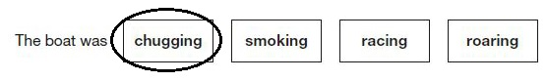

1 mark

Content domain: 2d – make inferences from the text / explain and justify inferences with evidence from the text

Award 1 mark for:

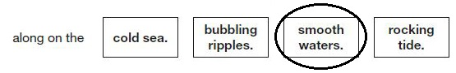

1 mark

4. Content domain: 2a – give / explain the meaning of words in context

Award 1 mark for both of the following:

1. savouring

2. delicious (coolness).

1 mark

5. Content domain: 2d – make inferences from the text / explain and justify inferences with evidence from the text

Acceptable points:

1. unexpected / unidentified / unfamiliar sound it makes

2. unexpected appearance / disappearance

3. Michael’s shock / confusion

4. it describes parts of the whale / the whale is only partly visible

5. it doesn’t immediately say what it is

6. it uses familiar things to describe the unrecognisable

7. rules out what it is not rather than telling you what it is.

Award 3 marks for two acceptable points, with at least one supported with evidence, e.g.

• the whale is made mysterious because out of the blue, there is a ‘ppppfffffwwwraa’ noise. It is also mysterious as it seems to appear out of nowhere ‘A black shape much, much bigger than the biggest dolphin, showed about five metres from the boat’. [AP1 + evidence, AP2 + evidence]

• because of the unusual sound it makes and it doesn’t say it’s a whale until Michael realises – a whale! That’s what he had seen. [AP1, AP5 + evidence].

Award 2 marks for either two acceptable points, or one acceptable point supported with evidence, e.g.

• a black shape much much bigger than the biggest dolphin. It doesn’t tell you what the shape is but you know it isn’t a dophin which creates mystery. [evidence + AP7]

• something takes Michael by surprise and he keeps you in suspense by not saying what it is yet. [AP3, AP5].

Award 1 mark for one acceptable point, e.g.

• it only describes a bit of it so you don’t know what it is [AP4]

• by describing it as being like something you know to help you understand. [AP6].

Up to 3 marks

6. (a) Content domain: 2d – make inferences from the text / explain and justify inferences with evidence from the text

Award 1 mark for reference to it looking polished / like a polished rock.

Do not accept reference to it being shiny / wet.

1 mark

(b) Content domain: 2d – make inferences from the text / explain and justify inferences with evidence from the text

Award 1 mark for reference to either of the following:

1. the whale’s damaged skin / scars, e.g.

• it had bits of skin missing

• it had scars all over it.

2. the whale’s head looked like a patchwork / wreckage.

Also accept quotations which meet an acceptable point.

Do not accept reference to the crease of skin / it having creased skin.

Do not accept reference to injury without referring to scarring / skin damage.

1 mark

7. Content domain: 2d – make inferences from the text / explain and justify inferences with evidence from the text

Award 1 mark for:

in front of the boat
at the side of the boat
under the boat
five metres from the boat

1 mark

8. Content domain: 2d – make inferences from the text / explain and justify inferences with evidence from the text

Acceptable points:

1. curious / interested

2. observant

3. brave / daring

4. respectful / gentle

5. cautious / calm.

Award 3 marks for two acceptable points, at least one with evidence, e.g.

• He’s careful because instead of screaming or running to the side of the boat, he went carefully and calmly. He’s also very aware of the things around him. [AP5 + evidence, AP2]

• Michael is daring because he tried to touch the whale not knowing what would happen. He is very interested. [AP3 + evidence, AP1].

Award 2 marks for either two acceptable points, or one acceptable point with evidence, e.g.

• It tells you he is quite curious about things as a normal person would stay away, but he leaned over the boat so he could see it better. [AP1 + evidence]

• It tells us that he is a gentle kind character and cautious. [AP4 + AP5].

Award 1 mark for one acceptable point, e.g.

• He is very inquisitive. [AP1]

• He is very brave and adventurous. [AP3].

Do not accept general responses relating to Michael liking animals.

Up to 3 marks

9. Content domain: 2d – make inferences from the text / explain and justify inferences with evidence from the text

Award 1 mark for reference to any of the following, up to a maximum of 2 marks:

1. the whale stayed / left and came back

2. the whale allowed Michael to touch it, e.g.

• the whale stayed to be touched

• the whale didn’t draw away.

3. the whale looked Michael in the eye / allowed Michael to look it in the eye

4. the whale came close to Michael / close enough to touch the boat, e.g.

• the whale came near the boat.

5. the whale slowly went away / caressed the boat.

Also accept quotations which meet an acceptable point.

Do not accept answers referring to possible aggression by the whale, e.g.

• the whale didn’t attack him

• the whale didn’t swallow him / the boat.

Do not accept reference to the whale remaining calm without further explanation.

Up to 2 marks

10. Content domain: 2d – make inferences from the text / explain and justify inferences with evidence from the text

Award 1 mark for:

he wanted the experience to continue.
he had experienced something similar before.
the experience was unreal.
the experience was worrying.

1 mark

11. Content domain: 2b – retrieve and record information / identify key details from fiction and non-fiction

Award 1 mark for all four correct:

 | True | False
Michael was in an unfamiliar area of sea when he saw the whale. |  | ✔
The boat was still motoring forwards when the whale appeared. |  | ✔
The whale felt warm and soft when Michael touched it. |  | ✔
Michael could not name the colour of the whale’s eye. | ✔

1 mark

Tuesday Maths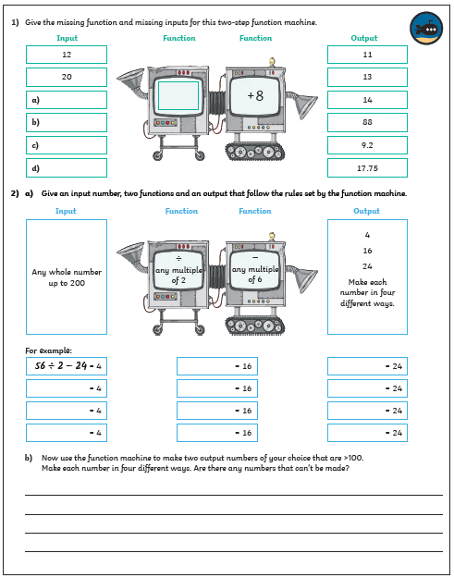

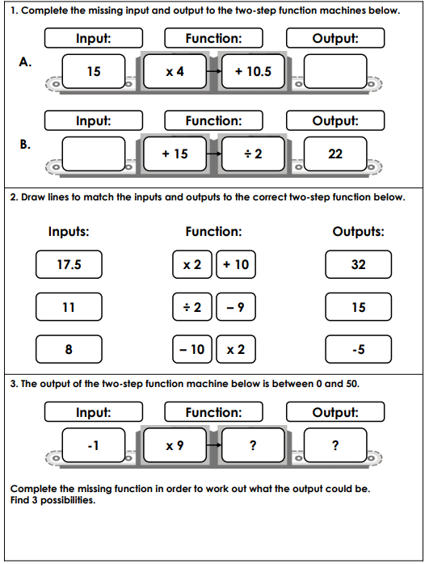

Maths answers
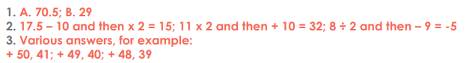

Tuesday – PSHE
