Week commencing 13/07/2020

Hi Everyone!

It’s the last week of Year 6 and this is your last learning pack of the year!

For Reading, you will have sections of mock SATs papers, along with some questions that focus on 3 mark answers.

In Maths this week you will continue with algebra. There is an end of topic assessment for you to complete on Friday.

There is also some Science and PSHE for you to complete in your topic pack

If you need us, we are still here. You can email the Year 6 email address and we will respond as soon as we can. Over the summer, your families can still contact the school office if you need anything, but unfortunately they won’t be able to print any more learning packs for you.

Have a great last week – you have all done a super job!
Have a lovely summer and good luck in Year 7 – you will all be fantastic!

Miss Dibble

Tuesday 14th July 2020

Spellings

Correct the spellings of the words below

- idntety
- imedate,
- imediatle
- indvidul
- intrfer
- interup
- lnguge
- leisre
- lihtnig
- marvelus

Reading
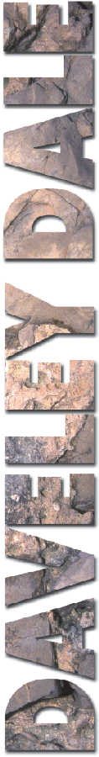 | 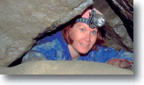  An interview with Lisa Clark,  an experienced caver  My first question has to be: why do you do it? Why do you go exploring caves?  Because they’re there. That’s what mountaineers sometimes say when asked that question and I think my answer’s the same. I suppose the big difference is that a climber can stand and look up and see the challenge while for a caver, really you have to imagine it. To me, that makes it even more appealing. How does what I imagine a cave system will be like compare to what I find when I get in there?  How did you get started as a caver?  Well, as a child my interests were all to do with exploration, but on the surface! On family walking holidays in the Lake District my brother, Chris, and I used to go racing ahead of our parents, always trying to get to the top of some hill to see what was there. But actually it was only when I went to university that I got the chance to try caving. Chris is a keen climber now and I haven’t been able to tempt him underground!  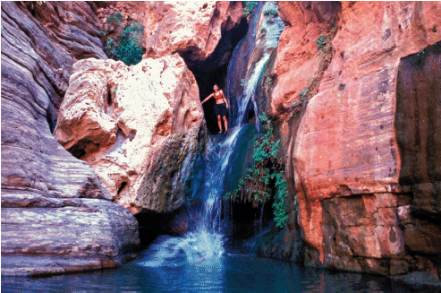

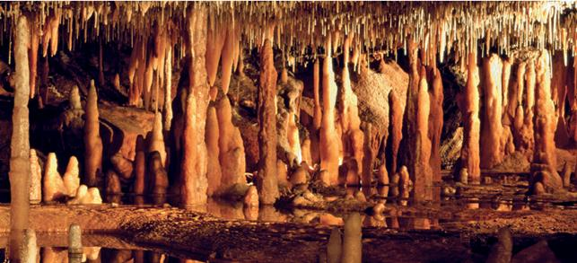

What was it like the first time you went underground?

It was here in Daveley Dale! My first thought was: this is crazy, I can’t see a thing! Then of course your eyes get used to the dark and you begin to make out shapes in the light from the headlamps. But in those first few moments your other senses take over – you realise how reliant you’re going to be on touch or hearing for example. You know the saying about hearing a friendly voice? Well that’s exactly how it is when you’re underground: hearing that familiar voice, especially if it’s an experienced caver, is very reassuring.

What’s the most dangerous thing you’ve done while caving?

I think it would have to be an exploration of the caves in New Dell. It’s not a particularly dangerous system and we were well prepared, but while we were underground there was a flash flood. That’s one of the biggest threats to cavers because the water level can rise so suddenly. Team work is critical in caving, you really do have to work together and in this case, the team on the surface realised we might be at risk and were ready to help us; luckily we made our own way out just in time.

And the best moment?

For me, it’s that moment when you’ve been sliding on your stomach for ages, moving more like a worm than a two-legged creature and wondering just why you’re doing this, when the tunnel opens out and you slither into a cavern in all its silent splendour. There’s tremendous beauty of a sort that you just don’t see anywhere else – everywhere you look you can see the work of nature rather than the hand of a human. And how many other places are like that in this country, completely without human influence? There’s nothing to compare it to on the surface.

1. In which order did the interviewer organise the interview?

Insert numbers in the boxes to show the order. The first one has been done for you.

worst moment
early childhood memory
first caving experience
best moment
what inspires Lisa to go caving | 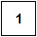

1 mark

2. What does Lisa say is the main difference between caving and climbing a mountain?

______________________________________________________________

______________________________________________________________

1 mark

3. Look at the second paragraph: How did you get started...

How can you tell that Lisa would like her brother to try caving?

______________________________________________________________

______________________________________________________________

1 mark

4. Look at the third paragraph What was it like the first time...

Give the meaning of the word familiar.

______________________________________________________________

1 mark

5. Lisa always goes caving with other people.

Give two reasons from the text why she does this.

1. ____________________________________________________________

2. ____________________________________________________________

2 marks

6. The interviewer spoke to Lisa’s mother too.

Write down what you think she would have said about Lisa, using what you have read in the interview.

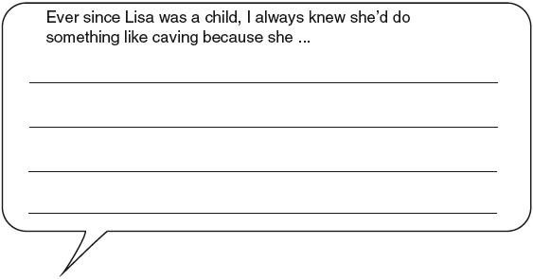

2 marks

1. Award 1 mark for all four stages correctly numbered.

worst moment
early childhood memory
first caving experience
best moment
what inspires Lisa to go caving

1 mark

2. Award 1 mark for answers that refer to the difference between seeing and imagining (this may be quoted directly from Lisa’s answer to the first question), eg:

• a climber can stand and look up and see the challenge while for a caver, really you have to imagine it

• a caver has to crouch down and try and picture in their heads what is in front of them, a climber can stand and see their goal.

Do not accept answers that focus only on climbing or caves, eg:

• that a climber can stand and look up and see the challenge

• for a caver you have to imagine your challenge.

Do not accept answers which do not make the difference between seeing and imagining clear, eg:

• that a mountaineer can see the challenge and a caver can’t.

1 mark

3. Award 1 mark for recognising and/or interpreting the use of the word tempt or copying the relevant sentence, eg:

• she says ‘I haven’t been able to tempt him’

• she says that she tries to persuade him

• she is trying to get him underground

• she says she can’t get him to go underground which suggests that she wants him to.

1 mark

4. Award 1 mark for references to being well known eg:

• it means she knew the voice

• she had heard it before

1 mark

5. Award 1 mark for each valid point made from the categories below, up to a maximum of 2 marks:

• reassurance of another voice (in the darkness), eg:

• so you can hear a familiar voice

• reliance on others / explicit advantages of teamwork if in danger, eg:

• something might go wrong and if someone needs help you can help each other when in danger

• identification of a specific danger that is mentioned in the text, eg:

• in case there are flash floods.

Do not accept reference to reassurance without reference to hearing another voice or to teamwork without stating advantages, eg:

• so she is reassured

• for reassurance

• teamwork / teamwork is good / critical.

Do not accept answers which could relate to any non-hazardous activity, eg:

• to keep her company / for safety / getting lost / to encourage her

• you can help each other.

Do not accept a quotation from the text without explanation, eg:

• you really do have to work together.

up to 2 marks

6. Award 2 marks for answers which identify one aspect of Lisa’s character.

Appropriate characteristics:

• adventurous

• keen on exploration

• enjoys a challenge

• determined

• enthusiastic

• confident / fearless / brave.

For example:

• likes to explore

• was extremely adventurous. Always climbing trees, exploring. Nothing ever scared Lisa

• would take on a challenge

• was keen on exploring. Also she would always love a hard challenge to knuckle down to

• always wanted to beat her brother to the top of the hill and she was determined to win

• is very confident and not scared in any way.

Award 1 mark for answers which provide a text-based reference to Lisa’s behaviour which exemplifies an appropriate characteristic, eg:

• always liked climbing so I thought she would do something like caving

• was always racing ahead and always trying to get to the top of the hill.

up to 2 marks

Tuesday Maths

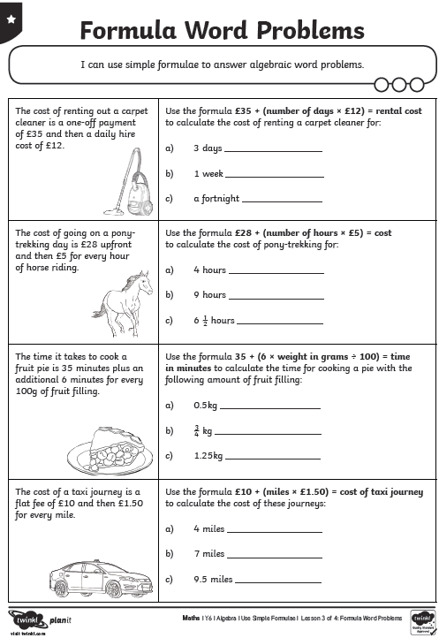
Maths Answers

