Week commencing 06/07/2020

Hey Everyone!

We hope you all staying healthy and happy and managing to still have some fun at home.

In maths this week you will continue with algebra. This week we are looking at formulae and forming equations.

For reading, you will have sections of mock SATs papers, along with some questions that focus on 3 mark answers.

Don’t forget, if you need us we are still here for you – just email the Year 6 email address and we will respond as soon as we can!

Have a great week – you are all doing a super job! Keep it up!

Thursday 9th July 2020

Spellings

Use the words below in a sentence

Challenge: can you use all of the words in just one sentence?
Or can you use all of the words in a cohesive paragraph, about just one topic?

- frequently
- government
- guarantee
- harass
- hindrance

Reading

Pamela Gillian wrote this poem about long distance swimming in a different kind of pool - a ‘sea-pool’. There are not very many of these around the country. They are ‘tidal’ pools which fill up with seawater at every high tide. When the tide goes down, the sun heats the water and makes an ideal swimming pool, without the dangers of waves or unexpected currents.

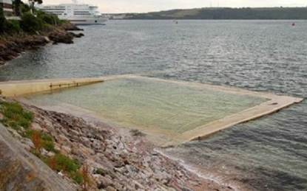

The half-mile

I was twelve when I swam the half-mile,
up and down the tide-fed cold concrete
pool, with a slow steady side-stroke.
My father counted the lengths,
at first from the deep-end board
and then, as I moved more laboriously,
pacing alongside, urging me on.

The race was only against myself
and distance. The grainy salt water,
though not translucent like the chlorinated
blue lidos of town, buoyed me helpfully,
lapped softly against the bath’s grey sides
variegated with embedded hardcore pebbles.
I swam from goal to alternate goal; he counted.

When he called enough I scrambled
over the sharp shutter-cast lip,
shuddered into a dry towel, drank
the words of praise. The planks
of the changing-room walls
were warm to touch. It had seemed to be
a great deal of swimming; still does.

1. Pamela Gillian describes the half-mile swim as being both a positive and a negative experience.

Identify and explain one positive and one negative phrase from the poem in the table below.

Positive experience | Negative experience
Phrase  ____________________________  ____________________________  Explanation  ____________________________  ____________________________  ____________________________  ____________________________  ____________________________ | Phrase  ____________________________  ____________________________  Explanation  ____________________________  ____________________________  ____________________________  ____________________________  ____________________________

2 marks

2. Find and copy one phrase in the poem which suggests that Pamela Gillian followed a rhythm when swimming.

______________________________________________________________

______________________________________________________________

1 mark

3. What do you find out about the father’s character from the poem?
Explain your answer, using evidence from the text.

______________________________________________________________

______________________________________________________________

______________________________________________________________

______________________________________________________________

______________________________________________________________

______________________________________________________________

______________________________________________________________

3 marks

4. Look at verse 2.

The grainy salt water,

though not translucent...

Give the meaning of the word translucent in this sentence.

______________________________________________________________

1 mark

1.
Positive experience | Negative experience
Phrase - Acceptable points:  1. (with a slow) steady (side stroke)  2. urging me on  3. (the race was) only against myself  (and the distance)  4. (the grainy salt water) buoyed me  (helpfully)  5. lapped softly  6. (I swam from) goal to alternate goal  7. (shuddered) into a dry towel  8. (drank the words of) praise  9. (changing-room walls were) warm  (to touch)  10. (It had seemed to be) a great deal  of swimming(; still does). | Phrase - Acceptable points:  11. up and down  12. (the tide-fed) cold / concrete (pool)  13. (as I moved more) laboriously  14. urging me on  15. (the race was) only against myself  (and distance)  16. not translucent  17. (I swam from) goal to alternate goal  18. scrambled  19. (the) sharp (shutter-cast lip)  20. shuddered (into a dry towel)  21. (It had seemed to be) a great deal of  swimming(; still does).

Explanation  Accept any reasonable explanation of the phrase given, eg:  • shows she is calm [B1]  • her dad helped her to keep up the good  work and not to stop [B2]  • because she had it all to herself and not  racing other people and not distracted  by other people [B3]  • helped her float which was handy for  swimming [B4]  • there weren’t too many waves and it was  nice to swim in that [B5]  • she’s proud of herself for doing a lot of  laps and it’s an achievement [B6]  • it shows it was nice to get a dry towel  because she had been cold and wet [B7]  • she was happy that her father praised  her and she remembered them [B8]  • it was a pleasant contrast from the very  cold water [B9]  • that even though it was a lot she  remembers it and is proud that she did  it [B10]. | Explanation  Accept any reasonable explanation of the phrase given, eg:  • it’s boring and repetitive [B11]  • as it was cold it would be hard to get  used to and it would take your breath  away for a bit due to how cold it was [B12]  • she was tired and had to move slower  because it drained her [B13]  • her father was making her carry on  swimming [B14]  • she had to fight against herself which is  mostly quite hard; and you want to stop  but you know you shouldn’t [B15]  • suggests that the water is dirty, salty,  murky and not pleasant to swim in than  a swimming pool [B16]  • it seemed to go on and on and on [B17]  • glad to be out and really not wanting to  do it again, quickly getting over and in a  big rush to get out [B18]  • it will be sharp and it may cut you [B19]  • she got badly cold and shivering [B20]  • it must have been very hard to swim that  much [B21].

Award 2 marks for identifying and explaining both a positive and a negative phrase.

Award 1 mark for identifying and explaining a positive or a negative phrase.

Do not accept:

• explanations using general words that paraphrase positive / negative in the question
(eg nice / horrible) without further development.

Up to 2 marks

2. Award 1 mark for either of the following:

1. (with a slow) steady side-stroke

2. (I swam from) goal to alternate goal.

Accept quotations that add ‘and’ before ‘steady’.

1 mark

3. Acceptable points:

1. supportive / helpful

2. encouraging

3. proud

4. patient

5. committed

6. pushy / determined for her to win

7. unsympathetic.

Award 3 marks for reference to three of the acceptable points together with evidence from the text to support each point, eg:

• I think he was quite helpful, as it says ‘my father counted the lengths’. I think he’s determined for his child to win because ‘he was pacing along the side, urging me on’. I think he was encouraging because it says; drank words of praise’ which shows he congratulates her. [B1 + B6 + B2 with evidence for each]

Award 2 marks for reference to two of the acceptable points together with evidence from the text to support each point, eg:

• you find out that he was a very supportive dad as he was counting all of the lengths, first from the deep-end board and then he was pacing along side her, urging her on. From the text you could also hear he was proud of her as she said ‘As I drank the words of praise’. [B1 and B3 with evidence for both]

Award 1 mark for reference to one of the acceptable points together with evidence from the text, eg:

• the father seems to be very competitive because ‘he was pacing alongside, urging me on’. He wants his child to do well at all costs. [B6 + evidence].

Also award 1 mark for simple reference to more than one of the acceptable points without evidence from the text, eg:

• you find out the father is a very encouraging person and has all the confidence in his daughter. He believes in her and is very proud of her. [B2 + B3, no evidence]

Accept the same evidence for more than one acceptable point, if appropriate.

Up to 3 marks

4. Award 1 mark for answers that recognise it as allowing light to pass through but not clearly defined objects eg:

• you can see through it but a but blurred

• semi-transparent

1 mark

Thursday Maths
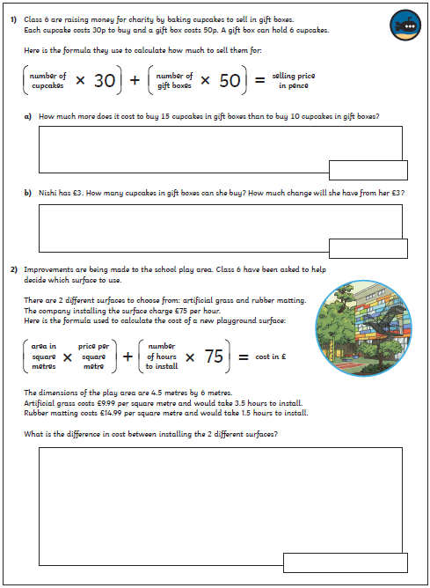
Maths Answers

