Ebony Regular

Week commencing 1/6/2020

Hey Everyone!

We hope you all had a good half term break and are staying healthy and happy.

In maths this week you will be using fractions to find the whole. For example: Find 2/5 of 25.

In order to calculate this, you must first divide the whole by the denominator, then multiply the quotient – the answer – by the numerator. This is your answer.

25 ÷ 5 = 5

5 x 2 = 10

2/5 of 25 is 10.

For reading, you will have sections of mock SATs papers, along with some questions that focus on 3 mark answers.

Don’t forget, if you need us we are still here for you – just email the Year 6 email address and we will respond as soon as we can!

Have a great week – you are all doing a super job!

Thursday 4th June 2020

Spellings

Use the words below in a sentence

*Challenge: can you use all of the words in just one sentence?*

*Or can you use all of the words in a cohesive paragraph, about just one topic?*

frequently

government

guarantee

harass

hindrance

Reading

**The Flames Come Closer**

*A baby impala is born on the African plains.  
                        A thunderstorm starts a fire some miles off.  
                   The smoke and flames are too far off to worry the  
                         impala doe, its mother … for the moment.*

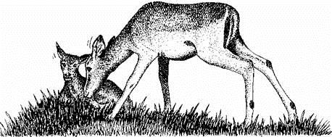

The new-born baby was struggling to stand, helped by his mother who nudged him with her soft muzzle. The baby rose, fell, rose again.

After ten minutes he was standing and trying to take his first feed. In that time the peace of the morning was going.

To the north there was a widening belt of smoke, in which the crimson of flames flickered. The bone dry grass was burning in a wall of fire which seemed to create its own wind. At more than a walking pace the wind blew the fire southwards.

Out of the grass, insects rose in their thousands and, within minutes, birds were congregating as if called to a free feast. They kept just ahead of the thickening smoke, gulping down the dazed insects as they fled before the fire.

The animals began to move south. The baboons were the first to take the alarm. With the old dog baboons barking furiously and nipping at the hindquarters of the stragglers, the families moved out of harm’s way, the babies clinging underneath their mothers, whimpering.

Zebra, impala, wildebeest, a pride of lions and two cheetahs, all headed away from the approaching flames. There was a vague smell of burning covering the whole landscape, even when the fire was still two miles away. Only those unable to run stayed to wait for the terror which would not stop until it came to bare ground, and there was nothing else to burn.

The impala doe was nervous, and when a family of wild dogs ran by without even giving her a second glance, it seemed to make her even more determined to move. She got her baby to feed and, when he had taken all he could and wanted to lie down and rest, she butted him gently to his feet again.

He tottered a dozen yards, then gave an excited little jump, only to topple and lie panting. His mother butted him gently again, encouraging him to stand. She ran a few yards away and her son bleated in terror. She came back and stood close, making coaxing sounds, and he struggled again to his feet. His mother turned and walked away, calling to him.

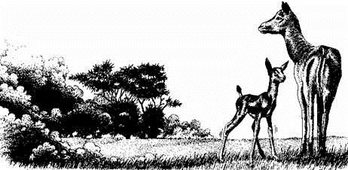

Bleating feebly, as if trying to tell his mother he was doing his very best, the new-born impala began to run. His spindly legs looked far too thin and shaky to support even a body as delicate as his. Yet he ran at least three yards before slipping into a wart hog hole.

For a moment the impala stared with widening eyes at the spot where her baby had been a moment before, then she bounded back. He was there, staring up with big brown eyes, and it was a minute or more before he tried to get out. He was still too young to be afraid.

The smell of burning was greater now. The impala doe knew the danger. At other times it had been easy enough to escape the approaching flames. She could leap thirty feet at a time ... but her baby could not even walk now.

It took several minutes to get him out of the hole, and then he stood on three legs. He had injured a back leg. It was not serious, but it meant he would have to walk slowly, with a limp.

There were no other animals about now. They were all moving south, just a little more quickly than the fire. They were in no real danger.

The impala mother and son moved at only half the speed of the advancing fire. Very soon she could hear the warning crackle as the flames ate up the dead grass, and even consumed shrubs and small trees.

They found themselves at a dried-up river bed. The baby impala, so tired now that his legs were trembling, rolled down the steep bank and lay too exhausted to get to his feet. Now there was thick smoke billowing overhead, and the crackling roar of the fire was terrifyingly loud.

The impala doe, eyes bulging with fear, leaped across the dry stream bed, and hesitated as if not quite sure whether to leap up the steep bank, and so go on to safety. The fawn watched her, and his anxious cries were drowned by the roar and crackle of the fire.

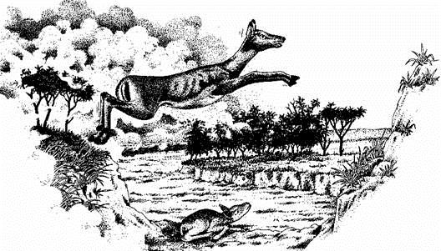

His mother came back to him in one beautiful bound. Above her, smoke and burning grass swept over the edge of the bank, forming a curtain which shut out the sky. The impala doe suddenly lay down, partly covering her baby.

The fire leaped across the dry river bed. It flared up on the other side. There were a few moments when the air was almost too hot to breathe, then the flames had gone; only smoke and ash remained. A welcome breath of air swept softly down the dried river bed, and the smoke swirled and eddied, then began to lift upwards. For the impala and her baby, the danger had passed.

1.      Look at the paragraph beginning ‘*To the north…*’.

Tick the correct option to complete the sentence below.

         The flames move quickly because of

|  |  |
| --- | --- |
|  | Tick **one.** |
| the animals. |  |
| the sun. |  |
| the wind. |  |
| the smoke. |  |

1 mark

2.      Look at page 2.

Underline **two** words in the paragraph below which describe the impala doe’s feelings:

|  |
| --- |
| *The impala doe was nervous, and when a family of wild dogs ran by without even giving her a second glance, it seemed to make her even more determined to move. She got her baby to feed and, when he had taken all he could and wanted to lie down and rest, she butted him gently to his feet again.* |

1 mark

3.      Here are some of the main events from the story.

Number them 1 to 5 to show the sequence of events.

The first one has been done for you.

|  |  |
| --- | --- |
| Impala doe lies down covering the baby impala. |  |
| Impala doe encourages baby impala to stand. |  |
| Baby impala rolls down bank of dried-up river bed. |  |
| Animals begin to flee from the approaching fire. |  |
| Baby impala falls down wart hog hole. |  |
|  |  |

2 marks

4.

Circle the correct option to complete the sentence below.

         The impala doe is in particular danger because

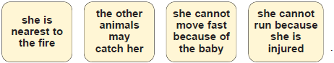

1 mark

5.      *Only those unable to run stayed to wait for* ***the terror*...**

(a)    What is *the terror*?

_______________________________

1 mark

(b)    Why do you think the writer used the word *terror*?

______________________________________________________________

______________________________________________________________

______________________________________________________________

1 mark

6.      *He was still too young to be afraid*

Explain what this means and why it is important to the story.

___________________________________________________________________

___________________________________________________________________

___________________________________________________________________

2 marks

7.      The impala doe *hesitated as if not quite sure whether to leap up the steep bank*...

         Explain fully what this shows about the impala doe’s actions and feelings at this point in the story.



3 marks

8.      *His mother came back to him in one* ***beautiful bound***

         Why has the word *beautiful* been used to describe the impala doe’s action?

___________________________________________________________________

___________________________________________________________________

2 marks

9.      Look at the last paragraph.

**Find** and **copy** a phrase which tells you that the impala doe and her baby were safe.

___________________________________________________________________

1 mark

10.    Look at the first three paragraphs starting from

*Out of the grass...*

How does the sense of fear build up as the fire approaches?

Give **three** points

**1.** _________________________________________________________________

___________________________________________________________________

**2.** _________________________________________________________________

___________________________________________________________________

**3.** _________________________________________________________________

___________________________________________________________________

3 marks





PE

Complete the animal workouts below. Complete each movement for 45 seconds, and rest for 15 seconds in-between each movement.

Once you are finished, can you create three more animal workouts you could add to the list?

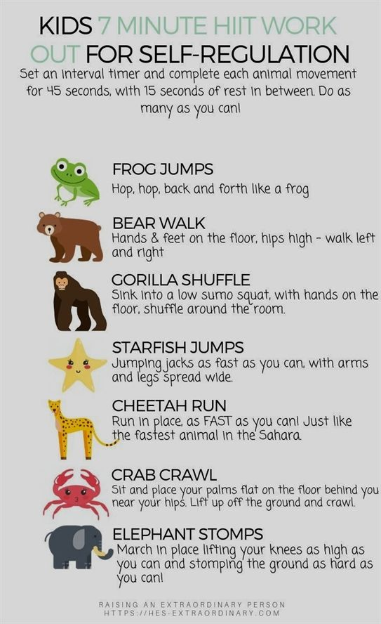

Mark schemes

1.**** .

**1 mark**

2.       Award **1 mark** for both (*was*) *nervous and* (*even more*) *determined* underlined and no others.

**1 mark**

3.       Award **2 marks** for all 4 statements correctly numbered and **1 mark** for 2 or 3 correctly numbered.

|  |  |
| --- | --- |
| Impala doe lies down covering the baby impala. |  |
| Impala doe encourages baby impala to stand. |  |
| Baby impala rolls down bank of dried-up river bed. |  |
| Animals begin to flee from the approaching fire. |  |
| Baby impala falls down wart hog hole. |  |

**up to 2 marks**

4.       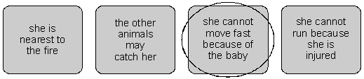

**1 mark**

5.      (a)     Award **1 mark** for reference to fire / flames.

**1 mark**

(b)     Award **1 mark** for responses which recognise the threat implied by the word terror, eg:

*•        ‘the terror’ seems more dramatic than ‘the fire’ or ‘the flames’,*

*•        ‘terror’ makes you think that something really bad is going to happen;*

*•        it’s making it sound very frightening and it may harm them;*

*•        because terror describes horror and means scary.*

          Also, award **1 mark** for answers which explain that the writer is suggesting an instinctive reaction on the part of the animals / taking the animals’ point of view, eg:

*•        because it is a terror to the animals;*

*•        it shows that they didn’t know what it was but they just ran anyway;*

*•        the word terror means worried and frightened and that’s what the animals were when there was a fire;*

*•        they don’t know what fire is, all they know is that it causes terror.*

**Do not accept:**

–       very general responses, eg: because the fire was a danger / to create  
suspense and make you read on;

–       responses based on the word ‘terror’, eg: *because fire is terrifying*;

–       imprecise explanations, eg: *terror means horrified.*

**1 mark**

6.       Award **1** **mark** for answers which explain that the baby impala did not know what was happening / about the danger associated with fire because he was so young.

Award **1** **mark** for recognition, which may be implicit, that the baby’s lack of fear meant that escape was harder for the impala doe, eg:

*•        this means he didn’t really understand. (*1 mark*)*

*•        he is**a baby and doesn’t know about danger. It is important because if he knew what was going to happen he wouldn’t just lie there. (*2 marks*)*

*•        it means he doesn’t know what fear is and what fire is so if he doesn’t know why would he be afraid? It is important because he slows his mother down and that is one of the points of the story. (*2 marks*)*

**up to 2 marks**

7.       Award **1 mark** for answers which recognise that the hesitation indicates that the doe has a dilemma, eg:

*•        she was thinking about what to do;*

*•        she wants to live but is scared.*

Award **2 marks** for answers which explain the situation faced by the doe of whether to escape to safety or to return to the fawn, eg:

*•        she didn’t know whether to rescue her baby or to escape herself.*

Award **3 marks** for answers which explain the situation faced by the doe and also include the sense of the doe’s terrible dilemma, eg:

*•        she felt very nervous because she didn’t know whether to leave the little baby to die or to stay with him;*

*•        the impala doe was so scared about the fire she was contemplating leaving her newborn baby and going on to save her own life;*

*•        she wasn’t sure whether she should go on running, leaving the baby behind and almost securing her own safety or whether she should shield the baby impala from the flames. She must have been very scared because she was staring death in the face.*

**up to 3 marks**

8.       Award **1 mark** for responses which focus on the doe’s agility, eg:

*•        the doe was very graceful;*

*•        it was a spectacular leap;*

*•        the leap was magnificent.*

Award **2 marks** for responses which recognise the effectiveness of *beautiful* in acknowledging the doe’s selflessness in returning to the fawn, eg:

*•        the doe was returning to save the baby impala;*

*•        she was risking her life for the baby;*

*•        it shows she cared;*

*•        because the action she took was beautiful. She chose to try and save her baby’s life.*

**up to 2 marks**

9.       Award **1 mark** for any one of:

–     (*the*) *danger had passed;*

–(*the*) *flames had gone;*

–(*a*) *welcome breath of air.*

**1 mark**

10.     Award **1** **mark** for any of the following points, to a maximum of **3** **marks:**

–     gradual involvement of more and larger creatures as the fire gets nearer;

–     how the animals sense the approaching fire or are unable to move away;

–     how the actions of the animals show fear, such as whimpering, nipping, barking;

–     suggestion of haste / rush, such as animals fleeing;

–     predators ignoring their prey;

–     aspects of the fire such as thickening smoke, approaching flames, vague smell of burning;

–     use of specific vocabulary such as *fled, alarm, approaching flames****,*** *furiously.*

Eg:

*•        by saying that the animals are fleeing in their hundreds and thousands;* (1 mark)

*•        it says the smoke came out of nowhere from the north;* (1 mark)

*•        the way everything is calm then the animals are barking and running, whimpering. It is very noisy and how everything just rushes and the impala doe is left alone nervously with her baby;* (2 marks)

*•        all the animals were running away trying to go from the danger. There was also a smell**of burning so that meant the fire was coming closer. The fire was two miles away so it was burning a lot of things;* (2 marks)

*•        he starts with the insects and small animals and then a whole lot of animals come running out but the impala doe and her baby are just stuck there while the fire comes nearer and nearer;* (3 marks)

*•        he builds it up as at first, only the little creatures start to flee. Then the bigger ones. Finally, all the predators and large animals start to flee. He also includes smells, sights and sounds, and adds feelings of terror, such as ‘There was a vague smell of burning covering the whole landscape’ and ‘only those unable to run stayed to wait for the terror’.* (3 marks)

**Do not accept** quotations without any interpretation.

**up to 3 marks**



