Week commencing 29/06/2020

Hey Everyone!

We hope you all staying healthy and happy and managing to still have some fun at home.

In maths this week you will carryon with algebra

For reading, you will have sections of mock SATs papers, along with some questions that focus on 3 mark answers.

Don’t forget, if you need us we are still here for you – just email the Year 6 email address and we will respond as soon as we can!

Have a great week – you are all doing a super job! Keep it up!

Thursday 2nd July 2020

Spellings

Use the words below in a sentence

Challenge: can you use all of the words in just one sentence?
Or can you use all of the words in a cohesive paragraph, about just one topic?

- equipped
- equipment
- especially
- exaggerate
- excellent

Reading

Weird but wonderful...

The Octopus

An amazing body
Octopuses are boneless animals and because of this, their bodies are extremely flexible, allowing them to squeeze through small spaces.
To swim, an octopus squirts jets of water through a tube called a siphon. The force of these jets is powerful enough to move the octopus quickly through the water.
The octopus travels backwards with its eight tentacles trailing behind it. These tentacles have suction cups, or suckers, with sensors that enable them to ‘taste’ whatever they touch.

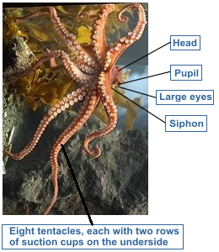

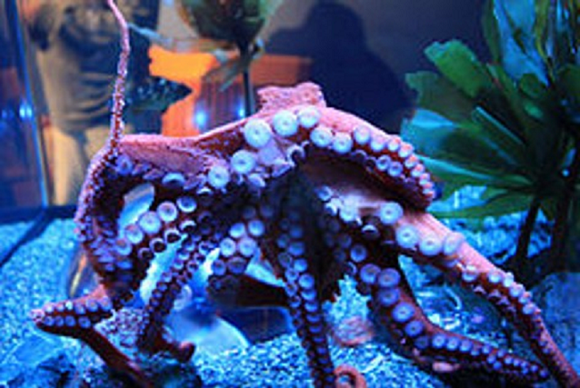

Octopuses have the largest brains of any invertebrate (an animal that does not have a backbone). They can learn and invent solutions to problems. Captive octopuses have been observed to play, repeatedly releasing bottles or toys into a circular current in their tanks and then catching them again. Octopuses often escape from their tanks in search of food and sometimes even break into the tanks of other creatures. They have also been known to board fishing boats and open the cargo hold to eat crabs.
The way the octopus’s nervous system is organised means that only part of it is in the brain. The majority of an octopus’s nerve cells are actually in its tentacles. This has some curious results: when an octopus’s tentacle is cut off, it will crawl away on its own. But that’s not all. If this tentacle meets a food item, it will seize it and try to pass it to where the mouth would have been if it was still connected to the body.

Part of body | How many | What it does | Weird but wonderful
Tentacle | 8 | Catches and chokes prey | The underside of each tentacle is covered in 240 suckers. That means an octopus has a total of 1,920 suckers.
Heart | 3 | Pumps blood | The blood that each heart pumps is blue.
Eye | 2 | Sees pray and predators, even in low light | The pupils remain horizontal even if the octopus turns on its side or upside down.

Defence and attack
Octopuses have a number of different ways to defend themselves.
They have a well-developed ability to hide. For example, the common octopus is able to camouflage itself by changing its skin to match the colours, patterns and even textures of its surroundings. Predators such as sharks, eels and dolphins swim by without even noticing it.
When an octopus is discovered, it releases a cloud of black ink. This blocks the predator’s view, giving the octopus time to escape. The ink also contains a substance that can reduce the predator’s ability to smell, making the fleeing octopus even harder to track.
If necessary, an octopus can squeeze into tiny cracks and crevices where predators can’t reach it. If all else fails, an octopus can lose a tentacle to escape a predator’s grasp and re-grow it later.

Invertebrate - imitators
An octopus in a German zoo learned to open jars of shrimps by copying zoo staff. The octopus, named Frida, opened the jars by pressing her whole body onto the lid and grasping the sides with her eight tentacles. She unscrewed the lid by repeatedly twisting her body. It took Frida anything from ten seconds to an hour to get a lid off, depending on how tightly it had been screwed on.

Octopus facts

Type of animal
Invertebrate (no backbone)

Diet
Carnivore: crabs, crayfish, shellfish

Average lifespan in the wild
1 to 3 years

Largest octopus
Giant Pacific Octopus Weighs up to 70kg (close to the weight of an average person) Measures 7.5m from tentacle tip to tentacle tip

Smallest octopus
Octopus Wolfi Can be as light as 1g (the weight of 1 raisin) Measures 1.5cm in length

Venom
The tiny Blue-ringed Octopus of Australia is the only octopus that has venom deadly to humans.

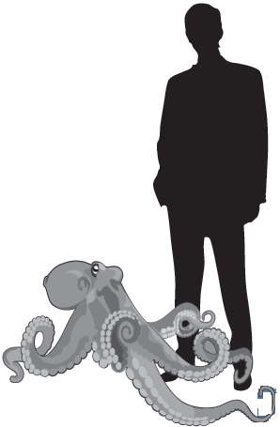 Size of a common octopus relative to an average man
Questions

1. What allows octopuses to be extremely flexible?

______________________________________________________________

1 mark

2. 1. Which body part does an octopus use to move through the water?

_________________________________________________________

1 mark

2. How does this body part help it to move?

_________________________________________________________

_________________________________________________________

1 mark

3. Where is most of an octopus’s nervous system located?

______________________________________________________________

1 mark

4. The table on page 2 contains information that is weird but wonderful about octopuses’ tentacles:

Part of  body | How  many | What it does | Weird but wonderful
Tentacle | 8 | Catches and chokes prey | The underside of each tentacle is covered in 240 suckers. That means an octopus has a total of 1,920 suckers.

Give two other pieces of information about octopuses’ tentacles that could have been included in this table.

1. ____________________________________________________________

2. ____________________________________________________________

2 marks

5. Look at the paragraph beginning: The way the octopus's nervous system...

Give the meaning of the word majority, in the second sentence.

______________________________________

1 mark

6. How does releasing black ink help the octopus to escape from predators?
Give two ways.

1. ____________________________________________________________

2. ____________________________________________________________

2 marks

7. Look at the section headed: Defence and attack.

Octopuses can squeeze into small spaces. How does this protect them?

______________________________________________________________

______________________________________________________________

1 mark

8. Octopuses are very determined.

Give two examples from the text that support this.

1. ____________________________________________________________

______________________________________________________________

2. ____________________________________________________________

______________________________________________________________

2 marks

9. What is special about Octopus Wolfi?

______________________________________________________________

1 mark

10. Which octopus produces a poison that can kill people?

______________________________________________________________

1 mark

11. 1. What creatures do octopuses eat?

_________________________________________________________

1 mark

2. What creatures eat octopuses?

_________________________________________________________

1 mark

12. Draw a line to match the heading with the information that is provided in each text box of Weird but wonderful... The Octopus.

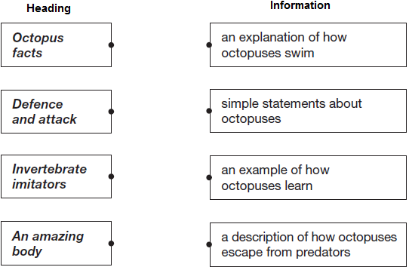

1 mark

13. Look at the section headed: Octopus Facts.
Find and copy one word that tells you an octopus eats the flesh of other animals.

_____________________________________

1 mark

Mark scheme

1 Award 1 mark for answers that refer to octopuses having no bones, eg:

• boneless

• they have no bones.

Also accept they are invertebrates / they have no backbone.

Do not accept synonyms for flexible, eg:

• they are squishy / bendy.

1 mark

2 1. Award 1 mark for answers that refer to the siphon.

1 mark

2. Award 1 mark for answers that refer to water being squirted / blown / pushed water through the siphon (force of the water), eg:

• it blows water through it

• squirting jets of water through the siphon.

Do not accept answers referring to the release of water with no reference to force, eg:

• water comes out through the siphon.

1 mark

3 Award 1 mark for:

• tentacles.

Do not accept: brain

1 mark

4 Award 1 mark for answers that refer to any of the following up to a maximum of 2 marks:

1. when detached, it can move / function / feed an imaginary mouth

• If it is cut off, it can still move

• It tries to feed itself when detached

2. can (lose and) regrow / lose if necessary

• They can lose a tentacle and re-grow it later

3. has ability to ‘taste’

• It can taste from its tentacles

4. contains the majority of its nerve cells

• Most of its nerves are in the tentacles.

Do not accept any details already included in the table, eg:

• It has 8 tentacles

• 240 suckers.

Up to 2 marks

5 Most of, more than half.

1 mark

6 Award 1 mark for referring to any of the following up to a maximum of 2 marks:

1. the predator can’t see the octopus / the ink blocks the predator’s view

2. the predator can’t smell the octopus / the ink reduces the predator’s ability to smell.

3. gives them longer to escape

4. makes them harder to track.

Up to 2 marks

7 Award 1 mark for responses which identify that predators can’t reach them (may be implied), eg:

• Other animals cannot reach into the tiny spaces to get them

• predators are too big to get at them.

Do not accept references to hiding without further development.

1 mark

8 Award 1 mark for any of the following up to a maximum of 2 marks:

1. they can break out of / into tanks / board fishing boats / open cargo holds (to get food)

• they break into other tanks to get food

• they break out of their own tanks and into other ones to find food

2. (it took Frida) anything up to an hour to open the jar

• the German octopus wouldn’t stop until the jar was open

• Frida didn’t give up until she’d opened the jar

• Frida tried to open the jar for a whole hour

3. they will lose a tentacle in order to escape a predator

• if they are being chased by a predator, they will even lose a tentacle to escape.

Up to 2 marks

9 Award 1 mark for any of the following:

1. it is the smallest octopus

2. it only weighs 1 g / It is only 1.5 cm long

3. it weighs the same as a raisin.

1 mark

10 Award 1 mark for answers that identify the Blue-ringed Octopus.

1 mark

11 1. Award 1 mark for any of the following:

1. crabs

2. crayfish

3. shellfish

4. shrimps.

1 mark

2. Award 1 mark for any of the following:

1. sharks

2. eels

3. dolphins.

Do not accept creatures not mentioned in the text.

1 mark

12 Award 1 mark for all boxes correctly matched.

Heading Information

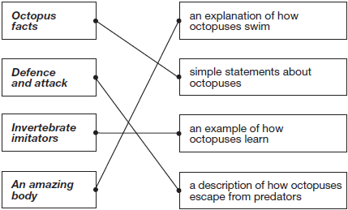

1 mark

13 Award 1 mark for: carnivore.

1 mark

Thursday Maths

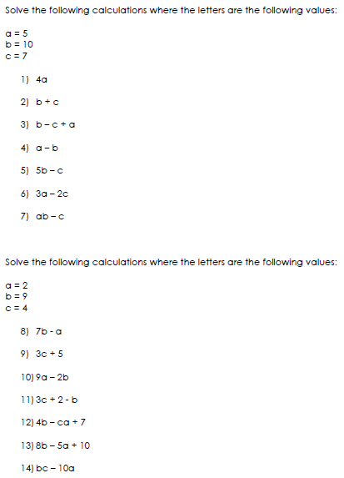
Maths Answers

