Week commencing 22/06/2020

Hey Everyone!

We hope you all had a good half term break and are staying healthy and happy.

In maths this week you will be practising forming expressions in algebra.

For reading, you will have sections of mock SATs papers, along with some questions that focus on 3 mark answers.

Your topic work is in a separate pack this week for you to work through at your own pace.

Don’t forget, if you need us we are still here for you – just email the Year 6 email address and we will respond as soon as we can!

Have a great week – you are all doing a super job! Keep it up!

Thursday 25th June 2020

Spellings

Use the words below in a sentence

Challenge: can you use all of the words in just one sentence?
Or can you use all of the words in a cohesive paragraph, about just one topic?

1. correspond
2. criticise
3. curiosity
4. definite
5. desperate

Reading

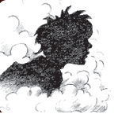 | Charlie Small  Charlie Small is a young boy who has had lots of amazing adventures.

Meet Charlie Small!
When Charlie Small was eight years old he just popped out to go exploring and something strange happened to him. Since then he has never got any older
(he is still eight years old!) but he has had lots of different adventures, helped
by his friend, the inventor Jakeman.
We recently caught up with Charlie and asked him some questions.
Tell us about some of your adventures.
I’ve travelled in space, been King of Gorillas, joined a gang of cut-throat pirates
and lots more.
What was your most exciting adventure?
The Mummy’s Tomb, when I got chased by a smoke demon.
What are your favourite pastimes?
Riding my hover-scooter, swinging through trees and battling
to defeat my arch enemy Joseph Craik.

What other languages can you speak,  apart from Gorilla?  I can speak a little bit of Mole. I can understand the howls of Braemar the White Wolf and I can speak Chimp too.  When will you return home?  I am still trying to get back home, but until I do,  I’m going to keep a diary for each of my adventures. Meanwhile, mum is still expecting me back for tea... | 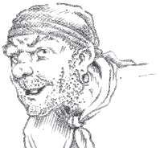  Joseph Craik

This is the opening of one of Charlie Small’s diaries.

Chapter 1

A Rude Awakening

I was driving across a wide plain on the Air-rider, a hover-scooter specially designed for me by my pal, Jakeman. He’s an incredible inventor whose marvellous machines have helped me loads on my adventures.

I hovered a few centimetres from the ground and skimmed along at thirty kilometres an hour. The long grass rippled and the hot sun beat down, making the air shimmer and my eyes ache. In danger of getting heatstroke, I needed to get out of the sun.

To my left, the ground rose forming a series of cone-shaped hills, covered with patchy woodland. Opening the scooter’s throttle, I zoomed towards the trees, and parked in their cool shade.

Suddenly, as I stepped from my scooter, a large flower sprang up towards me. Its bright purple, rubbery petals opened like a fan and sprayed powdery mist into my face. I coughed and spluttered as more flowers rose up, filling the air with strong perfume. I tried to weave my way through them but my head began to spin. My eyes closed and I gave a jaw-shaking yawn. I felt I must lie down. I had to sleep.

Gradually, I became aware of a hand on my collar. I was lifted up, put under a rough arm and carried into the trees. The next thing I knew, a shower of icy-cold water splashed my face and a leathery hand gently slapped my cheeks.

“Wake up, Charlie,” said a deep voice.

Opening my eyes, I looked into the face of an adult male gorilla. His great head and short, thick neck stood on massive shoulders, with arms as thick as my waist, and covered in coarse black hair.

Mark Scheme

1. Look at Meet Charlie Small!

Find and copy the information from the text to complete the fact file below about Charlie Small.

Name | Charlie Small
Age
Friend
Worst enemy
Most exciting adventure

2 marks

2. How does Charlie keep a record of his adventures?

______________________________________________________________

1 mark

3. Look at the paragraph beginning: I was driving across…

Find and copy two words that show how much Charlie admires Jakeman.

1. _______________________________

2. _______________________________

1 mark

4. Look at the paragraph beginning: I hovered a few centimetres…

What effect did the heat have on Charlie?

______________________________________________________________

1 mark

5. Look at the paragraph beginning: To my left, the ground...

Give the meaning of the word zoomed in this sentence.

______________________________________________________________

______________________________________________________________

1 mark

6. Where does Charlie leave his scooter?

______________________________________________________________

1 mark

7. Look at the paragraph beginning: Suddenly, as I stepped…

How does the text make the flowers seem dangerous?

Give two ways.

1. ____________________________________________________________

______________________________________________________________

2. ____________________________________________________________

______________________________________________________________

2 marks

8. Look at A Rude Awakening.

Number the following (1-5) to show the order in which they happen in the story.

The first one has been done for you.

A gorilla carries Charlie into the trees.
A gorilla stands looking down at Charlie.
Flowers spring up, spraying a mist.
Charlie feels extremely tired.
Charlie drives across a wide plain.

1 mark

9. Read from the paragraph beginning: “Wake up, Charlie...” to the end of
the story.

How does this ending create suspense?

______________________________________________________________

______________________________________________________________

______________________________________________________________

1 mark

10. Look at Meet Charlie Small! and A Rude Awakening.

How do the texts suggest that Charlie has met gorillas in his
past adventures?

Give two ways.

1. ____________________________________________________________

2. ____________________________________________________________

2 marks

1. Award 2 marks for four correct.

Award 1 mark for two or three correct.

Name | Charlie Small
Age | (he is still) eight / 8 (years old)
Friend | (the inventor) Jakeman
Worst enemy | (my arch enemy) Joseph (Craik)  (my arch enemy Joseph) Craik
Most exciting adventure | (The) Mummy’s Tomb (when I got  chased by a smoke demon)  (when I got) chased by a smoke

up to 2 marks

2. Award 1 mark for:

■ (he writes / keeps a) diary.

Also accept: journal

1 mark

3. Award 1 mark for both:

1. incredible (inventor)

2. marvellous (machines).

Also accept (my) pal.

1 mark

4. Award 1 mark for answers that recognise any of the following:

1. his eyes ached, eg:

• it made his eyes hurt.

2. he was in danger of heatstroke / sunstroke, eg:

• he was getting heatstroke.

3. he needed to get out of the sun, eg:

• he wanted to get out of the sun.

Do not accept simple references to Charlie getting / feeling hot.

1 mark

5. Award 1 mark for reference to speed, eg:

• that he was going quickly

• things that zoom go fast.

Do not accept answers that refer to travelling directly / getting closer to the trees, eg:

• he went straight there.

1 mark

6. Award 1 mark for reference to him parking it:

1. (in the) woodland / trees, eg:

• in the woods

• next to some trees.

2. under / beside a tree, eg:

• under the branches of a tree.

3. (in the cool) shade, eg:

• in a shady place.

1 mark

7. Award 1 mark for reference to each of the following, up to a maximum of 2 marks:

1. the sudden appearance / opening of the flowers, eg:

• they pop out at your face

• the way the flowers sprang out of the ground very suddenly.

2. the flowers spraying (Charlie), eg:

• they sprayed powdery mist into his face

• they kept squirting that mist.

3. the unpleasant effect the flowers had on Charlie, eg:

• they made him cough and splutter

• it made him pass out.

4. the unusual appearance of the flowers, eg:

• they looked strange

• the purple rubbery petals looked weird.

5. the flowers surrounding him, eg:

• they were crowded round him

• they surrounded him.

Accept relevant responses in the first person, or quotations that meet one acceptable point, eg:

• a large flower sprang up towards me.

Also accept general responses about the flowers attacking Charlie / Charlie trying to get away from the flowers.

up to 2 marks

8. Award 1 mark for:

A gorilla carries Charlie into the trees.
A gorilla stands looking down at Charlie.
Flowers spring up, spraying a mist. | 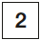
Charlie feels extremely tired. | 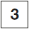
Charlie drives across a wide plain. | 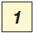

1 mark

9. Award 1 mark for responses which recognise that we are left with questions about: the gorilla / what the gorilla might do / how Charlie will react to the gorilla, eg:

• the gorilla suddenly arrives but we don’t know who he is

• we want to know how he knows Charlie’s name

• we are left wondering why the gorilla has rescued Charlie

• we don’t know if Charlie will be safe with him.

Also accept answers referring to not knowing who is waking Charlie up, eg:

• It says ‘a deep voice’ and you don’t know who that is.

Do not accept general answers about endings, eg:

• it’s a cliff-hanger

• we want to know what’s going to happen.

1 mark

10. Award 1 mark for reference to each of the following, up to a maximum of 2 marks:

1. Charlie has been King of Gorillas, eg:

• he was the Gorilla king.

2. Charlie speaks / understands Gorilla, eg:

• it says he can speak Gorilla

• you can’t speak Gorilla without meeting one.

3. The gorilla seems to know him / knows his name, eg:

• the gorilla knows what he is called

• the Gorilla says “Wake up Charlie”.

4. Charlie’s apparent lack of surprise / fear (at being woken up by a gorilla), eg:

• the way Charlie describes the gorilla is really calm

• he’s not afraid of it.

up to 2 marks

Maths

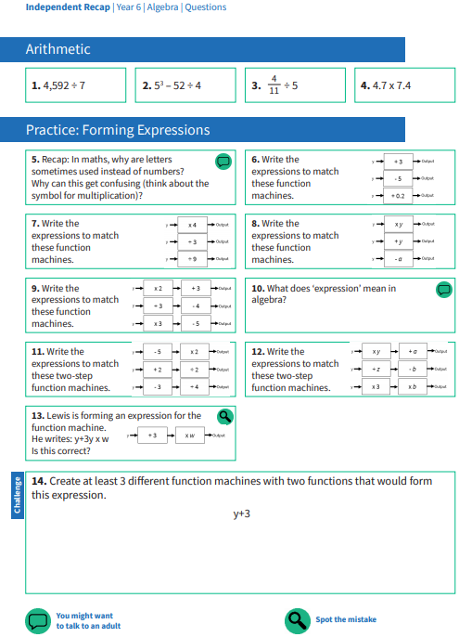
Use this page to record your working out and your answers

Maths answers