Week commencing 15/06/2020

Hey Everyone!

We hope you all had a good half term break and are staying healthy and happy.

In Maths this week you will continue working on algebra.

For reading, you will have sections of mock SATs papers, along with some questions that focus on 3 mark answers.

There is also some PSHE and PE for you to do this week.

Don’t forget, if you need us we are still here for you – just email the Year 6 email address and we will respond as soon as we can!

Have a great week – you are all doing a super job!

Thursday 18th June 2020

Spellings

Use the words below in a sentence

Challenge: can you use all of the words in just one sentence?
Or can you use all of the words in a cohesive paragraph, about just one topic?

1. category
2. cemetery
3. committee
4. communicate
5. community

Reading

Wild Ride

This story takes place in a huge grassland area in southern Africa. The grasslands there are called 'savannah'.

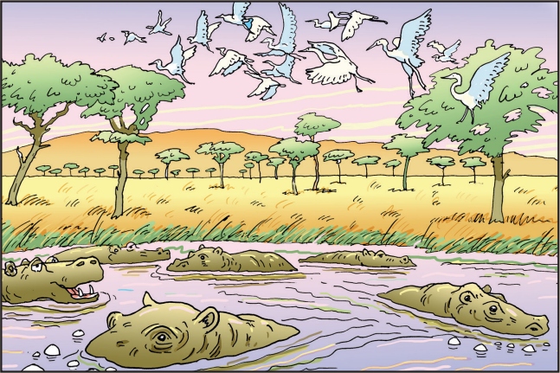

Dawn was casting spun-gold threads across a rosy sky over Sawubona Game Reserve as Martine Allen took a last look around to ensure there weren't any witnesses. She leaned forward like a jockey on the track, wound her fingers through a silver mane, and cried, 'Go, Jemmy, go.'

The white giraffe sprang forward so suddenly that she was almost unseated, but she recovered and, wrapping her arms around his neck, quickly adjusted to the familiar rhythm of Jemmy's rocking-horse stride. They swept past the dam and a herd of bubble-blowing hippos, past a flock of startled egrets lifting from the trees like white glitter, and out onto the open savannah plain. An early morning African chorus of doves, crickets and go-away birds provided a soundtrack.

For a long time Martine had only ever ridden Jemmy at night and in secret, but when her grandmother had found out about their nocturnal adventures she'd promptly banned them, on the grounds that the game reserve's deadliest animals were all in search of dinner after dark and there was nothing they'd like more than to feast on a giraffe-riding eleven-year-old. For a while Martine had defied her, but after several close calls and one terrible row with her grandmother, she had come to accept that the old lady was right. When lions were on the hunt, the game reserve was best avoided.

Another of her grandmother's rules was that Martine ride sedately at all times. 'No faster than a trot and, in fact, I'd rather you stuck to a walk,' she'd counselled sternly.

Martine had paid almost no attention. The way she saw it, Jemmy was a wild animal and it was only fair that he should have the freedom to do what came naturally, and if that meant tearing across the savannah at a giraffe's top speed of thirty-five kilometres per hour, well, there wasn't a lot she could do about it. It wasn't as if she had reins to stop him. Besides, what was the point of riding a giraffe if the most he was permitted to do was plod along like some arthritic pony from the local stables?

Jemmy clearly agreed. They flew across the grassy plain with the spring breeze singing in Martine's ears. 'Faster, Jemmy!' she yelled. 'Run for your life.' And she laughed out loud at the heart-pounding thrill of it, of racing a wild giraffe.

A streak of grey cut across her vision, accompanied by a furious, nasal squeal: 'Mmwheeeh!'. Jemmy swerved. In the instant before her body parted company with the white giraffe's, Martine caught a glimpse of a warthog charging from its burrow, yellow tusks thrust forward. Had her arms not been wrapped so tightly around the giraffe's neck, she would have crashed ten feet to the ground. As it was, she just sort of swung under his chest like a human necklace. There she dangled while Jemmy pranced skittishly and the warthog, intent on defending her young, let out enraged squeals from below. Five baby warthogs milled around in bewilderment, spindly tails pointing heavenwards. | 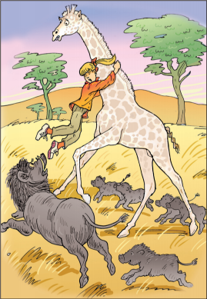

The pain in Martine's arms was nearly unbearable, but she didn't let go. She adored warthogs – warts, rough skin, ugly ears and all – but their Hollywood movie star eyelashes didn't fool her. In a blink of those lashes, their tusks could reduce her limbs to bloody ribbons.

'Jemmy,' she said through gritted teeth, 'walk on. Good boy.'

Confused, the white giraffe started to lower his neck as he backed away from the warthog.

'No, Jemmy!' shrieked Martine as the warthog nipped at the toe of one of her boots. 'Walk! Walk on!'

Jemmy snatched his head up to evade the warthog's sharp tusks, and Martine was able to use the momentum to hook her legs around his neck. From there, she was able to haul herself onto his back and urge him into a sprint. Soon the warthog family was a grey blur in the distance, although the mother's grunts of triumph took longer to fade.

Martine rode the rest of the way home at a gentle walk, a thoughtful smile on her lips. That would teach her to show off – even if it was only to an audience of hippos. At the game reserve gate, Jemmy dipped his head and Martine slid down his silvery neck as though she was shooting down a waterslide. That, too, wasn't the safest way of dismounting, but it was fun. She gave the white giraffe a parting hug, and strolled through the mango trees to the thatched house.

1. Circle the correct option to complete each sentence below.

(a) The text begins with Martine going out to ride her giraffe...

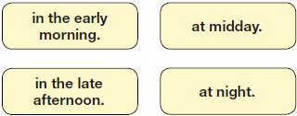

1 mark

(b) Martine rode her giraffe...

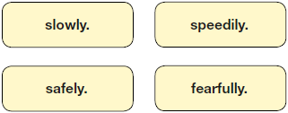

1 mark

(c) Everything was fine on that day until...

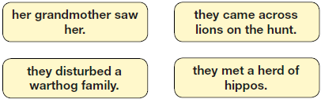

1 mark

(d) At the end of the text, Martine...

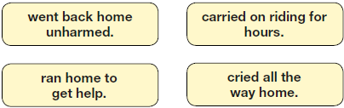

1 mark

2. Look at the first paragraph, beginning: Dawn was casting...

How do you know that Martine wanted to keep this ride a secret?

______________________________________________________________

______________________________________________________________

1 mark

3. What were Martine’s grandmother’s rules about riding the giraffe?

Tick two.
Ride only in daylight.
Don’t show off.
Stay in the game reserve.
Keep to a slow speed.
No jumping.

1 mark

4. (a) What evidence is there of Martine being stubborn in the way she behaved with her grandmother?

Give two points.

1. _______________________________________________________

_________________________________________________________

2. _______________________________________________________

_________________________________________________________

2 marks

(b) What evidence is there of Martine being determined when she met the warthogs?

_________________________________________________________

_________________________________________________________

1 mark

5. ...milled around in bewilderment (page 3)

Explain what this description suggests about the baby warthogs.

______________________________________________________________

______________________________________________________________

______________________________________________________________

2 marks

6. What evidence in the text is there that warthogs can be dangerous?

Give two examples.

1. ____________________________________________________________

2. ____________________________________________________________

2 marks

7. What helped Martine to get safely on Jemmy’s back after the warthog’s attack?

______________________________________________________________

______________________________________________________________

1 mark

8. The warthog mother made grunts of triumph (page 3)

Why was she triumphant?

______________________________________________________________

______________________________________________________________

1 mark

9. Do you think that Martine will change her behaviour on future giraffe rides?

Tick one.
yes
no
maybe

Explain your choice fully, using evidence from the text.

3 marks

10. In what ways might Martine’s character appeal to many readers?

Explain fully, referring to the text in your answer.

3 marks

11. Draw lines to match each part of the story with the correct quotation from the text.

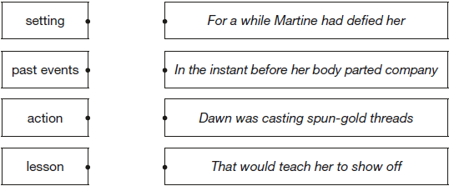

1 mark

1. (a) Content domain: 2a – give / explain the meaning of words in context

Award 1 mark for:

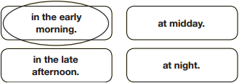

1 mark

(b) Content domain: 2b – retrieve and record information / identify key details from fiction and non-fiction

Award 1 mark for:

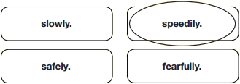

1 mark

(c) Content domain: 2b – retrieve and record information / identify key details from fiction and non-fiction

Award 1 mark for:

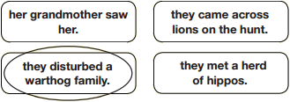

1 mark

(d) Content domain: 2b – retrieve and record information / identify key details from fiction and non-fiction

Award 1 mark for:

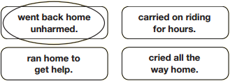

1 mark

2. Content domain: 2d – make inferences from the text / explain and justify inferences with evidence from the text

Award 1 mark for reference to Martine checking for / not wanting witnesses, e.g.

• she checked that no one saw what she was doing

• it says she looks around for witnesses which shows she doesn’t want anyone to know.

Also accept the quotation: (Martine Allen took a last look around to) ensure there weren’t any witnesses.

Also accept references to Martine riding at dawn, e.g.

• she was doing it very early in the morning.

1 mark

3. Content domain: 2b – retrieve and record information / identify key details from fiction and non-fiction

Award 1 mark for both correct:

Ride only in daylight.
Don’t show off.
Stay in the game reserve.
Keep to a slow speed.
No jumping.

1 mark

4. (a) Content domain: 2d – make inferences from the text / explain and justify inferences with evidence from the text

Award 1 mark for reference to each of the following up to a maximum of 2 marks:

1. defies her / pays no attention to her rules, e.g.

• she pays no attention to her grandmother’s instructions

• she went faster than her grandma wanted her to.

2. she argues with her grandmother, e.g.

• she had a row with her.

Up to 2 marks

(b) Content domain: 2d – make inferences from the text / explain and justify inferences with evidence from the text

Award 1 mark for reference to Martine refusing to let go of the giraffe / her determination to get back on the giraffe, e.g.

• she kept hold of the giraffe’s neck

• she manages to haul herself back on to the giraffe’s back.

Also accept recognition that Martine keeps telling the giraffe to move away, e.g.

• she kept telling Jemmy to walk on so that they can escape

• she carries on telling Jemmy to keep going.

Do not accept references to gritted teeth.

1 mark

5. Content domain: 2d – make inferences from the text / explain and justify inferences with evidence from the text

Award 2 marks for responses that explain both the baby warthogs’ aimless / random movement and their confusion, e.g.

• they had no idea what was happening and just walked around with no purpose

• they wandered around slowly in curiosity, they were confused and wondered what was going on.

Award 1 mark for responses that explain either the baby warthogs’ aimless / random movement or their confusion, e.g.

• they just roamed around

• they didn’t know what was going on.

Up to 2 marks

6. Content domain: 2d – make inferences from the text / explain and justify inferences with evidence from the text

Award 1 mark for reference to any of the following, up to a maximum of 2 marks:

1. it charges / its tusks are thrust forward

2. it has sharp tusks / it could tear her to pieces

3. it tries to bite her

4. the giraffe seems frightened / backs away

5. Martine not wanting to let go.

Also accept references to the mother warthog protecting her young, e.g.

• they’ll defend their babies.

Also accept references to the warthog being fast.

Accept quotations that meet an acceptable point.

Do not accept references to angry noises.

Up to 2 marks

7. Content domain: 2b – retrieve and record information / identify key details from fiction and non-fiction

Award 1 mark for reference to either of the following:

1. Jemmy lifting his head

2. momentum.

Also accept hooking her legs around his neck.

1 mark

8. Content domain: 2d – make inferences from the text / explain and justify inferences with evidence from the text

Award 1 mark for reference to either of the following:

1. she had chased away the intruders / the intruders had left, e.g.

• she thought she had successfully chased them off

• she had frightened the girl away

• they had gone away.

2. she had protected her young / territory, e.g.

• she thought she had saved her babies from them

• she had defended her young and got Jemmy out of her territory.

Do not accept general answers relating to triumph, e.g.

• she got what she wanted

• she won.

1 mark

9. Content domain: 2e – predict what might happen from details stated and implied

Acceptable points (yes):

1. she had started to listen to / obey her grandmother

2. she got a fright / found herself in danger

3. she had learnt from the experience.

Acceptable points (no):

4. she has been in danger before and not been hurt / got away with it

5. she is stubborn / defiant / does not listen to others

6. she had fun / she is adventurous / she is thrill-seeking.

Award 3 marks for three acceptable points or two acceptable points with at least one supported with evidence, e.g.

• because it says Martine rode the rest of the way home at a gentle walk. This explains that Martine had learnt her lesson and she won’t go fast again. But then she has got into trouble before and didn’t change [evidence + AP3, AP4]

• even though she has just had a scare with the warthogs she has got through it unharmed and she may think she can do anything. However, because of this experience she may feel that that ride could have got her hurt and decided to play it safe [AP2, AP4, AP3].

Award 2 marks for two acceptable points or one acceptable point supported with evidence, e.g.

• no because she seems very determined to have her own way like when she ignores her grandma [AP5 + evidence]

• I think she will try for a little while because of the scare she got that day but I think she loves speed too much and that will get the better of her [AP2, AP6].

Award 1 mark for one acceptable point, e.g.

• yes, because the warthogs gave her a fright [AP2]

• no because she likes the thrill of riding fast [AP6].

Do not accept answers that speculate about Martine’s future behaviour without reference to what has happened in the text to motivate the change.

Up to 3 marks

10. Content domain: 2d – make inferences from the text / explain and justify inferences with evidence from the text

Acceptable points refer to Martine being:

1. fun-loving / carefree

3. brave / risk-taking / adventurous

3. resilient / adaptable / calm under pressure

4. unconventional

5. strong-willed / defiant / determined / independent.

Also accept answers that recognise Martine has an affinity for / empathy with animals.

Do not accept general answers relating to Martine liking / loving animals.

Award 3 marks for three acceptable points or two acceptable points, with at least one supported with evidence, e.g.

• she likes doing fun things and she stands up for herself against the warthog and the grandma [AP1, AP5 + evidence]

• she is adventurous as she rides giraffes. She is cheeky and defying because she doesn’t always heed her grandmother’s warnings [AP2 + evidence, AP5 + evidence].

Award 2 marks for two acceptable points or one acceptable point supported with evidence, e.g.

• she likes doing exciting things like riding into the game reserve at night when it’s really dangerous [AP2 + evidence]

• she does unusual things and stands up for her right to do them [AP4, AP5].

Award 1 mark for identifying one acceptable point, e.g

• because most people don’t listen to grown ups [AP5]

• she doesn’t panic [AP3].

Up to 3 marks

11. Content domain: 2f – identify / explain how information / narrative content is related and contributes to meaning as a whole

Award 1 mark for all correctly matched:

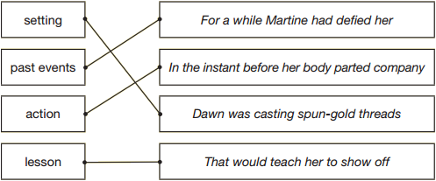

1 mark

Thursday - Maths

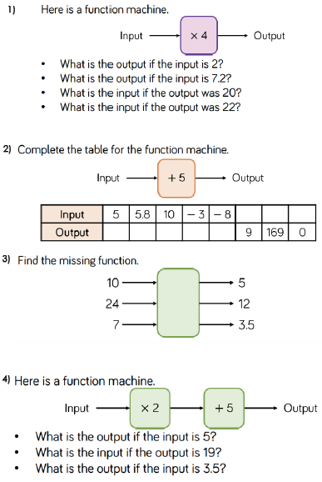
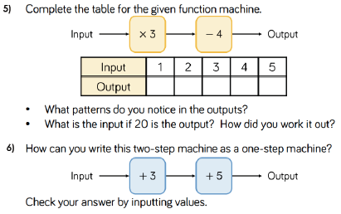

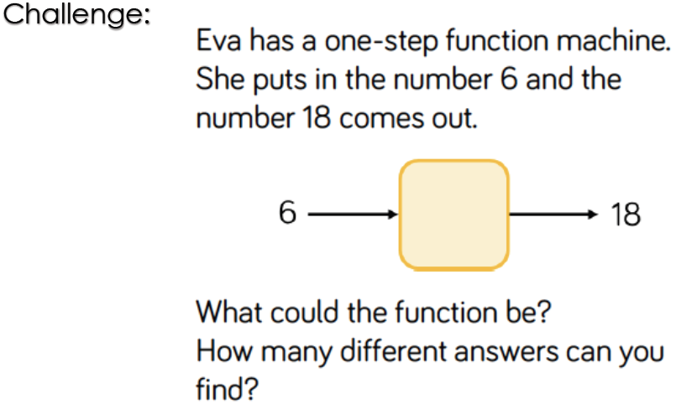
Maths Answers
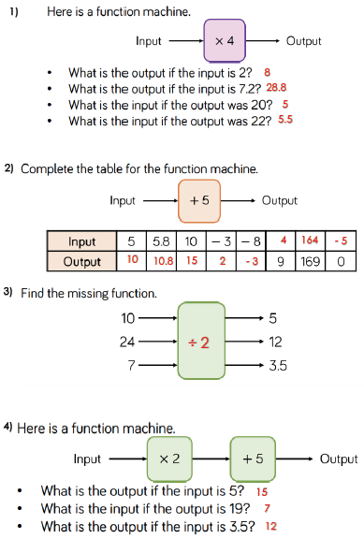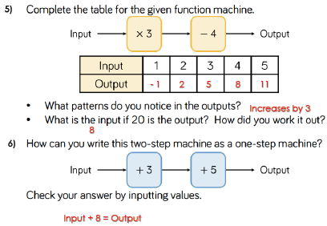
Thursday - PE

ABOUT THE GAME
Challenge your family memeber to see who has the fastest reaction time by each attempting to catch an object before it hits the ground.
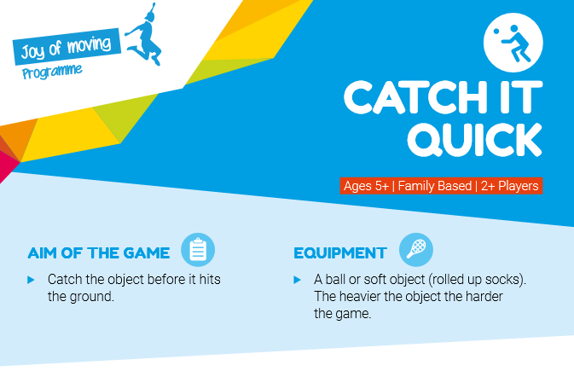
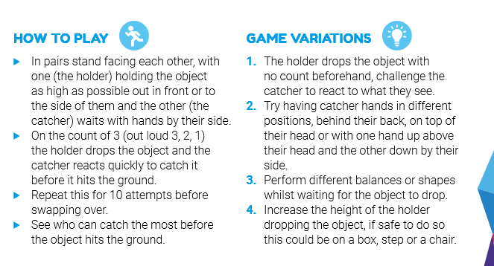
www.joyofmovingresourcehub.co.uk

