Week commencing 13/07/2020

Hi Everyone!

It’s the last week of Year 6 and this is your last learning pack of the year!

For Reading, you will have sections of mock SATs papers, along with some questions that focus on 3 mark answers.

In Maths this week you will continue with algebra. There is an end of topic assessment for you to complete on Friday.

There is also some Science and PSHE for you to complete in your topic pack

If you need us, we are still here. You can email the Year 6 email address and we will respond as soon as we can. Over the summer, your families can still contact the school office if you need anything, but unfortunately they won’t be able to print any more learning packs for you.

Have a great last week – you have all done a super job!
Have a lovely summer and good luck in Year 7 – you will all be fantastic!

Miss Dibble

Thursday 16th July 2020

Spellings

Use the words below in a sentence

Challenge: can you use all of the words in just one sentence?
Or can you use all of the words in a cohesive paragraph, about just one topic?

1. interrupt
2. language
3. leisure
4. lightning
5. marvellous

Reading

The Hottest Day
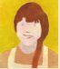  Garnet | In the 1930s, farmers in the Midwest of America went  through very hard times. This is a story about a girl,  Garnet, who lived at that time. Citronella was her  friend and neighbour.  **** | Citronella

Garnet thought this must be the hottest day that had ever been in the world. Every day for weeks she had thought the same thing, but this was really the worst of all. This morning the thermometer outside had pointed a thin red finger to one hundred and ten degrees Fahrenheit*.

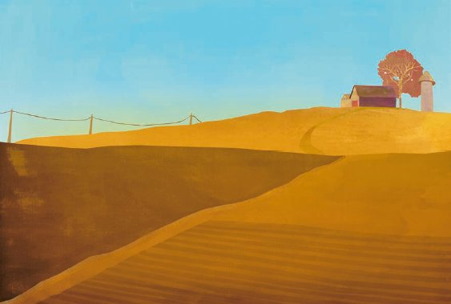

It was like being inside a drum. The sky like a bright skin was stretched tight above the valley, and the earth too was tight and hard with heat. Later, when it was dark, there would be a noise of thunder, as though a great hand beat upon the drum; there would be heavy clouds above the hills, and flashes of heat lightning, but no rain. It had been like that for a long time. After supper each night, her father came out of the house and looked up at the sky, then down at his fields of corn and oats. ‘No,’ he would say, shaking his head. ‘No rain tonight.’__________________________________

* Very hot temperature, roughly 46°C.

The oats were turning yellow before their time, and the corn leaves were torn and brittle, rustling like newspaper when the dry wind blew upon them. If the rain didn’t come soon there would be no harvest.

Garnet looked up at the smooth sky angrily, and shook her fist. ‘You!’ she cried. ‘Why can’t you let down a little rain!’

At each step her bare feet kicked up a small cloud of dust. There was dust in her hair and up her nose, making it tickle.

Behind her, a door twanged shut and Citronella came down the steps of her house flapping a dish towel like a fan.

‘Isn’t it hot!’ she called to Garnet. ‘Where you going?’

‘For the mail,’ said Garnet.

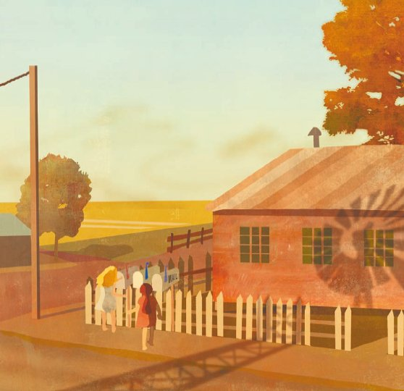

Citronella had to help her mother with the ironing. ‘A fine thing to have to do on a day like this,’ she said rather crossly. ‘I bet you I’ll melt all over the kitchen floor like a lump of butter.’

Garnet giggled at this picture and started on her way.

‘Wait a minute,’ said Citronella, ‘I might as well see if there’s any mail for us too … Days like this make me wish I could find a waterfall somewhere. One that poured lemonade instead of water. I’d sit under it all day with my mouth open.’

‘I’d rather be up on an Alp,’ said Garnet. ‘You know, one of those mountains they have in Europe. There’s snow on top of them even on the hottest days of summer. I’d like to be sitting in the snow looking miles and miles down into a valley.’

‘Too much trouble climbing up,’ sighed Citronella.

They turned the corner and came to the mailboxes. Garnet took the mail from her box. These weren’t real letters, she could tell at a glance. The envelopes were thin and business-like with small printed names of companies in upper left-hand corners. No, these weren’t real letters. Bills, that’s what they were.

Bills. She knew what that meant. Tonight her father would sit late in the kitchen, worried and silent, doing sums on a piece of paper. Long after everyone else had gone to bed, he would be there by himself. If it would only rain! Then there would be good crops and more money. She looked up at the sky. It was as smooth, as empty, as it had been for weeks.

‘I’ve got to get back to my precious ironing board,’ said Citronella grimly.

As Garnet walked up the hill to her house, drops of perspiration rolled down her forehead and into her eyes like big tears. Her back felt wet. She wished that she didn’t have to give those bills to her father. Slowly Garnet walked to the yellow house under tall maple trees and opened the kitchen door.

Her mother was cooking supper and her little brother Donald sat on the floor making a noise like a train.

Her mother looked up. Her cheeks were red from the hot stove. ‘Any mail, darling?’ she asked.

‘Bills,’ replied Garnet.

‘Oh,’ said her mother and turned back to her cooking. Garnet set the table by the open window. Knife, fork, knife, fork, knife, fork, but only a spoon for Donald. Then she went down to the cold room.

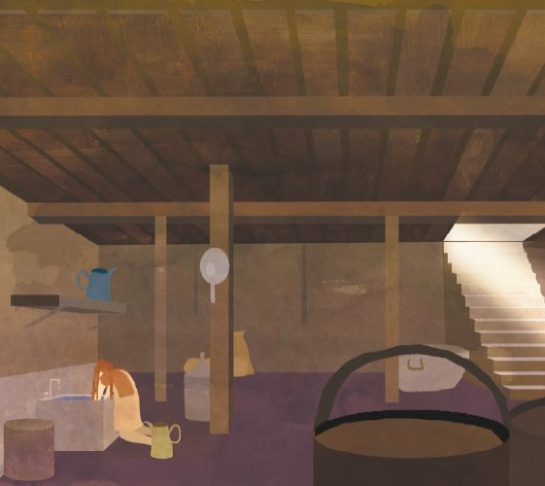

It was still and dim down there. A tap dripped peacefully into the deep pool of water below, where the milk cans and stone butter crock were sunk. Garnet filled a jug with milk and put a square of butter on the plate she had brought. She knelt down and plunged both her arms into the water. It was cloudy with spilled milk but icy cold. She could feel coolness spreading through her veins and a little shiver ran over her.

Going into the kitchen was like walking into a red hot oven.

Donald had stopped being a train and had become a fire engine. He charged round and round the room hooting and shrieking. How could he be so lively, Garnet wondered. He didn’t even notice the awful heat although his hair clung to his head like wet feathers and his cheeks were red as radishes.

Her mother looked out of the window. ‘Father’s coming in,’ she said. ‘Garnet, don’t give him the mail now, I want him to eat a good supper. Put it behind the calendar and I’ll tend to it afterwards.’

Garnet hastily pushed the bills behind the calendar on the shelf over the sink.

The door opened with its own particular squeak and her father came in. He went to the sink and washed his hands. He looked tired and his neck was sunburned. ‘What a day!’ he said. ‘One more like this –’ and he shook his head.

It was too hot to eat.

****

Garnet said goodnight and tiptoed up the stairs to her room under the eaves. It was so hot there that the candle in its holder had swooned till it was bent double. Garnet blew out the candles and lay down. It was too hot even for a sheet. She lay there, wet with perspiration, feeling the heat like heavy blankets and listening to the soft thunder, the empty thunder, that brought no rain. After a while she fell asleep and dreamed that she was in a rowing boat on a wide, flat ocean.

Late in the night Garnet woke up with a strange feeling that something was about to happen. She lay quite still, listening.

The thunder rumbled again, sounding much louder than it had earlier in the evening; almost as though it were in the earth instead of the sky, making the house tremble a little. And then slowly, one by one, as if someone were dropping pennies on the roof, came the raindrops. Garnet held her breath: the sound paused. ‘Don’t stop!’ she whispered.

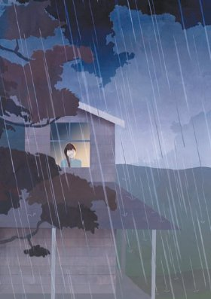 | A noise of wind stirred in the leaves, and then the rain burst strong and loud upon the world. Garnet leaped out of bed and ran to the window. The watery air was cold against her face and as she looked the many-branched lightning stood for an instant on the horizon like a tree on fire.  Quickly she turned and ran down the little stairway to her father’s and mother’s bedroom. Loudly she banged upon the door and threw it open, calling, ‘It’s raining! It’s raining hard!’ She felt as though the thunderstorm were a present she was giving to them.

1. Circle the correct option to complete each sentence below.

(a) The girl, Garnet, looked up at the sky on that

1 mark

morning.

(b) It had not rained for weeks and that made Garnet

1 mark

(c) She went to collect the mail with her neighbour, a girl called

1 mark

(d) However, the letters in the mailbox were not real ones. They were

1 mark

(e) Back at the house, Garnet’s mother decided to

1 mark

(f) Garnet helped to get supper ready but everyone was too hot to eat. They all went to bed. Later on that night, she was woken up by the sound of thunder and then heard the

1 mark

2. Explain fully why Garnet wanted it to rain.

___________________________________________________________________

___________________________________________________________________

___________________________________________________________________

2 marks

3. Garnet and Citronella talked about their daydreams.

What did their daydreams have in common with Garnet’s dream on the last page?

___________________________________________________________________

___________________________________________________________________

1 mark

4. Citronella said:

‘I’ve got to get back to my precious ironing board.’

How can you tell that she really did not like ironing?

___________________________________________________________________

___________________________________________________________________

___________________________________________________________________

2 marks

5. When Garnet’s mother heard that they had received bills in the post, she only said: ‘Oh’.

What do you think the mother was thinking at that point?

Write her thoughts in this thought bubble.

2 marks

6. In the cold room, Garnet shivered when she dipped her arms in the water.

Why?

___________________________________________________________________

___________________________________________________________________

___________________________________________________________________

2 marks

7. ‘What a day!’ … ‘One more like this –’

Why did Garnet’s father leave this sentence on the last page unfinished?

___________________________________________________________________

___________________________________________________________________

1 mark

8. What do you think will happen after the rain comes?

Explain your answer fully.

3 marks

9. Match the events below to show what purpose they have in the story.
The first one has been done for you.

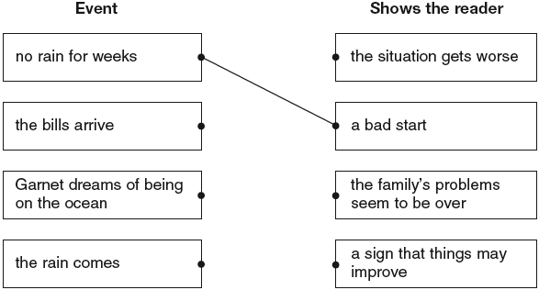

1 mark

1. Award 1 mark for each correct choice.

(a)

(b)

(c)

(d)

(e)

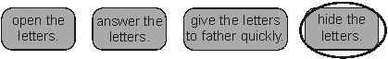

(f)

Up to 6 marks

2. Award 1 mark for each issue covered, to a maximum of 2 marks:

• physical relief, eg: it was too hot / to cool down

• effect on environment, eg: the crops will grow / the corn needed water / the crops were dying

• financial relief, eg: to save the family from financial problems

• relief from anxiety, eg: everyone would stop worrying.

Do not accept:

• so that they could eat again

• because it had not rained.

up to 2 marks

3. Award 1 mark for answers that identify a similarity between the daydreams and Garnet’s dream, eg:

• there’s lots of water in it

• their dreams are both about water

• they made you cool / they both wanted it to be cold

• they were about things that you would like on a hot day.

Do not accept reference to rainfall, eg:

• it rained / there was rain in both of them.

Do not accept answers in which the (day)dreams are retold without drawing out the common factors linking them, eg:

• in the daydreams they wanted lemonade and to be up a mountain and in the dream she was rowing on the ocean.

1 mark

4. Award 2 marks for answers which refer to the ironic use of the word precious, eg:

• she was being sarcastic / she meant the opposite of what she said

• because when she said ‘precious’ she meant it in a ‘sarcy’ way

• because it wasn’t precious, it was a horrible job she had to do.

Award 1 mark for answers which refer to her manner of speech or draw attention to the word precious, eg:

• she said it grimly / grumpily

• she sounded sulky

• the way she said ‘my precious ironing board’

• she said ‘got to’

• she uses the word precious.

Do not accept references to crossness / melting on the floor like butter (ie references to the top of the page), eg:

• she said it crossly

• she said ‘a fine thing to do on a day like this’.

up to 2 marks

5. Acceptable points:

• money / crop / weather concerns

• the effect on other members of the family

• hiding the bills.

Award 2 marks for a negative reaction with some expansion referring to two of the points above, eg:

• oh no, bills! We won’t be able to pay them if it doesn’t rain. Garnet’s father will be up all night trying to make it all work out

• oh no what am I going to do. I don’t wish to worry my husband. I wish it would rain then all our problems would be over.

Award 1 mark for a negative reaction (which may be implicit) with little or no expansion, eg:

• oh not more bills. Couldn’t they have come when the crops have grown?

• oh bills again, that’s all we ever receive. If only it would just rain

• if our crops don’t start growing, we won’t have any more to pay these bills

• oh no, not more bills

• oh no, what shall I do?

• oh I don’t want any more bills. I’m fed up with these bills.

Accept answers which are not written in the first person.

Do not accept references to father’s violent anger / anger expressed to family.

up to 2 marks

6. Award 2 marks for answers which explain the physical shock of the contrast between the heat and the cold water or which focus on reactions other than physical, eg:

• it was so pleasant to feel suddenly cold

• the water was icy cold and she was boiling hot so she shivered with happiness

• a shiver of pleasure / delight / relief

• because the water was cold and she was hot and so it made her shiver because her body was changing temperature fast

• she had not felt the cold for a long time so she shivered because she was used to the heat.

Do not accept for 2 marks answers that are very close to the original text.

Award 1 mark for answers which focus only on one side of the contrast between the coldness of the water and the heat or supply a simple contrast, eg:

• because the water was really cold

• Garnet was very hot

• because the water would be freezing cold because Garnet was in the cold room

• it was cold and she had been in the sun

• she was hot and the water was cold.

up to 2 marks

7. Award 1 mark for answers which reveal an understanding of the father’s possible motives, such as:

• not wanting to spread his fears / aggravate a bad situation, eg: he didn’t want to upset the children

• not wanting to think about / discuss the matter, eg: he didn’t want to talk about it

• knowing that the family probably realises what he is about to say, eg: they know what he would say.

Do not accept answers which attribute the father’s motive to anger.

1 mark

8. Acceptable points:

• physical relief, eg: it was finally going to cool down

• psychological relief, eg: all their worries would be over

• effect on environment, eg: the harvest was to be saved

• financial relief, eg: the family was saved from financial problems.

Award 3 marks for answers which include reference to three of the possible outcomes listed above in an assessment of the rain’s impact on the family, eg:

• after the rain comes, I think it will cool down, the crops will grow and there will be a harvest. They’ll sell the crops and pay the bills

• joy, happiness and gladness. Joy because the father could make some money. Happiness because it had been really, really hot. Glad because it had finally rained after all the waiting.

Award 2 marks for answers which include reference to at least two of the points indicated above, eg:

• it could be just in time to save the crops and if that happens then they won’t go bankrupt

• the crops will start to grow after the rain and Garnet’s father can sell some of the best crops for money. Then, when he has the money, he will be able to pay off his bills.

Award 1 mark for answers which cover only one point, eg:

• the crops won’t die, but will recover and it will be alright

• the family will go outside and just sit there because they’ve been so hot over the past weeks and it would cool them down.

Do not accept reasoned speculations which are not covered by the points above, eg:

• I think it will rain for one day and then it will be boiling for another week as in the beginning paragraph

• I think that they will have too much rain and it will ruin the crops that her father was going to sell and they will get waterlogged. They will still have to be careful with how they spend their money.

up to 3 marks

9. Award 1 mark for three correctly matched pairs.

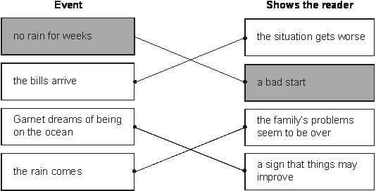

1 mark

Thursday Maths

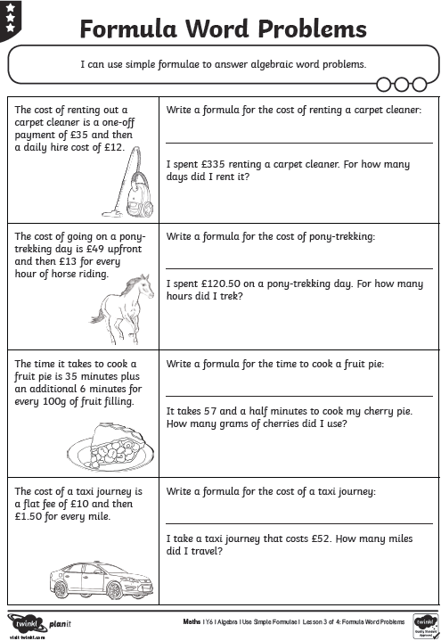
Maths Answers

