Week commencing 08/06/2020

Hey Everyone!

We hope you all had a good half term break and are staying healthy and happy.

In maths this week you will begin to look at algebra. Today you need to carry out some investigations to find the correct answers.

For reading, you will have sections of mock SATs papers, along with some questions that focus on 3 mark answers.

Don’t forget, if you need us we are still here for you – just email the Year 6 email address and we will respond as soon as we can!

Have a great week – you are all doing a super job!

Thursday 11th June 2020

Spellings

Use the words below in a sentence

Challenge: can you use all of the words in just one sentence?
Or can you use all of the words in a cohesive paragraph, about just one topic?

- amateur
- ancient
- apparent
- appreciate
- attached

Reading

In this text, Edward describes a strange incident that happened to him in an old farmhouse owned and inhabited by his Uncle Jack.

Albion’s Dream
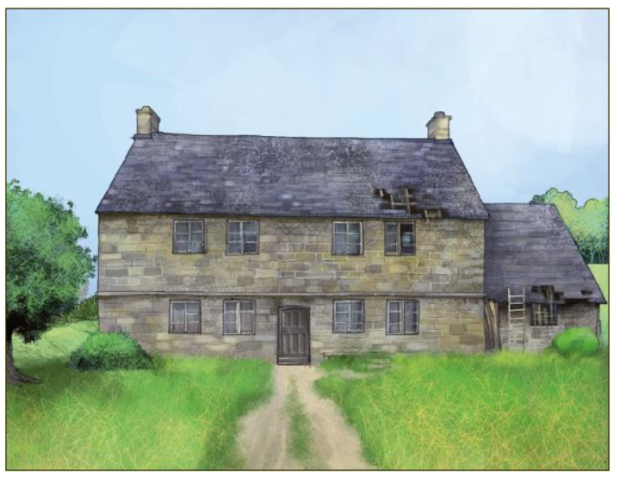

There were rooms in the old farmhouse which I never saw used and which smelt of a past that held extraordinary fascination for me: little windows where unknown ancestors had sat on autumn evenings; old leather-lined bookcases with books that no one had handled for fifty years; dust that no one had bothered to remove; piles of candle wax in unlikely corners; huge chamber pots and cracked basins, and everywhere a great generosity of space.

Outside there was a big lawn hardly walked on, flowerbeds hardly looked at, a vegetable garden which always produced too much, a vast horse chestnut with enough conkers to satisfy the needs of a whole village of boys, a second lawn that nobody ever sat on, and the poignant smells of animals and harvests of a bygone age.

There also lived with Jack an elderly spinster called Em Sharp who was the true guardian of the place and of the memories of the family. The farmhouse never got any cleaner under her care, but it never got any dirtier either. In fact, she was determined that nothing should change, and nothing did.

There were times, as I grew older, when I went to stay with Jack on my own. I followed him on his work around the farm, or explored the empty rooms of the farmhouse. One day − I was twelve years old − it was raining and Jack had taken the car on business. Left to my own devices, I visited the dogs and young chicks, watched Em Sharp for a while as she prepared lunch, then made my way upstairs into the largest and most remote of the empty rooms, where one of the big bookcases had attracted my curiosity.

I pulled out some of the books, glancing idly at the contents, and then, as I went to return one of them to its place, my eye was caught by something in the dark recesses of the shelf. I reached in and drew it out. It was a large red dice, but like no other dice I had ever seen.

I took it to the window to inspect it. Each face had a symbol: a tower, a sword, a broken circle, something that looked like a pillar of stone. It was obvious that the dice had been fashioned by hand, for I could even make out the tiny blade marks, and none of the faces was precisely even.

As I sat and puzzled over the symbols, it dawned on me that the dice ought to belong to a game of some kind. So I returned to the bookcase to make a thorough search.

I looked behind every book and even used my hand to sweep out the shallow gap under the bottom shelf. There must have been ten years’ worth of assorted debris under there. Finally I began to edge the entire bookcase away from the wall. It was extremely heavy and it took me some time to get it out far enough to look behind. There was a thick network of cobwebs and dust. I thought for a moment and plunged my hand in the gap.

There was something there, a flat box. It was covered with grime and falling apart. Opening it, I found a board, counters, cards, and a number of little figures. I wiped away the dirt from the lid and made out the title. Albion’s Dream it said.

At that moment I heard Em Sharp’s voice coming up the stairs.

“Edward. EDWARD!” she called. “What on Earth are you up to in there?”

The door opened.

It took her a few seconds to work out what I was doing; then she leapt towards me.

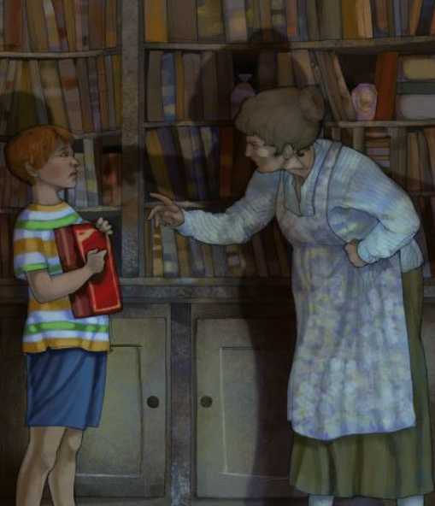

“Give me that immediately, Edward.” I drew back cautiously. “That box is mine. It’s nothing to do with you. It belongs to me.” She came forward with frightening intensity, her hand reaching out for the box. I hesitated. If it really was hers, I had no right… But a stronger sense of justice broke out in me. I had found it by my own efforts. For the time being, at least, it should be mine.

1. Look at the first paragraph.

What suggests that the inside of the old farmhouse was not very well looked after?

Give two things.

1. ____________________________________________________________

2. ____________________________________________________________

1 mark

2. Look at the first two paragraphs.

Which sentence below best describes the farmhouse?

Tick one.
It had always been a lifeless place.
No one ever went there by choice.
It seemed stuck in the past.
The outside was better looked after than the inside.

1 mark

3. Look at page 2.

Find and copy one word which shows that Em Sharp was in charge of the house.

____________________________________

1 mark

4. Look at the second paragraph on page 2.

Left to my own devices…

This means that Edward…

Tick one.
had lost something.
was confident with equipment.
had a good imagination.
was free to do what he wanted.

1 mark

5. When Edward was exploring the bookcase, he noticed something in the dark recesses of the shelf.

Which of the following words is closest in meaning to recesses?

Tick one.
wood
spaces
contents
design

1 mark

6. …it dawned on me that the dice ought to belong to a game…

Which of the following is closest in meaning to dawned on me as it is used here?

Tick one.
began to worry me
became clear to me
made me feel better
puzzled me

1 mark

7. How do you know that the bookcase had not been moved for a long time?

Give two ways.

1. ____________________________________________________________

2. ____________________________________________________________

1 mark

8. How can you tell that Edward was determined to find the game?

Give one piece of evidence that shows his determination.

______________________________________________________________

1 mark

9. Look at page 3.

What impressions do you get of Em Sharp at this point in the extract?

Give two impressions, using evidence from the text to support your answer.

Impression | Evidence
__________________________ | __________________________  __________________________  __________________________
__________________________ | __________________________  __________________________  __________________________

3 marks

10. In the last paragraph, Edward does not want to give the game to Em Sharp.

Give two reasons why he does not want to part with it.

1. ____________________________________________________________

2. ____________________________________________________________

2 marks

11. Edward found a game. How can you tell that there was something strange about the game?

Explain two ways, using evidence from the text to support your answer.

1. ____________________________________________________________

______________________________________________________________

______________________________________________________________

2. ____________________________________________________________

______________________________________________________________

______________________________________________________________

3 marks

1. Content domain: 2d − make inferences from the text / explain and justify inferences with evidence from the text

Award 1 mark for reference to any two of the following:

1. dusty, e.g.

• the house had dust everywhere.

2. piles of candle wax, e.g.

• no-one had bothered moving the candle wax that was in all the corners.

3. cracked basins, e.g.

• there were basins that were cracked.

4. smells old / of the past

Also accept reference to untouched books, e.g.

• books which hadn’t been handled for a very long time.

Also accept reference to unused rooms, e.g.

• there were rooms he never saw used.

1 mark

2. Content domain: 2c − summarise main ideas from more than one paragraph

Award 1 mark for:

It had always been a lifeless place.
No one ever went there by choice.
It seemed stuck in the past.
The outside was better looked after than the inside.

1 mark

3. Content domain: 2d − make inferences from the text / explain and justify inferences with evidence from the text

Award 1 mark for:

• guardian.

1 mark

4. Content domain: 2a − give the meaning of words in context

Award 1 mark for:

had lost something.
was confident with equipment.
had a good imagination.
was free to do what he wanted.

1 mark

5. Content domain: 2a − give the meaning of words in context

Award 1 mark for:

wood
spaces
contents
design

1 mark

6. Content domain: 2a − give the meaning of words in context

Award 1 mark for:

began to worry me
became clear to me
made me feel better
puzzled me

1 mark

7. Content domain: 2b − retrieve and record information / identify key details from fiction and non-fiction

Award 1 mark for reference to any two of the following:

1. cobwebs / dust, e.g..

• the cobwebs were very thick

• there was dust all over it.

2. old / assorted debris, e.g.

• there were piles of stuff on the floor behind it.

3. the grimy box / things behind the bookcase being grimy, e.g.

• the game from behind it was all grimy.

Also accept reference to the quotation old leather-lined bookcases with books that no one had handled for fifty years.

1 mark

8. Content domain: 2d − explain and justify inferences with evidence from the text

Award 1 mark for reference to any of the following:

1. conducting a thorough search / looking everywhere, e.g.

• he’s searching in every nook and cranny

• he looked behind every single book

• it took me some time.

2. ignoring the dirt / cobwebs behind the bookcase, e.g.

• he even stuck his hand in all the dirt behind it

• used my hand to sweep out the shallow gap.

3. moving the bookcase, e.g.

• the bookcase was really heavy but he still tried to move it.

Do not accept general definitions of determination without relevant reference to the text, e.g.

• he didn’t give up.

1 mark

9. Content domain: 2d − make inferences from the text / explain and justify inferences with evidence from the text

Acceptable points  (impressions) | Acceptable evidence
1. she was angry | • give me that immediately, Edward  • that box is mine / it’s nothing to do with you / it belongs to me  • she leapt towards me  • she came forward with frightening intensity
2. she was scary / mean | • I drew back cautiously  • she came forward with frightening intensity / her hand reaching out for the box  • she leapt towards me  • give me that immediately, Edward  • that box is mine / it’s nothing to do with you / it belongs to me
3. she was bossy / demanding | • give me that immediately, Edward
4. she was possessive | • that box is mine / it’s nothing to do with you / it belongs to me  • give me that immediately, Edward
5. she was hiding something / secretive | • that box is mine / it’s nothing to do with you / it belongs to me
6. she was defensive / concerned about the game | • give me that immediately, Edward  • that box is mine / it’s nothing to do with you / it belongs to me  • she leapt towards me
7. she was quick | • she leapt towards me

Award 3 marks for two acceptable points, at least one with evidence.

Award 2 marks for either two acceptable points, or one acceptable point with evidence.

Award 1 mark for one acceptable point.

Up to 3 marks

10. Content domain: 2d − make inferences from the text / explain and justify inferences with evidence from the text

Award 1 mark for reference to any of the following, up to a maximum of 2 marks:

1. he worked hard to find it, e.g.

• he had to move a heavy bookcase to find it

• he went to a lot of effort to get it.

2. he found it (so it belongs to him), e.g.

• because he found it, so technically it belongs to him not Em Sharp

• he found it so he should have it.

3. he questions her claim to it, e.g.

• he didn’t know if it was hers

• he wasn’t 100% sure it was Em Sharp’s.

4. he feels a sense of injustice / she’s being mean to him, e.g.

• she had no reason to take the game off him

• it wouldn’t be fair for him to give it up now.

Do not accept speculative answers, e.g.

• he wants to find out more about it.

Up to 2 marks

11. Content domain: 2d − make inferences from the text / explain and justify inferences with evidence from the text

Acceptable points:

1. it was hidden / in an unusual location

2. the unusual dice

3. Em Sharp’s unusual / negative reaction to the discovery of the game

4. the unusual / mysterious name of the game

5. it was split up

6. Edward’s reaction to the game / Em Sharp.

Award 3 marks for two acceptable points, at least one with evidence, e.g.

• Because it was hidden behind the shelf and looked like it hasn’t been opened. Em Sharp was very angry that he had that in his hands. [AP1 + evidence, AP3]

• The dice had some very odd symbols on it that Edward had not seen before on a regular dice. The title of the game seems creepy. [AP2 + evidence, AP4].

Award 2 marks for either two acceptable points, or one acceptable point with evidence, e.g.

• It had weird symbols on the dice. Em Sharp was very determined to get it. [AP2 + AP3]

• It had a weird name to it ‘Albion’s Dream’. [AP4 + evidence].

Award 1 mark for one acceptable point, e.g.

• Some of its parts were randomly placed on the bookshelf. [AP5]

• Because he did not let go of the game even though he was told to. [AP6].

Up to 3 marks

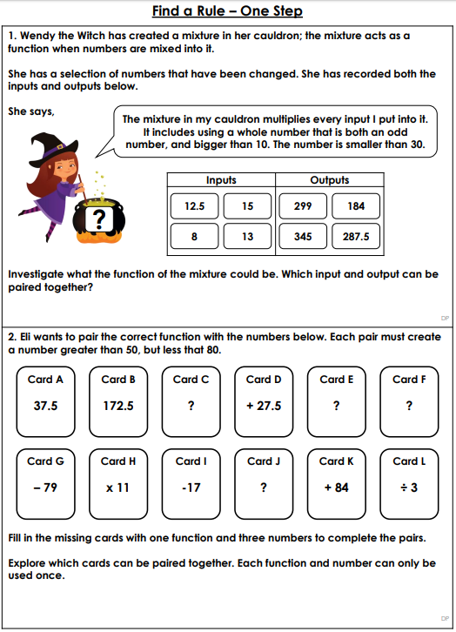
Maths Answers

Question 1

Question 2

PE -Thursday
