**Pandora Pictures**

1. Created by John William Waterhouse in 1896.

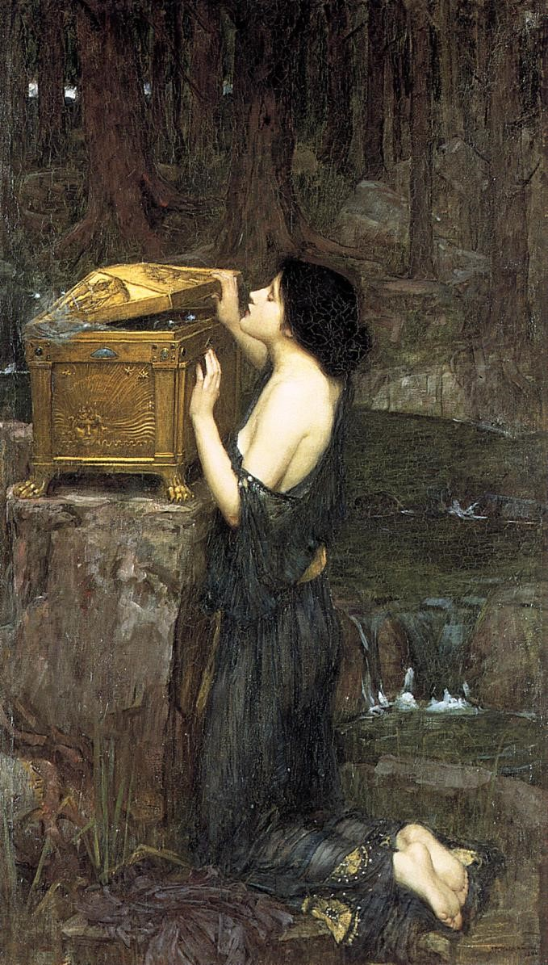

1. Created by Dante Gabriel Rossetti in 1871.