Week commencing 8/6/2020

Hey Everyone!

We hope you all had a good half term break and are staying healthy and happy.

In maths this week you will begin to look at algebra. Today, we will start with some function machines.

For reading, you will have sections of mock SATs papers, along with some questions that focus on 3 mark answers.

Don’t forget, if you need us we are still here for you – just email the Year 6 email address and we will respond as soon as we can!

Have a great week – you are all doing a super job!

Monday 8th June 2020

Spellings

Can you think of a definition for these words? Copy each word three times, in your best handwriting!

- accommodate
- accompany
- according
- achieve
- aggressive
- amateur
- ancient
- apparent
- appreciate
- attached

Reading

This is an extract from an adventure story set in a different world. Micah, who earns money by finding things and selling them, goes to visit his 13-year-old friend, Piper.

Music Box

Micah brought the music box to her on the night of the meteor storm. Piper never slept on these nights, when debris from other worlds fell from the sky. Restlessness kept her awake in bed, staring at the slanted ceiling of her house. She counted the widening cracks in the grey scrub-pine planks and then counted the seconds as they ticked by on the tarnished silver watch she wore around her neck. Beneath her cotton nightdress, the metal lay warm and comfortable against her skin. Micah’s knock made her lose count, but the watch ticked on steadily.

She pulled on a pair of her father’s old boots, slung his brown coat over her nightdress, and opened the door. Wind blew a harsh breath of snow and ice crystals into her face. Piper wiped her eyes and fixed a look of annoyance on the boy huddled in the doorway.

‘I must be seeing things,’ Piper said. ‘This can’t be Micah Howell standing at my door, dragging me out of bed in the drop dead of night. Look at me – I’m stunned stiff. I’m speechless.’

Micah snorted. ‘That’ll be the day, then. Let me in, Piper, will ya?’ He stomped snow off his boots. ‘Stinks out here, and it’s so cold my teeth are cracking together.’

‘That’s your own fault for being out on a storm night. Most scrappers have the sense to stay inside.’ He was right, though. The air already reeked of brimstone. The storm was coming. Piper moved to let him in, then shut the door behind him. He immediately ran to the cast-iron stove to warm his hands. Piper nudged him aside and adjusted the controls. ‘Hand me a log before you make yourself at home,’ she said. It was her habit to pretend to be bothered by her friend, even though she was happy to see him.

Micah handed her a piece of wood from the basket near the stove and reached into the bulky sack he had slung over his shoulder. ‘I brought it, just like I said I would.’

‘That’s great, kid, but I thought you were going to bring it a few hours ago – you know, before I made a comfortable nest in the middle of my bed.’ Piper tended the stove, and then she went to the window and looked out at the sky, which had begun to lighten, though it was still several hours until dawn. The moon was a sickly greenish colour, as it always was before the meteors fell, making the clouds around it look like swelling bruises on the sky.

Piper’s skin itched. She had the urge to go outside and watch the fields, to see the first of the meteors streak from the sky, but it was too cold, too dangerous. And besides, she’d promised to fix Micah’s toy. A musical box – Piper rolled her eyes. Machines couldn’t make proper music. You needed a person for that.

She lit an extra kerosene lamp and placed it on the small kitchen table. Piston rings, bolts, and cylinders littered its surface. Piper shifted these aside, wishing she had a bigger work space, one she didn’t also have to eat at. ‘Let’s see it, then.’

Micah set the music box between them. ‘Isn’t she beautiful?’ he said, his fingers lingering on the lid. It was decorated with a painted figure of a woman in a white silk robe. She reclined on a strip of grass, her long black hair falling around her waist. At her back grew a tree full to bursting with pink blossoms that hung over her like a veil.

Whoever had made the music box was a skilled artist. Piper could practically smell the flowers, each one hand-painted in white, coral, and cerise. In a few places, the paint had cracked and faded, but those were hardly noticeable. Overall, it was an incredible piece. Micah had been lucky to find it.

‘But she won’t sing?’ Piper lifted the lid to get a look at the musical components. She’d seen contraptions like these before. A series of pins arranged on a metal cylinder struck the teeth of a steel comb while the cylinder turned, making the tinkling notes of a song. She’d heard this type of music and had always thought the sound was a little annoying. ‘Did you clean the inside after you dug it out of the crater?’

‘Course I did.’ The boy was indignant. ‘You think I’m stupid?’

Piper glanced up from the box and raised an eyebrow.

‘Ha-ha. You watch – the coin I get from that thing will feed my family and me for a month. She’ll look smart in one of those fancy mansions in Ardra. Don’t you think she will, Piper?’ His excitement faltered, and he looked at her anxiously.

‘Yeah, it’ll look smart. Just make sure you find a buyer with a stiff hip at the market,’ Piper said. ‘They’re the ones who’ll be looking for these kinds of pretties.’ She felt the cylinder and its tiny pins. Micah had done a decent job cleaning it, but flecks of dirt still caked the comb, and something was keeping the cylinder from turning. She heard the soft, strangled notes of a song trying to play.
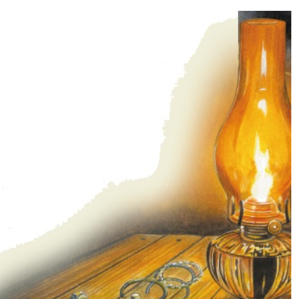

1. What has Piper been counting in the first paragraph?

1. ____________________________________________________________

2. ____________________________________________________________

1 mark

2. She pulled on a pair of her father’s old boots, slung his brown coat over her nightdress, and opened the door.

The word slung suggests that Piper put on the brown coat…
Tick one.
carelessly.
slowly.
tidily
thoughtfully.

1 mark

3. Look at page 1.

Why is the boy huddled in the doorway while he waits for Piper to open the door?

______________________________________________________________

______________________________________________________________

1 mark

4. Look at page 2.

Why has Micah come to Piper’s house on the night of the storm?

______________________________________________________________

1 mark

5. What impressions do you get of Piper’s house?

Give two impressions, using evidence from the text to support your answer.

Impression | Evidence
__________________________ | __________________________  __________________________  __________________________
__________________________ | __________________________  __________________________  __________________________

3 marks

6. Piper has mixed feelings about music boxes.

Complete the table below to show her thoughts.

What Piper likes about the music box | ______________________________
What Piper dislikes about music boxes | ______________________________

2 marks

7. Look at page 2.

‘But she won’t sing?’

What does Piper mean when she says this?

______________________________________________________________

1 mark

8. Look at page 2.

Where did Micah find the music box?

______________________________________________________________

1 mark

9. What work has Micah done to the music box before showing it to Piper?

______________________________________________________________

1 mark

10. Piper thinks Micah has done a decent job.

She thinks his work has been...
Tick one.
excellent.
careful.
sloppy.
reasonable.

1 mark

11. Look at the last paragraph, beginning: ‘Yeah, it’ll look smart.’

Find and copy one word that suggests that the sound coming from Micah’s music box is unpleasant.

____________________________________

1 mark

12. What impressions do you get of the relationship between Piper and Micah?

Give two impressions, supporting your answer with evidence from the text.

1. ____________________________________________________________

______________________________________________________________

______________________________________________________________

2. ____________________________________________________________

______________________________________________________________

______________________________________________________________

3 marks

Mark scheme

1. Content domain: 2b − retrieve and record information / identify key details from fiction and non-fiction

Award 1 mark for reference to both of the following:

1. the cracks (in the ceiling), e.g.

• cracks in the boards

• widening cracks.

2. seconds / time, e.g.

• the watch ticks

• seconds.

1 mark

2. Content domain: 2g − identify / explain how meaning is enhanced through choice of words and phrases

Award 1 mark for:

carelessly.
slowly.
tidily.
thoughtfully.

1 mark

3. Content domain: 2d − make inferences from the text / explain and justify inferences with evidence from the text

Award 1 mark for reference to either of the following:

1. the weather / the effect of the weather on Micah, e.g.

• he was really cold so was trying to keep warm

• because it is snowy and windy outside.

2. the smell, e.g.

• it smells bad outside.

Do not accept answers about Micah being scared, e.g.

• he was probably frightened of the storm.

1 mark

4. Content domain: 2d − make inferences from the text / explain and justify inferences with evidence from the text

Award 1 mark for reference to bringing the music box to Piper / getting the music box repaired, e.g.

• he wanted her to see the music box he had found

• because she promised to fix Micah’s toy

• so Piper can mend a music box.

1 mark

5. Content domain: 2d − make inferences from the text / explain and justify inferences with evidence from the text

Acceptable points (impressions) | Likely evidence
1. it is rickety / old | • there are widening cracks in the planks in the  ceiling
2. it is small / tiny | • she wishes she had a bigger work space  • she has to eat at the same table that she works at
3. it is warm / cosy | • there is a fire / stove  • comfortable nest
4. it is untidy / cluttered | • Piston rings, bolts, and cylinders littered its surface
5. it is old fashioned | • no electricity / kerosene lamps / cast-iron stove
6. it is isolated | • is situated among fields  • to go outside and watch the fields
7. it is safe | • the storm coming outside is dangerous

Award 3 marks for two acceptable points, at least one with evidence.

Award 2 marks for either two acceptable points, or one acceptable point with evidence.

Award 1 mark for one acceptable point.

Up to 3 marks

6. Content domain: 2b − retrieve and record information / identify key details from fiction and non-fiction

Award 1 mark for reference to any of the following in the appropriate box, up to a maximum of 2 marks:

What Piper likes about the music box
1. the (skilful) painting / painter, e.g.
• it is beautifully decorated
• the art on it
• she likes the flowers on it.
Do not accept general references to the appearance of the box without reference to the painting / painter, e.g.
• it looks nice
• the box is pretty
• it’s beautiful.
What Piper dislikes about music boxes
2. the sound they make, e.g.
• the music was annoying
• the songs it plays.
3. machines don’t make proper music / only people make proper music, e.g.
• only a person could make good music.
4. she considers them toys / contraptions.
Do not accept reference to the music box being broken, e.g.
• that it won’t sing
• not playing music.

Up to 2 marks

7. Content domain: 2d − make inferences from the text / explain and justify inferences with evidence from the text Award 1 mark for reference to the music box not working correctly, e.g.

• the music box’s song isn’t playing properly

• there is no music coming out of the box

• the toy doesn’t play.

1 mark

8. Content domain: 2b − retrieve and record information / identify key details from fiction and non-fiction

Award 1 mark for reference to him finding it inside a crater / where a meteor landed, e.g.

• in a crater

• he dug it out of a crater

• in a hole.

1 mark

9. Content domain: 2b − retrieve and record information / identify key details from fiction and non-fiction

Award 1 mark for reference to him cleaning it, e.g.

• he had cleaned it

• cleaned the inside.

1 mark

10. Content domain: 2a − give / explain the meaning of words in context

Award 1 mark for:

excellent.
careful.
sloppy.
reasonable.

1 mark

11. Content domain: 2g − identify / explain how meaning is enhanced through choice of words and phrases

Award 1 mark for:

• strangled.

1 mark

12. Content domain: 2d − make inferences from the text / explain and justify inferences with evidence from the text

Acceptable points:

1. they know each other well / like each other

2. they pretend to be rude to each other

3. they work together

4. they trust each other

5. Piper is in charge

Award 3 marks for two acceptable points, at least one with evidence, e.g.

• 1. They were best buddies because it says she was pretending to be bothered by him though she was happy to see him. [AP1 + evidence]

2. They like to tease each other. [AP2]

• 1. They care about each other. [AP1]

2. They work together because he finds stuff and she fixes the stuff he finds. [AP3 + evidence]

• 1. They are good friends who like to banter with each other, she says at the beginning she’s ‘stunned stiff.’ [AP2 + evidence]

2. Piper seems to be the mature one. [AP5]

Award 2 marks for either two acceptable points, or one acceptable point with evidence, e.g.

• 1. You get the impression they are very close friends. [AP1]

2. Piper acts like she’s the boss. [AP5]

• 1. They trust each other because he asked for her opinion about how his music box will sell at the market. [AP4 + evidence]

Award 1 mark for one acceptable point, e.g.

• 1. Piper and Micah work together to fix the music box. [AP3]

Up to 3 marks

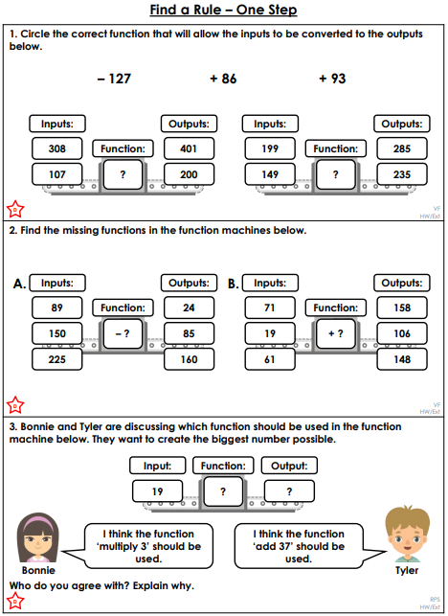

PE - Monday

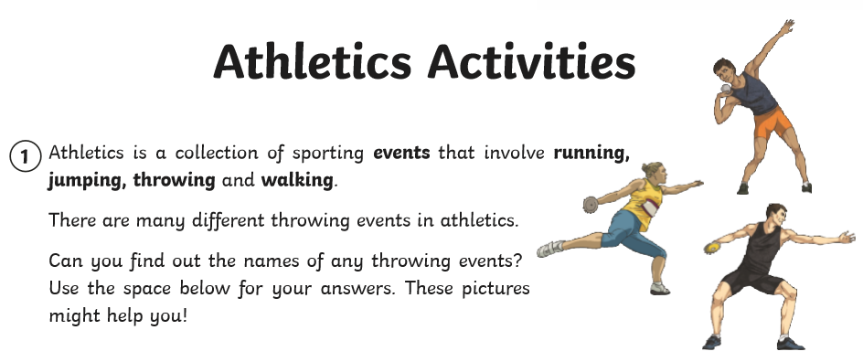

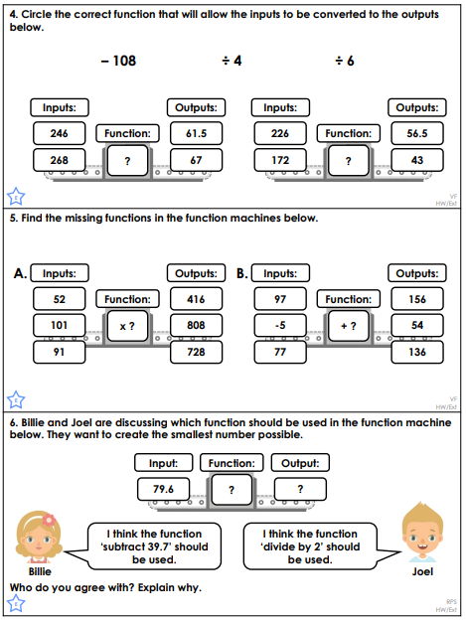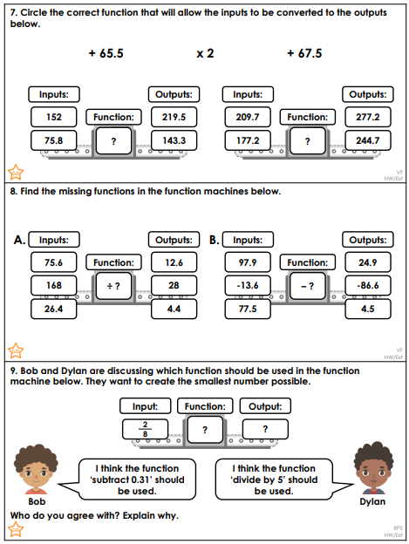

Maths Answers

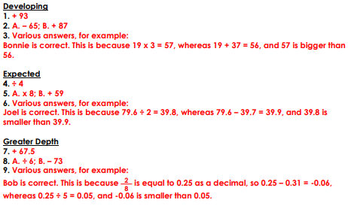

PE – Monday

