Week commencing 22/06/2020

Hey Everyone!

We hope you all had a good half term break and are staying healthy and happy.

In maths this week you will be practising forming expressions in algebra.

For reading, you will have sections of mock SATs papers, along with some questions that focus on 3 mark answers.

Your topic work is in a separate pack this week for you to work through at your own pace.

Don’t forget, if you need us we are still here for you – just email the Year 6 email address and we will respond as soon as we can!

Have a great week – you are all doing a super job! Keep it up!

Monday 22nd June 2020

Spellings

Can you think of a definition for these words? Copy each word three times, in your best handwriting!

1. competition
2. conscience
3. conscious
4. controversy
5. convenience
6. correspond
7. criticise
8. curiosity
9. definite
10. desperate

Reading

The Way of the Dodo

This is an article about the dodo, a bird that is now extinct.

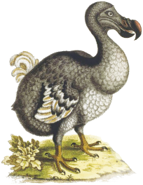

An artist's impression of the dodo from 300 years ago.

The dodo was first sighted around 1600 on an island in the Indian Ocean. It was extinct by 1680. Since then the phrase 'dead as a dodo' has been used to describe something which is lifeless or has disappeared from the world completely. Because of its rapid disappearance, a number of myths developed about the dodo, for example that it was a fat, silly creature that brought its fate upon itself.

But what is the truth about the dodo?

For thousands of years the island of Mauritius was a paradise. It was spat out of the ocean floor by an underwater volcano 8 million years ago. With warm sun, plentiful food and no predators to speak of, the isolated island became a haven for a variety of unusual species, including reptiles and flightless birds.

Then, in 1598, humans descended on this paradise, accompanied by their own animals – dogs, goats, cats (and a fair number of rats!). Curious and unafraid, the animals of Mauritius offered themselves up for slaughter and, within just a few decades, much of the island's unique wildlife had been wiped out forever.

One of the victims was a large, flightless relative of the pigeon. The island invaders started to call the bird a 'dodo', which meant 'silly bird'.

Although the dodo was hunted for food, this was not the main reason it died out. It is more likely that having never faced predators before, and unable to fly away, the adult birds fell prey to dogs and cats. Meanwhile, their eggs and chicks, defenceless in their nests on the ground, were easy pickings for rats.

Less than 100 years after man's arrival, the dodo, which had once numbered in the hundreds of thousands, slipped into the pages of folklore.

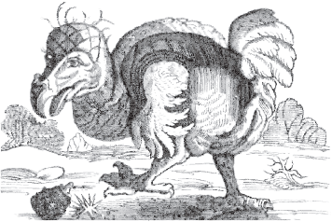

A drawing of a dodo from around 1646.

Until a few years ago, all knowledge of the dodo came from secondary reports from the time that were not always reliable, a handful of remains and just one complete skeleton. Nobody knew what the dodo really looked like. Before cameras, newly discovered animals could only be drawn or painted. However, many of the artists had no knowledge of natural history and were more interested in producing colourful paintings of animals than recording their true likeness.

Then, in 2005, a team of scientists unearthed thousands of dodo bones in some mud flats in Mauritius. The remains date back to over 4,000 years ago, when the island was suffering from a lengthy drought. The mud flats would have formed a freshwater oasis in an otherwise parched environment. It is thought that most of the animals, while trying to reach the slowly receding waters of the lake, became stuck and died of thirst or suffocation. However, clearly some dodos survived as they did not become extinct until much later.

This discovery is helping to rehabilitate the image of this much-ridiculed bird. The very fact that the dodo was still alive and well on Mauritius 4,000 years after a drought that claimed the lives of thousands of animals is an indication of the bird's ability to survive. The remains are also helping scientists to find out more about the anatomy of the dodo, for example that it was a much slimmer bird than any pictures suggest.

As scientists learn more about the dodo, and begin to see the bird in a new light, we are reminded that the dodo was badly misjudged. Maybe it is humans who should be judged, as we can have a devastating impact on the natural world. No other creature should be allowed to go the way of the dodo.

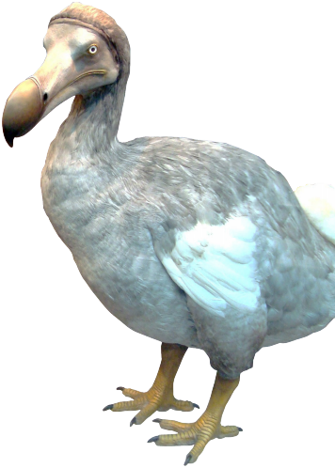

A modern reconstruction of a dodo.

1. Look at the introduction.

Why is space tourism impossible for most people?

______________________________________________________________

______________________________________________________________

1 mark

2. How would you get from the spacecraft to the space hotel?

______________________________________________________________

______________________________________________________________

1 mark

3. According to the text, what could you do on your space holiday?

Give two examples:

1. ____________________________________________________________

2. ____________________________________________________________

2 marks

4. How much did the first space tourist pay to go into space?

______________________________________________________________

1 mark

5. How can you tell that the International Space Station is very large?

______________________________________________________________

______________________________________________________________

1 mark

6. How did Anousheh’s trip into space make history?

______________________________________________________________

______________________________________________________________

1 mark

7. Look at the text box Who has already had a holiday in space?

Complete the table about Anousheh’s trip into space.

Where did she start her trip?
Where did she stay in space?
How long did she stay in space?

2 marks

8. Look at Anousheh’s blog entry for September 25th.

Find and copy a group of words that shows that Anousheh wrote her
blog for others to read.

______________________________________________________________

______________________________________________________________

1 mark

9. Look at Anousheh’s blog entry for September 27th.

Explain how Anousheh felt about being in space that day.

______________________________________________________________

______________________________________________________________

______________________________________________________________

______________________________________________________________

2 marks

10. Match the events below to the year in which they happened.

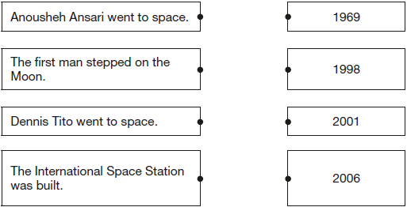

1 mark

11. Using information from the text, tick one box in each row to show whether each statement is a fact or an opinion.

 | Fact | Opinion
Anousheh Ansari kept an online diary.
Brushing your teeth in space is a joy.
Being weightless is endlessly entertaining.
Tourists can stay on the International
Space Station.

1 mark

12. …in a flash...

What does this tell you about the burning of rocks in space?

______________________________________________________________

______________________________________________________________

1 mark

13. Find out when a meteor shower is due and arrange to go star spotting
with an adult…

In this sentence, the word arrange is closest in meaning to…

Tick one.
set out.
meet.
pack up.
plan.

1 mark

14. How does the information make it sound easy to be a star spotter?

Give two ways.

1. ____________________________________________________________

______________________________________________________________

2. ____________________________________________________________

______________________________________________________________

2 marks

15. Tick true or false in the following table to show what you should do when
spotting shooting stars.

 | True | False
Take warm clothes, a blanket, a pillow and a torch.
Stay close to town.
Point your torch up to the sky.
You must have binoculars.

1 mark

- Mark Scheme

1. Award 1 mark for explaining that it is impossible for most people because it costs too much, e.g.

• most people can’t afford it

• it is too expensive.

1 mark

2. Award 1 mark for answers that refer to floating down the tube (holding the cable).

1 mark

3. Award 1 mark for identifying any of the following activities, up to a maximum of
2 marks:

1. look at Earth or space / admire the view, e.g.

• admire unique views of Earth

• look at the outside of earth

• look down at Earth.

2. experience weightlessness / activities associated with floating, e.g.

• enjoy being weightless

• enjoy the endless entertainment of being weightless.

3. space-walk, e.g.

• do a space walk.

Do not accept plausible experiences that are not derived from the text or are unconnected with space travel, e.g.

• take photos of the moon / see what the Moon is made from

• I’d write a blog

• stay in a hotel.

Up to 2 marks

4. Award 1 mark for (around £)14 million / (£)14m.

1 mark

5. Award 1 mark for answers referring to the fact that it can be seen from Earth, e.g.

• You can see it from / on Earth.

1 mark

6. Award 1 mark for answers recognising that she was the first female space tourist.

• she was the first lady to have a holiday in space

• she was the first female tourist in space.

Do not accept answers that say she was the first female (into space).

1 mark

7. Award 2 marks for all three correct.

Award 1 mark for two correct.

Where did she start her trip? | • Russia  Do not accept Russian ISS or Earth
Where did she stay in space? | • space station / ISS
How long did she stay in  space? | • 8 days  Do not accept 8

Up to 2 marks

8. Award 1 mark for either of the following:

1. (Well) my friends

2. Everyone wants to know.

Do not accept longer quotations from the text.

1 mark

9. Award 2 marks for answers that contain both an appropriate reference to Anousheh’s positive attitude, inferred from the text, and development in the form of a relevant quote / example(s) of activities she did in space, e.g.

• you can tell that she liked space because of all the fun things she wrote like floating about without any effort and lifting heavy things
[positive attitude + examples of activities]

• she enjoyed it because of all the wonderful advantages she kept on describing [positive attitude + quote]

• she felt wonderful being able to do somersaults and flying around
[positive attitude + examples of activities].

Award 1 mark for identifying Anousheh’s positive attitude inferred from the text, e.g.

• she loved it / she felt it was wonderful.

Also accept for 1 mark the following quotations (as they convey positive emotion), e.g.

• she said being weightless had some wonderful advantages

• everything is effortless.

Do not accept emotions that are not supported by the text, e.g. pride.

Up to 2 marks

10. Award 1 mark for all four pairs matched correctly.

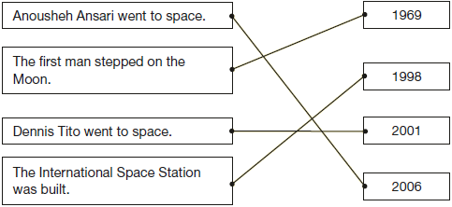

1 mark

11. Award 1 mark for all four correct.

 | Fact | Opinion
Anousheh Ansari kept an online diary.
Brushing your teeth in space is a joy.
Being weightless is endlessly entertaining.
Tourists can stay on the International
Space Station.

1 mark

12. Award 1 mark for either acceptable point:

1. the rock burns very quickly, e.g.• they burn quickly / suddenly / instantly

• it happens fast.

2. the rock burns brightly, e.g.

• when the rock burns you get a dazzling light.

Do not accept reference to speed of travel, e.g.

• they go / fly / travel very quickly.

1 mark

13. Award 1 mark for the correct option ticked.
set out.
meet.
pack up.
plan.

1 mark

14. Award 1 mark for reference to any of the following acceptable points, up to a maximum of 2 marks:

1. accessible location, e.g.

• You don’t have to travel far to do it

• You don’t have to be in space (to see them)

• You don’t have to leave Earth.

2. you do not need specialist equipment, e.g.

• You can do it with things you’ll have in the house

• You don’t need a telescope or binoculars

• You don’t need any expensive equipment

• It sounds easy because all you need is a nice spot, a blanket, pillow and torch.

3. you don’t need an expert to show you how to do it, e.g.

• You just need to go with an adult, they don’t need to know anything about space.

Do not accept answers that are focussed on the structure of page 6, e.g.

• the instructions are laid out clearly.

2 marks

15. Award 1 mark for all four correct.

 | True | False
Take warm clothes, a blanket, a pillow and a torch.
Stay close to town.
Point your torch up to the sky.
You must have binoculars.

1 mark

Maths

Have a look on BBC Biteseize before you start this work. It will help you. https://www.bbc.co.uk/bitesize/articles/ztqdbqt
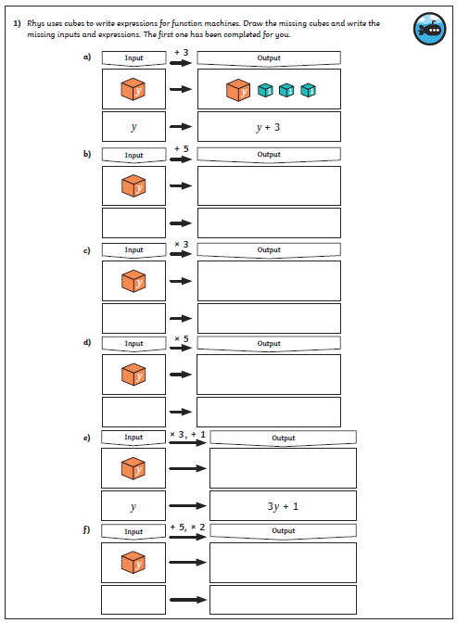
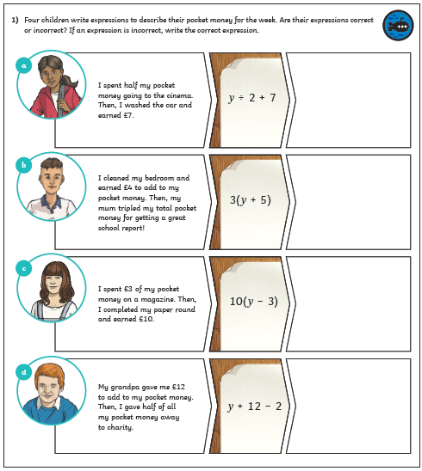
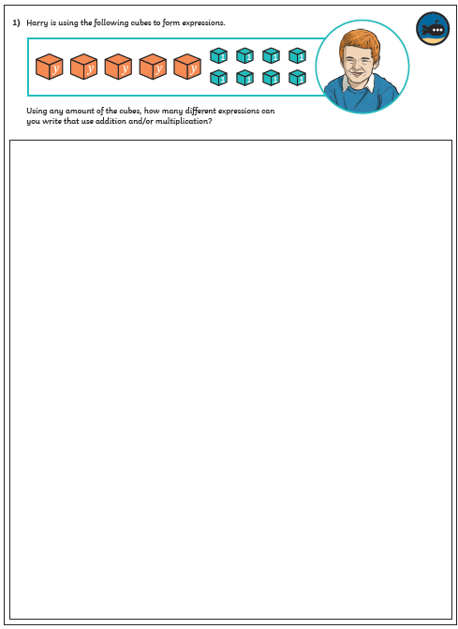
Maths answers
