Ebony Regular

Week commencing 1/6/2020

Hey Everyone!

We hope you all had a good half term break and are staying healthy and happy.

In maths this week you will be using fractions to find the whole. For example: Find 2/5 of 25.

In order to calculate this, you must first divide the whole by the denominator, then multiply the quotient – the answer – by the numerator. This is your answer.

25 ÷ 5 = 5

5 x 2 = 10

2/5 of 25 is 10.

For reading, you will have sections of mock SATs papers, along with some questions that focus on 3 mark answers.

Don’t forget, if you need us we are still here for you – just email the Year 6 email address and we will respond as soon as we can!

Have a great week – you are all doing a super job!

Monday 1st June 2020

Spellings

Can you think of a definition for these words? Copy each word three times, in your best handwriting!

existence

explanation

familiar

foreign

forty

frequently

government

guarantee

harass

hindrance

Reading

***SPINNER***

*Secret and swift,*

*Light and small,*

*The Spinner rakes my garden*

*Wall to wall,*

*For shadowed caves between the stones*

*And leafy holes within the hedge,*

*A guttering tunnel, dark and damp,*

*An empty pot on a window ledge.*

*Each greyish, brownish, blackish place*

*Is laced with threads too fine to see*

*'I have my secrets,' Spinner says*

*And waits, expectantly.*

*Cold dark comes,*

*Frost lies white,*

*Thickens over my garden*

*Until the night*

*Thins*

*And day begins.*

*Suddenly under the primrose sun*

*Spinner's secrets known.*

*Every webbed and shadowed place,*

*Beautiful with diamond lace*

*Is shown.*

***Gwen Dunn***

1.      What creature is this poem about?

________________________________________

1 mark

2.      Look at verse 1.

What sorts of places does the *Spinner* look for?

___________________________________________________________________

___________________________________________________________________

2 mark

3.      Look at verse 2.

What **two** changes take place that give the *Spinner’s* secrets away?

**1.** _________________________________________________________________

**2.** _________________________________________________________________

2 marks

4.      The last line of the poem is: *Is shown*.

         What would you see if you were there?

___________________________________________________________________

___________________________________________________________________

2 marks

5       Find five words to do with *darkness* in the first verse of the poem.

**1.** __________________________________

**2.** __________________________________

**3.** __________________________________

**4.** __________________________________

**5.** __________________________________

2 marks

6.      *...beautiful with* ***diamond*** *lace.* (verse 3)

What does the word ***diamond*** tell you about the webs?

___________________________________________________________________

___________________________________________________________________

___________________________________________________________________

2 marks

7.      The second verse of the poem is different from the first and third verses.

         Write down **one** main way in which it is different.

___________________________________________________________________

___________________________________________________________________

___________________________________________________________________

1 mark

8.      What are the main contrasts the poet makes in the first and third parts of the poem?



3 marks



PE:

We will be attempting different fitness tasks throughout this week! Write a short description of what you did each day, and how it made you feel in the box at the bottom of this page.

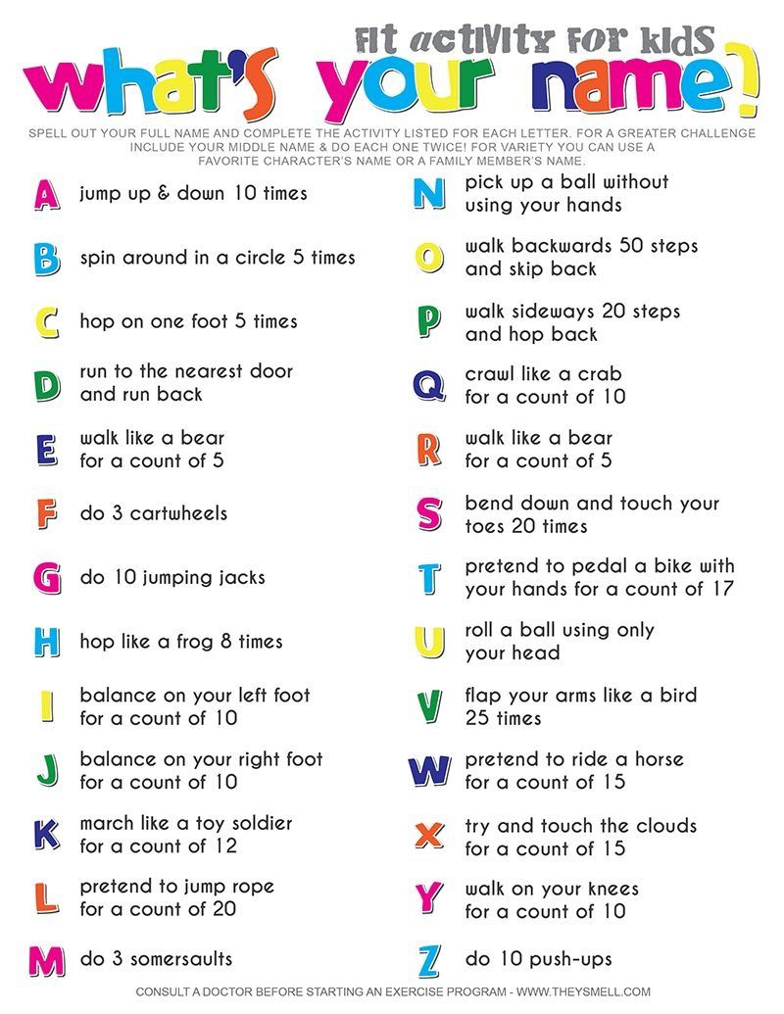

Mark schemes

**Spinner:**

1.      Award **1 mark** for

*•        a spider*

**Do not accept:**

*•        Spinner*

**1 mark**

2.      Award **1 mark** for answers that are taken directly from the text and refer to **two or more** of the following:

*•        shadowed / caves;*

*•        stones;*

*•        pots;*

*•        dark / tunnel;*

*•        hedge;*

*•        gutter;*

*•        (leafy) holes;*

*•        in the wall;*

*•        greyish / brownish / blackish place(s).*

Award **2 marks** for answers that summarise, categorise **or** generalise from the poem, eg:

*•        dark / shady / shadowy places;*

*•        somewhere where it can hide away.*

**Do not accept:**

*•        garden*

or direct quotations of the first three lines of the poem.

**up to 2 marks**

3.      Award **1 mark each** for one answer from each group, up to a maximum of **2**:

*•        frost / ice / dew;*

*•        sun / daylight / dawn.*

**up to 2 marks**

4.      Award **1 mark** for answers that reveal understanding of the key feature of the final stanza, ie webs:

*•        a web / webs;*

*•        beautiful webs / webs like lace.*

Award **2 marks** for a fuller description of what is revealed, eg:

*•        a spider’s webs covered in frost / drops / dew;*

*•        a spider’s webs glistening in the sunshine;*

*•        dew clinging to the webs and sparkling.*

**Do not accept** only direct quotation from the text.

**up to 2 marks**

5.      Award **1 mark** for **four** correctly identified words.

Award **2 marks** for **five** correctly identified words.

•*shadowed;* •*holes;* •*tunnel;*

•*greyish;* •*brownish;* •*caves;*

•*dark;* •*secrets;* •*blackish.*

**Do not accept:**

*•        damp.*

**up to 2 marks**

6.      Award **1 mark** for answers which refer only to the shining / glistening / sparkling quality of diamonds.

Award **2 marks** for answers which refer to other aspects of diamonds, such as their value or use in jewellery, eg:

*•        shiny, glittering and valuable;*

*•        the webs are like diamond necklaces because the spider’s silk is like the thread on which the diamonds of dewdrops are laced;*

*•        the web is as precious to the spider as a diamond is to us and it is also beautiful the way it shines in the sun;*

*•        beautiful chains of crystals, transparent and sparkling.*

**Do not accept** answers that refer only to the strength or shape of spiders’ webs.

**up to 2 marks**

7.      Award **1 mark** for answers which refer **either** to line /word length **or** to change of content, eg:

*•        not about the spider / it is about the weather / time of day;*

*•        the lines are shorter.*

**Do not accept:**

*•        it is shorter;*

*•        it is dark.*

**1 mark**

8.      Main contrasts:

*•        darkness / light*

*•        secrecy / revelation*

*•        mystery / openness*

*•        mundane / beautiful, magical.*

Award **1 mark** for a contrast or contrasts expressed in very general terms, or rather trivial or implicit contrasts, eg:

*•        verse 1 is about the spider’s hiding places, verse 3 is about the webs;*

*•        in part 1 it’s saying where it tries to put its web, in part 3 the spider has put up its web.*

Award **2 marks** for answers which include **one** of the main contrasts and reference to the text, eg:

*•        the webs are all hidden in dark places in verse 1, in the last verse they are still in those same places but the sun has shone on them, so they’re in the light;*

*•        you don’t know what it’s all about in part 1, but in part 3 you find out what the secret is;*

*•        the poet contrasted darkness with day and the spider making the web with the finished web.*

Award **3 marks** for explaining and exploring at least **two** of the contrasts, eg:

*•        In the first part everything is dark and secret with the spider hiding its webs in all sorts of nasty, dark places, so that they can’t be seen by the flies. In the last part it shows you how lovely they are in the light, with the sun shining to make them look like strings of diamonds;*

*•        The first part is very descriptive in a way that is realistic. The third part is descriptive but leaves things to your imagination. The first part is just a setting whereas the third part is the revealing of the magic.*

**up to 3 marks**

