Week commencing 15/06/2020

Hey Everyone!

We hope you all had a good half term break and are staying healthy and happy.

In Maths this week you will continue working on algebra.

For reading, you will have sections of mock SATs papers, along with some questions that focus on 3 mark answers.

There is also some PSHE and PE for you to do this week.

Don’t forget, if you need us we are still here for you – just email the Year 6 email address and we will respond as soon as we can!

Have a great week – you are all doing a super job!

Monday 15th June 2020

Spellings

Can you think of a definition for these words? Copy each word three times, in your best handwriting!

1. available
2. average
3. awkward
4. bargain
5. bruise
6. category
7. cemetery
8. committee
9. communicate
10. community

Reading

Swimming the English Channel

from Dover in England to Calais in France

The first Channel swimmer  On a foggy August afternoon in 1875, a lone swimmer dived from Admiralty Pier in Dover into the cold waters of the English Channel. Nearly twenty-two hours later, the exhausted man staggered onto French soil at Calais and became an instant hero. Captain Matthew Webb had become the first person to swim across the English Channel.  Twenty-seven-year-old Webb was a merchant seaman from Shropshire. He had always been a powerful swimmer and, hearing of J.B. Thompson’s failed attempt to swim the Channel in 1872, he was inspired to give up his job and train as a long-distance swimmer. Webb’s first attempt had to be abandoned due to bad weather, but he returned to the icy Channel waters two weeks later. | 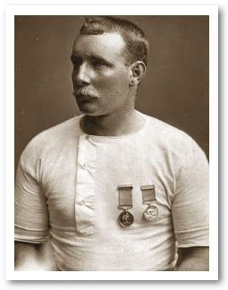  Captain Matthew Webb

Many of the hardships that Matthew Webb had to deal with during his pioneering swim are still faced by modern-day Channel swimmers. In fact, some of his methods for dealing with these hardships are still used today. Webb coated himself in oil for protection against the cold and jellyfish stings. He was also accompanied by boats so his friends could protect and feed him. It must be said, however, that the ale, brandy and beef tea they supplied are not standard for today’s cross-Channel swimmers! | 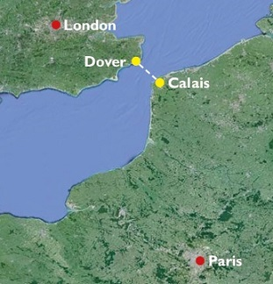

Frequently asked questions

Q: How cold is the water?

A: The water temperature can range from 12°C to 18°C. Most people would consider water below 20°C too cold for swimming.

Q: How far is it from England to France?

A: The direct distance from Dover to Cape Gris Nez near Calais is approximately 21 miles, but a swimmer always swims further than that due to the movement of tides.

Q: How long does it take to swim across the Channel?

A: How fast do you swim? The faster you are, the more direct your swim will be. A slower swimmer will not only take longer but will have to swim further because of the tides and currents. Swimmers also have to plan stops for feeding. The fastest recorded crossing is 7 hours; the slowest is nearly 29 hours. An average swimmer doing two miles per hour would be in the water for up to 16 hours, but a stronger swimmer may take only 10 hours.

Q: Will you succeed if you train hard?

A: Preparation for a Channel swim involves months of training in very cold ocean water. But even this does not guarantee success. Fewer people have swum the English Channel than have climbed Mount Everest, the world’s highest mountain! Some hazards of the swim include hypothermia (dangerous loss of body heat), seasickness and jellyfish. Unforeseen obstacles like rubbish floating in the sea can also cause problems no matter how hard you train.

Q: Why do people swim the English Channel?

A: That isn’t a question with a single answer! The motivations for such a venture are as varied as the swimmers. Some people do it for glory, some to raise money for charity, but most do it to challenge themselves and for the satisfaction of being one of a select few to achieve this feat.
Safe to swim?  The French and UK coastguards are responsible for search and rescue operations in the English Channel. The French authorities outlawed swimming from France to England in 1993 for safety reasons. Then in 2010 the deputy director of the French coastguard, Jean-Christophe Burvingt, said he was in favour of a complete ban on swimming in either direction. He pointed out that the swim uses the same stretch of water as 500 vessels each day. Critics compare the swim to crossing a motorway on foot; supporters say the swim is well regulated and comparatively safe. |  | Celebrity swimmer
 |  | The author, comedian and actor, David Walliams, says that he was never sporty at school but he did enjoy swimming. | 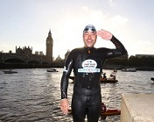
 |  | While preparing for his Channel swim, Walliams didn’t miss a single training session in nine months. He knew that more than 90 per cent of people who attempt the swim fail. Walliams took 10 hours and 34 minutes to cross the Channel. His swim raised more than £1 million in donations for the charity Sport Relief.

. 1. Nearly twenty-two hours later, the exhausted man staggered onto French soil at Calais and became an instant hero.

Find and copy two different words from the sentence above that show how tired Matthew Webb was.

1. ____________________________________________________________

2. ____________________________________________________________

1 mark

2. What event made Matthew Webb want to swim the English Channel?

______________________________________________________________

______________________________________________________________

1 mark

3. Look at the paragraph beginning: Twenty-seven-year-old Webb...

Find and copy one word from this paragraph that is closest in meaning to ‘motivated’.

____________________________________

1 mark

4. Using information from the text, put a tick in the correct box to show whether each statement is true or false.

 | True | False
Matthew Webb’s first attempt to swim the English Channel was not successful.
The first successful swim of the English Channel was in 1872.
J.B. Thompson and Matthew Webb swam the English Channel in 1875.
Matthew Webb took twenty hours to swim the English Channel.

2 marks

5. Name two of the hardships that Matthew Webb faced in swimming the English Channel and explain how he dealt with them.

1. Hardship: _________________________________________________

How he dealt with it: _________________________________________

2. Hardship: _________________________________________________

How he dealt with it: _________________________________________

2 marks

6. Find and copy a group of words that tells you that the drinks of ale, brandy and beef tea given to Matthew Webb would be considered unusual today.

____________________________________

1 mark

7. Why do slow Channel swimmers swim further than faster swimmers?

______________________________________________________________

1 mark

8. Look at the section headed: Frequently asked questions.

How long did the fastest swim across the Channel take?

______________________________________________________________

1 mark

9. Look at the section headed: Frequently asked questions.

Put a tick in the correct box to show whether each of the following statements is a fact or an opinion.

 | Fact | Opinion
The temperature of the water in the Channel can range from 12°C to 18°C.
Water with a temperature of 18°C is too cold to swim in.
The direct distance across the Channel is approximately 21 miles.
Faster swimmers do not swim as many miles across the Channel.

2 marks

10. In what year did the French authorities make it illegal for people to swim from France to England?

____________________________________

1 mark

11. Look at the section headed: Safe to swim?

Find and copy one word which shows that swimming the Channel is illegal in France.

____________________________________

1 mark

12. David Walliams was determined to be successful in his attempt to swim the English Channel.

Give one piece of evidence from the text which shows this.

______________________________________________________________

______________________________________________________________

1 mark

13. Which of the following would be the most suitable summary of the whole text?

Tick one.
The Life of David Walliams
A Sporting Challenge
Sailing the Channel
Training for Survival

1 mark

14. Draw lines to match each section to its main content.

One has been done for you.

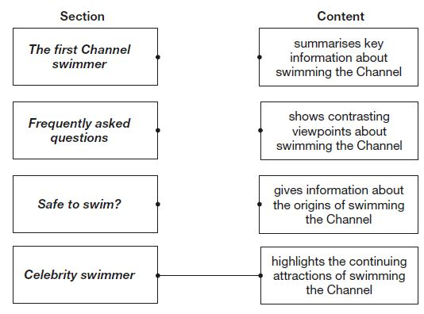

1 mark

1. Content domain: 2a – give / explain the meaning of words in context

Award 1 mark for both of the following:

1. exhausted (man)

2. staggered (onto).

1 mark

2. Content domain: 2b – retrieve and record information / identify key details from fiction and non-fiction

Award 1 mark for reference to the (unsuccessful) attempt, e.g.

• J.B. Thompson failed to swim it in 1872 which inspired him to swim it

• someone failed in 1872

• J.B. Thompson’s attempt.

Do not accept reference to J.B. Thompson alone, e.g.

• he was inspired by J.B. Thompson.

1 mark

3. Content domain: 2a – give / explain the meaning of words in context

Award 1 mark for:

■ inspired.

1 mark

4. Content domain: 2b – retrieve and record information / identify key details from fiction and non-fiction

Award 1 mark for three correct or 2 marks for all four correct:

 | True | False
Matthew Webb’s first attempt to swim the English Channel was not successful. | ✔
The first successful swim of the English Channel was in 1872. |  | ✔
J.B. Thompson and Matthew Webb swam the English Channel in 1875. |  | ✔
Matthew Webb took twenty hours to swim the English Channel. |  | ✔

Up to 2 marks

5. Content domain: 2b – retrieve and record information / identify key details from fiction and non-fiction

Award 1 mark for any of the following combinations of hardship and action up to a maximum of 2 marks:

Hardship | How he dealt with it
■ cold / hypothermia | ■ coated himself in oil
■ jellyfish / stings | ■ coated himself in oil
■ limited access to food / drink | ■ accompanied by friends / boats  ■ food from his friends / boats
■ danger / need for protection | ■ accompanied by friends / boats  ■ protection by his friends / boats

Up to 2 marks

6. Content domain: 2a – give / explain the meaning of words in context

Award 1 mark for:

■ (are) not standard (for today’s cross-Channel swimmers)

1 mark

7. Content domain: 2b – retrieve and record information / identify key details from fiction and non-fiction

Award 1 mark for reference to either of the following:

1. faster swimmers are more direct, e.g.

• The faster you are, the more direct your swim will be.

2. tides and / or currents, e.g.

• because of the tides and currents.

Also accept references to being pushed / pulled off course, e.g.

• waves take them off course.

1 mark

8. Content domain: 2b – retrieve and record information / identify key details from fiction and non-fiction

Award 1 mark for:

■ 7 hours.

Do not accept 7 without ‘hours’.

1 mark

9. Content domain: 2d – make inferences from the text / explain and justify inferences with evidence from the text

Award 1 mark for three correct or 2 marks for all four correct:

 | Fact | Opinion
The temperature of the water in the Channel can range from 12°C to 18°C. | ✔
Water with a temperature of 18°C is too cold to swim in. |  | ✔
The direct distance across the Channel is approximately 21 miles. | ✔
Faster swimmers do not swim as many miles across the Channel. | ✔

Up to 2 marks

10. Content domain: 2b – retrieve and record information / identify key details from fiction and non-fiction

Award 1 mark for:

■ 1993.

1 mark

11. Content domain: 2a – give / explain the meaning of words in context

Award 1 mark for:

■ outlawed.

Also accept ban.

1 mark

12. Content domain: 2d – make inferences from the text / explain and justify inferences with evidence from the text

Award 1 mark for reference to either of the following:

1. he did not miss a training session, e.g.

• David showed up to all the training sessions.

2. he trained for nine months.

1 mark

13. Content domain: 2c – summarise main idea from more than one paragraph

Award 1 mark for:

The Life of David Walliams
A Sporting Challenge
Sailing the Channel
Training for Survival

1 mark

14. Content domain: 2f – identify / explain how information / narrative content is related and contributes to meaning as a whole

Award 1 mark for all correctly matched:

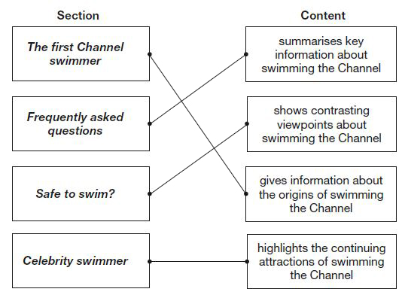

1 mark

Monday Maths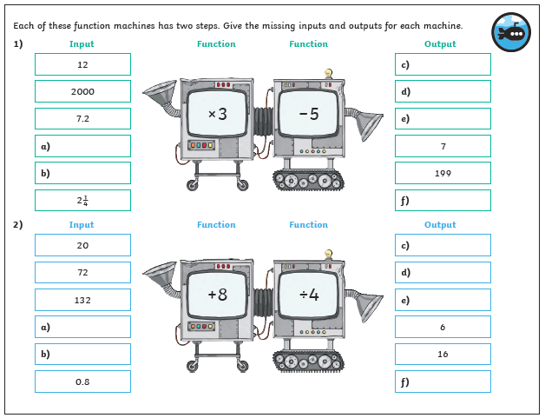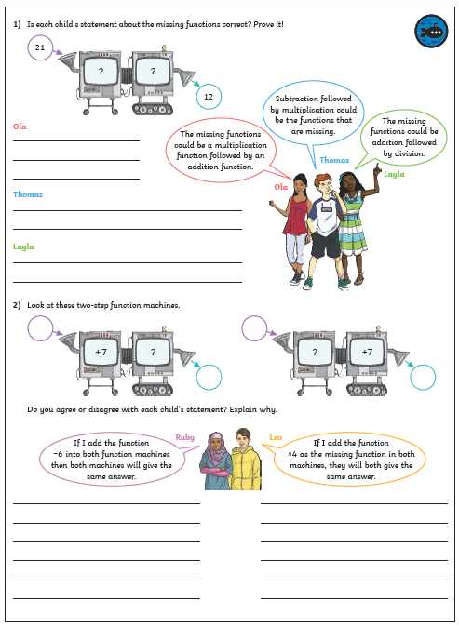
Maths Answers
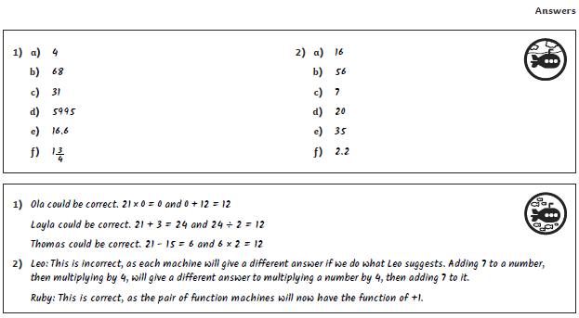
Monday – PE
https://youtu.be/0_-dqSQlTW8
Make a ‘catcher’ then try to get the ball inside by swinging the ball in different ways.
