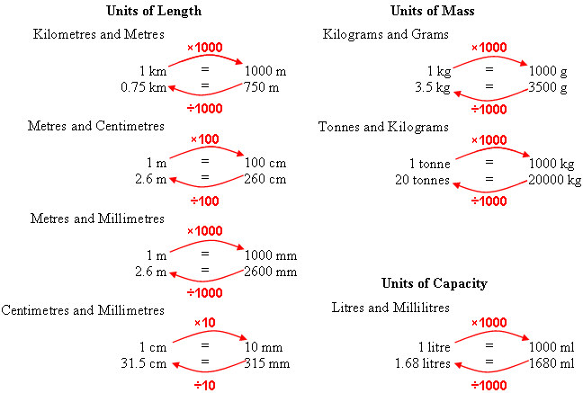
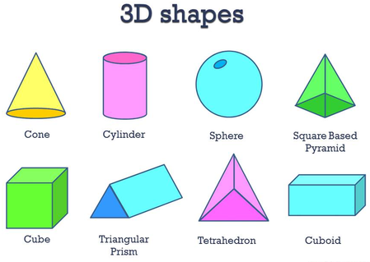

Area of Shapes (eg. cm², mm²)
To calculate the area of a parallelogram, rectangle or square:

Length x Width
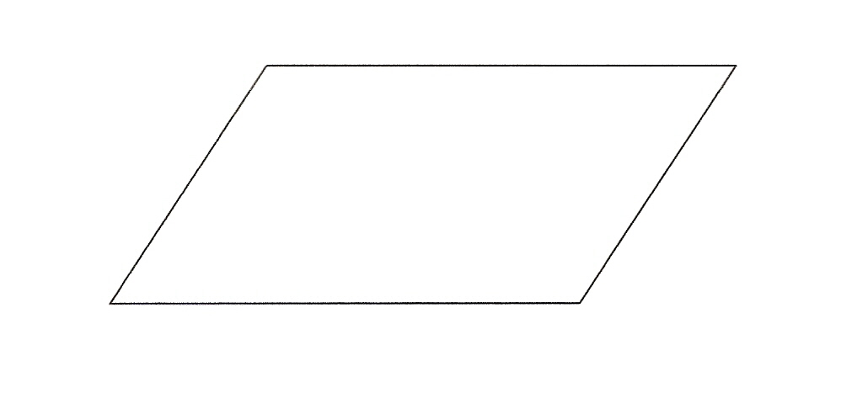
To calculate the area of triangle (eg. cm², mm²) :
(Base x Height) ÷ 2
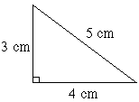
Volume: (Remember cm³)
Length x Width x Height
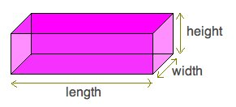

Angle Sums
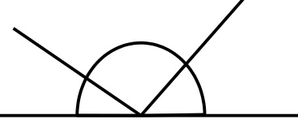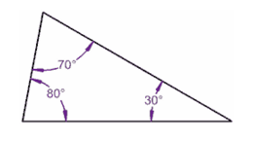
Straight Line and a triangle = 180°
Regular/ Irregular
In regular shapes, all of the angles are the same and all the sides are the same length.
In irregular shapes, the angles or sides are different.
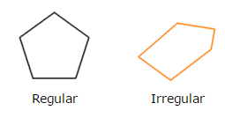
Circles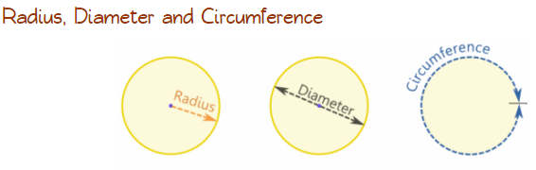

Angle Sums
Quadrilaterals and about a point = 360°
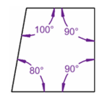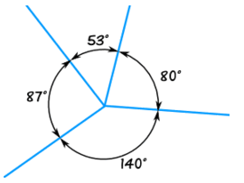
Parallel and Perpendicular
-Parallel lines or sides stay
The same distance apart.

-Perpendicular lines or sides
Meet at right angles.

The diameter is double the radius. The circumference is the distance around the circle.
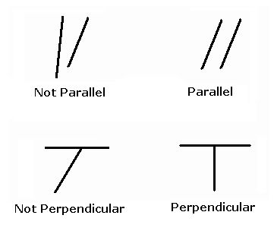
Perimeters of Shapes
The perimeter is the distance around a shape.
To calculate the perimeter, you add up lengths:

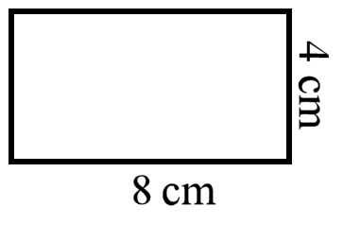
4cm + 4cm + 8cm + 8cm = 24cm
Perimeter of a compound shape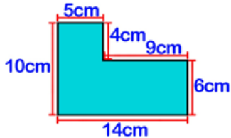
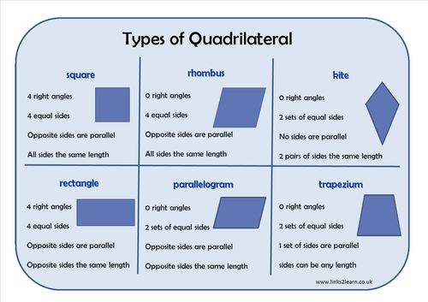
Days in a Month
30 days have September, April, June and November,
All the rest have 31,
Except February alone,
It has 28 days clear,
And 29 in each leap year.

Remember, in a year, there are: 52 weeks, 12 months or 365 days.
Types of Angles
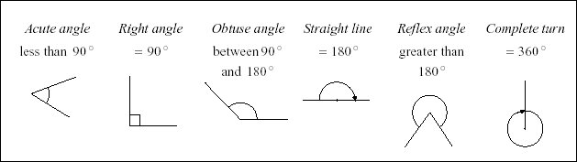
Roman Numerals
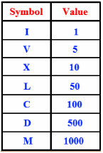
Prime Numbers
A number that is only divisible by itself and 1.
2, 3, 5, 7 (not 9) 11

Factors:
Factors divide into a number exactly.
Eg. The factors of 6 are: 1, 6, 2 and 3

Multiples
Think Times tables.
Multiples of 3 are: 6, 9, 12, 15 etc.

Squared Numbers
5² = 5 x 5 =25
Cubed Numbers:
5³ = 5 x 5 = 25 x 5 = 125

Averages
Hey Diddle, Diddle,
The median’s the Middle,
You Add and Divide for the Mean,
The Mode is the one that Appears the Most,
And the Range is the Difference Between
Maths Revision made Easy

