**This week’s homework (01.06.20).**

I have broken down your homework into

topics: Check in, Phonics/handwriting, Maths and Mindfulness/PE/Topic. I recommend that you do these topics in this order as they mirror your school day.

You still need to practice the days of the week and writing your name in your best handwriting. Pages for this are at the end of the workpack.

Try your best to get through all of this work, but don’t worry if it’s too difficult. I am so proud of you for adapting to your new school day - you are a superstar!



**Contents page**

Monday page 2

Tuesday page 7

Wednesday page 14

Thursday page 21

Friday page 28

**Monday 1st June 2020**

**Check in:**

How are you feeling today? Are worried, concerned or anxious about anything? Talk to someone at home about your feelings, or email me and I’ll email you back! Draw a picture below to show how you are feeling.

**Write your name in Monday’s box on page 34**

**Copy the word Monday on page 35**

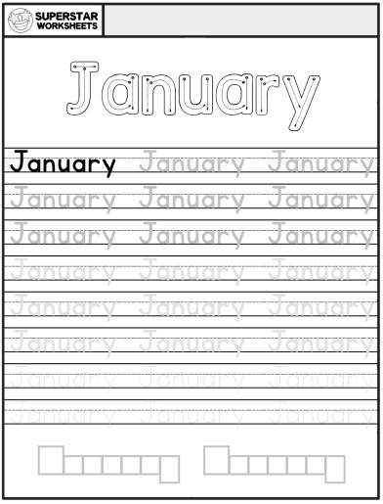

**Phonics/Handwriting**

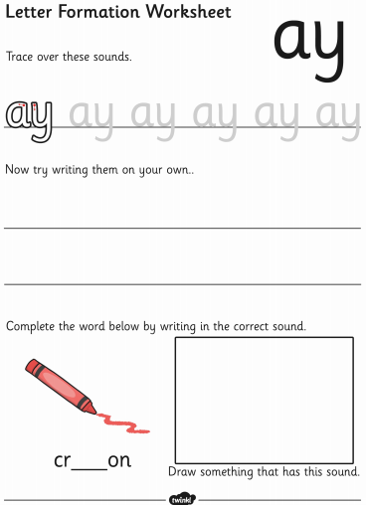

**Maths:**

**Go to Supermovers and practice your 6x table.**

[**https://www.bbc.co.uk/teach/supermovers/ks2-maths-the-6-times-table-with-fred-the-red/zrq3xyc**](https://www.bbc.co.uk/teach/supermovers/ks2-maths-the-6-times-table-with-fred-the-red/zrq3xyc)

**Now try to complete the questions on the next page.**

**Ask a grown-up if there are other ways you can practise Maths at home. Can you count things in your house?**

**Afternoon**

**PE:**

**It’s time for some Yoga! Go to the link below to choose a video and complete the exercises**

**https://www.youtube.com/user/CosmicKidsYoga**

**Well done! You have completed today’s homework!**

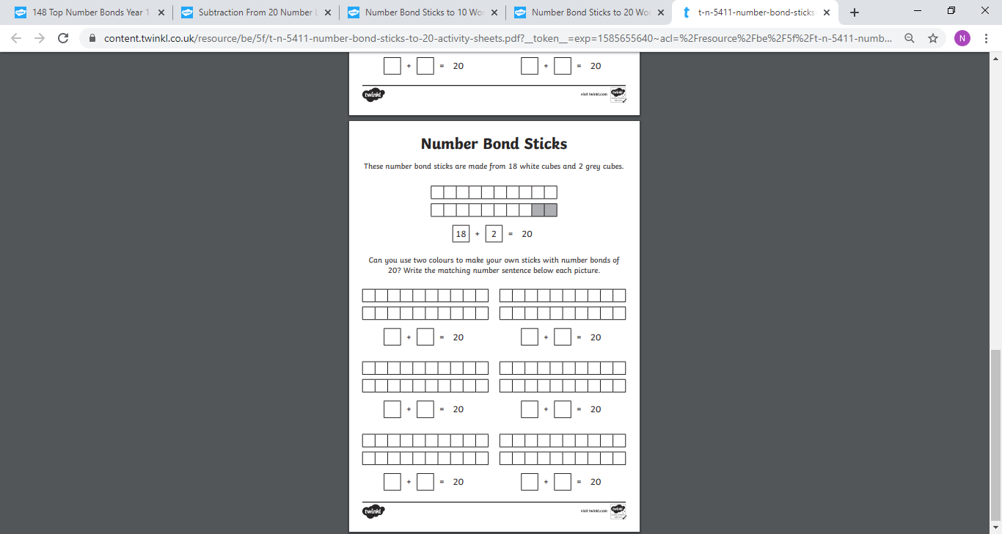

**Tuesday 2nd June 2020**

**Check in:**

How are you feeling today? Are worried, concerned or anxious about anything? Talk to someone at home about your feelings, or email me and I’ll email you back! Draw a picture below to show how you are feeling.

**Write your name in Tuesday’s box on page 34. Copy the word Tuesday on page 35**

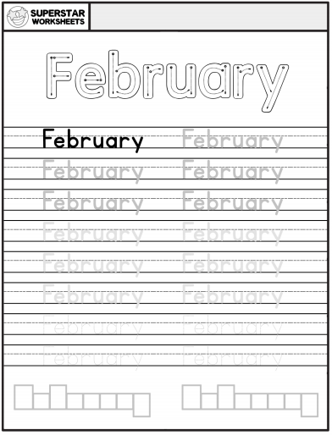

**Phonics/Handwriting:**

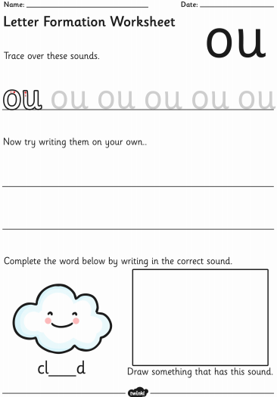

**Maths:**

**Go to Supermovers and practice your 6x table.**

[**https://www.bbc.co.uk/teach/supermovers/ks2-maths-the-6-times-table-with-fred-the-red/zrq3xyc**](https://www.bbc.co.uk/teach/supermovers/ks2-maths-the-6-times-table-with-fred-the-red/zrq3xyc)

**Now try to complete the questions on the next page.**

**Ask a grown-up if there are other ways you can practise Maths at home. Can you add items in your house?**

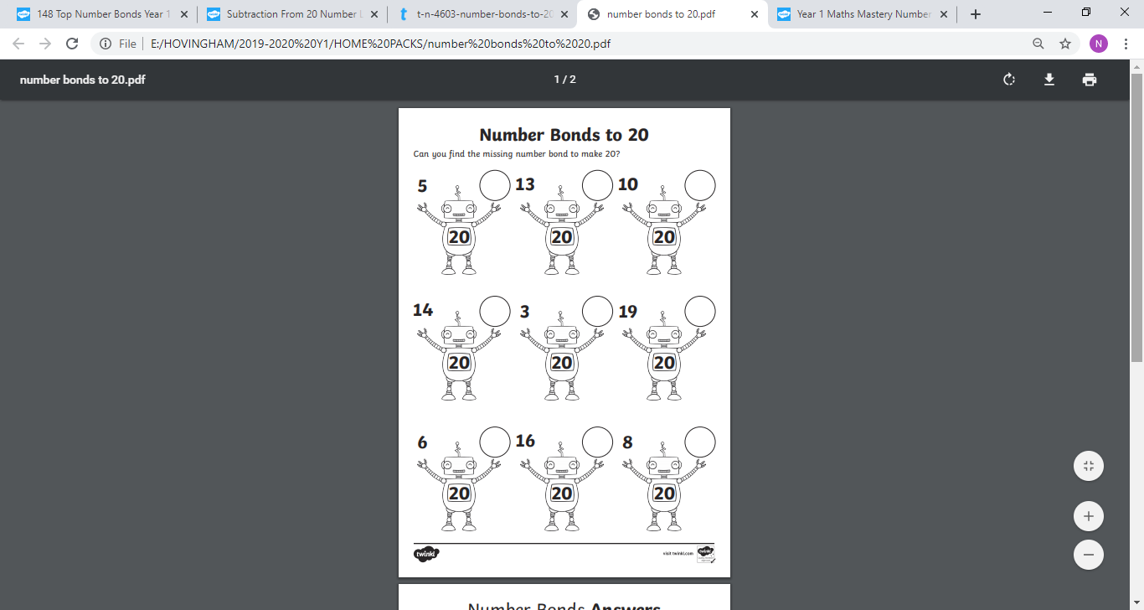

**Mindfulness/RE:**

**You may have celebrated Eid with your family and friends over half term. Colouring can make us feel calm and happy. Colour the Eid themed pictures as brightly as you can.**

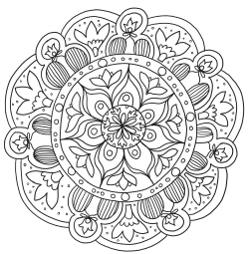

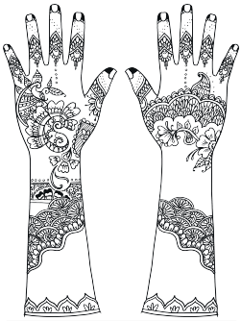

**Well done! You have completed today’s homework!**

**Wednesday 3rd June 2020**

**Check in:**

How are you feeling today? Are worried, concerned or anxious about anything? Talk to someone at home about your feelings, or email me and I’ll email you back! Draw a picture below to show how you are feeling.

**Write your name in Wednesday’s box on page 34. Copy the word Wednesday on page 35**

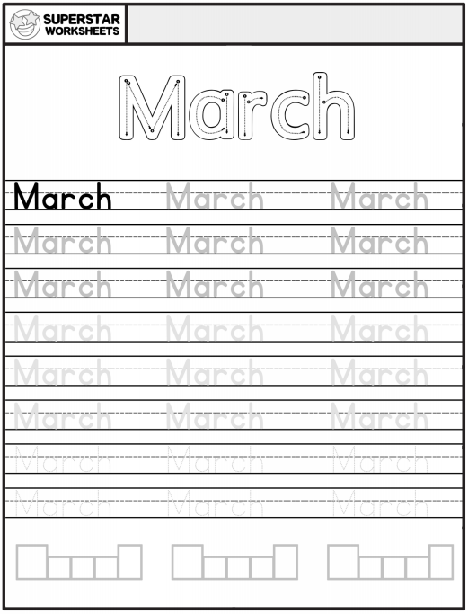

**Phonics/Handwriting:**

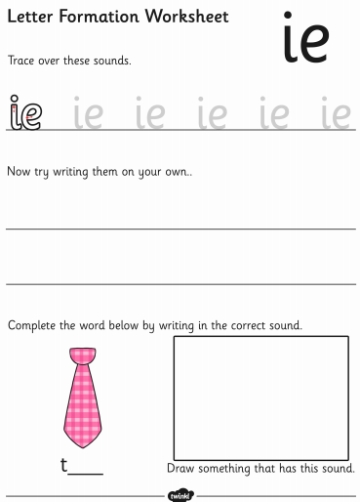

**Maths:**

**Go to Supermovers and practice your 6x table.**

[**https://www.bbc.co.uk/teach/supermovers/ks2-maths-the-6-times-table-with-fred-the-red/zrq3xyc**](https://www.bbc.co.uk/teach/supermovers/ks2-maths-the-6-times-table-with-fred-the-red/zrq3xyc)

**Now try to complete the questions on the next page**

**Ask a grown-up if there are other ways you can practise Maths at home. Can you subtract items in your house?**

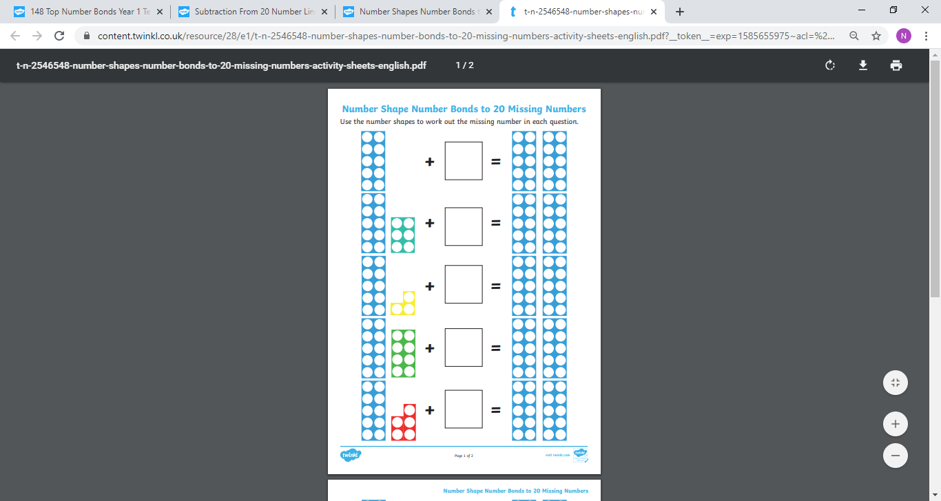

**RE:**

**How did you celebrate Eid? On the next page draw a picture in each box to show a different way of celebrating the festival. If there are ways of celebrating that you weren’t able to do this year, draw them anyway. You can look forward to doing them in the future.**

**Well done! You have completed today’s homework**

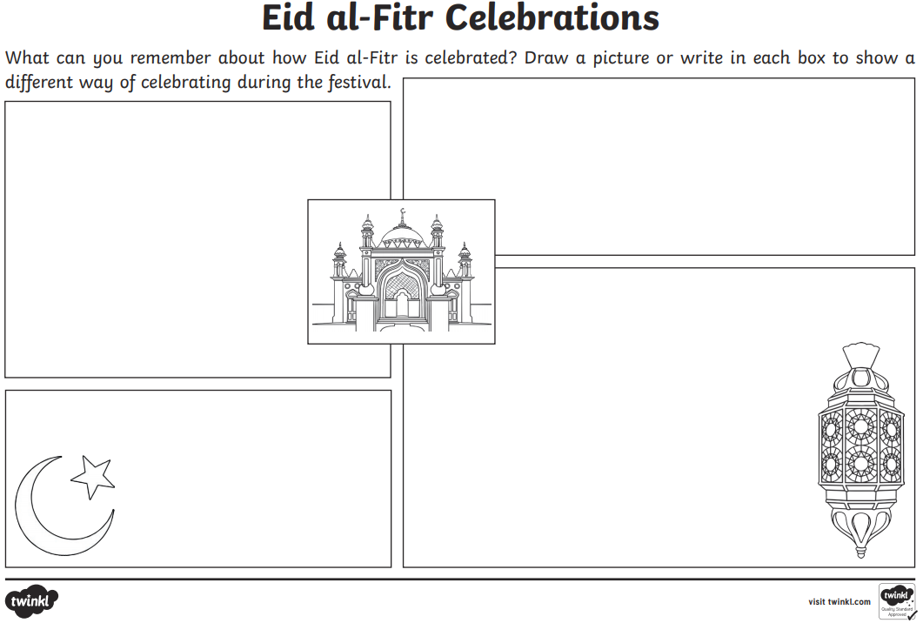

**Thursday 4 June 2020**

**Check in:**

How are you feeling today? Are worried, concerned or anxious about

anything? Talk to someone at home about your feelings, or email me and I’ll email you back! Draw a picture below to show how you are feeling.

**Write your name in Thursday’s box on page 34. Copy the word Thursday on page 35**

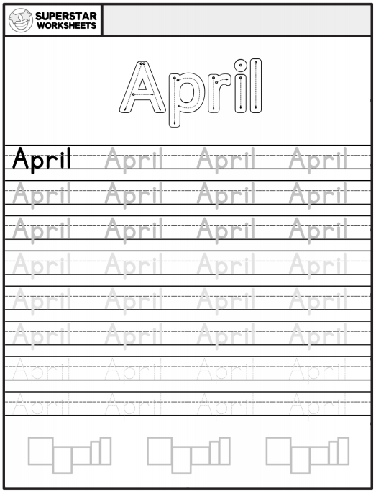

**Phonics/Handwriting:**

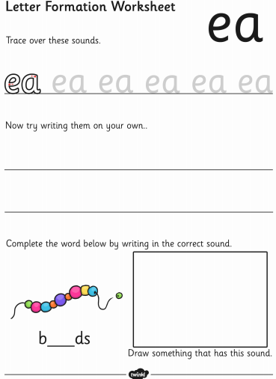

**Maths:**

**Go to Supermovers and practice your 6x table.**

[**https://www.bbc.co.uk/teach/supermovers/ks2-maths-the-6-times-table-with-fred-the-red/zrq3xyc**](https://www.bbc.co.uk/teach/supermovers/ks2-maths-the-6-times-table-with-fred-the-red/zrq3xyc)

**Now try to complete the questions on the next 2 pages..**

**Then ask a grown-up if there are other ways you can practise Maths at home. Can you put items in groups in your house?**

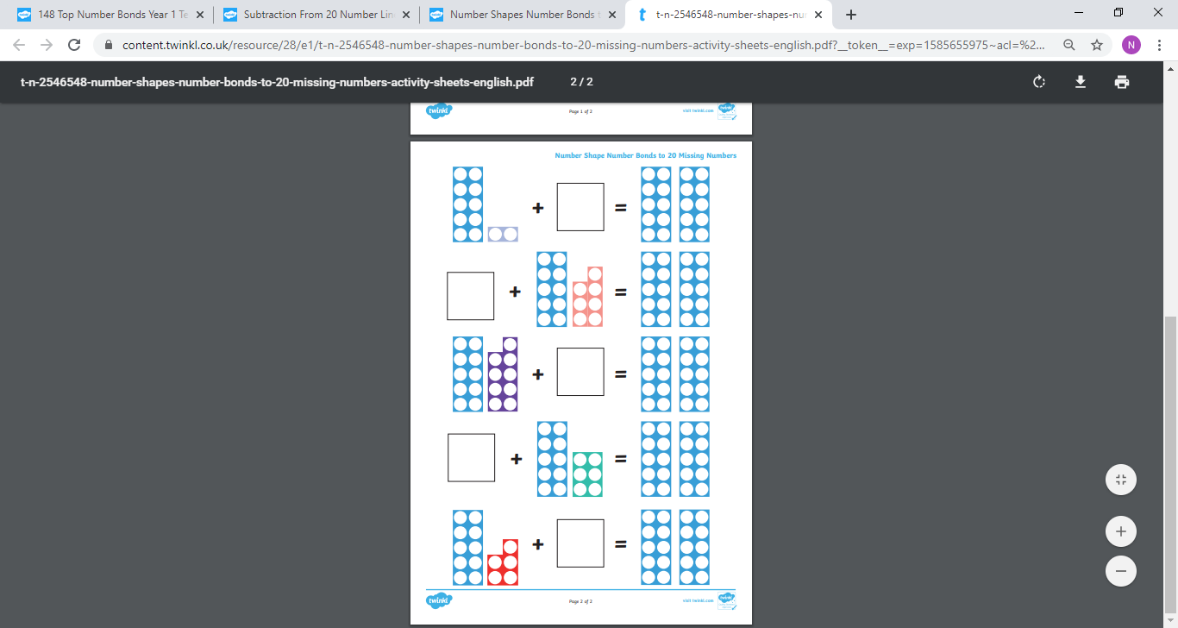

**RE:**

**Complete the Eid themed word search on the next page. Remember they can go across, down diagonally.**

**Well done! You have completed today’s homework!**

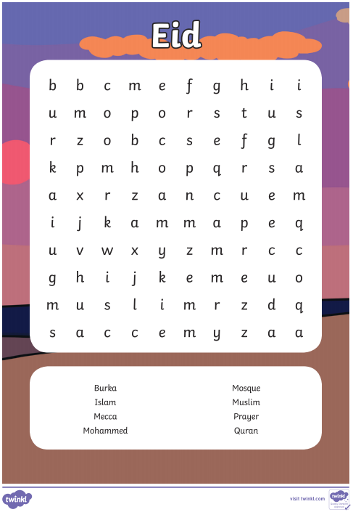

**Friday 5th June 2020**

**Check in:**

How are you feeling today? Are worried, concerned or anxious about

anything? Talk to someone at home about your feelings, or email me and I’ll email you back! Draw a picture below to show how you are feeling.

**Write your name in Friday’s box on page 34.**

**Copy the word Friday on page 35**

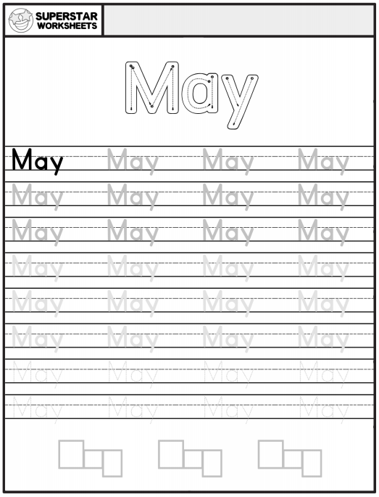

**Phonics/Handwriting:**

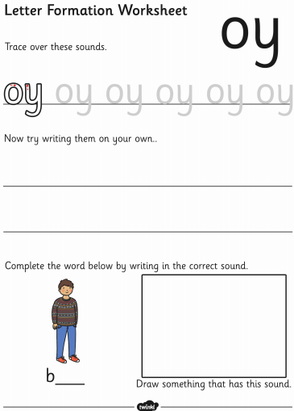

**Maths:**

**Go to Supermovers and practice your 6x table.**

[**https://www.bbc.co.uk/teach/supermovers/ks2-maths-the-6-times-table-with-fred-the-red/zrq3xyc**](https://www.bbc.co.uk/teach/supermovers/ks2-maths-the-6-times-table-with-fred-the-red/zrq3xyc)

**Now try to complete these questions**

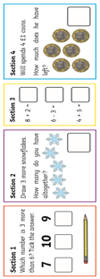

 **Ask a grown-up if there are other ways you can practise Maths at home. Can you put items in order in your house from smallest to biggest?**

**PE:**

**It’s time for PE! Go to the website below and complete today’s workout:**

[**https://www.youtube.com/playlist?list=PLyCLoPd4VxBudCnXPQCehUq4iBnmPTKZm**](https://www.youtube.com/playlist?list=PLyCLoPd4VxBudCnXPQCehUq4iBnmPTKZm)

**Well done! You have completed today’s homework!**

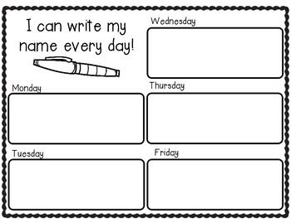

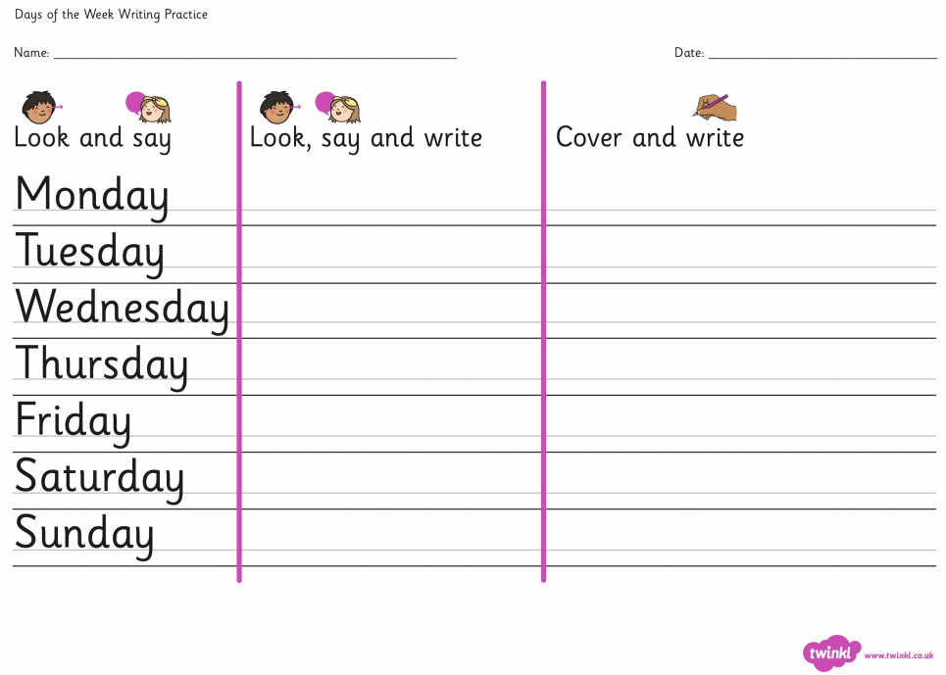

**Parents, if you need extra work for your child please email** [**year6.year6@hovingham.org**](mailto:year6.year6@hovingham.org) **and ask for more green group resources. I will get back to you as soon as I can.**

**In the meantime, you may also want to have a look at the pack for 6PN and 6SD on the Year 6 website.**

**On there, you will also find resources related to transition to high school as well as links to online education websites.**