**This week’s homework (04.05.20).**

I have broken down your homework into

topics: Check in, Phonics/handwriting, Maths and Mindfulness/PE/Topic. I recommend that you do these topics in this order as they mirror your school day.

You still need to practice the days of the week and writing your name in your best handwriting.

Try your best to get through all of this work, but don’t worry if it’s too difficult. I am so proud of you for adapting to your new school day - you are a superstar!



**Contents page**

Monday page 2

Tuesday page 8

Wednesday page 15

Thursday page 22

Friday page 30

**Monday 4th May 2020**

**Check in:**

How are you feeling today? Are worried, concerned or anxious about anything? Talk to someone at home about your feelings, or email me and I’ll email you back! Draw a picture below to show how you are feeling.

**Write your name in Monday’s box on page 33**

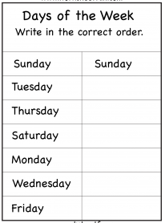

**Phonics/Handwriting**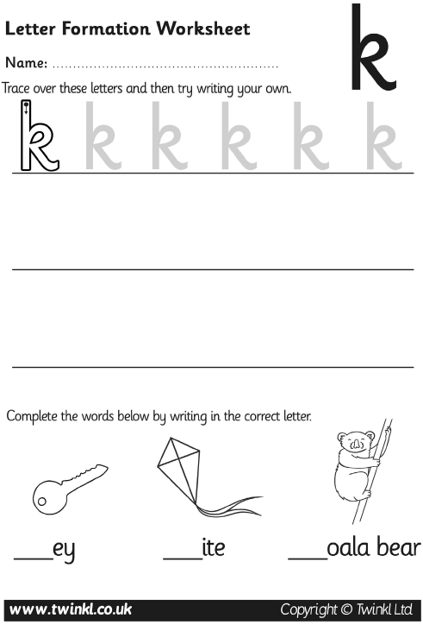

**Maths:**

**Go to Supermovers and practice your 10x table.**

**https://www.bbc.co.uk/teach/supermovers/ks1-maths-the-10-times-table-with-webster-the-spider/zm32cqt**

**Now try to complete these questions.**

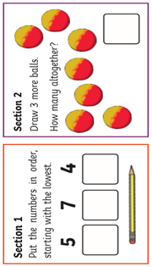

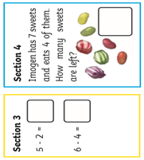

**Ask a grown-up if there are other ways you can practise Maths at home. Can you count things in your house?**

**PE:**

**It’s time for some Yoga! Go to the link below to choose a video and complete the exercises**

**https://www.youtube.com/user/CosmicKidsYoga**

**Well done! You have completed today’s homework!**

**Tuesday 5th May 2020**

**Check in:**

How are you feeling today? Are worried, concerned or anxious about anything? Talk to someone at home about your feelings, or email me and I’ll email you back! Draw a picture below to show how you are feeling.

**Write your name in Tuesday’s box on page 33**

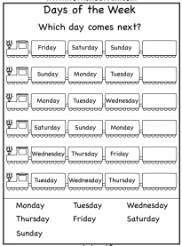

**Phonics/Handwriting:**

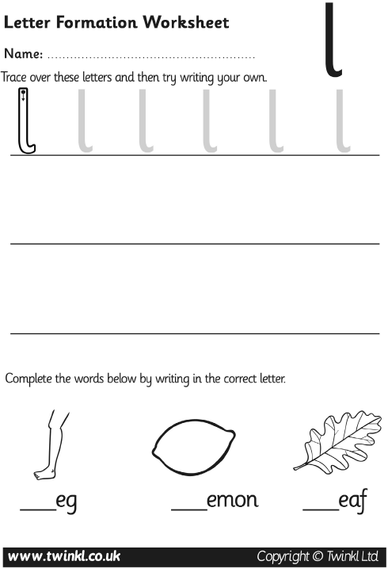

**Maths:**

**Go to Supermovers and practice your 10x table.**

**https://www.bbc.co.uk/teach/supermovers/ks1-maths-the-10-times-table-with-webster-the-spider/zm32cqt**

**Now try to complete these questions.**

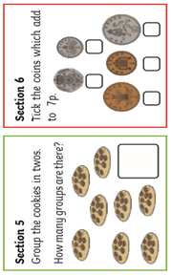

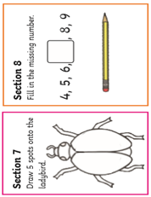

**Ask a grown-up if there are other ways you can practise Maths at home. Can you add items in your house?**

**RE:**

**You may be celebrating Ramadan with your family at the moment. Colour the Ramadan themed pictures**



**Well done! You have completed today’s homework!**

**Wednesday 6th May 2020**

**Check in:**

How are you feeling today? Are worried, concerned or anxious about anything? Talk to someone at home about your feelings, or email me and I’ll email you back! Draw a picture below to show how you are feeling.

**Write your name in Wednesday’s box on page 33**

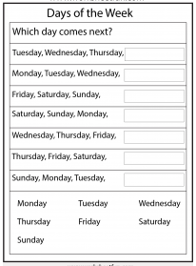

**Phonics/Handwriting:**

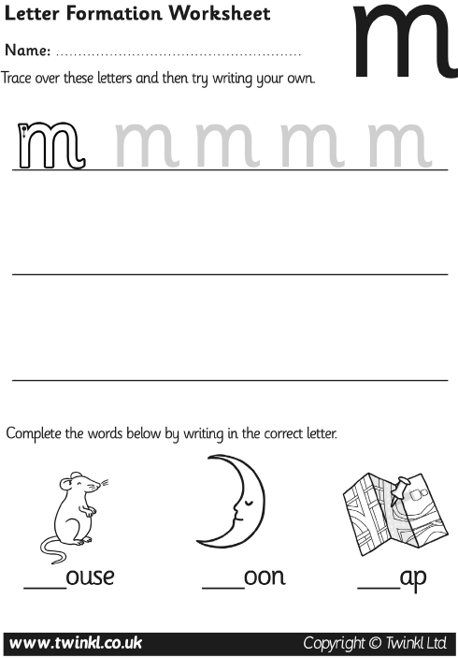

**Maths:**

**Go to Supermovers and practice your 10x table.**

**https://www.bbc.co.uk/teach/supermovers/ks1-maths-the-10-times-table-with-webster-the-spider/zm32cqt**

**Now try to complete these questions**

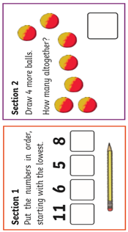

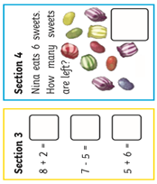

**Ask a grown-up if there are other ways you can practise Maths at home. Can you subtract items in your house?**

**PSHE:**

**Things are very strange at the moment and life isn’t normal. It’s ok to feel sad sometimes, but it’s important to think about what we can still be grateful for. On the next page are instructions for making a gratitude jar. Ask an adult to help you make one or a poster if you don’t have a spare jar.**

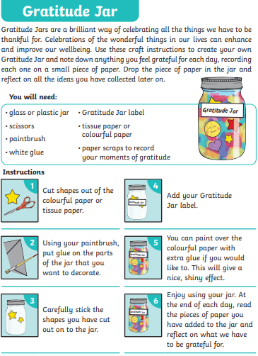

**Well done! You have completed today’s homework!**

**Thursday 7th May 2020**

**Check in:**

How are you feeling today? Are worried, concerned or anxious about

anything? Talk to someone at home about your feelings, or email me and I’ll email you back! Draw a picture below to show how you are feeling.

**Write your name in Thursday’s box on page 33.**

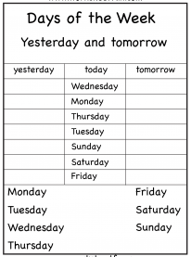

**Phonics/Handwriting:**

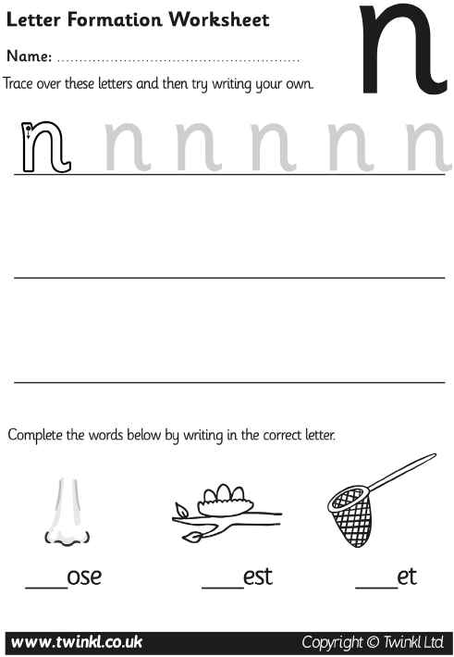

**Maths:**

**Go to Supermovers and practice your 10x table.**

**https://www.bbc.co.uk/teach/supermovers/ks1-maths-the-10-times-table-with-webster-the-spider/zm32cqt**

**Now try to complete these questions.**

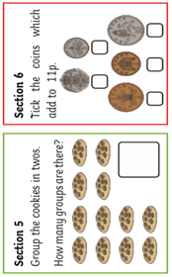

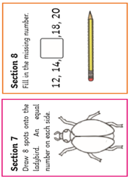

**Then ask a grown-up if there are other ways you can practise Maths at home. Can you put items in groups in your house?**

**PSHE:**

**You will be going to high school in September. You will have new teachers who will love getting to know you. Today you need to write a letter introducing yourself to your new teacher.**

**Use the word mats and prompt pages to help you. Email me a photo of it when you have completed it so I can give you some feedback!**

**Well done! You have completed today’s homework!**

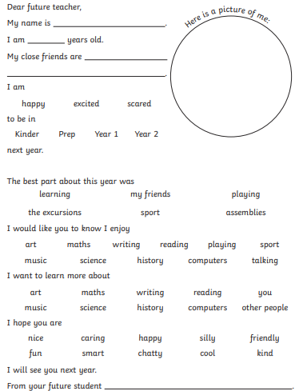

Year 7

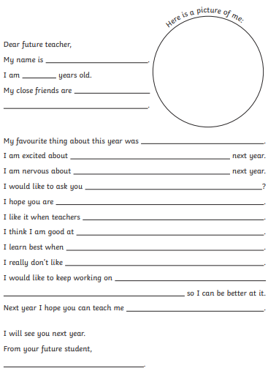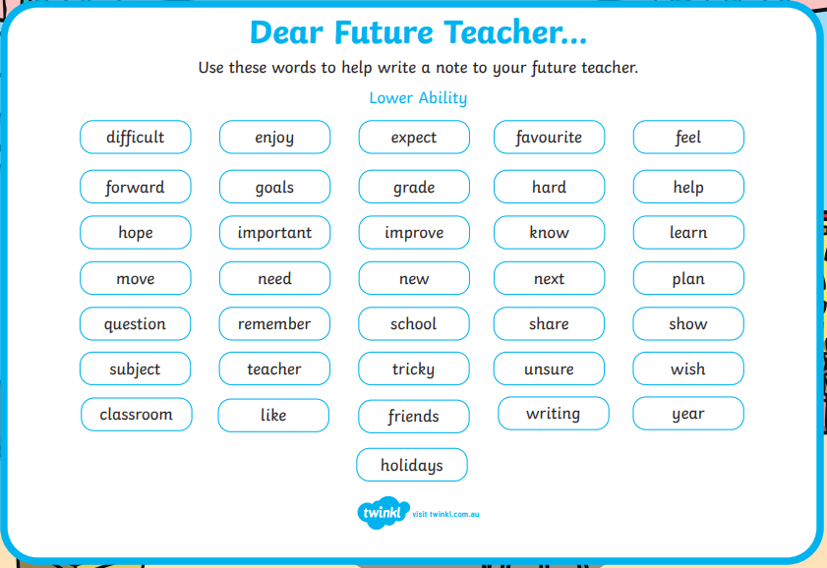

**Friday 8th May 2020**

**Check in:**

How are you feeling today? Are worried, concerned or anxious about

anything? Talk to someone at home about your feelings, or email me and I’ll email you back! Draw a picture below to show how you are feeling.

**Write your name in Friday’s box on page 33.**

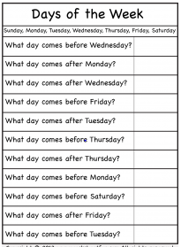

**Phonics/Handwriting:** 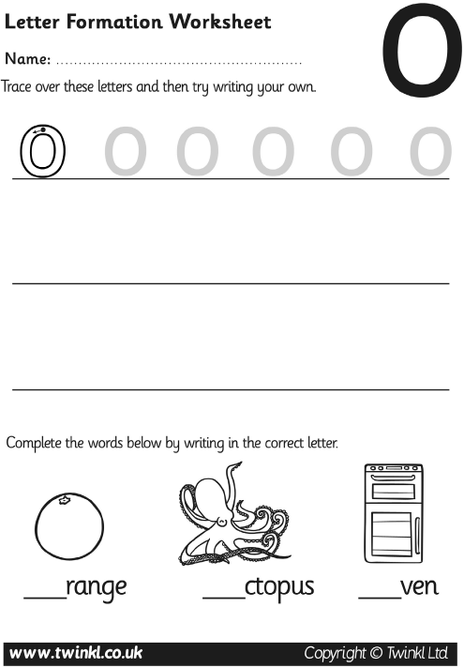

**Maths:**

**Go to Supermovers and practice your 10x table.**

**https://www.bbc.co.uk/teach/supermovers/ks1-maths-the-10-times-table-with-webster-the-spider/zm32cqt**

**Now try to complete these questions**

**.** 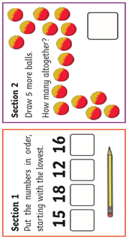

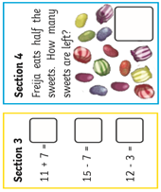

**Ask a grown-up if there are other ways you can practise Maths at home. Can you put items in order in your house from smallest to biggest?**

**PE:**

**It’s time for PE! Go to the website below and complete today’s workout:**

[**https://www.youtube.com/playlist?list=PLyCLoPd4VxBudCnXPQCehUq4iBnmPTKZm**](https://www.youtube.com/playlist?list=PLyCLoPd4VxBudCnXPQCehUq4iBnmPTKZm)

**Well done! You have completed today’s homework!**

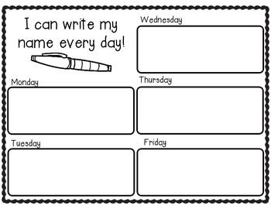

**Extra Maths**

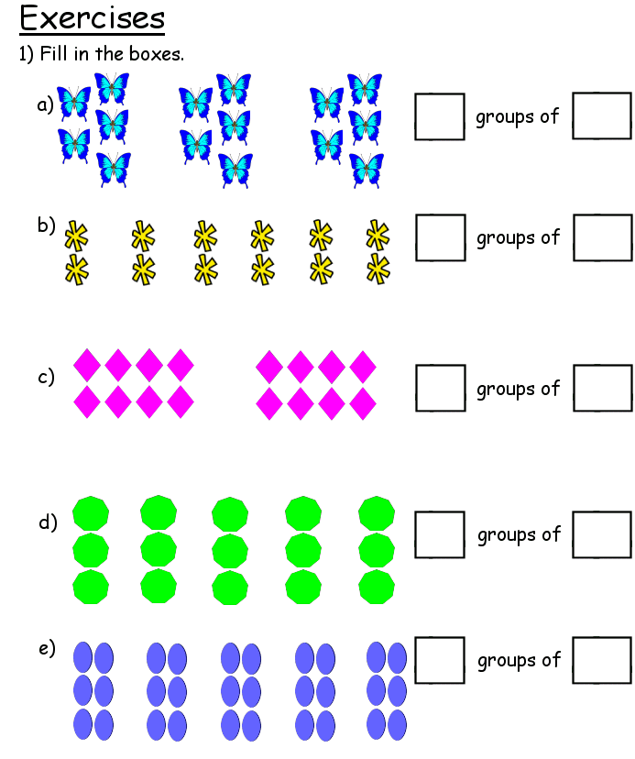

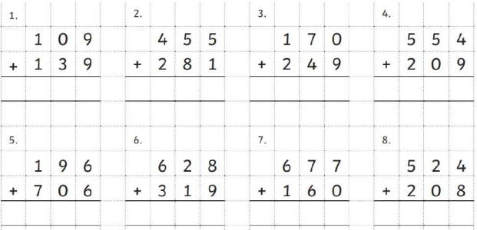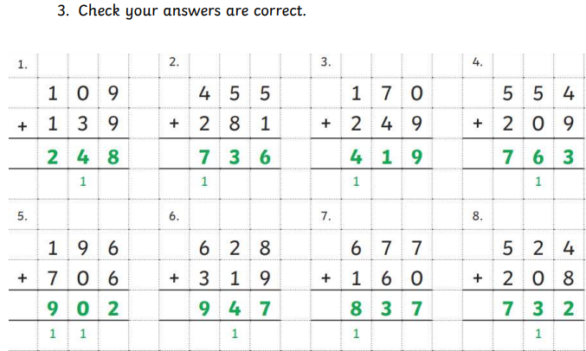

**Parents, if you need extra work for your child please email** [**year6.year6@hovingham.org**](mailto:year6.year6@hovingham.org) **and ask for more green group resources. I will get back to you as soon as I can.**

**In the meantime, you may also want to have a look at the pack for 6PN and 6SD on the Year 6 website.**

**On there, you will also find resources related to transition to high school as well as links to online education websites.**