**This week’s homework (27.04.20).**

I have broken down your homework into

topics: check in, phonics/handwriting, maths and mindfulness/PE. I recommend that you do these topics in this order as they mirror your school day.

Try your best to get through all of this work, but don’t worry if it’s too difficult. I am so proud of you for adapting to your new school day - you are a superstar!



**Contents page**

Monday page 2

Tuesday page 8

Wednesday page 15

Thursday page 22

Friday page 30

**Monday 27th April 2020**

**Check in:**

How are you feeling today? Are worried, concerned or anxious about anything? Talk to someone at home about your feelings, or email me and I’ll email you back! Draw a picture below to show how you are feeling.

**Write your name in Monday’s box on page 36**

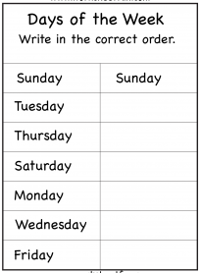

**Phonics/Handwriting**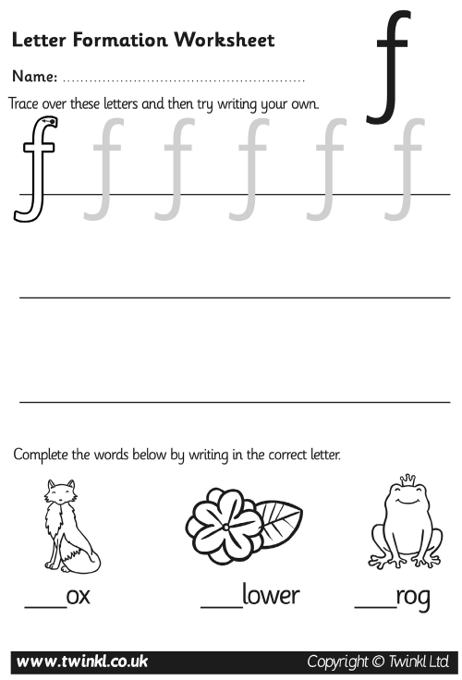

**Maths:**

**Go to Supermovers and practice your 5x table.**

**https://www.bbc.co.uk/teach/supermovers/ks1-maths-the-5-times-table/zhbm47h**

**Now try to complete these questions.**

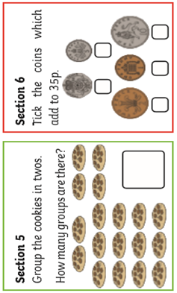

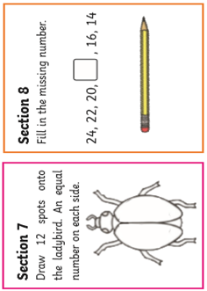

**Ask a grown-up if there are other ways you can practise Maths at home. Can you count things in your house?**

**PE:**

**It’s time for some Yoga! Go to the link below to choose a video and complete the exercises**

**https://www.youtube.com/user/CosmicKidsYoga**

**Well done! You have completed today’s homework!**

**Tuesday 28th April 2020**

**Check in:**

How are you feeling today? Are worried, concerned or anxious about

anything? Talk to someone at home about your feelings, or email me and I’ll email you back! Draw a picture below to show how you are feeling.

**Write your name in Tuesday’s box on page 36**

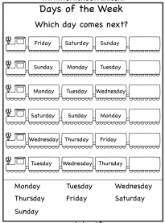

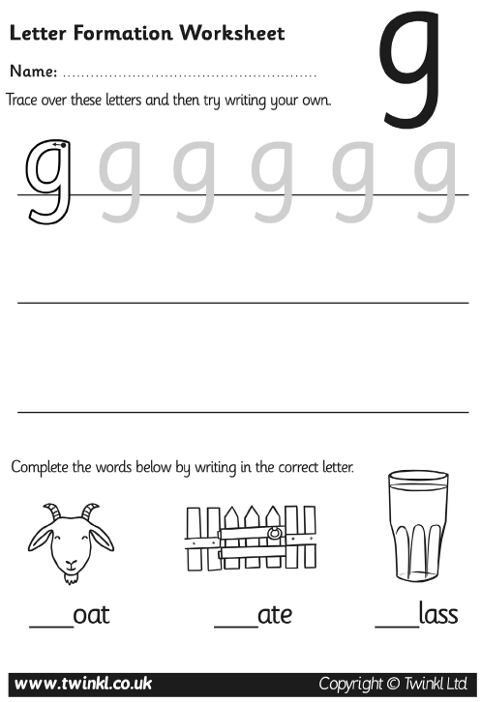

**Maths:**

**Go to Supermovers and practice your 5x table.**

**https://www.bbc.co.uk/teach/supermovers/ks1-maths-the-5-times-table/zhbm47h**

**Now try to complete these questions.**

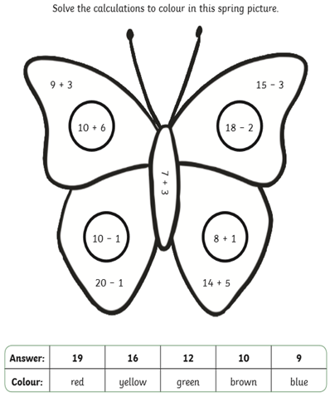

**Ask a grown-up if there are other ways you can practise Maths at home. Can you add items in your house?**

**Topic:**

**This week we will be exploring life on the Seven Continents of the world.**

**Have a look at this video:**

<https://www.youtube.com/watch?v=IlFRPkT-hVc>

Can you identify any of these continents?

Do you recognise any of the animals?

What can you see?

**On the next page, design your own passport. You would need this to be able to visit other countries and continents.**

**Well done! You have completed today’s homework!**

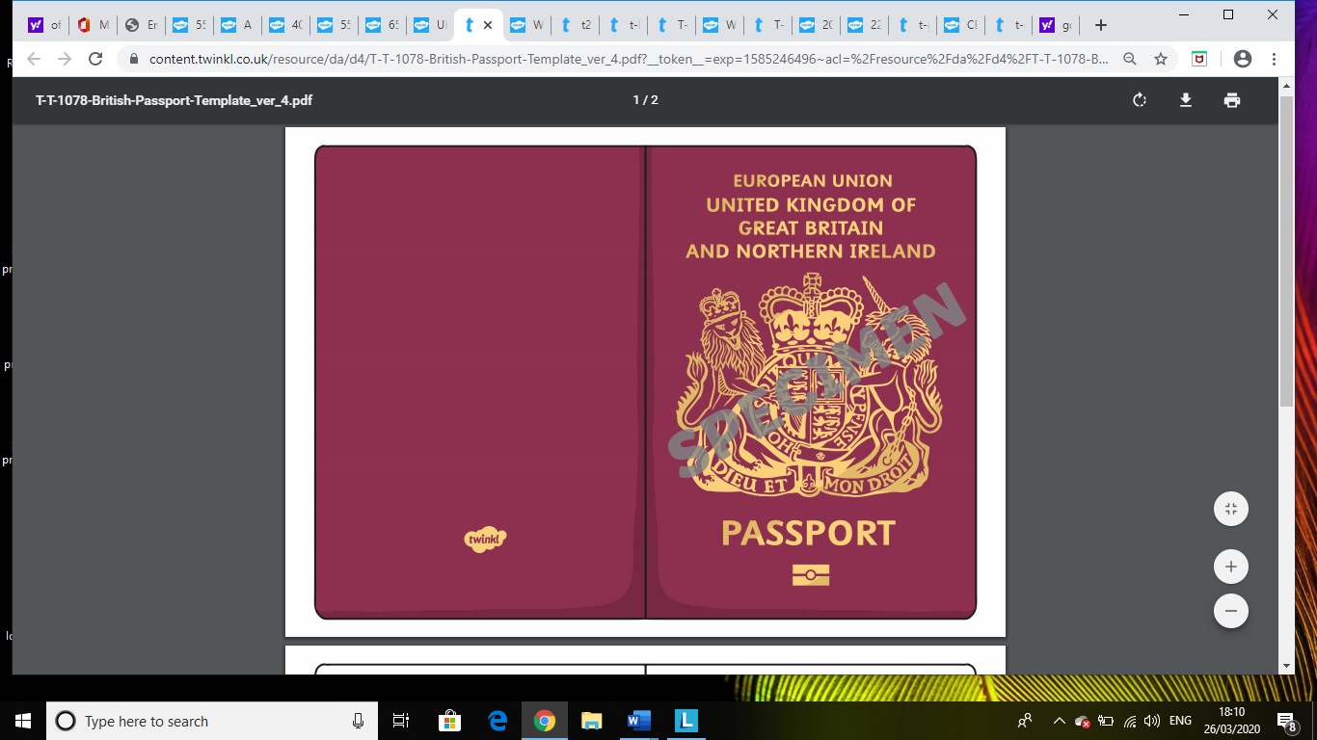

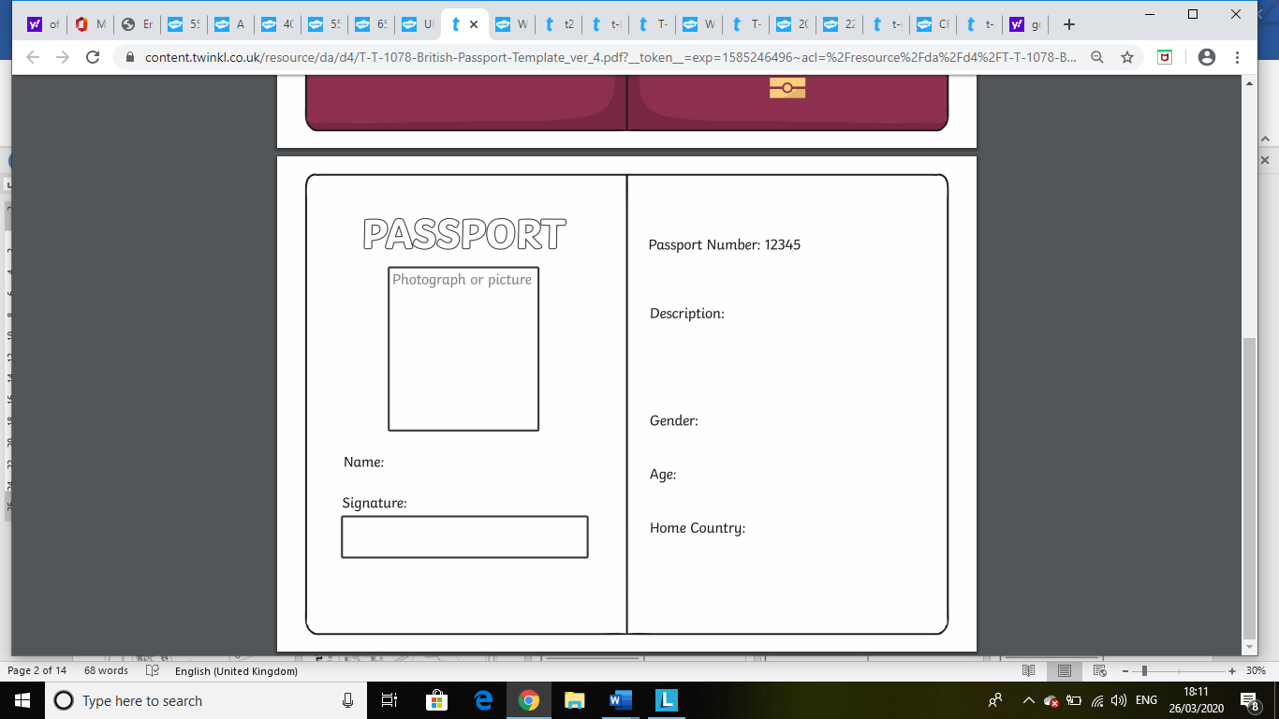

**Wednesday 29th April 2020**

**Check in:**

How are you feeling today? Are worried, concerned or anxious about

anything? Talk to someone at home about your feelings, or email me and I’ll email you back! Draw a picture below to show how you are feeling.

**Write your name in Wednesday’s box on page 36**

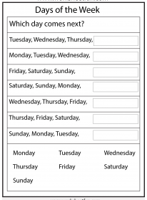

**Phonics/Handwriting:**

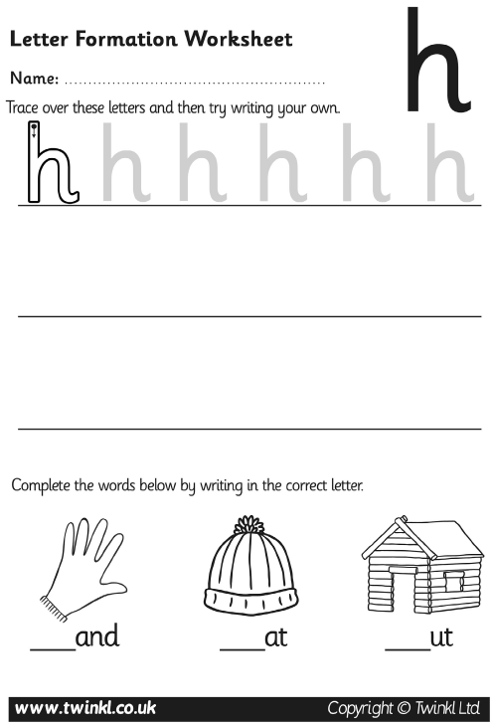

**Maths:**

**Go to Supermovers and practice your 5x table.**

[**https://www.bbc.co.uk/teach/supermovers/ks1-maths-the-5-times-table/zhbm47h**](https://www.bbc.co.uk/teach/supermovers/ks1-maths-the-5-times-table/zhbm47h)

**Ask a grown-up if there are other ways you can practise Maths at home. Can you subtract items in your house?**

**Now try to complete the picture on the next page**

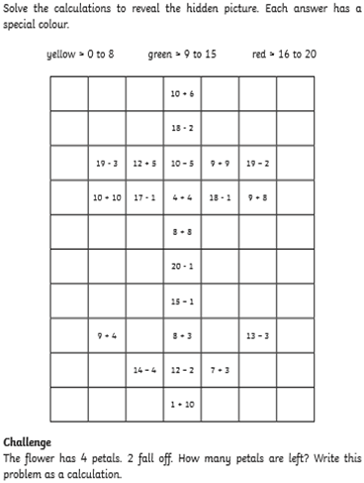

**Topic:**

**Let’s find out more about the seven continents of the world.**

**Use this video to remind you of their names:**

<https://www.youtube.com/watch?v=K6DSMZ8b3LE>

**On the next page, label the continents.**

**Here is a word bank to help you:**

Europe

Asia

Africa

North America

South America

Australasia

Antarctica

**Then colour each continent a different colour.**

**Well done! You have completed today’s homework!**

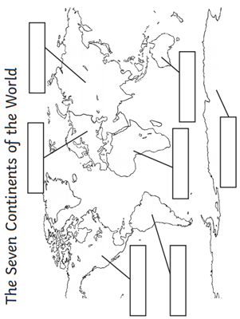

**Thursday 30th April 2020**

**Check in:**

How are you feeling today? Are worried, concerned or anxious about

anything? Talk to someone at home about your feelings, or email me and I’ll email you back! Draw a picture below to show how you are feeling.

**Write your name in Thursday’s box on page 36.**

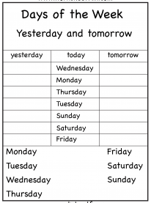

**Phonics/Handwriting:**

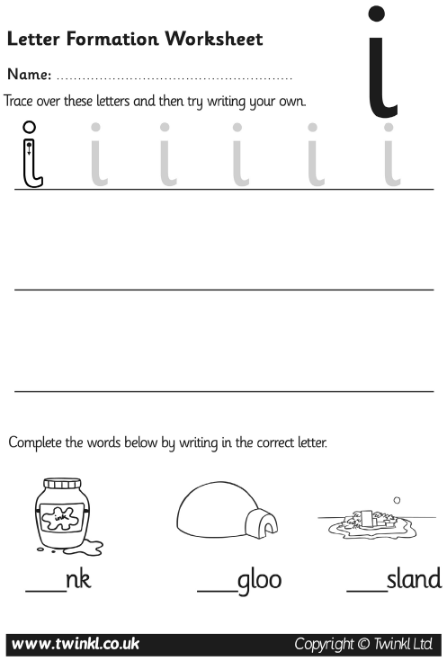

**Maths:**

**Go to Supermovers and practice your 5x table.**

**https://www.bbc.co.uk/teach/supermovers/ks1-maths-the-5-times-table/zhbm47h**

**Now try to complete the questions on the next page.**

**Then ask a grown-up if there are other ways you can practise Maths at home. Can you put items in groups in your house?**

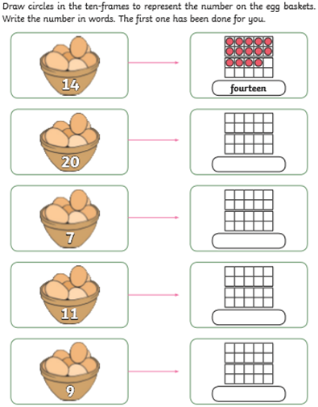

**Topic:**

**Let’s find out more about the seven continents of the world.**

**Use this video to remind you of their names:**

<https://www.youtube.com/watch?v=K6DSMZ8b3LE>

**Now, can you cut and stick the continents in the correct place to finish the world map?**

**Well done! You have completed today’s homework!**

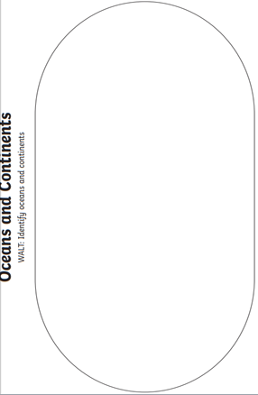

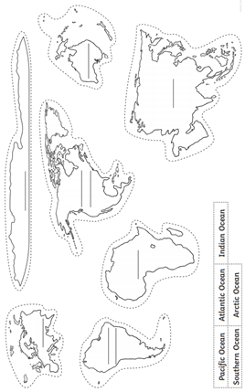

**Friday 1st May 2020**

**Check in:**

How are you feeling today? Are worried, concerned or anxious about

anything? Talk to someone at home about your feelings, or email me and I’ll email you back! Draw a picture below to show how you are feeling.

**Write your name in Friday’s box on page 36.**

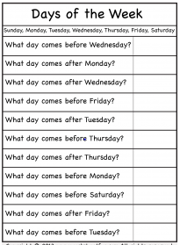

**Phonics/Handwriting:** 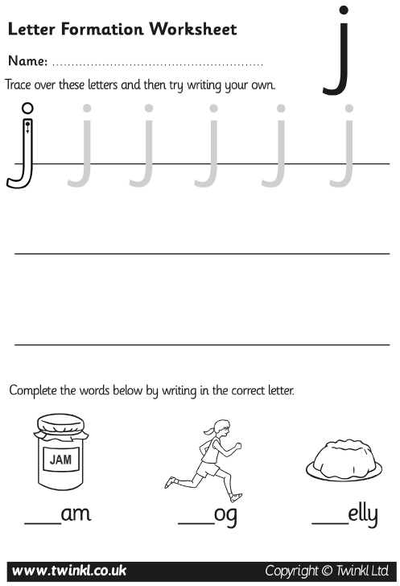

**Maths:**

**Go to Supermovers and practice your 5x table.**

**https://www.bbc.co.uk/teach/supermovers/ks1-maths-the-5-times-table/zhbm47h**

**Now try to complete these questions**

**Ask a grown-up if there are other ways you can practise Maths at home. Can you put items in order in your house from smallest to biggest?**

**.**

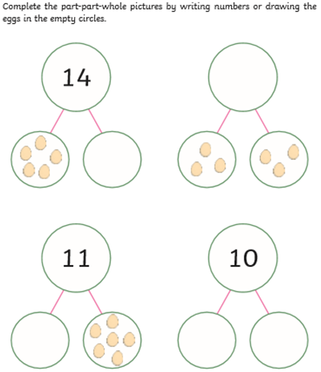

**PE:**

**It’s time for PE! Go to the website below and complete today’s workout:**

<https://www.youtube.com/channel/UCAxW1XT0iEJo0TYlRfn6rYQ>

**Well done! You have completed today’s homework!**

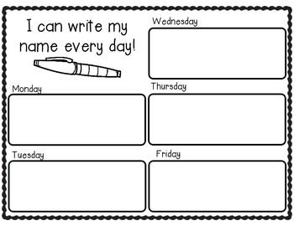

**Extra Maths**

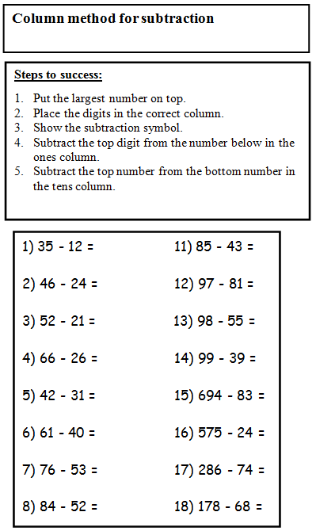

**Parents, if you need extra work for your child please email** [**year6.year6@hovingham.org**](mailto:year6.year6@hovingham.org) **and ask for more green group resources. I will get back to you as soon as I can.**

**In the meantime, you may also want to have a look at Mrs Thompson’s learning pack on the Year 6 website.**