**This week’s homework (06.04.20).**

I have broken down your homework into

topics: check in, phonics/handwriting, maths and mindfulness/PE. I recommend that you do these topics in this order as they mirror your school day.

Try your best to get through all of this work, but don’t worry if it’s too difficult. I am so proud of you for adapting to your new school day - you are a superstar!



**Contents page**

Monday page 2

Tuesday page 8

Wednesday page 15

Thursday page 20

Friday page 25

**Monday 6th April 2020**

**Check in:**

How are you feeling today? Are worried, concerned or anxious about anything? Talk to someone at home about your feelings, or email me and I’ll email you back! Draw a picture below to show how you are feeling.

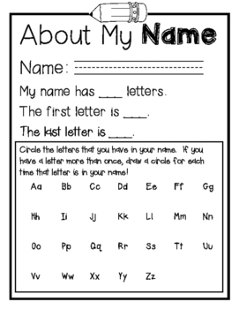

**Write your name in Monday’s box on page 30**

**Phonics/Handwriting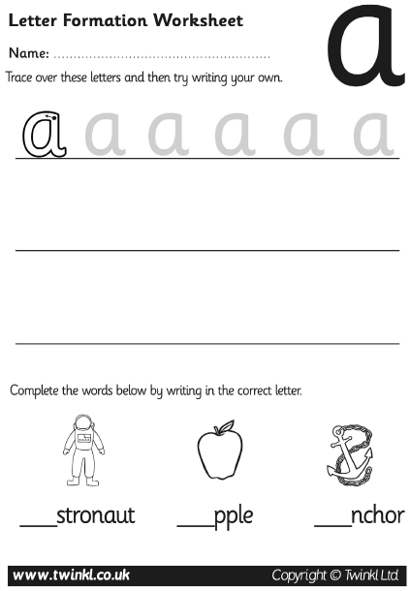Maths:**

**Go to Supermovers and practice your 2x table.**

[**https://www.bbc.co.uk/teach/supermovers/ks1-maths-the-2-times-table-with-bridget-the-lioness/zrrx92p**](https://www.bbc.co.uk/teach/supermovers/ks1-maths-the-2-times-table-with-bridget-the-lioness/zrrx92p)

**Now try to complete these questions.**

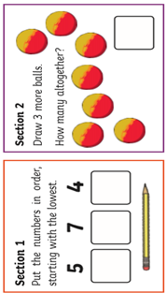

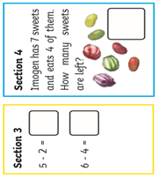

**Ask a grown-up if there are other ways you can practise Maths at home. Can you count things in your house?**

**PE:**

**It’s time for some Yoga! Go to** [**https://www.youtube.com/watch?v=X655B4ISakg**](https://www.youtube.com/watch?v=X655B4ISakg) **and complete the exercises**

**Well done! You have completed today’s homework!**

**Tuesday 7th April 2020**

**Check in:**

How are you feeling today? Are worried, concerned or anxious about

anything? Talk to someone at home about your feelings, or email me and I’ll email you back! Draw a picture below to show how you are feeling.

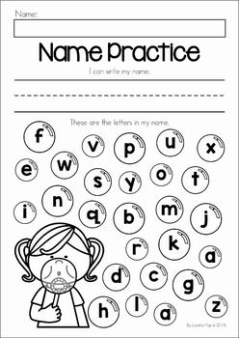

**Write your name in Tuesday’s box on page 30**

**Phonics/Handwriting:**

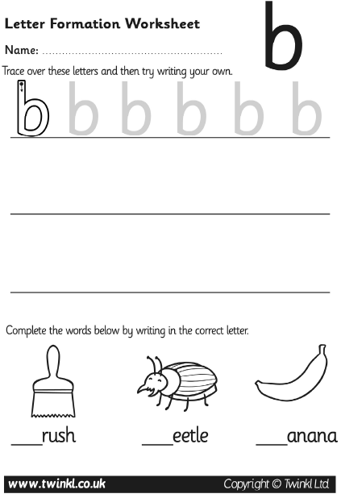

**Maths:**

**Go to Supermovers and practice your 2x table.** [**https://www.bbc.co.uk/teach/supermovers/ks1-maths-the-2-times-table-with-bridget-the-lioness/zrrx92p**](https://www.bbc.co.uk/teach/supermovers/ks1-maths-the-2-times-table-with-bridget-the-lioness/zrrx92p)

**Now try to complete these questions.**

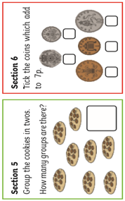

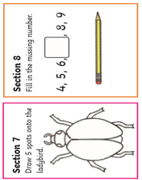

**Ask a grown-up if there are other ways you can practise Maths at home. Can you add items in your house?**

**Mindfulness Art:**

**It’s nearly Easter! Some people celebrate Easter by painting eggs in bright colours or patterns. Colour in the picture of these Easter eggs and try to make them look as bright as you can.**

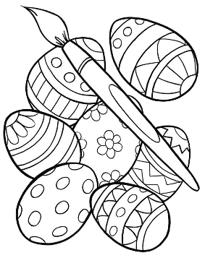

**Well done! You have completed today’s homework!**

**Wednesday 8th April 2020**

**Check in:**

How are you feeling today? Are worried, concerned or anxious about

anything? Talk to someone at home about your feelings, or email me and I’ll email you back! Draw a picture below to show how you are feeling.

**Write your name in Wednesday’s box on page 30.**

**Phonics/Handwriting:**

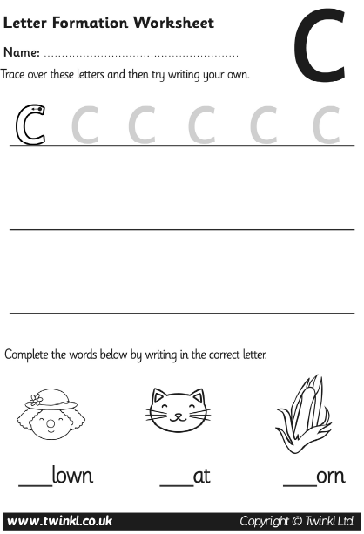

**Maths:**

**Go to Supermovers and practice your 2x table.**

[**https://www.bbc.co.uk/teach/supermovers/ks1-maths-the-2-times-table-with-bridget-the-lioness/zrrx92p**](https://www.bbc.co.uk/teach/supermovers/ks1-maths-the-2-times-table-with-bridget-the-lioness/zrrx92p)

**Now try to complete these questions**

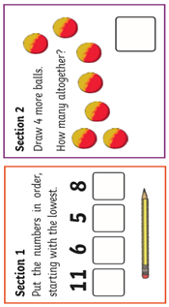

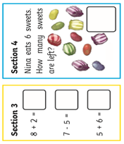

**Ask a grown-up if there are other ways you can practise Maths at home. Can you subtract items in your house?**

**Mindfulness:**

**Try to find the Easter words in the wordsearch on the next page. They could be written up, down or across. Tick them off as you find them, then colour in the eggs, bunny and lamb.**

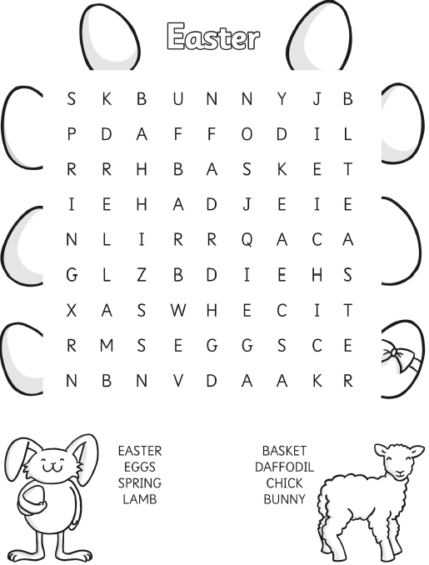

**Well done! You have completed today’s homework!**

**Thursday 9th April 2020**

**Check in:**

How are you feeling today? Are worried, concerned or anxious about

anything? Talk to someone at home about your feelings, or email me and I’ll email you back! Draw a picture below to show how you are feeling.

**Write your name in Thursday’s box on page 30.**

**Phonics/Handwriting:**

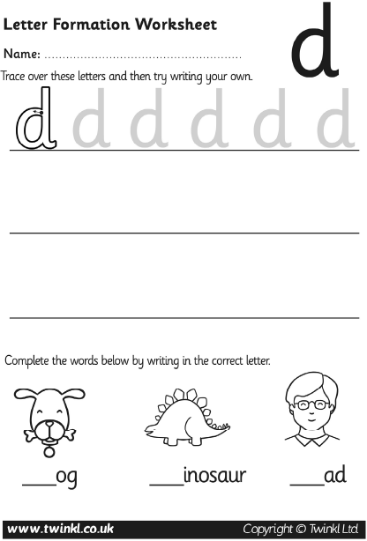

**Maths:**

**Go to Supermovers and practice your 2x table.**

[**https://www.bbc.co.uk/teach/supermovers/ks1-maths-the-2-times-table-with-bridget-the-lioness/zrrx92p**](https://www.bbc.co.uk/teach/supermovers/ks1-maths-the-2-times-table-with-bridget-the-lioness/zrrx92p)

**Now try to complete these questions.**

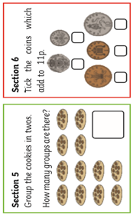

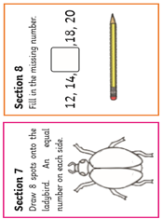

**Ask a grown-up if there are other ways you can practise Maths at home. Can you put items in groups in your house?**

**Mindfulness/Art:**

**Design your own Easter egg on the next page. You can draw different patterns and use lots of colours. If you want to design a chocolate Easter egg, draw what you could put in the egg to make it extra tasty!**

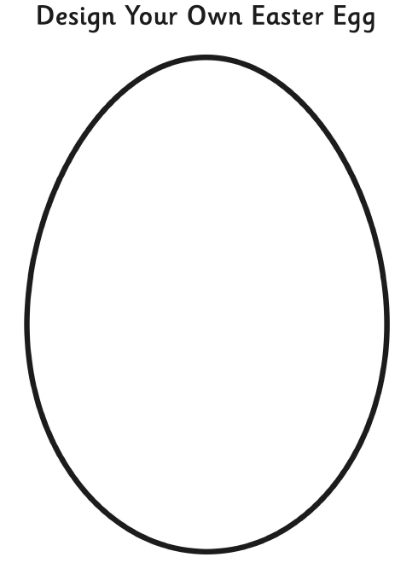

**Well done! You have completed today’s homework!**

**Friday 10th April 2020**

**Check in:**

How are you feeling today? Are worried, concerned or anxious about

anything? Talk to someone at home about your feelings, or email me and I’ll email you back!

**Write your name in Friday’s box on page 30.**

**Phonics/Handwriting:**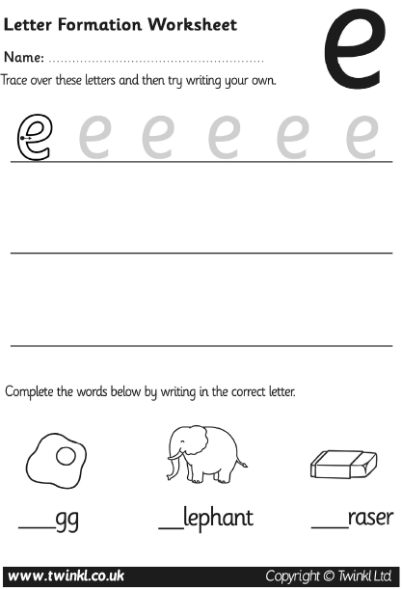

**Maths:**

**Go to Supermovers and practice your 2x table.**

[**https://www.bbc.co.uk/teach/supermovers/ks1-maths-the-2-times-table-with-bridget-the-lioness/zrrx92p**](https://www.bbc.co.uk/teach/supermovers/ks1-maths-the-2-times-table-with-bridget-the-lioness/zrrx92p)

**Now try to complete these questions.** 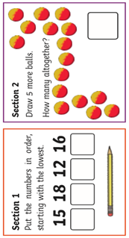

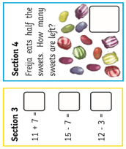

**Ask a grown-up if there are other ways you can practise Maths at home. Can you put items in order in your house from smallest to biggest?**

**PE:**

**It’s time for PE! Go to** [**https://www.youtube.com/watch?v=faE7889AIaU**](https://www.youtube.com/watch?v=faE7889AIaU) **and complete today’s workout**

**Well done! You have completed today’s homework!**

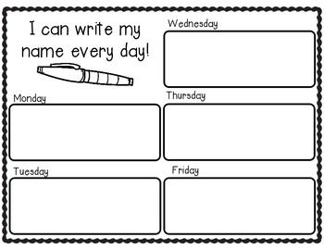

**Extra Maths**

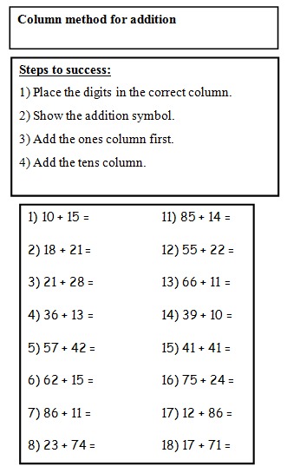

**Parents, if you need extra work for your child please email** [**year6.year6@hovingham.org**](mailto:year6.year6@hovingham.org) **and ask for more green group resources. I will get back to you as soon as I can.**

**In the meantime, you may also want to have a look at Mrs Thompson’s learning pack on the Year 6 website.**