Week commencing 13/07/2020

Hi Everyone!

It’s the last week of Year 6 and this is your last learning pack of the year!

For Reading, you will have sections of mock SATs papers, along with some questions that focus on 3 mark answers.

In Maths this week you will continue with algebra. There is an end of topic assessment for you to complete on Friday.

There is also some Science and PSHE for you to complete in your topic pack

If you need us, we are still here. You can email the Year 6 email address and we will respond as soon as we can. Over the summer, your families can still contact the school office if you need anything, but unfortunately they won’t be able to print any more learning packs for you.

Have a great last week – you have all done a super job!
Have a lovely summer and good luck in Year 7 – you will all be fantastic!

Miss Dibble

Friday 17th July 2020

Spellings

Get someone in your house to test you on the spellings below. Remember to write your answers in your neatest handwriting

- identity
- immediate,
- immediately
- individual
- interfere
- interrupt
- language
- leisure
- lightning
- marvellous

Reading

This is an extract from the autobiography of Hong Ying, where she writes about her life as a child in China during the 1960s.
She lived with her family on the banks of the River Yangtze.

Daughter of the River

My house was on the southern bank of the Yangtze. By standing on the ridge in front of my house, I could see where the Yangtze and Jialong rivers meet. An assortment of buildings on the surrounding hills looks like a jumble of children’s building blocks. Quays dot the riverbanks, steamships tie up between the quays. Cable cars, dripping rust, crawl slowly up and down the slopes. Dark clouds blanket the river at dawn, and at dusk, when the sun’s rays slant down on the water before settling behind the hills to the north, a few bursts of sunlight emerge from the dark mist.

For us, water was precious. Several hundred families shared a single tap. Queuing up was only part of the problem, for once water came, it was usually a dirty yellow. If we went down to the river to fetch water, a hard sweaty job at best, we had to treat it with bleach to make it fit for drinking or cooking, and it left a metallic taste. Except for times when the running water was turned off, we fetched water from the river only for laundry or to mop the floors.

Anyone who has never suffered the heat of this place cannot possibly understand how it burns its way from your heart and clogs up every pore on your body, to lie there baking your skin. Normally there is no wind, but when there is, it’s like adding coal to a fire. That was in the summer. Then when the Yangtze began to rise the water flowed from the higher reaches and hundreds of metres of riverbank would be swallowed up overnight when the flood season arrived.

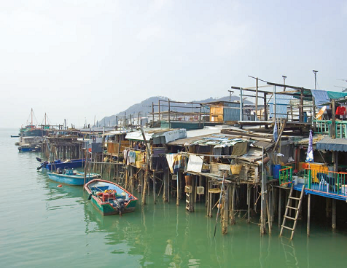

Once the weather cooled off, the inconvenience of bathing increased. Hot water was particularly scarce, but since we couldn’t afford to go to the public baths, we simply took fewer baths or no baths at all. The winter cold was as oppressive as the summer heat. Our houses weren’t heated and heating materials were virtually non- existent. Sometimes we simply cocooned ourselves in quilts and lay in bed. At night we bundled up in as many clothes as we could wear and climbed into bed, shivering until morning with freezing hands and feet. I don’t think there was a winter in my childhood when my hands weren’t covered with chilblains that made my fingers look like carrots.

For my brother, the river was a source of food. Water from the snowy peaks kept the river temperature icy cold most of the year. Nevertheless, whenever he saw something that even looked like food, he dived in after it: vegetable skins, leafy greens, even melon rinds. Once he had whatever it was in his grasp, he’d swim back to shore and take it home, where mother would wash it, cut out the rotten parts, and throw it in the wok. But he wasn’t always lucky. Most of the time all the river offered up was muddy water and he’d return home empty-handed.

Questions

1. Look at the paragraph beginning My house...

What impressions do you get of the area where Hong Ying lived?

Support your explanation with brief quotations.

3 marks

2. Give two reasons why clean water was precious in Hong Ying's community.

1. ____________________________________________________________

2. ____________________________________________________________ 1 mark

3. Explain how the language in paragraphs 3 and 4 shows that life by the Yangtze River was very harsh.

3 marks

4. Look at the final paragraph.

What does the expression something that even looked like food suggest about Hong Ying's family attitude to food?

______________________________________________________________

______________________________________________________________

1 mark

5. Look at the last sentence. What impression does the phrase offered up suggest about the river?

______________________________________________________________

______________________________________________________________

1 mark

Answers

1 Award 3 marks for answers which explain the different features of the landscape described in paragraph one, and which recognise that different impressions can be formed about the area from the descriptions. References to the text support developed answers.

• You get the impression of poverty because of the descriptions of crowdedness and jumble of where it is that people live 'an assortment of buildings… a jumble of children's building blocks'. The scene is chaotic and dirty – 'cable cars, dripping rust, crawl slowly…'. Even the weather is sinister and clouds of pollution hang over the scenery, preventing the sun from shining fully 'a few bursts of sunlight emerge from the dark mist'.

• The impression I got was that Hong Ying's neighbourhood was very uncared for: ‘Steamships tie up between the quays … dripping rust.’ Dripping rust suggests that the cable-cars have not been used for a long time, and have not been cared for. Hong Ying's neighbourhood also sounds disorganised: ‘An assortment of buildings on the surrounding hills looks like a jumble of children's building blocks,’ suggesting clumsiness and a feeling of being far away.

Award 2 marks for answers which identify one or more feature(s) of the landscape described in paragraph one and which offer some discussion of the nature of the area. Answers should make appropriate references to the text and include some development.

• That it was poor but beautiful. Things like ‘dripping with rust, crawl slowly up’ make it sound like a poor community. On the other hand, things like ‘a few bursts of sunlight emerge’ make it sound like a beautiful place to live.

• Right from the start of the first paragraph, you get a sense that the area was shabby and poor. 'Like a jumble of children's building blocks' describes a wide mass of jumbled houses, small houses, that are so close together you could reach from your house to the others.

Award 1 mark for answers which identify straightforward impressions based upon limited reference to the features of the landscape.

• That it was very poor, it might have smelt a lot and very industrial. There was dripping rust so quite dirty and very populated.

• That it is a river bank and that they are not very rich. The hills looked like jumbled children's building blocks. Dripping rust crawl up and down the slopes.

Do not accept answers that simply describe the scene without reference to an impression or an impression is given but not linked to any textual reference.

up to 3 marks

2. Award 1 mark for answers linked to any two of the following ideas:.

♦ Several hundred families had to share one tap.

♦ Sometimes the tap water was turned off.

♦ People had to queue.

♦ The effort required to collect/treat the river water.

Also accept answers which refer to the lack of clean tap water.

Do not accept answers which quote 'dirty yellow' without further explanation, eg:

• even when they could get it, it was a dirty, yellow colour.

1 mark

3. Award 3 marks for answers which offer some detailed explanation, with appropriate references to how the writer's choice of language in paragraphs 3 and 4 shows that life by the Yangtze River was harsh. Answers will explain how the writer's choice of language contributes to the overall effect. References to the text support developed answers.

• Ying uses a simile in paragraph 3, 'like adding coal to a fire', suggesting oppressive, deadly heat. On paragraph 4, she writes about being too poor to go to the public baths, '…we simply took fewer baths or no baths at all.' She uses the word 'cocooned' suggesting that she slept through harsh winters. 'At night we bundled up in as many clothes we could wear…shivering until morning with freezing hands and feet,' shows her discomfort and pain. The simile 'My hands covered in chilblains that made my fingers look like carrots.' Gives the reader a vivid picture of Hong Ying's pain at the bitter winter.

• Living where Hong Ying lives sounds terrible, 'the burning heat of the city.' Makes it sound not for the faint-hearted, as just being there is bad enough, not just living. Another extract says 'Normally there is no wind, but when there is, it's like adding coal to a fire.' Now as far as I know wind cools us down but if there is no escape from the heat, that not even wind, which only makes it hotter, can't cool it down. That must be a terrible place. But more to that in winter it cools way down and you can't keep warm even wrapped up in your quilt and clothes.

Award 2 marks for answers which offer some explanation of how the writer shows life by the Yangtze River was harsh, with one or two appropriate references.

• '…anyone who has never suffered the heat of this city cannot possibly understand…'. The word 'suffered' shows it is not easy living by the Yangtze river. It is not very pleasant.

• 'to lie there baking your skin.' The word 'baking' suggests the summers are hot.

• I don't think there was a winter in my childhood where my hands weren't covered in chilblains'. This quote shows the bad conditions were consistent every year.

Award 1 mark for answers which identify or make reference to one feature of the writer's use of language in paragraphs 3 and 4. There will be little or no explanation of how it shows that life by the Yangtze River was harsh.

• Baking hot in summer and very cold, dirty, freezing hands and fingers like 'carrots' in winter. 'Icy cold', shows how cold it was.

• Water of the river was dangerous it could overflow.

up to 3 marks

4. Award 1 mark for answers which recognise that the expression conveys the family's desperation for food.

• They are so desperate for food that her brother will take any chance to dive for it.

• They were scavengers who had hardly any food and were desperate.

Also accept answers that convey that they will eat practically anything.

1 marks

5. Award 1 mark to answers which recognise that the writer personifies the river as a (grudging or reliable) source of food.

• The river was like a person that served food.

• It was like a chef who was too mean to cook much food.

1 mark

Friday Maths
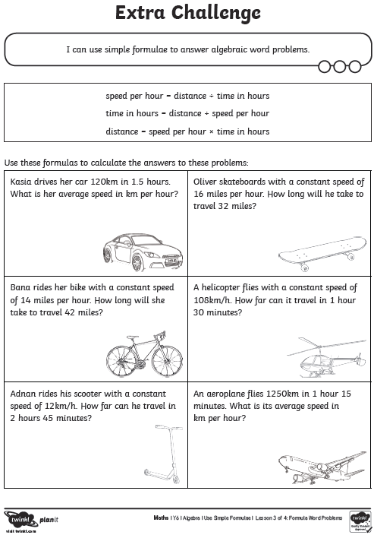
Maths Answers

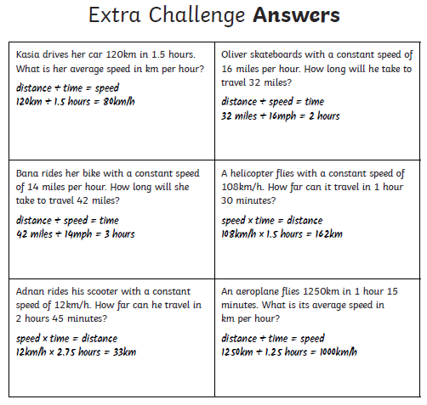

End of topic assessment