Week commencing 06/07/2020

Hey Everyone!

We hope you all staying healthy and happy and managing to still have some fun at home.

In maths this week you will continue with algebra. This week we are looking at formulae and forming equations.

For reading, you will have sections of mock SATs papers, along with some questions that focus on 3 mark answers.

Don’t forget, if you need us we are still here for you – just email the Year 6 email address and we will respond as soon as we can!

Have a great week – you are all doing a super job! Keep it up!

Friday 10th July 2020

Spellings

Get someone in your house to test you on the spellings below. Remember to write your answers in your neatest handwriting

1. existence
2. explanation
3. familiar
4. foreign
5. forty
6. frequently
7. government
8. guarantee
9. harass
10. hindrance

Reading

This is an introduction to Stephen Halliday's book The Great Stink of London. During Victorian times, there were serious problems with water supply and sanitation in London. Crisis point was reached in the summer of 1858.

The Great Stink of London

In the mid-19th century, Britain was gripped by the fear of cholera, a highly infectious and deadly disease. When cholera struck Hamburg in Germany, the British government grew alarmed that this latest outbreak might spread to Britain. They decided to create a special committee to deal with the expected epidemic.

However, the epidemic never happened because of the work of one man: Sir Joseph Bazalgette.

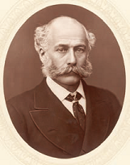 | At that time, London’s sewage flowed straight into the River Thames. From here it leaked into adjacent springs, wells and other sources of drinking water. This was the root cause of cholera, a waterborne disease. Contemporary accounts describe London being crowded with men, women and children struggling to survive in terrible conditions. In 1849, one journalist reported that the air had 'the smell of a graveyard, and a feeling of nausea comes over anyone unaccustomed to it.' About the Thames, he wrote, 'heavy bubbles now and then rise up in the water, which is covered with a scum like an encrusted cobweb. In it float large masses of noxious, tangled weed and against the posts of the bridges are swollen carcasses of dead animals.'

In the summer of 1858, the stench from the Thames was so bad that Members of Parliament fled from the rooms overlooking the river. The Prime Minister, Benjamin Disraeli, rushed from the debating chamber, handkerchief to nose. The press called the crisis The Great Stink. Disraeli introduced to Parliament a Bill that gave Bazalgette the authority to construct the sewers which he had designed; it was rushed through within sixteen days and Bazalgette began work immediately.

By 1874 Bazalgette had completed his ingenious scheme. He designed a grand system of drains and sewers to carry foul water to new pumping stations and holding tanks, and new embankments to make the river cleaner. In all, he built 1,182 miles of sewers, four pumping stations and two major water treatment works which are still operating to this day. | 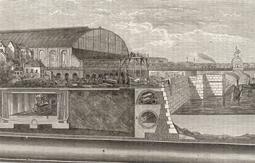

Bazalgette did much else besides. He designed and created many famous London streets and several magnificent bridges across the River Thames, including Tower Bridge, a present day London landmark. In fact, Bazalgette created more of London than anyone else before or since. But his greatest claim to fame is the system of sewers, which banished cholera forever and which still serve the capital city to this day.

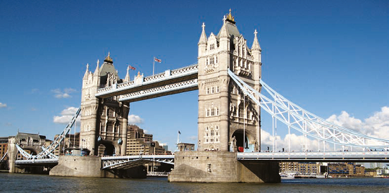

1. Look at the paragraphs beginning:

In the mid-19th century...

and

In the summer...

Give one short quotation from each paragraph which shows that Britain took the threat of cholera seriously.

(a) (In the mid-19th century)

_________________________________________________________

_________________________________________________________

(b) (in the summer)

_________________________________________________________

_________________________________________________________

1 mark

2. Contemporary accounts describe London...

Which word most closely matches the meaning of the word contemporary?

Tick one.
modern
detailed
old
brief

1 mark

3. ...scum like an encrusted cobweb

Explain what the choice of language in the phrase above tells us about how dirty the river was.

______________________________________________________________

______________________________________________________________

1 mark

4. Imagine Sir Joseph Bazalgette was interviewed by a newspaper journalist late in his career.

Decide which of the following statements he might have made during the interview.

Tick two statements.

Tick two.
"It was essential we started straight away. We had to work quickly, there was no time to lose."
"I was really just responsible for the construction work. I was given a brilliant design to follow."
"Our London sewerage system was built to last."
"Everything I have built is hidden beneath the streets."

2 marks

1 Award 1 mark for two correct answers, 1 for paragraph 1 (In the mid-19th century) and 1 for paragraph 4 (In the summer); award 0 marks for one or no correct answers:

paragraph 1 (In the mid-19th century):

♦ (Britain was) gripped by the fear (of cholera a highly infectious and deadly disease).

♦ (The British government) grew alarmed (that this latest outbreak might spread to Britain).

♦ (They decided to create a) special committee (to deal with the expected epidemic).

paragraph 4 (In the summer):

♦ (The press called the) crisis (the Great Stink)

♦ (Disraeli) introduced to Parliament a Bill

♦ a bill that gave Bazalgette the authority to construct the sewers (which he had designed)

♦ (it was) rushed through (within sixteen days)

♦ (Bazalgette) began work immediately

Also accept a combination of bullets 5 and 6 or of bullets 7 and 8

1 mark

2. Award 1 mark for:

• modern.

1 mark

3. Award 1 mark for an explanation that recognises what the writer's choice of language tells us, linked to one of the following ideas:

♦ Answers which recognise that the river was extremely dirty / unpleasant.

• It tells us very effectively that the river was disgusting.

♦ Answers which recognise that it is dangerous.

• It's like a trap.

• It's harmful.

Comments must be rooted in the text.

Also accept answers that focus on how dirty it is by using an intensifier, eg really.

Do not accept answers that identify dirty without an intensifier.

1 mark

4. Award 2 marks for two correctly ticked boxes.

Award 1 mark for one correctly ticked box.

Award 0 marks for answers where more than two boxes are ticked.

"It was essential we started straight away. We had to work quickly, there was no time to lose."
"I was really just responsible for the construction work. I was given a brilliant design to follow."
"Our London sewerage system was built to last."
"Everything I have built is hidden beneath the streets."

up to 2 marks

Friday Maths
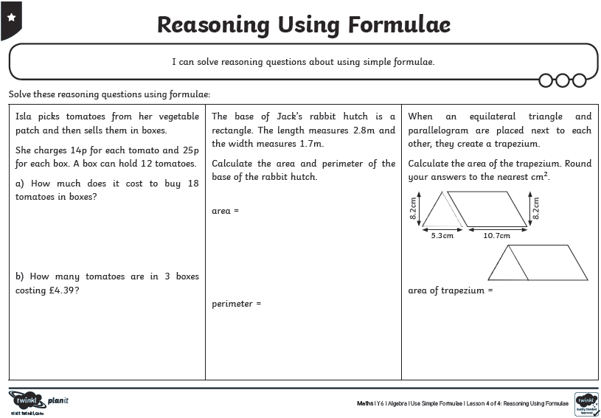
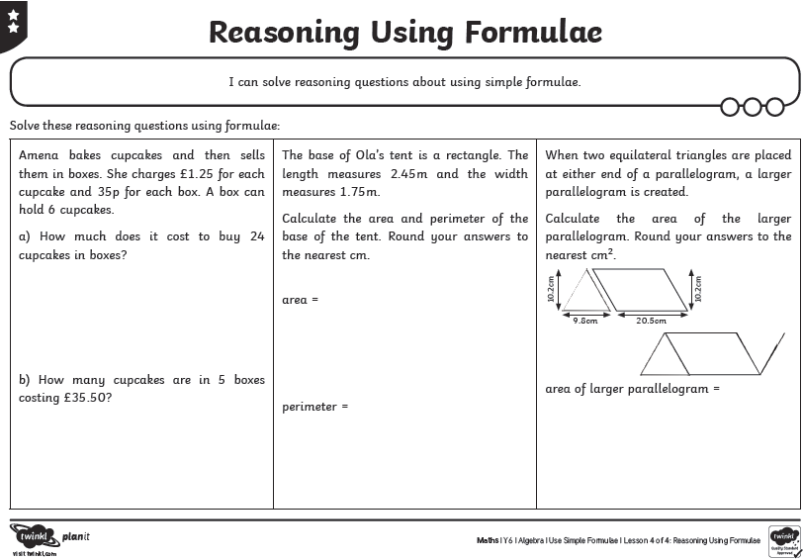
Maths Answers

