Week commencing 22/06/2020

Hey Everyone!

We hope you all had a good half term break and are staying healthy and happy.

In maths this week you will be practising forming expressions in algebra.

For reading, you will have sections of mock SATs papers, along with some questions that focus on 3 mark answers.

Your topic work is in a separate pack this week for you to work through at your own pace.

Don’t forget, if you need us we are still here for you – just email the Year 6 email address and we will respond as soon as we can!

Have a great week – you are all doing a super job! Keep it up!

Friday 26th June 2020

Spellings

Get someone in your house to test you on the spellings below. Remember to write your answers in your neatest handwriting

1. competition
2. conscience
3. conscious
4. controversy
5. convenience
6. correspond
7. criticise
8. curiosity
9. definite
10. desperate

Reading

This text is about how ladybirds helped farmers in California to get rid of a plague
of tiny insects that were killing their orange trees.

California’s 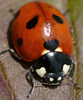

Unlikely Warriors

Over 100 years ago in America, Californian orchards were almost destroyed by a plague of thousands of tiny creatures called scale insects. These tiny sap-sucking bugs were attacking the orange trees and ruining all the fruit.

Scale insects had never been seen in America before. So where had they come from? Eventually the invasion was traced to some acacia plants that had been shipped in from Australia.

The scale insects spread so quickly that unless something was done to get rid of them, the whole fruit industry in California would be ruined. The situation was so bad that Californian fruit growers were pulling up their fruit trees and burning them to destroy the pests. Soon, the takeover started to spread to other parts of America. Different kinds of pesticides were used to try to kill the insects but none of them worked.

By now thousands of orange trees were dying.

A professor from the Department of Agriculture, Charles V. Riley, suggested that the scale insects might be controlled by introducing other insects to feed on them. But no-one listened to him. No-one had ever heard such a theory before! They thought it was a crazy idea and laughed at his suggestion. This made Mr Riley more determined. He was sure that he was right.

He had heard that in Australia, scale insects were much less of a problem. So, why was this? Why were the Australians not suffering the same damage to their trees and plants?

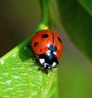 | Mr Riley predicted that the Australian scale insects must  have a natural enemy that was reducing their numbers.  Eventually he was able to persuade a researcher called Alfred Koebele to go to Australia to try to find out if this was the case.

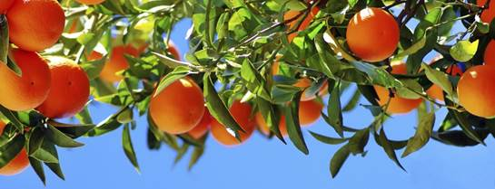

In Australia, Mr Koebele visited many of the trees that attracted scale insects and made a surprising discovery – a large number of small colourful beetles were living in them. They were ladybirds, and everywhere he found scale insects on the fruit trees of Australia, he found ladybirds feasting on them. Mr Koebele scooped up as many of the little red and black creatures as he could and sent them back to California.

When the unlikely warriors were set free in one of the dying Californian orange groves, they cleared all the scale insects from the trees in just a few days. The original 350 ladybirds sent from Australia multiplied at such a staggering rate that by June that year over 10,000 were available to be distributed to fruit growers across California. The speed at which the pests were wiped out was astonishing. One grower, who had abandoned all hope for his young orange trees, was able to harvest two to three boxes of oranges from each tree by the end of the growing season.

So successful was the experiment that soon the Americans were breeding and distributing more and more ladybirds. Not only that, but before long other countries around the world also decided to import and breed Australian ladybirds.

Because of this remarkable result, we now know a lot more about these ladybirds.
We know that scale insects are their favourite food and that some ladybirds
can eat large amounts in a day. Ladybirds also like to eat honeydew,
nectar and pollen – but they still need insects to help them grow and breed.

Today, scientists are still studying ways of using insects to help control the pests and parasites that regularly destroy our plants and trees. As we learn about some of the damage that chemical pesticides can cause, it seems even more important to take care of small creatures that can help us protect our environment.

There is an old superstition which says that ladybirds bring you luck. They certainly brought good fortune to the fruit growers of California! | 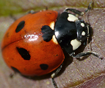

1. How long ago did the plague of scale insects attack in America?

_______________________________

1 mark

2. What did the scale insects attack?

______________________________________________________________

1 mark

3. The scale insects sound like an army.

Find and copy two words in the first two paragraphs that support this idea.

1. _______________________________

2. _______________________________

2 marks

4. It was important to find a solution to the plague of insects quickly.

Explain why.

______________________________________________________________

______________________________________________________________

______________________________________________________________

1 mark

5. Before ladybirds were introduced, how did the fruit growers try to solve the problem of scale insects?

______________________________________________________________

______________________________________________________________

1 mark

6. Look at page 1.

1. What did Mr Riley suggest to solve the problem of scale insects?

_________________________________________________________

1 mark

2. How did other people react to Mr Riley’s suggestion?

_________________________________________________________

1 mark

7. In the paragraph beginning: In Australia, Mr Koebele visited…,
the ladybirds are described as feasting on the scale insects.

What does the word feasting suggest about the ladybirds?

______________________________________________________________

______________________________________________________________

1 mark

8. Look at the paragraph on page 2 beginning:

When the unlikely warriors...

How does the text emphasise the success of the ladybirds?

Explain fully, referring to the text in your answer.

3 marks

9. Tick one box in each row to show whether each statement about ladybirds is true or false.

 | True | False
They help protect the environment.
They only eat scale insects.
They can survive on just nectar and pollen.
Some people say that they bring you good luck.

1 mark

- Mark Scheme

1. Award 1 mark for:

■ over 100 years / more than 100 years.

Do not accept 100 / 100 years ago.

1 mark

2. Award 1 mark for any of the following:

1. (Californian) orchards

2. orange / fruit trees.

Do not accept trees / fruit.

1 mark

3. Award 1 mark for each of the following, up to a maximum of 2 marks:

1. (the) invasion

2. (were) attacking

3. (almost) destroyed.

Also accept:

4. thousands (of)

5. ruining (all).

Up to 2 marks

4. Award 1 mark for reference to any of the following:

1. orange / fruit trees were being killed / orchards destroyed, eg:

• because they were killing the orange trees

• fruit trees were dying

• farmers were having to burn all their orange trees to get rid of them.

2. the fruit industry was on the point of being destroyed, eg:

• otherwise the fruit industries would be ruined.

3. the problem was spreading to other parts of America / the country, eg:

• the scale insects were starting to spread to other parts of America.

4. reference to the speed at which the insects were spreading, eg:

• the insects were spreading quickly.

Accept quotations that meet the acceptable points.

1 mark

5. Award 1 mark for reference to the fact that the fruit growers tried to destroy the trees by burning them / using pesticides, eg:

• pulling up the fruit trees then burning them

• they burnt the fruit trees

• the fruit growers used pesticides / bug spray.

Do not accept reference only to them pulling up / chopping down the trees.

1 mark

6. 1. Award 1 mark for answers that refer to Mr Riley suggesting that other
insects could be introduced to kill / eat the scale insects, eg:

• other insects might be found to eat the scale insects

• introducing other insects to eat the pests.

Also accept the quotation:

• (that the scale insects might be controlled by) introducing other insects
to feed on them.

Do not accept responses which refer to sending ladybirds to California.

1 mark

2. Award 1 mark for answers that refer to other people not listening to him
or reacting with scorn / disbelief, eg:

• no one thought it could work

• everyone thought it was a daft idea

• he got laughed at.

Also accept direct quotations, eg:

• But no-one listened to him

• They thought it was a crazy idea.

1 mark

7. Award 1 mark for any of the following:

1. ate a huge quantity (of scale insects), eg:

• that the ladybirds ate and ate and stuffed themselves.

2. ate (the scale insects) quickly, eg:

• they ate the scale insects as fast as they could.

3. enjoyed eating (the scale insects), eg:

• that the ladybirds loved eating them.

Do not accept simple statements that the ladybirds ate them / were hungry.

1 mark

8.
Acceptable points | Acceptable evidence
1. the speed at which they destroyed the  scale insects | • (just) a few days  • astonishing
2. the speed at which the ladybirds  multiplied / the size of the increase | • staggering (rate)  • reference to the fact that the increase  was from 350 to 10,000
3. the ruthlessness / thoroughness of the  ladybirds | • cleared all the scale insects  • wiped out  • (unlikely) warriors
4. the surprise at the result / unlikelihood  of the success | • unlikely (warriors)  • able to harvest (two to three boxes)
5. the change in fortune for the grower(s) | • abandoned all hope  • able to harvest (two to three boxes)

Award 3 marks for reference to at least three acceptable points or two acceptable points with text-based evidence for at least one, eg:

• It says ‘staggering’ to show the increase in ladybirds was really fast. He also says the insects were cleared out really quickly. [AP2 + evidence, AP1]

• It says ‘unlikely warriors’ to show everyone was surprised at how well they did and they did it really quickly. [AP4 + evidence, AP1]

Award 2 marks for reference to two acceptable points or one acceptable point with text-based evidence, eg:

• The farmers didn’t think they would get any fruit but things got better and some were able to harvest 3 boxes from each tree. [AP5 + evidence]

• He says they multiplied rapidly. The scale insects were killed really quickly. [AP2, AP1]

Award 1 mark for reference to one acceptable point, eg:

• because you would not have thought they could save the fruit industries [AP4]

• the ladybirds totally destroyed all the scale insects. [AP3]

Also accept, for a maximum of 1 mark, relevant quotations taken from the paragraph without a link to an acceptable point, eg:

• …they cleared all the scale insects from the trees in just a few days

• he uses words like staggering, wiped out and astonishing.

Do not accept generic reference to powerful or effective language choices, eg:

• he uses powerful and effective words

• by using great vocabulary to exaggerate the ladybirds.

up to 3 marks

9. Award 1 mark for:

Statement | True | False
They help protect the environment.
They only eat scale insects.
They can survive on just nectar and pollen.
Some people say that they bring you good luck.

1 mark

Maths
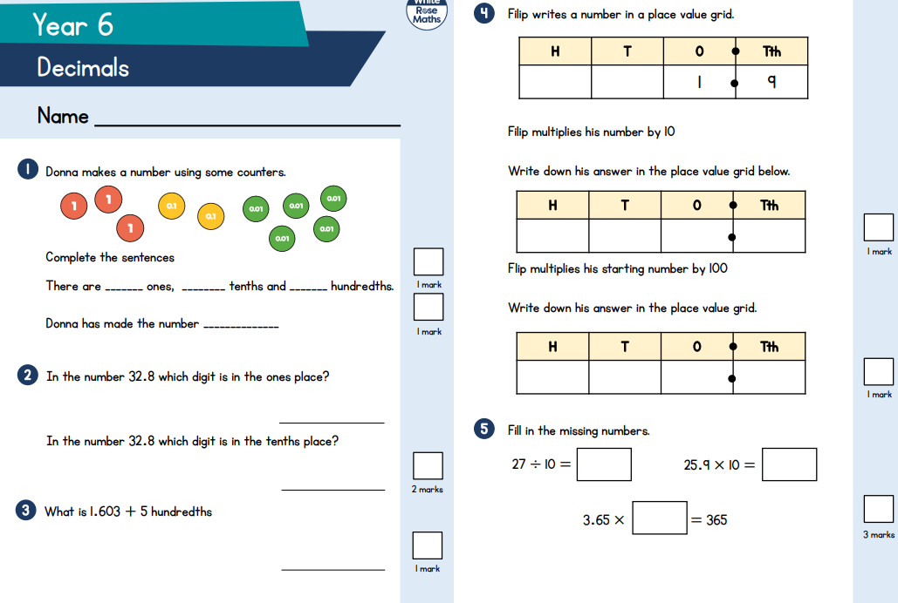

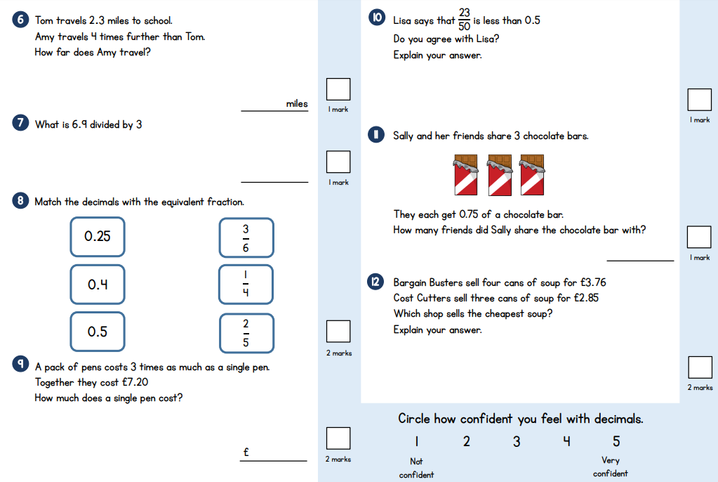
Maths answers

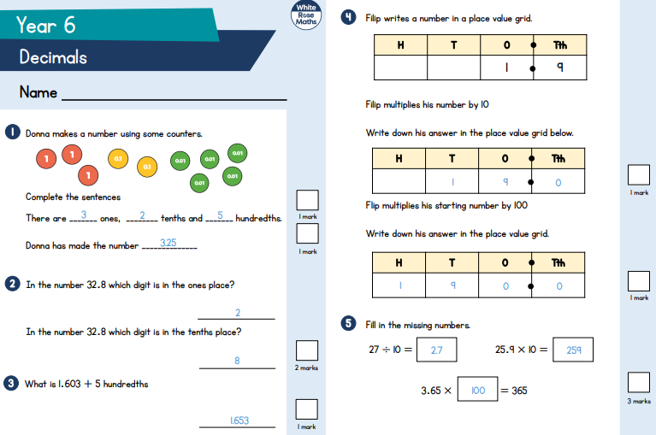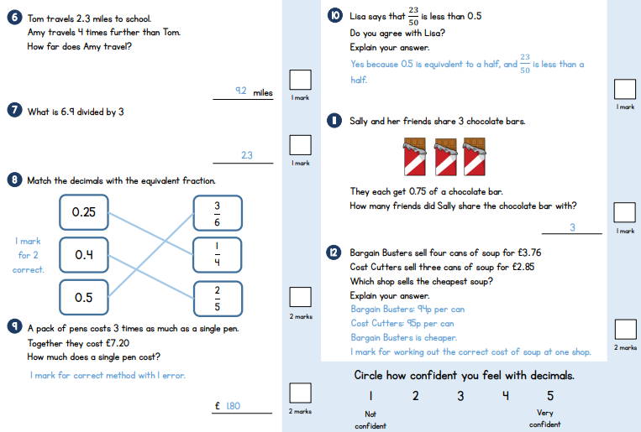
Friday - Writing task

Rewatch the following video about a day in a life of a boy at high school

https://www.bbc.co.uk/bitesize/articles/zmgkf4j

Now write a diary entry about your own imaginary first day at high school. It should be written in the first person, using the past tense and lots of emotive language. Using the following ideas to help you:

- Think about you might have felt in the morning – would you have been nervous/happy/excited?
- What did you need to take with you?
- Who did you meet in your new class, in the playground or at lunch?
- What lessons did you have?
- How did you feel by the end of the day?

Make sure you use correct grammar and punctuation!

_________________________________________________________________________________________________________________________________________________________________________________________________________________________________________________________________________________________________________________________________________________________________________________________________________________________________________________________________________________________________________________________________________________________________________________________________________________________________________________________________________________________________________________________________________________________________________________________________________________________________________________________________________________________________________________________________________________________________________________________________________________________________________________________________________________________________________________________________________________________________________________________________________________________________________________________________________________________________________________________________________________________________________________________________________________________________________________________________________________________________________________________________________________________________________________________________________________________________________________________________________________________________________________________________________________________________________________________________________________________________________________________________________________________________________________________

