Week commencing 08/06/2020

Hey Everyone!

We hope you all had a good half term break and are staying healthy and happy.

In maths this week you will begin to look at algebra.

For reading, you will have sections of mock SATs papers, along with some questions that focus on 3 mark answers.

Don’t forget, if you need us we are still here for you – just email the Year 6 email address and we will respond as soon as we can!

Have a great week – you are all doing a super job!

Friday 12th June 2020

Spellings

Get someone in your house to test you on the spellings below. Remember to write your answers in your neatest handwriting

- accommodate
- accompany
- according
- achieve
- aggressive
- amateur
- ancient
- apparent
- appreciate
- attached

Reading

This is an extract from The Lost World by Sir Arthur Conan Doyle, written in 1912. Professor Challenger has claimed that he discovered dinosaurs in a distant part of South America. He is now on an expedition to prove his story with another scientist, Professor Summerlee. Also on the expedition are Lord John, an explorer, and Malone, a journalist. In this extract, narrated by Malone, the men are about to set off into the remote area where Professor Challenger believes they will find dinosaurs...
The Lost World
We slowly and cautiously set forth into the unknown. After a few hundred yards of thick
forest, we entered a region where the stream widened out and formed a considerable
bog. High reeds grew thickly before us, with tree-ferns scattered amongst them, all of
them swaying in a brisk wind. Suddenly Lord John, who was walking first, halted.
“Look at this!” said he. “This must be the trail of the father of all birds!”
An enormous three-toed track was imprinted in the soft mud before us.
“I’ll stake my good name,” said Lord John, “that the track is a fresh one. See, here is the
mark of a little one too!”
“But what of this?” cried Professor Summerlee, triumphantly, pointing to what looked
like the huge print of a five-fingered human hand appearing among the three-toed
marks. “Not a bird.”
“A beast?”
“No; a reptile – a dinosaur! Nothing else could have left such a track.”
Summerlee’s words died away into a whisper, and we all stood in motionless amazement.
Following the tracks, we passed through a screen of brushwood and trees. Beyond was an
open glade, and in this were five of the most extraordinary creatures that I have ever seen.
Crouching down among the bushes, we observed them at our leisure.
There were, as I say, five of them, two adults and three young ones. In size they were
enormous. Even the babies were as big as elephants, while the two large ones were far
beyond all creatures I have ever seen. They had slate-coloured skin, which was scaled like
a lizard’s and shimmered where the sun shone upon it. All five were sitting up, balancing
themselves upon their broad, powerful tails and their huge three-toed hind feet, while
with their small five-fingered front feet they pulled down the branches upon which they
browsed. I can only bring their appearance home to you by saying that they looked like
gigantic kangaroos with skins like black crocodiles.
I do not know how long we stayed gazing at this marvellous spectacle. From time to
time the little ones played round their parents in unwieldy gambols, bounding into the
air and falling with dull thuds upon the earth. The strength of the parents seemed to be
limitless, for one of them, having some difficulty in reaching a bunch of foliage, put his
forelegs round the trunk of the tree and tore it down as if it had been a sapling. Then
it slowly lurched off through the wood, followed by its mate and its three enormous
infants. We saw the glistening grey gleam of their skins between the tree-trunks, and
their heads high above the brushwood. Then they vanished from our sight.
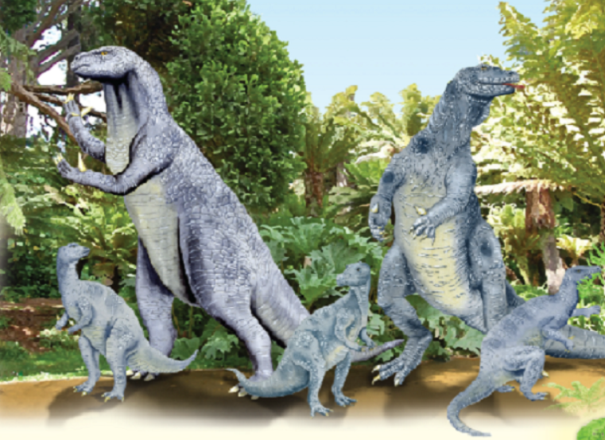
I looked at my comrades. The two professors were in silent ecstasy.
“What will they say in England of this?” Professor Summerlee cried at last.
“They will say that you are a liar,” said Professor Challenger, “exactly as you and
others said of me.”
“In the face of photographs?”
“Faked, Summerlee! Clumsily faked!”
“Who’s to blame them? For this will seem a dream to ourselves in a month or two,”
said Lord John. “What were they?”
“Iguanodons,” said Summerlee. “England was once alive with them when there was
plenty of good lush green-stuff to keep them going.”
“I don’t know what anyone else thinks, but this place makes me feel very uneasy…”
said Lord John.
I had the same feeling of mystery and danger around us. In the gloom of the trees
there seemed a constant menace and as we looked up into their shady foliage,
vague terrors crept into one’s heart. The iguanodons we had seen were lumbering,
inoffensive brutes which were unlikely to hurt anyone, but what other creatures
might there not be – ready to pounce upon us from their lair among the rocks
or brushwood?

1. Circle the correct option to complete each sentence below.

(a) The story is told from the perspective of…

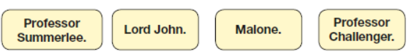 1 mark

(b) At the start of the extract the men entered the forest…

1 mark

(c) There, they came to a patch where the stream was…

1 mark

(d) The ferns here were spaced…

1 mark

2. How far into the forest did the stream become a considerable bog?

______________________________________________________________

1 mark

3. How does the first paragraph suggest that the characters are in a ‘lost world’?

______________________________________________________________

______________________________________________________________

1 mark

4. In the paragraph beginning, There were, as I say… Malone compares the
iguanodons to different animals. How do these comparisons help the reader understand what the iguanodons look like?

______________________________________________________________

______________________________________________________________

______________________________________________________________

1 mark

5. The iguanodons are described as inoffensive brutes…

Look at the paragraph beginning: I do not know how long… .

Explain how the descriptions of the iguanodons in this paragraph support
the idea that they were both inoffensive and brutes.

Use evidence from the text to support your answer.

______________________________________________________________

______________________________________________________________

______________________________________________________________

______________________________________________________________

______________________________________________________________

3 marks

6. Look at the paragraph beginning: I do not know how long…

The word unwieldy in this paragraph is closest in meaning to…
Tick one.
fast.
violent.
clumsy.
gentle.

1 mark

7. Find and copy one word that suggests Malone feels part of the team of explorers.

___________________________

1 mark

8. How can you tell that Professor Summerlee is an expert on dinosaurs?

______________________________________________________________

______________________________________________________________

1 mark

9. Look at the paragraph beginning: I had the same feeling of mystery and
danger around us.

Find and copy four different words from the rest of the paragraph that
suggest danger.

1. ___________________________

2. ___________________________

3. ___________________________

4. ___________________________

2 marks

10. Using information from the text, tick one box in each row to show whether
each statement is true or false.

 | True | False
Lord John saw the dinosaur tracks first.
Professor Summerlee has faked the evidence.
Professor Challenger worries that people won’t believe them.
They are all frightened of the iguanodons.

1 mark

11. The mood of the characters changes throughout the extract.

(a) Find and copy the group of words on page 2 where Lord John’s mood
changes.

_________________________________________________________

1 mark

(b) How does Lord John’s mood change?

_________________________________________________________

1 mark

12. Based on what you have read, what does the last paragraph suggest might
happen to the explorers next?

Use evidence from this paragraph to support your prediction.

______________________________________________________________

______________________________________________________________

______________________________________________________________

______________________________________________________________

______________________________________________________________

2 marks

1. (a) Award 1 mark for the correct option indicated.

The story is told from the perspective of...

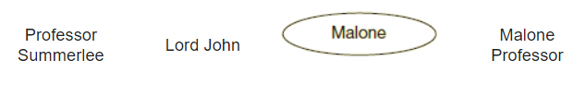

1 mark

(b) Award 1 mark for the correct option indicated.

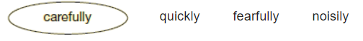 1 mark

(c) Award 1 mark for the correct option indicated.

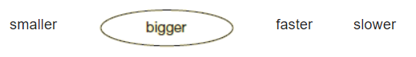

1 mark

(d) Award 1 mark for the correct option indicated.

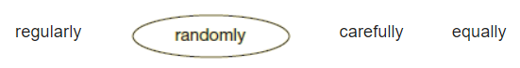

1 mark

2. Award 1 mark for: (After a) few hundred yards.

1 mark

3. Award 1 mark for reference to either acceptable point:

1. it is referred to as ‘the unknown’

2. they entered cautiously.

Do not accept reference to it being overgrown.

1 mark

4. Award 1 mark for reference to providing a comparison to something the reader will recognise, e.g.

• because we know how big elephants are

• we know what lizard’s skin is like

• it compares them to animals we know.

1 mark

5.
Acceptable Points | Likely evidence (accept paraphrase)
inoffensive
1. acted like children /  playful | • little ones played round their parents  • unwieldy gambols  • bounding into the air
2. they are herbivores /  vegetarians | • reaching a bunch of foliage
3. being together as a  family / looking after  their young | • little ones played round their parents  • followed by its mate and its three enormous  infants
4. the men don’t find  them frightening /  they don’t harm  the men | • I do not know how long we stayed gazing  • this marvellous spectacle
5. slow movement | • slowly lurched
brutes
6. strength | • tore it down as if it had been a sapling  • the strength of the parents seemed to be limitless
7. huge size | • dull thuds  • its three enormous infants  • put his forelegs round the trunk of the tree  • their heads high above the brushwood  • tore it down as if it had been a sapling  • lurched
8. the way they move | • unwieldy gambols  • dull thuds  • lurched off

Award 3 marks for a response that identifies one acceptable point for inoffensive and one acceptable point for brutes, both with evidence, e.g.

• it explains that the iguanodons were harmless because it says they eat foliage which means they are vegetarians. It also says ‘I do not know how long we have stared at this spectacle’ which means they hadn’t tried to hurt them or kill them when most dinosaurs would have tried to kill them for food. They were like brutes because they were so strong and pulled out trees without any effort. [AP2 - inoffensive + ev, AP4 - inoffensive + ev and AP6 – brutes + ev]

• They were not offensive as they let the men stare at them for ages and they didn’t attack them. But they were also like brutes as they were strong and pulled trees up really easily. [AP4 - inoffensive + ev and AP6 - brutes + ev]

• You could tell that they were inoffensive because they were playing. One of the parents was followed by its mate so they were friendly. It says they lurched which makes them sound big and heavy. [AP1, AP3 - inoffensive + ev, AP7 brutes + ev]

Award 2 marks for a response that identifies one acceptable point for inoffensive and one acceptable point for brutes, one with evidence, e.g.

• They were very strong as they could tear down a tree. And the children played lots of games [AP6 - brutes + ev and AP1 - inoffensive]

• They were moving really slowly because he says they lurched. They were also huge. [AP5 - inoffensive + ev and AP7 - brutes]

Award 1 mark for two acceptable points, one for inoffensive and one for brutes or one acceptable point with evidence for either inoffensive or brutes, e.g.

• They are vegetarians but they are really stron
[AP2 - inoffensive and AP6 - brutes]

• It explains that the iguanodons are harmless by saying they eat foliage so they are vegetarians. Also the little ones play around in ‘unwieldy gambols’ giving a cute impression. [AP2 - inoffensive + ev, AP1- inoffensive + ev]

• They must have weighed a lot because they made dull thuds when they fell over. [AP7 - brutes + ev]

Also accept, for a maximum of 1 mark, relevant quotations taken from the paragraph without a link to an acceptable point, that evidence both inoffensive and brutes, e.g.

• The little ones played round their parents in unwieldy gambols

• It calls them little ones and enormous infants

Up to 3 marks

6. Award 1 mark for the correct option ticked.
fast.
violent.
clumsy.
gentle.

1 mark

7. Award 1 mark for: (my) comrades.

1 mark

8. Award 1 mark for one of the following acceptable points:

1. he knows what the tracks are / that they are dinosaur tracks

2. he is completely fascinated (ecstasy) by the iguanodons / the opportunity to study pre-historic life

3. he knows that they are iguanodons / that they once lived in England.

Do not accept he was a professor (he could be a professor of anything).

1 mark

9. Award 2 marks for four correct words and 1 mark for two or three correct words from the list below:

1. gloom

2. menace

3. terrors

4. pounce

5. lair

6. crept.

Up to 2 marks

10. Award 1 mark for all four correct.

 | True | False
Lord John saw the dinosaur tracks first.
Professor Summerlee has faked the evidence.
Professor Challenger worries that people won’t believe them.
They are all frightened of the iguanodons.

1 mark

11. (a) Award 1 mark for:

• (“I don’t know what anyone else thinks, but this place) makes me feel very uneasy…” (said Lord John).

1 mark

(b) Award 1 mark for answers that refer to both his mood at the beginning and at the end of the extract.

Beginning:

Accept appropriate synonyms for: enthusiastic / excited / curious.

End:

Accept appropriate synonyms for: cautious / scared / anxious.

1 mark

12. Award 2 marks for an acceptable point supported by text-based evidence.

Award 1 mark for either an acceptable point or a relevant piece of text-based evidence.

Acceptable points (can be implied) | Evidence
1. death / attack / threat | feelings of danger  gloom  constant menace  terrors  pounce  iguanodons  lair
2. lost | gloom  shady foliage  rocks
3. discovering other dinosaurs | other creatures  constant menace  terrors  the iguanodons we had seen  lair  gloom

Examples of 2 mark responses:

• A vicious beast is going to eat them later on because it says there is a constant menace therefore they may not get to confirm to England that they were real dinosaurs.

• I think they will journey on to try to locate some more creatures, for in the text it says ‘what other creatures might there not be ready to pounce upon us from their lair among the rocks and brushwood’

• It says ‘but what other creatures might there not be there ready to pounce upon us from their lair among the rocks or brushwood?” which implies that something might jump out and attack them

• They were in a dangerous place and suddenly a dinosaur will pounce from behind a rock and grab one of them and eat him.

Examples of 1 mark responses:

• They got lost and stayed there and became friends with the Iguanodons

• They might be pounced on.

Do not accept general answers not relating to specific events or actions, e.g.

• It’s going to be dangerous

• They carry on exploring.

Do not accept textual evidence that is not taken from the last paragraph, e.g.

• They will find more footprints and follow them.

Do not accept predictions not supported by the last paragraph, e.g.

• They catch some dinosaurs and take them back to England.

Up to 2 marks
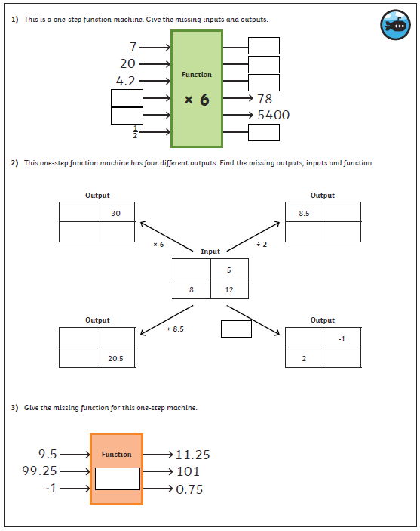

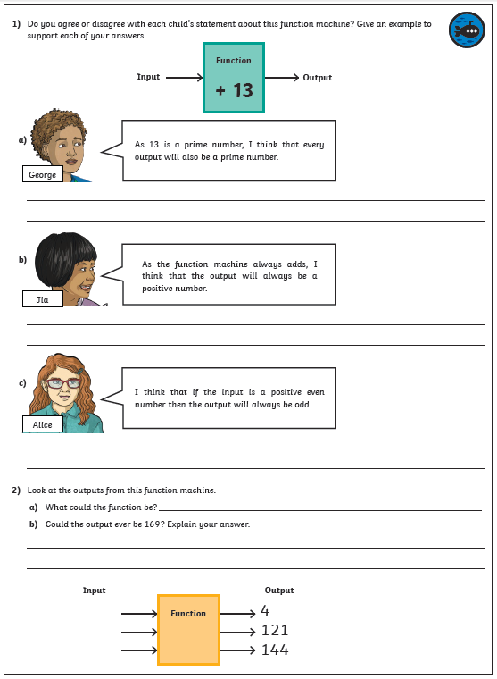
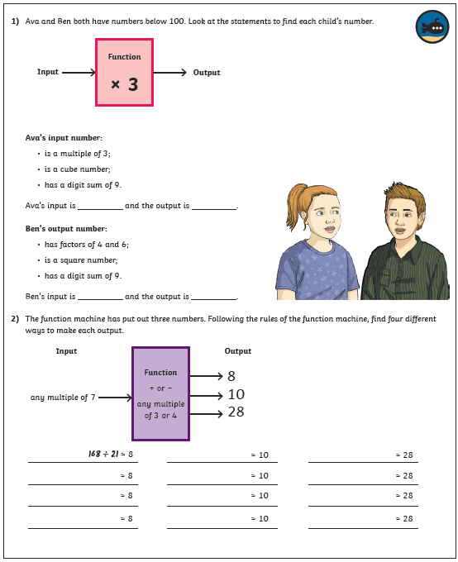

Maths Answers
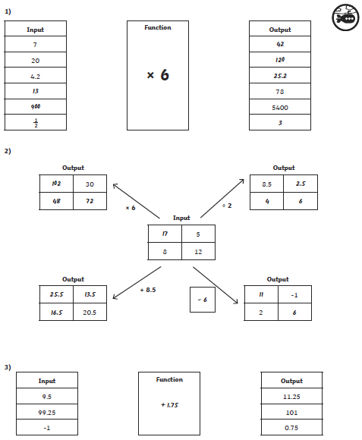
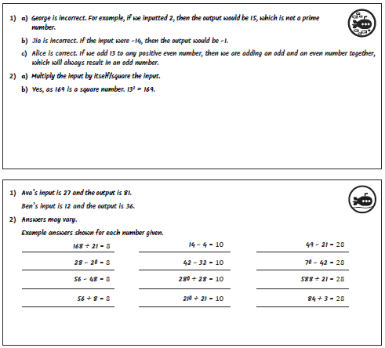

PE - Friday

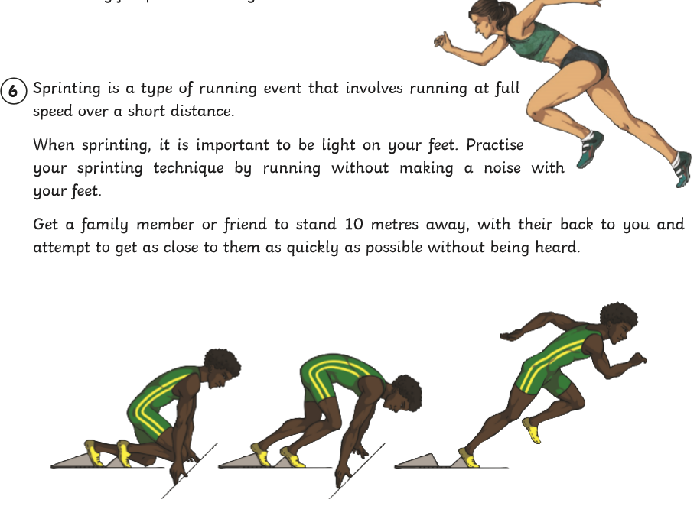

PSHE - Writing task

Watch the following video about a day in a life of a boy at high school

https://www.bbc.co.uk/bitesize/articles/zmgkf4j

Now write a story about a child’s first day a high school. Using the following ideas to help you:

- Think about how they might feel in the morning – will they be nervous/happy/excited?
- What will they need to take with them?
- Who will they meet in their new class, in the playground or at lunch?
- What lessons might they have?
- How will they feel by the end of the day?

Make sure you use correct grammar and punctuation!

________________________________________________________________________________________________________________________________________________________________________________________________________________________________________________________________________________________________________________________________________________________________________________________________________________________________________________________________________________________________________________________________________________________________________________________________________________________________________________________________________________________________________________________________________________________________________________________________________________________________________________________________________________________________________________________________________________________________________________________________________________________________________________________________________________________________________________________________________________________________________________________________________________________________________________________________________________________________________________________________________________________________________________________________________________________________________________________________________________________________________________________________________________________________________________________________________________________________________________________________________________________________________________________________________________________________________________________________________________________________________________________________________________________________________________________________________________________________________________________________________________________________________________________________________________________________________________________________________________________________________________________________________________________________________________________________________________________________________________________________________________________________________________________________________________________________________________________________________________________________________________________________________________________________________________________________________________________________________________________________________________________________________________________________________________________________________________________________________________________________________________________________________________________________________________________________________________________________________________________________________________________________________________________________________________________________________________________________________________________________________________________________________________________

