Name:_________________________

Easter Activity

Booklet 2

|  |
| --- |
|  |
| [http://sweetclipart.com/multisite/sweetclipart/files/easter_bunny_3_pink.png](http://www2.trendfromf.tk/wall/free-cartoon-easter-bunny-clip-art/) |  |  |
| [http://www.thinkmoney.co.uk/content/images/articles/easter.jpg](http://www.google.co.uk/url?sa=i&rct=j&q=&esrc=s&source=images&cd=&cad=rja&uact=8&ved=0ahUKEwi1vZzx6pLLAhVlG5oKHeIBDEIQjRwIBw&url=http://www.thewhitehorsebaston.co.uk/dining/mothering-sunday-easter-sunday&psig=AFQjCNH3M8JSPxLlfOlqUjfdY1uzkg7ItA&ust=1456486958551009) |  |  |

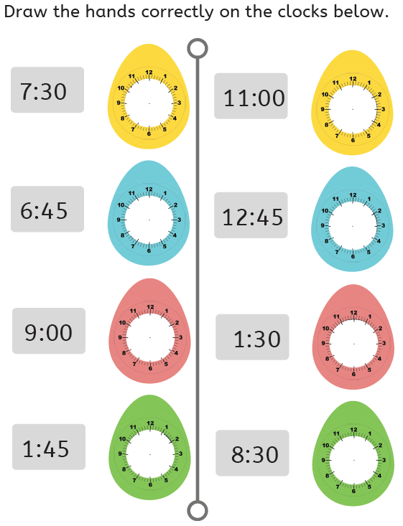

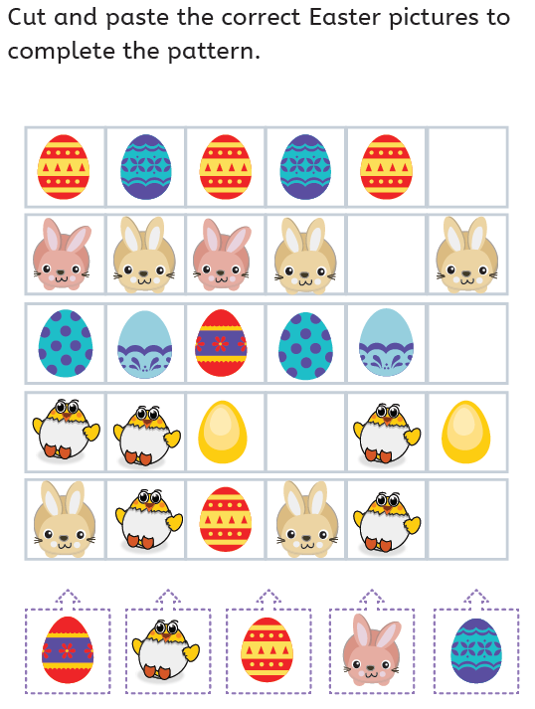

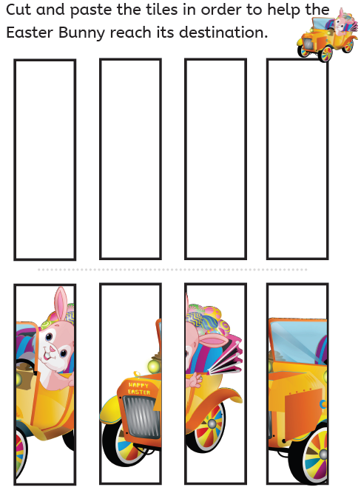

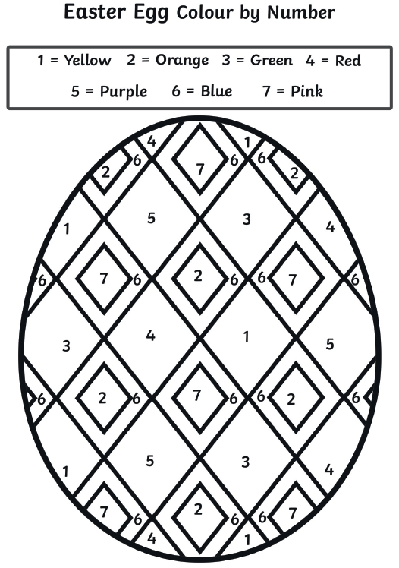

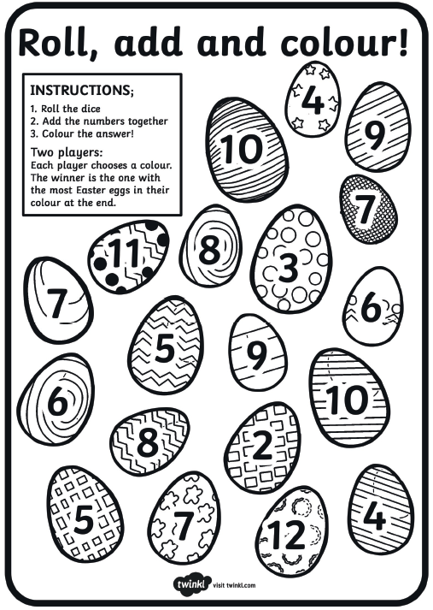

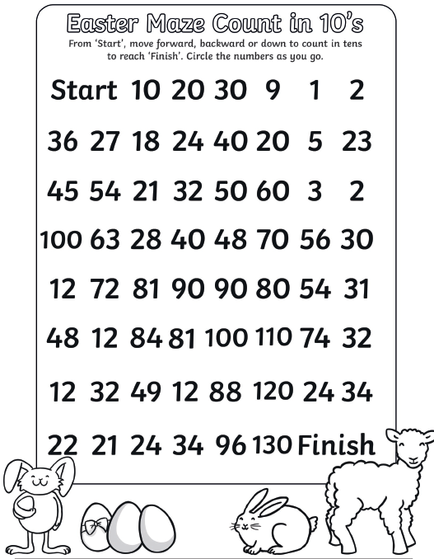

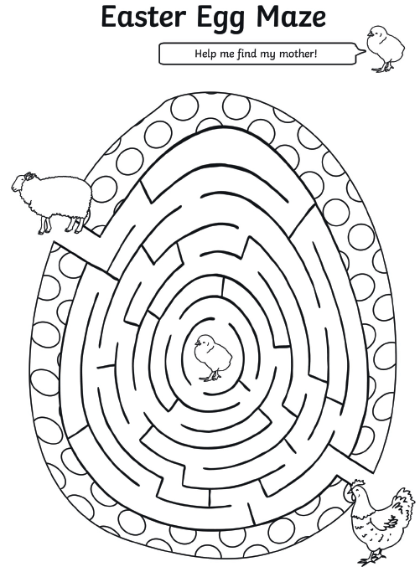

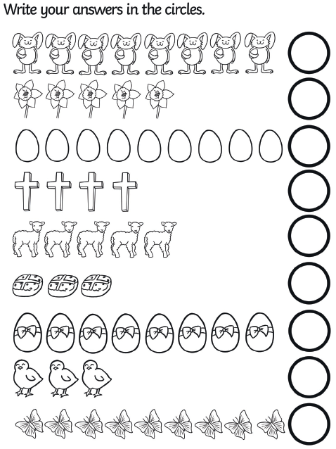

**Now colour each row of images to create repeating patterns.**

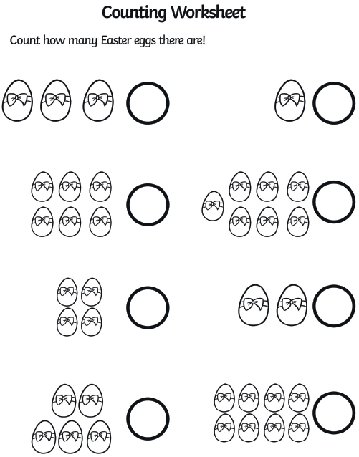

**How many are there in total? Can you write the total in words as well as numerals?**

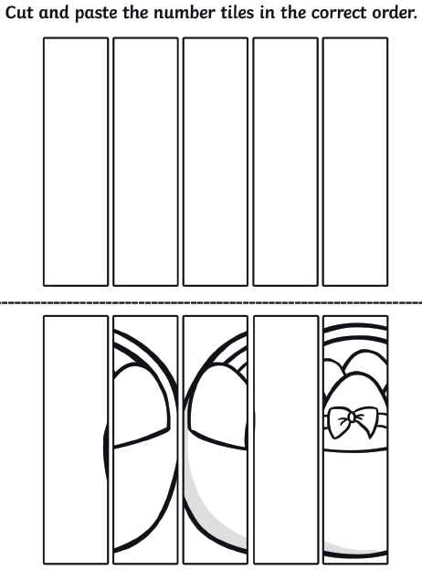

**Can you draw your own picture, cut it into strips and put them in the right order again?**

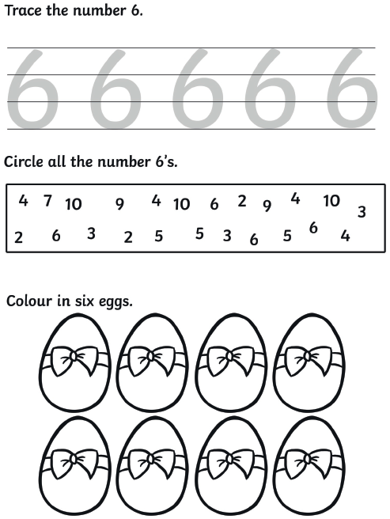

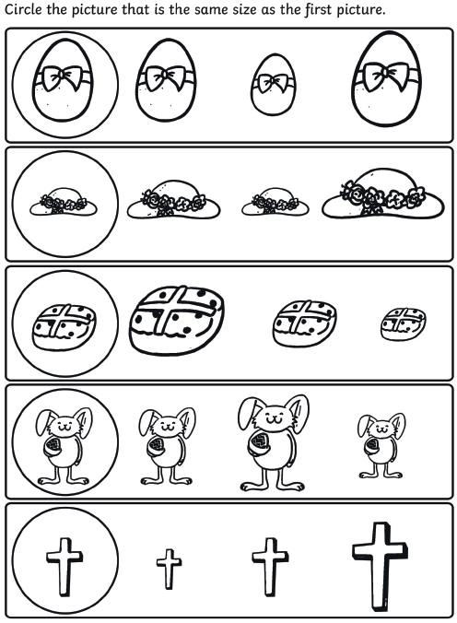

**Colour me in!**

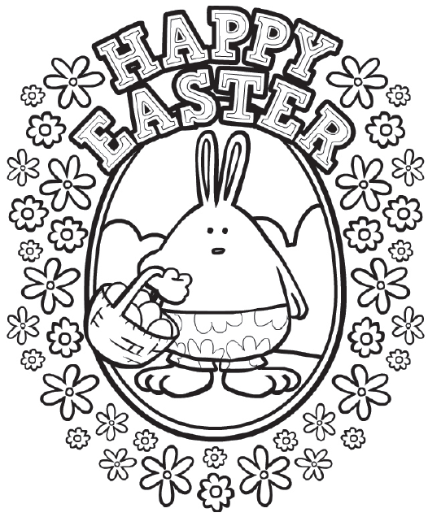

**Find your way through the chocolate egg maze…**

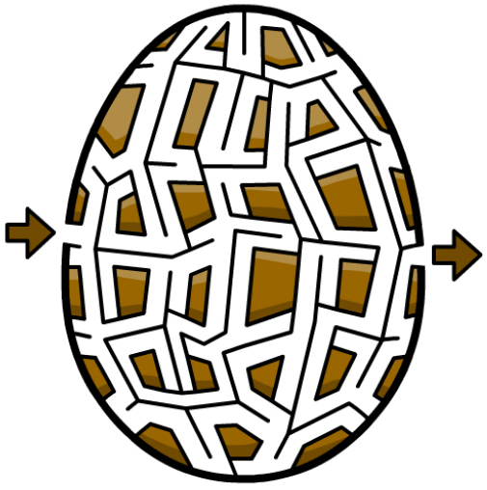

**There are 27 egg shapes in this picture of a yellow monster.**

**Can you find them all?**

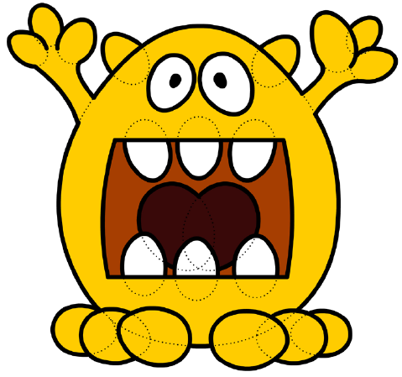

**Can you complete the patterns on each row of this egg?**

