Name:_________________________

Easter Activity Booklet

[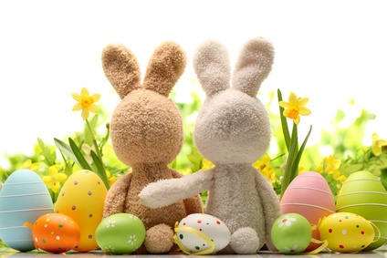](http://www.google.co.uk/url?sa=i&rct=j&q=&esrc=s&source=images&cd=&cad=rja&uact=8&ved=0ahUKEwi1vZzx6pLLAhVlG5oKHeIBDEIQjRwIBw&url=http://www.thewhitehorsebaston.co.uk/dining/mothering-sunday-easter-sunday&psig=AFQjCNH3M8JSPxLlfOlqUjfdY1uzkg7ItA&ust=1456486958551009)

How many different words can you make from the words **Easter Bunny**?

1. Eat
2. [](http://www2.trendfromf.tk/wall/free-cartoon-easter-bunny-clip-art/)___________________
3. ___________________
4. ___________________
5. ___________________
6. ___________________
7. ___________________
8. ___________________
9. ___________________

10.___________________

The Easter Bunny has dropped all his Easter Eggs! Can you help him find them by circling all the Easter eggs in the picture?

[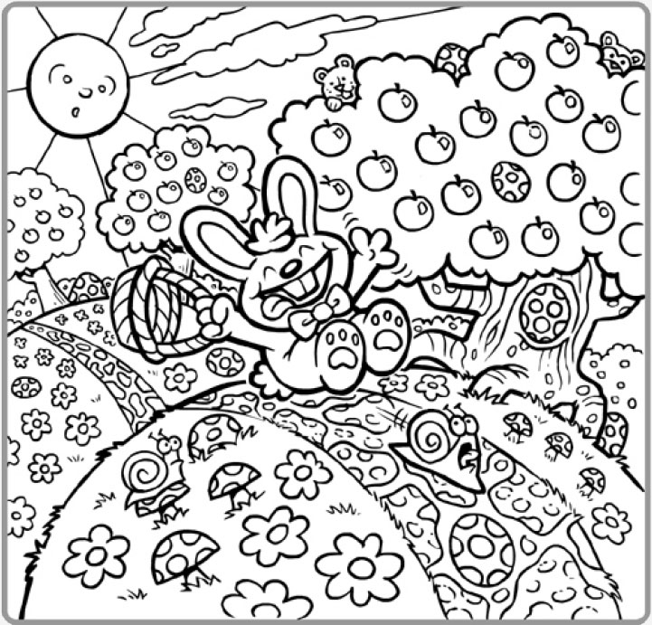](http://www.google.co.uk/url?sa=i&rct=j&q=&esrc=s&source=images&cd=&cad=rja&uact=8&ved=0ahUKEwicrfa55JLLAhUrM5oKHdZuDTgQjRwIBw&url=http://www.myeasterblog.com/easter-egg-hunt-printable-puzzle/&bvm=bv.115277099,d.d24&psig=AFQjCNGzFwsERUBdCidtV5A5SgwNofcyJA&ust=1456485196838310)

Circle the odd one out

1. 
2. [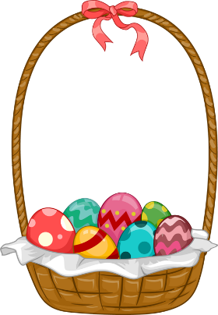](http://www.google.co.uk/url?sa=i&rct=j&q=&esrc=s&source=images&cd=&cad=rja&uact=8&ved=0ahUKEwjPycK37JLLAhXM2xoKHZaiByEQjRwIBw&url=http://www.clipartbest.com/easter-basket-clipart&bvm=bv.115277099,d.d2s&psig=AFQjCNGpFhtaUvw6UKuu5ZmiqajD4cJjhw&ust=1456487374603918)[](http://www.google.co.uk/url?sa=i&rct=j&q=&esrc=s&source=images&cd=&cad=rja&uact=8&ved=&url=http://cliparts.co/clip-art-barn&bvm=bv.115277099,d.d2s&psig=AFQjCNHHvt1NOsbxEPtSoqpH4MEmta6Tbg&ust=1456487319398924)

[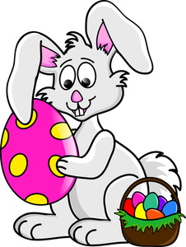](http://www.google.co.uk/url?sa=i&rct=j&q=&esrc=s&source=images&cd=&cad=rja&uact=8&ved=0ahUKEwi5gZX17JLLAhVFXRoKHUi_B64QjRwIBw&url=http://www.clipartpanda.com/clipart_images/this-easter-bunny-clip-art-35231833&bvm=bv.115277099,d.d2s&psig=AFQjCNFvmH94US8hXHs6SM7E4Sea7eK4rA&ust=1456487442059082)[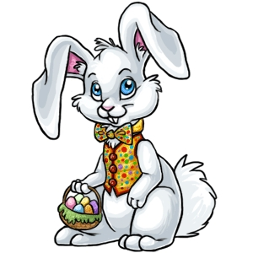](http://www.google.co.uk/url?sa=i&rct=j&q=&esrc=s&source=images&cd=&cad=rja&uact=8&ved=0ahUKEwi87sja7JLLAhUJnRoKHdodAM8QjRwIBw&url=http://www.clipartpanda.com/categories/easter-bunny-clip-art-animated&bvm=bv.115277099,d.d2s&psig=AFQjCNFvmH94US8hXHs6SM7E4Sea7eK4rA&ust=1456487442059082)

[](http://www.google.co.uk/url?sa=i&rct=j&q=&esrc=s&source=images&cd=&cad=rja&uact=8&ved=0ahUKEwi_msbO7ZLLAhVkJpoKHamTCpkQjRwIBw&url=http://www.clipartpanda.com/categories/christian-cross-clip-art-designs&psig=AFQjCNHbXG5Z86vV5S2bnIx7SpOW0r016g&ust=1456487595904391)

[](http://www.google.co.uk/url?sa=i&rct=j&q=&esrc=s&source=images&cd=&cad=rja&uact=8&ved=0ahUKEwid8ueg7ZLLAhUjM5oKHaecA4IQjRwIBw&url=http://www1.vidowsckomf.tk/wall/cross-free-clip-art/&psig=AFQjCNHbXG5Z86vV5S2bnIx7SpOW0r016g&ust=1456487595904391)4)

Design and Create your own Easter Egg

[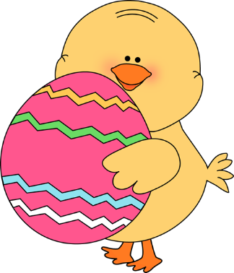](http://www.google.co.uk/url?sa=i&rct=j&q=&esrc=s&source=images&cd=&cad=rja&uact=8&ved=0ahUKEwjQv-Xa75LLAhVHWRoKHRXcDpAQjRwIBw&url=http://www.trendfromb.tk/wall/decorated-easter-eggs-clip-art/&bvm=bv.115277099,d.d24&psig=AFQjCNGLuOOSBgvEAWZOvnpv_Bm-P7l4gQ&ust=1456488250856949)[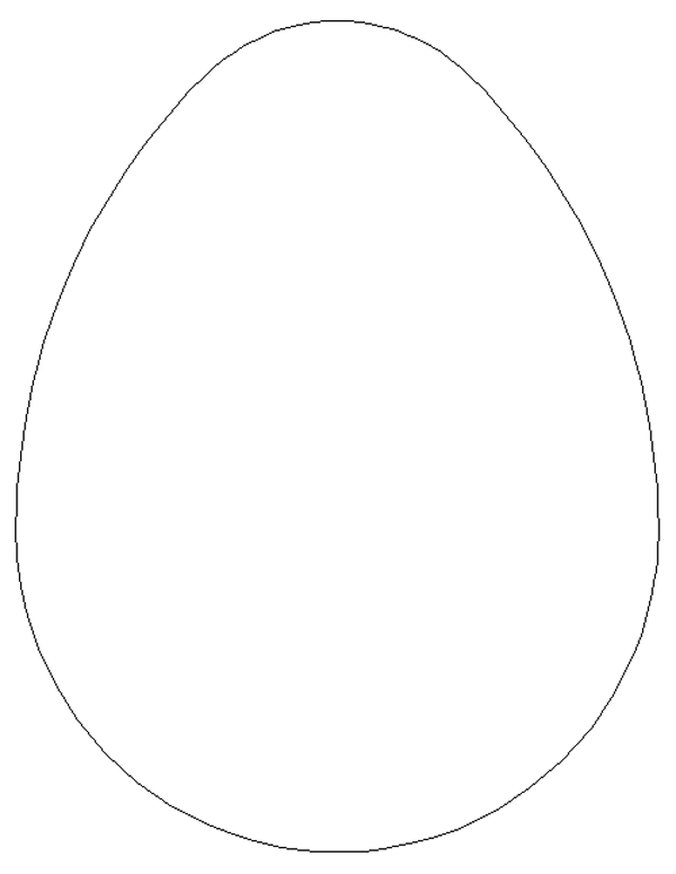](http://www.google.co.uk/url?sa=i&rct=j&q=&esrc=s&source=images&cd=&cad=rja&uact=8&ved=0ahUKEwjQ3snx7pLLAhUHXRQKHdShBJ4QjRwIBw&url=http://underwood.schooljotter2.com/classes/reception&bvm=bv.115277099,d.d24&psig=AFQjCNEY4BVqE_IbMBp2SCD8jW78Z9JvBQ&ust=1456487825660180)

**Unscramble these words:**

Restae E _ S_ _ _

Ybunn _ U _ N _

Sngir S _ _ _ G

Jsuse _ E S _ _

Mracile M _ R _ _ _

Ltecalhoco C_O_ _ L _ _ E

[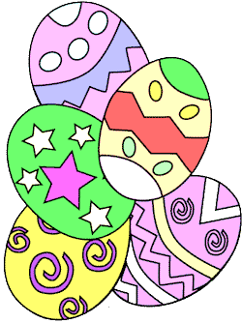](http://www.google.co.uk/url?sa=i&rct=j&q=&esrc=s&source=images&cd=&cad=rja&uact=8&ved=0ahUKEwicsejIkJPLAhWCORQKHWFIDK0QjRwIBw&url=http://www6.trendfrome.tk/wall/easter-clip-art-and-graphics/&bvm=bv.115277099,d.d24&psig=AFQjCNFAoC-YerGPf3sVgUKtNEgU_fistA&ust=1456497072638305)

|  |  |  |  |  |  |  |  |  |  |
| --- | --- | --- | --- | --- | --- | --- | --- | --- | --- |
| M | H | G | D | R | S | E | N | G | X |
| K | I | U | S | P | V | A | H | G | V |
| E | A | R | R | U | V | S | X | E | X |
| G | G | I | A | L | S | T | C | I | G |
| B | N | O | H | C | T | E | Y | H | I |
| G | A | V | O | C | L | R | J | O | J |
| A | Y | N | N | U | B | E | T | O | N |
| G | Z | G | M | K | Q | E | N | F | W |
| R | H | B | U | V | N | P | T | L | N |
| K | L | L | I | U | C | K | A | F | Q |

**Easter Wordsearch**

[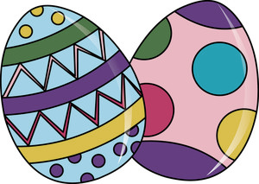](http://www.google.co.uk/url?sa=i&rct=j&q=&esrc=s&source=images&cd=&cad=rja&uact=8&ved=0ahUKEwjDts70kZPLAhWGuRoKHYGYD5YQjRwIBw&url=http://www.clipartpanda.com/categories/easter-egg-hunt-clipart&psig=AFQjCNEFbXA-SxGpBET1Xm-2vGux0T1GnQ&ust=1456497433812327)

[](http://www.google.co.uk/url?sa=i&rct=j&q=&esrc=s&source=images&cd=&cad=rja&uact=8&ved=0ahUKEwicsejIkJPLAhWCORQKHWFIDK0QjRwIBw&url=http://www6.trendfrome.tk/wall/easter-clip-art-and-graphics/&bvm=bv.115277099,d.d24&psig=AFQjCNFAoC-YerGPf3sVgUKtNEgU_fistA&ust=1456497072638305)

|  |
| --- |
|  |
| BUNNY | EASTER | EGG |
| JESUS | MIRACLE | SPRING |

Continue the patterns down the line of symmetry

Easter Egg Symmetry

